**GENERAL** **CYCLE** **AIR** **CONDITION** **TEST** **RIG** **MODEL**

1. Ashish R. Dahiwale & 2. Rushikant A. Nerkar

Madhukarrao pandav college of engineering , Bhandara (441904)

B.E. 6TH SEM (MECHANICAL DEPT.)

Email:- [ashishdahiwale@gmail.com](mailto:ashishdahiwale@gmail.com)

**ABSTRACT**

The AIR CONDITIONING test rig work on simple vapour compressor refrigeration cycle and uses R22 and R134a as a refrigerant. It is in environment friendly the arrangement of parts such that the parts are visible and working can be easily understood.

**AIR CONDITIONING** :- is a removal of heat for indoor air for thermal comfort in the other sense the term can refer to any form of cooling heating ventilation or disinfection that modifies the condition of air

The concept of air conditioning is known to have been applied in Ancient Rome where aqueduct water was circulated through the walls of certain houses to cool them. Similar techniques in medieval Persia involved the uses and wind towers to cool building during the hot season.

**Key words** :- Refrigerants, coil, compressor, rotameter, switches, TXVs condensers

**NOMENCLATURE:-** A = Inner diameter of the cylinder

B = Diameter of the roller

**ν**e = Specific volume of refrigeration at suction

**Ƞv** =Volumetric efficiency

L = Length of the cylinder block

**1.INTRODUCTION**:-

The A.C. test rig works on a simple vapour compression refrigeration cycle R134a & R22 as a refrigerant

The system is fabricated such that student can study all conditioning processes is also useful to understand working of all component of system, there performance and control etc.

All the component are mounted on a display board, so that the student can observe there working easily

The concept of air conditioning is known to have been applied in Ancient Rome, where aqueduct water was circulated through the walls of certain houses to cool them. Similar technique in medieval Persia involved the use of cisterns and wind towers to cool building during the hot season

**2.Different types of components :-**

1.Rotameter

2.Cooling coils

3.Fan

4.Expansion valves

5.Compressor

6.Blower

**3.COMPONENT OF AIR CONDITIONING TEST RIG:-**

|  |  |
| --- | --- |
| REFRIGERATION SYSTEM | Cooling Capacity |
|  | Compressor |
|  | Condenser |
|  | Condenser Fan |
|  | Drier/Filter |
|  | Expansion device |
|  | Evaporator |
|  | Accumulator |
|  | Refrigerant |
| CONTROLS & INDICATIONS | HP/LP Cut-out |
|  | Pressure indication |
|  | Temperature indication |
|  | Refrigerant flow indication |
| ELECTRICAL SYSTEM | Supply |
|  | Input power |
|  | Rated current |
|  | Operating switches |
|  | Indicating lamps |
|  | Energy meters |
|  |  |

**4.BASIC PRINCIPLE:-**

Two different pressure exist in the refrigeration cycle .The evaporator or low pressure, in the “low side” and the condenser, or high pressure, in the

“high side “. These pressure areas are divided by the other two component. On one end, is the metering flow, and on the other end, is the compressor

Refrigeration is the removal of heat from a material or space, so that it’s temperature is lower than of it’s surroundings.

When refrigeration absorbs the unwanted heat, this raises the refrigerants temperature (saturation temperature) so that it changes from a liquid to gas – it evaporates. The system then uses condensation to release the heat and changes the refrigeration back into a liquid. This is called “Latent Heat

This cycle is based on the physical principle, that a liquid extract heat from the surrounding areas as it expands (boils) into a gas.

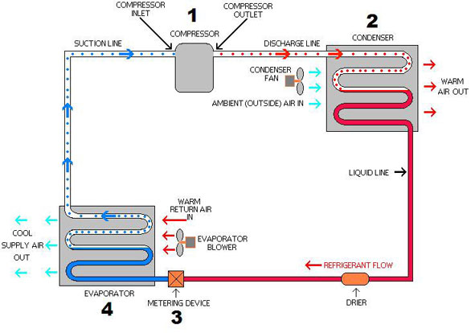

**FIG. NO. 1. BASIC PRINCIPLE OF AC TEST RIG5. Reciprocating Compressor:-**

It is the “**Heart**” of the system The compressor does just what its name is. It compresses the low pressure refrigerant vapour from the evaporator and compressor it into a high pressure vapour.

The inlet to the compressor is called the “Suction Line”. It brings the low pressure vapour into the compressor.

After the compressor compresses the refrigerant into a high pressure vapour, it removes it to the outlet called the “Discharge Line”.

**6.Thermal expansion valves, TXVs:-**

The three major types of expansion valves:

Internally balanced TXVs are the most common.

Externally balanced TXVs are used on some larger evaporators.

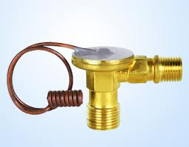Block valves route the refrigerant leaving the evaporator past the thermal sensing diaphragm so a thermal bulb is not needed.

**FIG.NO.2.TXVs**

**7.Refrigerants :-** A mechanical refrigerants absorbs the heat from the source and dissipate the same to the sink either in the form of sensible heat or in the form of latent heat.

**Refrigerants in consideration:-**

Chlorofluoro Carbon (CFCs)

Hydrochloro fluoro carbon (HCFC)

Hydrofluoro carbon(HFC)

Hydro carbon (HC)

**Properties of refrigerants:-**

**(A) :-Thermodynamic Properties**

. Boiling point

. Freezing point

.Evaporator & condenser pressure

.Critical temperature & pressure

.Latent heat of refrigeration

**(B):- Safe working properties**

.Toxicity

.Flammability

.Corrosive properties

.Chemical stability

**8.ROTAMETERS:- Rotameter is a device which measure the speed of flowing fluid, it may be water, air or gas.**

Operating principle :-

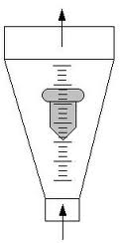A float is located in a vertical mounted conical tube. The pressure loss generated by the fluid at the float is carrying it. The height of the float is proportional to flow. Because the archimedic force is lifting the float too, the measuring principle is depending on density. Friction at the surface of the float influence the height so viscosity is restricted to low values

**FIG.NO.3 ROTAMETER**

**9.IMAGE OF COOLING TUBES AND ITS SYSTEM** 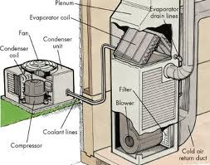

**FIG.NO.4.COOLING TUBES AND ITS SYSTEM**

**10.LINE DIAGRAM OF COMPLETE AC SYSTEM:-**



**FIG.NO.5.LINE DIAGFAM OF COMPLETE AC STSTEM**

**11.Present work:-**

It is used in a following cases:-

1.Relative Humidity

2.Specific Humidity

3.Sensible Cooling

4.Humidification

5.Dehumidification

6.Sensuble Heating

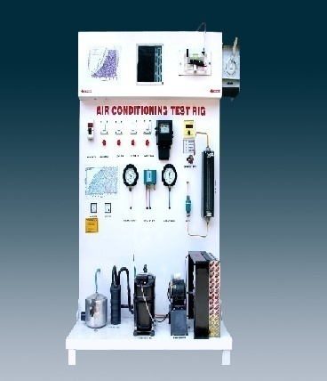**12.COMPLETE MODEL OF AC TEST RIG**

**FIG.NO.6.COMPLETE MODEL OF AC TEST RIG**

**13.REFERENCES :-**

1.”Air conditioning and refrigeration history ”-part 4, national academy of engineering journal

2 [WWW.”Air](http://WWW.) conditioning and refrigeration timeline”

3.AC & REFRIGERATION BOOK BY S. L. GAVHALE – S. Chand PUBLICATION