**MECH-89**

MADHUKARRAO PANDAV COLLEGE OF ENGINEERING  
BHILEWADA, BHANDARA  
2012-2013

SEMINAR ON

**Carona Losses And Their Effects**



**Presented By,**

**Ashish Gahane**

**Mitesh Satpute**

**Nikhil Diwathe**

**Contents**

* What is Carona?
* Caroa Inception and Extinction.
* Carona Detection.
* Electricity Losses and Carona Losses.
* Carona Effects.
* How can Carona losses should prevented?
* Beneficial Carona and their Disadvantage.
* Conclusion

**INTRODUCTION**

**C**orona is a phenomenon that has the capability for degrading insulators and causing systems to fail. In this discussion, formulas are provided to calculate the voltage at which corona occurs, and a mention is made of a useful application for corona. Corona power loss is one of the most important issues in extra high voltage power transmission systems. That is why corona discharge is taken into consideration in transmission line design.

A corona discharge is an electrical discharge on the surfaces of conductors, electrodes and dielectrics. It is caused by to the ionization of a fluid surrounding a conductor due to exposition of high electrical field stress. Sharp edges and cracks on an electrode are the most appropriate places for corona activity.

**Corona:-**Corona, also known as partial discharge, is a type of localized emission resulting from transient gaseous ionization in an insulation system when the voltage stress, i.e., voltage gradient, exceeds a critical value. The ionization is usually localized over only a portion of the distance between the electrodes of the system. Corona can occur within voids in insulators as well as at the conductor/insulator interfacena.

Corona can occur in applications as low as 300V

**How Does Carona Loss Occurs?**

* Corona extinction voltage is the highest voltage at which continuous corona of specified pulse amplitude no longer occurs as the applied voltage is gradually decreased from above the corona inception value. Thus, once corona starts, the voltage must be decreased to get it to stop.
* Losses due tooverloading and low voltage.
* Long transmission lines.
* Transformer and Transmission line losses due to poor maintainance poor standard of equipments**.**

**Corona Detection**

Corona can be visible in the form of light, typically a purple glow, as corona generally

consists of micro arcs. Darkening the environment can help to visualize the corona. We once attached a camera (set to a long exposure time) to a viewing window in a vacuum chamber to confirm that corona was indeed occurring, and thereby confirming our suspicions.

You can often hear corona hissing or cracking. Thus, stethoscopes or ultrasonic detectors (assuming you can place them in a safe location) can be used to find corona.

.

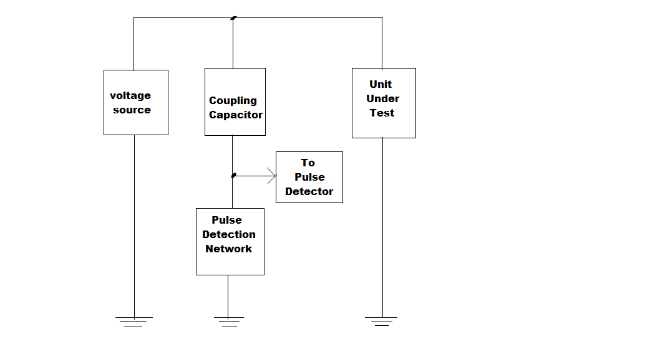

Fig. Carona Detection System.

The corona discharges in insulation systems result in voltage transients. These pulses are superimposed on the applied voltage and may be detected, which is precisely what corona

detection equipment looks for.

**Carona Calculations**

The following corona calculations are from Dielectric Phenomena in High Voltage.

*For Concentric Cylinders in Air:*

• Corona will not form when RO / RI < 2.718. (Arcing will occur instead

when the voltage is too high.)

*For Parallel Wires in Air:*

• Corona will not form when X / r < 5.85. (Arcing will occur instead when

the voltage is too high.)

*For Equal Spheres in Air:*

• Corona will not form when X / R < 2.04. (Arcing will occur instead when

the voltage is too high.)

• Arcing difficult to avoid when X / R < 8

*Where*

• RO = Radius of outer concentric sphere

• RI = Radius of inner concentric sphere

• R = Sphere radius

• r = wire radius

• X = Distance between wires or between spheres

**Corona Effects**

The presence of corona can reduce the reliability of a system by degrading insulation.

While corona is a low energy process, over long periods of time, it can substantially degrade insulators, causing a system to fail due to dielectric breakdown. The effects of corona are cumulative and permanent, and failure can occur without warning. Corona causes:

• Light

• Ultraviolet radiation

• Sound (hissing, or cracking as caused by explosive gas expansions)

• Ozone

• Nitric and various other acids

• Salts, sometimes seen as white powder deposits

• Other chemicals, depending on the insulator material

• Mechanical erosion of surfaces by ion bombardment

• Heat (although generally very little, and primarily in the insulator)

• Carbon deposits, thereby creating a path for severe arcing

**Applications of corona discharge**

* Corona discharge has a number of commercial and industrial applications.
* Drag reduction over a flat surface.
* Removal of unwanted electric charges from the surface of aircraft in flight and thus avoiding the detrimental effect of uncontrolled electrical discharge pulses on the performance of avionic systems,
* Manufacture of ozone,
* Sanitization of pool water,
* Scrubbing particles from air in air-conditioning systems (see electrostatic precipitator),
* Removal of unwanted volatile organics, such as chemical pesticides, solvents, or chemical weapons agents, from the Atmosphere
* Improvement of wetability or 'surface tension energy' of polymer films to improve compatibility with adhesives or printing inks
* Photocopying
* Air ionisers
* Production of photons for Kirlian photography to expose photographic film
* EHD thrusters, Lifters, and other ionic wind devices.
* Nitrogen laser
* Surface treatment for tissue culture (polystyrene)
* Ionization of a gaseous sample for subsequent analysis in a mass spectrometer or an ion mobility
* spectrometer
* Solid-state cooling components for computer chips (see solid-state fan)
* Coronas can be used to generate charged surfaces, which is an effect used in electrostatic copying (photocopying).

They can also be used to remove particulate matter from air streams by first charging the air, and then passing the charged stream through a comb of alternating polarity, to deposit the charged particles onto oppositely charged plates.

The free radicals and ions generated in corona reactions can be used to scrub the air of certain noxious products, through chemical reactions, and can be used to produce ozone.

**Images Of Carona Discharge and Flames**



Axial (left) and radial (right) views of discharge



**Axial view of discharge & flame (6.5% CH4-air, 33 msbetween images)**

Problems caused by corona discharges:-

Coronas can generate audible and radio-frequency noise, particularly near electric power transmission lines. They also represent a power loss, and their action on atmospheric particulates, along with associated ozone and NOx

production, can also be disadvantageous to human health where power lines run through built-up areas. Therefore, power transmission equipment is designed to minimise the formation of corona discharge.

Corona discharge is generally undesirable in:

* Electric power transmission, where it causes:
* Power loss
* Audible noise
* Electromagnetic interference
* Purple glow
* Ozone production
* Insulation damage
* Electrical components such as transformers, capacitors, electric motors and generators. Corona
* progressively damages the insulation inside these devices, leading to premature equipment failure. One form
* of attack is ozone cracking of elastomer items like O-rings.
* Situations where high voltages are in use, but ozone production is to be minimised
* Static electricity discharge

Coronas can be suppressed by corona rings, toroidal devices that serve to spread the electric field over larger area and decrease the field gradient below the corona threshold.

Mechanism of corona discharge

Corona discharge results when the electric field is strong enough to create a chain reaction: electrons in the air collide with atoms hard enough to ionize them, creating more electrons which ionize more atoms. The process is:

1. A neutral atom or molecule, in a region of strong electric field (such as the high potential gradient near the curved electrode) is ionized by a natural environmental event (for example, being struck by an ultraviolet photon or cosmic ray particle), to create a positive ion and a free electron.

2. The electric field accelerates these oppositely charged particles in opposite directions, separating them, preventing their recombination, and imparting kinetic energy to each of them.

3. The electron has a much higher charge/mass ratio and so is accelerated to a higher velocity than the ion. It gains enough energy from the field that when it strikes another atom it ionizes it, knocking out another electron, and creating another positive ion. These electrons are accelerated and collide with other atoms, creating further electron/positive-ion pairs, and these electrons collide with more atoms, in a chain reaction process called an *electron avalanche*. Both positive and negative coronas rely on electron avalanches. In a positive corona all the electrons are attracted inward toward the nearby positive electrode and the ions are repelled outwards. In a negative corona the ions are attracted inward and the electrons are repelled

outwards.

4. The glow of the corona is caused by electrons recombining with positive ions to form neutral atoms. When the electron falls back to its original energy level, it releases a photon of light. The photons serve to ionize other atoms, maintaining the creation of electron avalanches.

5. At a certain distance from the electrode, the electric field becomes low enough that it no longer imparts enough energy to the electrons to ionize atoms when they collide. This is the outer edge of the corona. Outside this the ions move through the air without creating new ions. The outward moving ions are attracted to the opposite electrode and eventually reach it and combine with electrons from the electrode to become neutral atoms again, completing the circuit.

Thermodynamically, a corona is a very *nonequilibrium*process, creating a non-thermal plasma. The avalanche mechanism does not release enough energy to heat the gas in the corona region generally and ionize it, as occurs in an electric arc or spark. Only a small number of gas molecules take part in the electron avalanches and are ionized, having energies close to the ionization energy of 1 - 3 ev, the rest of the surrounding gas is close to ambient temperature.

**Corona Prevention**

Corona can be avoided by minimizing the voltage stress and electric field gradient. This is accomplished by using utilizing good high voltage design practices, i.e., maximizing the voltage can sometimes be increased by using a surface treatment, such as a semiconductorlayer, high voltage putty or corona dope. Also, use a good, homogeneous insulator. Void free solids, such as properly prepared silicone and epoxy potting materials work well. If you are limited to using air as your insulator, then you are left with geometry as the critical parameter. Finally, ensure that steps are taken to reduce or eliminate unwanted voltage transients, which can cause corona to start

**Disadvantages**

* Corona from conductors and hardware may cause audible noise and radio noise.
* Audible noise from conductors may violate noise standards.
* Radio noise from conductors may interfere with communications or navigation.
* Corona loss may be significant when compared with resistive loss of conductor
* Corona can cause possible damage to polymeric insulators

**CONCLUSION**

This study has presented corona onset voltages and corona losses for several different conductor sizes in an indoor corona cage under DC and AC voltages. The results obtainedfrom the experiments have shown that:

* Corona onset voltage increases with an increasing conductor diameter,
* Corona onset gradient decreases with an increasing conductor diameter.
* Corona onset voltages for positive DC excitation are the highest while they are the lowest for AC excitations.
* Corona losses increase with an increasing conductor surface gradients for all types of voltages. AC corona losses are significantly higher when compared with DC losses and losses for negative DC are higher than those for positive DC.