***Technical Paper Presentation***

***On***

**Smart Materials : A Look Into The Future**



***Presented by***

**Mohit D. Wasnik**

**DEPARTMENT OF MECHANICAL ENGINEERING**

MADHUKARRAO PANDAV COLLEGE OF ENGINEERING

BHILEWADA,BHANDARA

***Abstract :***

This is the era of massive and complex manufacturing and we are now in need of materials, with properties, that can be manipulated according to our needs. The Smart materials are one among those unique materials, which can change its shape or size simply by adding a little bit of heat, or can change from a liquid to a solid almost instantly when near a magnet. These materials include piezoelectric materials, magneto-rheostatic materials, electro-rheostatic materials, and shape memory alloys (SMA’s). Shape memory alloys (SMA's) are metals, which exhibit two very unique properties, pseudo-elasticity (an almost rubber-like flexibility, under-loading), and the shape memory effect (ability to be severely deformed and then return to its original shape simply by heating). The two unique properties described above are made possible through a solid state phase change, that is a molecular rearrangement, in which the molecules remain closely packed so that the substance remains a solid. The two phases, which occur in shape memory alloys, are Martensite, and Austenite. Sensors and Actuators designs have mimicked nature to a large extent. Similar to our five senses - sight, sound, smell, taste and touch -correspondingly visual/optical, acoustic/ultrasonic, electrical, chemical and thermal/magnetic sensors have been developed. The response from these primary sensors is converted to electrical signals, which are transmitted to the brain (central processing unit) for further processing. In addition to the processing, the role of the processor is to make decision based on these inputs.The smart sensors and actuators derived using Smart material can come handy while such judgements to be made. Virtual human robots can be equipped with such sensors, memory, perception, and behavioural motor. This eventually makes these virtual human robots to act or react to events.

In this paper we have made a comparative study between SMA’s and other generally used materials or alloys, with the help of live examples (aircraft maneuverating, robotic muscles and human bone plates), Finally we have also suggested an idea, how the use of SMA’s in the mechanical couplings can make a powerful joint

**I. INTRODUCTION**

Nature is full of magic materials, which are to be discovered in forms suitable to our needs. Such magical materials, also known as intelligent or smart materials, can sense, process, stimulate and actuate a response. Smart materials have one or more properties that can be dramatically altered. Most everyday materials have physical properties, which cannot be significantly altered; for example if oil is heated it will become a little thinner, whereas a smart material with variable viscosity may turn from a fluid which flows easily to a solid. A variety of smart materials already exist, and are being researched extensively.

There is an increasing awareness of the benefits to be derived from the development and exploitation of smart materials and structures in applications ranging from hydrospace to aerospace. With the ability to respond autonomously to changes in their environment, smart systems can offer a simplified approach to the control of various material and system characteristics such as light transmission, viscosity, strain, noise and vibration etc. depending on the smart materials used. The virtual humans are expected in the near future to represent computer the concepts of behaviour, intelligence, autonomy, adaptation, perception, memory, freedom, emotion, consciousness, and unpredictability.

What Are Shape Memory Alloys?

Shape memory alloys (SMA's) are metals, which exhibit two very unique properties, [pseudo-elasticity](javascript:lookup('Pseudo-elasticity(or%20Super-elasticity)'))(An almost rubber-like flexibility demonstrated by shape memory alloys), and the [shape memory effect](javascript:lookup('Shape%20Memory%20Effect'))(The unique ability of shape memory alloys to be severely deformed and then returned to their original shape simply by heating them). The most effective and widely used alloys include NiTi (Nickel - Titanium), CuZnAl, and CuAlNi.

**Working of Shape memory alloys :**

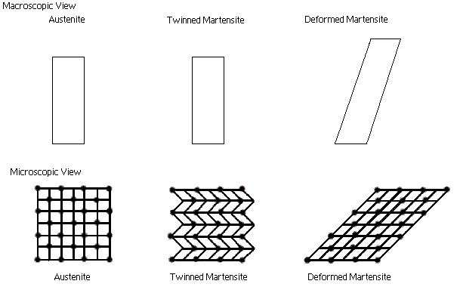The two unique properties described above are made possible through a solid-state phase change, that is a molecular rearrangement, which occurs in the shape memory alloy. A solid-state phase change is similar in that a molecular rearrangement is occurring, but the molecules remain closely packed so that the substance remains a solid.

The two phases, which occur in shape memory alloys, are Martensite, and Austenite.   
Martensite is the relatively soft and easily deformed phase of shape memory alloys, which exists at lower temperatures. The molecular structure in this phase is twinned as shown Figure 2. Upon deformation this phase takes on the second form shown in Figure 2, on the right. Austenite, the stronger phase of shape memory alloys, occurs at higher temperatures. The shape of the Austenite structure is cubic. The un-deformed Martensite phase is the same size and shape as the cubic Austenite phase on a macroscopic scale

**Shape Memory Effect :**

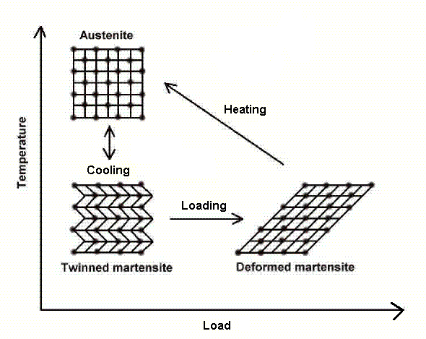The shape memory effect is observed when the temperature of a piece of shape memory alloy is cooled to below the temperature Mf. At this stage the alloy is completely composed of Martensite, which can be easily deformed. After distorting the SMA the original shape can be recovered simply by heating the wire above the temperature Af. The deformed Martensite is now transformed to the cubic Austenite phase, which is configured in the original shape of the wire. The Shape memory effect is currently being implemented in:

Figure 2: Microscopic Diagram of the Shape Memory Effect

► Coffeepots ►The space shuttle

**Pseudo-elasticity**

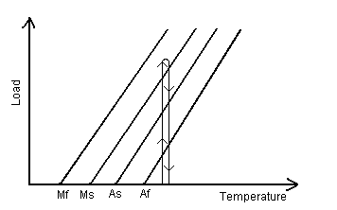Pseudo-elasticity occurs in shape memory alloys when the alloy is completely composed of Austenite (temperature is greater than Af). Unlike the shape memory effect, pseudo-elasticity occurs without a change in temperature. The load on the shape memory alloy is increased until the Austenite becomes transformed into Martensite simply due to the loading; this process is shown in Figure 4. The loading is absorbed by the softer Martensite, but as soon as the loading is decreased the Martensite begins to transform back to Austenite since the temperature of the wire is still above Af, and the wire springs back to its original shape.   
Some examples of applications in which pseudo-elasticity is used are:

Figure 3: Load Diagram of the pseudo-elastic effect Occurring

► Eyeglass Frames ► Cellular Phone Antennae

► Orthodontic Arches

Applications of Shape Memory Alloys

The unusual properties mentioned above are being applied to a wide variety of applications in a number of different fields.

Aircraft Maneuverability

Aircraft maneuverability depends heavily on the movement of flaps found at the rear or trailing edge of the wings. The efficiency and reliability of operating these flaps is of critical importance.   
 Most aircraft in the air today operate these flaps using extensive hydraulic systems. These hydraulic systems utilize large centralized pumps to maintain pressure, and hydraulic lines to distribute the pressure to the flap actuators. In order to maintain reliability of operation, multiple hydraulic lines must be run to each set of flaps. This complex system of pumps and lines is often relatively difficult and costly to maintain.   
 Many alternatives to the hydraulic systems are being explored by the aerospace industry. Among the most promising alternatives are piezoelectric fibers, electrostrictive ceramics, and **shape memory alloys**.

"Smart" wings, which incorporate shape memory alloys, are typically like the wing shown in Figure 6, this system is much more compact and efficient, in that the shape memory wires only require an electric current for movement.

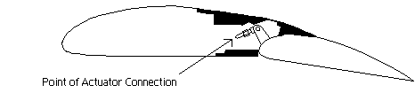

Figure 5: Typical Wing and Flap

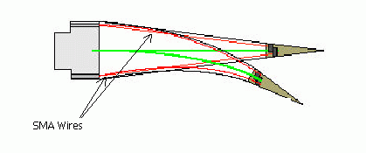

Figure 6: Hinge less shape memory alloy Flap SMA Based Aircraft Picture

The shape memory wire is used to manipulate a flexible wing surface. The wire on the bottom of the wing is shortened through the shape memory effect, while the top wire is stretched bending the edge downwards, the opposite occurs when the wing must be bent upwards. The shape memory effect is induced in the wires simply by heating them with an electric current, which is easily supplied through electrical wiring, eliminating the need for large hydraulic lines. By removing the hydraulic system, aircraft weight, maintenance costs, and repair time are all reduced.

#### Robotic Muscles :

There have been many attempts made to re-create human anatomy through mechanical means. The human body however, is so complex that it is very difficult to duplicate even simple functions. Robotics and electronics are making great strides in this field, of particular interest are limbs such hands, arms, and legs.

In order to reproduce human extremities there are a number of aspects that must be considered:

* The gripping force required to manipulate different objects (eggs, pens, tools)
* The motion capabilities of each joint of the hand
* The ability to feel or touch objects (tactile senses)
* The method of controlling movement within the limb
* Emulating real human movement (smoothness, and speed of response).

Many different solutions have been proposed for this problem, some include using "muscles" controlled by air pressure, piezoelectric materials, or shape memory alloys.

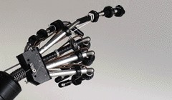 Shape memory alloys mimic human muscles and tendons very well. SMA's are strong and compact so that large groups of them can be used for robotic applications, and the motion with which they contract and expand are very smooth creating a life-like movement unavailable in other systems.   
 Creating human motion using SMA wires is a complex task but a simple explanation is detailed here. For example to create a single direction of movement (like the middle knuckle of your fingers) the setup shown in Figure 1 could be used. The bias spring shown in the upper portion of the finger would hold the finger straight, stretching the SMA wire, then the SMA wire on the bottom portion of the finger can be heated which will cause it to shorten bending the joint downwards (as in Figure 7).

The heating takes place by running an electric current through the wire; the timing and magnitude of this current can be controlled through a computer interface used to manipulate the joint.

**Conclusion:**

Its is clear from the foregoing, that this alterable property of the SMA’s will have a major say in the field of precision engineering and surgical operations in years to come. The biocompatibility, strength and corrosion resistance stands them ahead in tough competition with other materials used in Eyeglass Frames, Medical Tools, Cellular Phone Antennae, Orthodontic Arches, Robotics, the Space shuttle and thermostats. The sensing and responding property of these materials make them analogous to human brain and muscular system. By overcoming few of its setbacks we can make these magical materials unarguably the best alternative in the field of manufacturing**.**

**Bibliography:**

1. “ Material science and manufacturing “ M.Moallem 1987.
2. “ Materials science and engineering “ K.M.Gupta, Umesh publications.
3. “ Elements of material science and engineering” Van Vlack / Adison Wesley

### [Centre for Nanotechnology and Smart Materials](http://www.centi.pt/)

### [Smart Material Corp.](http://www.smart-material.com/) ([www.smart-material.com/](http://www.smart-material.com/))

### www.ted.com/talks/catarina_mota_play_with_smart_materials.html