**DESIGN AND DEVELOPMENT OF ASSEMBLY OF TROLLEY CUM STRETCHER & MODIFIED HOSPITAL BED**

**ARVIND T.WADGURE**

**K.D.K COLLEGE OF ENGINEERING,NAGPUR**

**DEPARTMENT OF MECHANICAL ENGINEERING**

**ABSTRACT**

In present investigation, in hospital we see that paitent transfer from hospital bed to another place like CT scan,ICU room,..etc. and for handling required more labour intensive work. During handling, patient and hospital staff suffer from many problem like stresses are produced in the body,some time chances to sleep down the paitent. it is required to eliminate all types of possibilities which Occure at the time of patient handling.

The present research work proposes a design and development of a new trolley along with the modification of a hospital bed which will totally eliminate the manual handling of patients.

**INTRODUCTION**

Owing to the demand for better living quality of immobilized patients, and working condition of caregiver, the functions and the convenience of hospital bed should be improved accordingly. Transferring of immobilized patients is usually the work of nursing staff. Transfer of patients from one bed to another or from bed to wheelchair or from bed to stretcher is a labour intensive work. It usually needs more than one nurse to do this job, which is very strenuous for nurses and dangerous for patient, if inappropriate operational procedure is used.

The present research work proposes a design of a new trolley along with the modification of a hospital bed which will totally eliminate the manual handling of immobilized patients.

The handling of the patient is rather difficult and is required to be planed meticulously. In ‘patient handling’, a lot of problems are faced by nursing staff, the people who handle the patient at home, and the patient himself. These problems consist of pain to patient, in various portions of body like shoulder, back, legs, etc; while moving him from one place to another. In the hospitals, the nursing staffs are also facing some health problems like pain in their shoulders and backbones, as they have to do the work of patient handling repeatedly.

According to a recent survey[4], it is found that, 38% of nursing staff suffers work related back injuries requiring time away from work, 12% of nursing staff considers leaving nursing due to low back pain at average age 39. Nursing staff aides have also experienced significant injury.

**IDENTIFICATIONOF PROBLEM**

**Present Method Of Patient Handling**

The patient transfer from hospital bed to X-ray centres /MR scan / Sonography can be divided into following stages.

**Patient bed to trolley**

The patient wrapped in canvas sheet is moved from bed to trolley with the help of three to four persons. They simply lift the canvas sheet with patient and keep it on trolley.

**Trolley to lift**

The trolley with patient is then moved to lift whose size is appropriate to accommodate the trolley.

**Trolley to Ground floor**

The lift transfers the trolley with patient to ground floor.

**Ground floor to Ambulance platform**

The trolley is moved closer to ambulance and the patient wrapped in canvas sheet is moved from trolley with the help of three to four nursing staff and put on the bed in ambulance. The trolley is lifted and put in ambulance.

**Hospital to CT scan centre**

The ambulance takes the patient from hospital to CT scan centre.

**Ambulance to trolley**

From the ambulance, the patient wrapped in canvas sheet is moved from ambulance bed to stretcher of the trolley with the help of three to four nursing staff.

**Movement of trolley to CT scan machine**

The trolley with patient is moved to the CT scan machine.

**Movement of Patient from trolley to CT scan Machine**

The patient wrapped in canvas sheet is lifted by two or more nursing staff from trolley bed and put on the CT scan machine bed.

**Movement of patient from CT scan machine to Hospital bed**

The patient is moved from CT scan machine to hospital bed by reversing above steps.

**The Problem Associated With Above Patient Handling**

1. When the patient is required to be moved the same floor he is wrapped in a canvaor cotton bed sheet and lifted by three to four person or nursing staff. Due to this handling, stresses are produced in the body of the patient as well as the nursing staff. This may result in injuries to the patient and

cramp may be produced in backbone and other parts of the body.

**2.** During the manual handling of the patient various accessories like oxygen supply, blood transmission facility, saline facility, are not available and this may createserious problem if the patient is serious.

**3.**When the patient is to be move from trolley to ambulance bed or to be moved on staircase at CT scan or X-ray centre, the movement of the patient is on inclined plane and during this movement, there is a chance that the patient may slip or slide down on stretcher.

The above problems of handling of patient can be eliminated by developing a new trolley to handle the patients and modifying hospital bed.

**FORMULATION OF PROBLEM**

**Design and development of assembly of Trolley cum stretcher and modified hospital bed for Eliminating Manual Patient Handling**

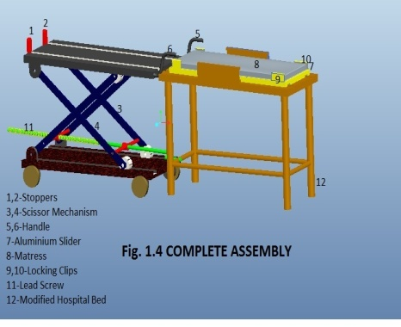

**Working of Trolley cum Stretcher**

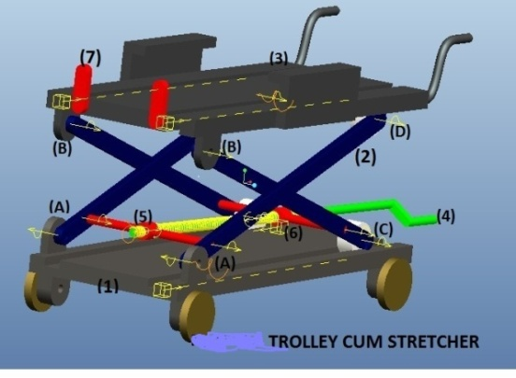

Fig. No. 5.3 shows the different parts of trolley cum stretche.The trolley cum stretcher consists of base plate (1), a scissor mechanism (2) and an aluminium channel (3) to accommodate aluminium slider as shown in Fig. No.1.1. A handle is provided to a lever to adjust the height of aluminium frame according to the height of hospital bed/ Sonography bed/ operation theatre bed etc. This whole trolley cum stretcher is made movable with the help of four wheels provided at base frame. In scissor mechanism two ends (A and B) are hinged to the top and base plate respectively as shown in Fig. No.1.1.The other ends (C and D) are free to move in the grooves provided in top frame and base plate respectively which moves to and fro according to the height adjustment. A lever (4) with trapezoidal thread up to half of its length passes through nuts (5, 6). The clockwise rotation of lever increases the height of trolley and vice versa. This whole mechanism plays the role of a typical lead screw mechanism used to lift heavy weight to considerable height. A pair of locking clips (7) is fixed at the end of both grooves as shown in Fig. No.1.1.

**Working of The modified hospital bed**

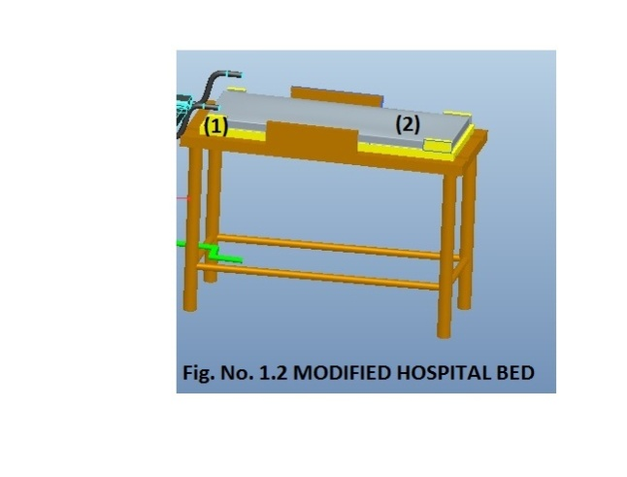

The modified hospital bed is shown in Fig. no.1.2. It consists of a detachable aluminium slider (1) which slides on 4 wheels provided at the four corners through v shape grooves. The conventional hospital bed’s top portion

is modified to accommodate aluminium slider in rectangular shape grooves. A mattress (2) is attached/ fixed to aluminium slider by locking clips.

The aluminium slider is divided into three parts which helps in providing sitting gesture to patients same as used in conventional hospital bed as shown in Fig. No.1.3.The two end of this section provides support to patient’s neck and leg. The arrangement provided to aluminium slider to change its position from sleeping to seating or for raising leg of patient is same as used in conventional hospital bed.

**LITERATURE REVIEW**

Literature review indicates that the great emphasis is done on patient handling system worldwide. All the researches have been done by keeping in mind to increase the awareness among nurses about safe patient handling and safety of patients and nurses also. They are also outlined the importance of a trolley which will assist in transfer of patient from hospital bed to stretcher/ wheelchair.

This section presents research work in the area of safe patient handling and development of trolley/ trolley cum stretcher.

**Kevin Hsu ET all** discusses a design of Portable Lift for Transferring Wheelchair Patients to Elevated Vehicle/ ambulance. Moving wheelchair bound people from their chair into a vehicle is often time consuming. The process gets more complex when the patient has to be lifted out of the chair and into a truck with an elevated seat height.

**Wei Ching-Hua ET all**  presents the mechanism

1. to change the position of patient from lying to sitting
2. to change the lateral position of patient
3. to transfer the patient from main bed to stretcher or trolley.

**Hongbo Wang and Fumio Kasagami** present a Careful-Patient Mover used for patient transfer in hospital. Using this Careful-Patient Mover, the nurse can transfer the weak, injured or paralyzed

patient from bed to stretcher or from stretcher to bed by oneself and the suffering, stress and uneasy feeling of the patient can be alleviated.

**Shih-Wei Peng and Feng-Li Lian** discusses the mechanism design and mechatronic control of a multifunctional test bed for testing and evaluating healthcare activities designed for assisting bedridden people.

**Patient Care Ergonomics Resource Guid** Safe Patient Handling and Movement developed by the Patient Safety Centre of

Inquiry (Tampa, FL), Veterans Health Administration and Department of Defence.

**Development of Trolley cum Stretcher & Modified hospital bed**

The dimensions of each part of trolley cum stretcher are taken from the standard sizes of hospital bed which is available in the market.

The following data have been assumed and used for the fabrication of trolley cum stretcher.

1. Maximum weight of the Patient to be lifted- 200 kg
2. Maximum lift distance trolley to be lifted- 3.0 ft.
3. Stretcher dimension- (6.0x3.5) ft
4. Overall size of Hospital bed- (6.5x3.5x2) ft.
5. Base plate dimension of proposed trolley- (6.5x3.0) ft.

**Fabrication of Base Platform**

The dimensions of base platform of trolley are assumed to be (6.5x3.0) ft. which is selected on the basis of modern hospital

bed dimensions available in the market. By taking the standard size of instrument as per above, desing the complete assembly and develop the assembly .

**REFERENCES**

1. Kevin Hsu ET all fall, “design of Portable Lift for Transferring Wheelchair patients to Elevated Vehicle/ ambulance”, University of Michigan Orthotics and Prosthetics Centre. 2008
2. Wei Ching-Hua et all, “Hospital bed with Auxiliary Functions of Lateral and Transferring for mmobilized patients Taipei”, Taiwan. Nov. 5-8 2007 The 33rd Annual Conference of the IEEE Industrial Electronics Society (IECON) Pgs.2991-2995.
3. Hongbo Wang and Fumio Kasagami, “A Patient Transfer Apparatus Between Bed and Stretcher”, IEEE transaction on System, Man, and Cybernetics-part-B:, Vol. 38,No.1, Feb.2008.
4. “Patient Safety Centre of Inquiry (Tampa, FL), Safe Patient Handling and Movement”, Veterans Health Administration and Department of Defence, October2001 Pgs.59-70.
5. Ehsanullah Khan et al., “Synthesis

of Trolley cum Wheelchair for Patient Handling”, International Journal of Engineering, Science and Technology (IJEST) Vol.3 No.8, Aug.2011 Pgs.6311-6316.

1. [www.narang.com/hospitalbed/27-09-12/8.06](http://www.narang.com/hospitalbed/27-09-12/8.06)pm/Tuesday