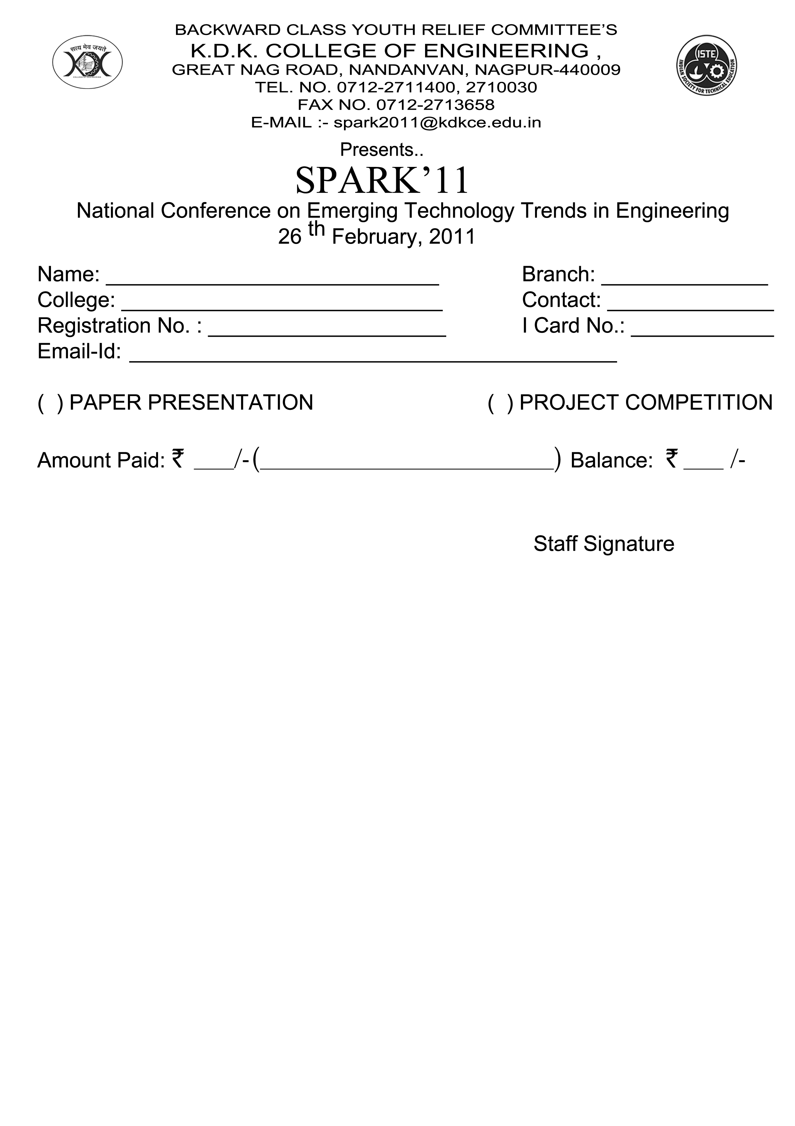

K.D.K. College of Engineering
&
ISTE Students Chapter

Organizes

SPARK’ 13
PROCEEDINGS

National Level Paper Presentation

&

Intercollegiate Poster Competition

22nd March, 2013

K. D. K. College of Engineering
Great Nag Road, Nandanwan,
Nagpur – 440 009.
Ph. : 0712 - 2711400 / 2710030
Fax: 0712 - 2711870 ]
Website : www.kdkce.edu.in
COMPUTER AND INFORMATION TECHNOLOGY
Serial No. | Paper Title | Id No.
1 | Cloud Computing | CT&IT 01
2 | Cloud Computing | CT&IT 02
3 | Bluejacking | CT&IT 03
4 | Spy Mobile | CT&IT 04
5 | Graphical Password Authentication Using Persuasive Cued Click Point | CT&IT 05
6 | 4g Wireless System:Technology And Applications | CT&IT 06
7 | Vmware Technology | CT&IT 07
8 | Review Paper On Image Annotation | CT&IT 08
9 | Wireless Communication | CT&IT 09
10 | Data Hiding Using Stegonography With Encryption And Decryption | CT&IT 10
11 | Worklight | CT&IT 11
12 | Abstract On Cloud Computing | CT&IT 12
13 | Real Time Operating System | CT&IT 13
14 | Overview On Feature Extraction Techniques For Devnagari Handwritten Character Recognition | CT&IT 14
15 | E-Cops (E-Computerized Operation For Police Service) | CT&IT 15
16 | Cloud Computing And Virtualization In Redhat | CT&IT 16
17 | Cloud Computing Vs. Grid Computing | CT&IT 17
18 | Artificial Intelligence | CT&IT 18
19 | Automatic Identification And Data Capturing Using Rfid | CT&IT 19
20 | Intelligent Monitoring Sensor  Harshalata Wadaskar  Dept.of Computer Science and Engineering  Dr. Babasaheb Ambedkar College of Engineering  Nagpur, Maharashtra | CT&IT 20
21 | Inforamtion Security On Wireless Networks | CT&IT 21
22 | Biometrics | CT&IT 22
23 | Microsoft Surface Computing | CT&IT 23
24 | 5g Mobile Technology | CT&IT 24
25 | Computer Viruses | CT&IT 25
26 | Near Field Communication (Nfc) | CT&IT 26
27 | Cloud Computing | CT&IT 27
28 | Composite Mail Server | CT&IT 28
29 | Cloud Computing | CT&IT 29
30 | A Genetic Algorithm Optimization Technique For Multiwavelet-Based Digital Audio Watermarking | CT&IT 30
31 | Sixth Sense Technology | CT&IT 31
32 | Overview On Various Feature Extraction Techniques  For Devnagari Handwritten Character Recognitionz | CT&IT 32
33 | A genetic algorithm optimization technique for multiwavelet-based digital audio watermarking | CT&IT 33

MECHANICAL ENGINEERING
Serial No. | Paper Title | Id No.
1 | Induced Transmission System For Bicycle | MECH-01
2 | Vapour Compression Refrigeration System Operated By Solar Power | MECH-02
3 | Solid Modelling And Finite Element Analysisofeot Crane Girder | MECH-03
4 | Fabrication Of Air Cooler Diverter Strip Mfg. | MECH-04
5 | Physical Cost Index Of Rice Mill Workers In Vidharbha Region | MECH-05
6 | Hybrid Power Sprayer | MECH-06
7 | Technology Of Groundnutshellermachine And Fabrication | MECH-07
8 | Load Operated Power Assisted Bicycle | MECH-08
9 | Thermal Stress Analysis By Thermo-Photo- Elasticity In The Shaft And Plate | MECH-09
10 | Modification Of Existing Plant Layout & Material Handling In M/S Agrofab Machineries Pvt.Ltd, Hingna, Nagpur | MECH-10
11 | Electrically Assisted Regenerative Bicycle | MECH-11
12 | Crack Detection Techniques In Overhang Beam | MECH-12
13 | Automatic Water Lifting Device And Approach | MECH-13
14 | Solar Operated Uv Water Purifier | MECH-14
15 | Analysis & Design Of Bridle Roll Shaft In Jsw Ispat Steel Ltd | MECH-15
16 | Design, Development & Fabrication Of Soil Tiller And Weeder For Soil Fertility & Fertilization | MECH-16
17 | A Multi-Channel Parameter Scanner Using Microcontroller And Plc | MECH-17
18 | Poka-Yoke | MECH-18
19 | Trigger Operated Hacksaw | MECH-19
20 | Design Of Dilute Phase Pneumatic Conveying System For Bulk Material | MECH-20
21 | Design And Fabrication Of Paddy Harvester | MECH-21
22 | Abs (Anti-Lock Breaking System) | MECH-22
23 | Role Of Personal Characteristics For Women For Choosing An Enterprenuership As Career | MECH-23
24 | Hydram-Working Principle And Conventional Approach | MECH-24
25 | Design & Fabrication Of Push Type Spraying Machine | MECH-25
26 | Design & Development Of Cleaning And Grinding Machine For Wheat Grains | MECH-26
27 | Design And Analysis Of Various Cutting Dies For Improved Bamboo Processing Machine | MECH-27
28 | Leaf Spring Analysis | MECH-28
29 | Design And Fabrication Of An Aqua Silencer | MECH-29
30 | Design Of A Treadle Pump | MECH-30
31 | Replacement Of Propellers With Fish Like Propulsion System For Ship | MECH-31
32 | Review Paper On Electro-Magnetic Iron Seperator | MECH-32
33 | Non-Conventional Energy | MECH-33
34 | Electrostatic Precipitator | MECH-34
35 | Simultaneous Heating And Cooling Using Co2  (R-744) As A Refrigerant | MECH-35
36 | Technology Of Treadle Pump And Fabrication | MECH-36
37 | Modeling And Simulation Of Hydraulic Ram Pump | MECH-37
38 | Application Of Six Sigma Methodology For Safety Improvements In A Hot Rolling Mill | MECH-38
39 | Project Report On Smasho-Crusher | MECH-39
40 | Six Sigma Approach To Safety And Initiative | MECH-40
41 | Development Of Multipurpose Robotic Arm | MECH-41
42 | Recovery Of Waste Heat From Domestic Lpg | MECH-42
43 | Design And Modeling Of Hydraulic Ram Pump | MECH-43
44 | Review Paper On Event Management | MECH-44
45 | Development Of Non-Conventional Energy Sources In India | MECH-45
46 | General Procedure Of Press Tool Design | MECH-46
47 | Review- Innovative Methods Of Modeling Gear Faults | MECH-47
48 | Feasibility Of Metro Rail In Nagpur | MECH-48
49 | Review Paper On Design, Construction And Testing Of A Zeolite-Water Solar Adsorption Refrigerator | MECH-49
50 | Agile Manufacturing | MECH-50
51 | Conceptual Design Of Dual System Lilliput Gin | MECH-51
52 | Determination Of Sample Size For Assigning The Job According To Physical Working Capacity Of Worker | MECH-52
53 | Maglev Turbine With Its Application | MECH-53
54 | Remote Controlled Screw Jack | MECH-54
55 | Twin Parabolic Solar Collector With Tracking System | MECH-55
56 | Implementation Of Mechanical Techniques For Automation Of Shirodhara Yantra- An Approach | MECH-56
57 | Design And Fabrication Of Air Engine | MECH-57
58 | Performance Evaluation Of Disel Engine Using Modified Air Filter | MECH-58
59 | Green Concrete Using Marble | MECH-59
60 | Application Of Six Sigma Methodology For Quality Improvements In A Hot Rolling Mill | MECH-60
61 | A Generalise Steps For Quantification Of Positional Error In Four Bar Mechanism | MECH-61
62 | Study Of Scooped Postured And Dust Problem In Rice Mill Labor | MECH-62
63 | Design And Fabrication Of Solar Operated Rice Cutter | MECH-63
64 | Microbial Fuel Cell: A New Approach Of Waste Water Treatment With Electricity Generation | MECH-64
65 | Hydraulic Ram Pump Working Principal | MECH-65
66 | Design And Fabrication Of Air Cooler Diverter Strip Mfg. Machine | MECH-66
67 | Four Wheel Steering System (4ws) | MECH-67
68 | Design & Fabrication Of Jet Loop Reactor | MECH-68
69 | Analysis Of The Effect Of Cutting Parameters On Tool Life And Machining Time In Turning Operation | MECH-69
70 | Design And Deveolpment Of Bamboo Stripping Machine Sufiyan Ahmad | MECH-70
71 | Study Of Galvanising Plant | MECH-71
72 | Introduction To Pneumatic Conveying System | MECH-72
73 | Remote Controlled Screw Jack | MECH-73
74 | Design And Fabrication Of “Magenn Air Power Generation” | MECH-74
75 | Development Of Commercial Vehicle For Carrying Load | MECH-75
76 | Modeling And Finite Element Analysis Of Knee Prosthesis | MECH-76
77 | Fem Analysis Of Spur Gear Tooth | MECH-77
78 | A Hybrid Solar-Wind Power Generation System | MECH-78
79 | Design And Development Of Tricycle Drive | MECH-79
80 | Design & Fabrication Of Maglev Turbine With Its Application | MECH-80
81 | Sensotronic Breaking System | MECH-81
82 | Internal Pipe Surface Panting Machine | MECH-82
83 | Magneto-Rheologocal Fluid | MECH-83
84 | General Cycle Air Condition Test Rig Model | MECH-84
85 | Carona Losses And Their Effects | MECH-85
86 | Fluidised Bed Combustion Boiler | MECH-86
87 | Smart Materials : A Look Into The Future | MECH-87
88 | Design And Fabrication Of Automated Machine To Clean Used Cotton | MECH-88
89 | 3d Printing Technlogy And Engineering Applications | MECH-89
90 | Synopsis On Design And Fabrication Of Spark Ignition System Of Rotary Vane Engine | MECH-90
91 | Design And Development Of Assembly Of Trolley Cum Stretcher & Modified Hospital Bed | MECH-91
ELECTRICAL ENGINEERING
Serial No. | Paper Title | Id No.
1 | “Monitoring System For Distribution Transformer Using Gsm Technology” | E&P 1
2 | Facts & It’s Applications | E&P 2
3 | Maintaining Dc-Link Voltage For High Performance Of Adjustable Speed Drives | E&P 3
4 | Maximum Demand Controller For Management Of Residential Loads During Peak Demand Periods | E&P 4
5 | Energy Audit And Management | E&P 5
6 | Nano Technology | E&P 6
7 | Stability Analysis In Power System By Using Static Var Compensator With And Without Power System Stabilizer | E&P 7
8 | Vibration Testing And Analysis Of Motor Based On Virtual Instrument | E&P 8
9 | Fault Detection And Protection Of Induction Motor Using P.L.C. | E&P 9
10 | Multipurpose Automatic Coil Winding Machine | E&P 10
11 | Transformerless Pv Inverter Topology | E&P 11
12 | Vibration Testing And Analysis Of Motor Based On Virtual Instrument | E&P 12
13 | Ac Chopper Fed Single Phase Induction Motor | E&P 13
14 | Inspection Of Transmission Lines Using Robot | E&P 14
15 | Maximum Power Point Tracking (Mppt) Algorithm F Or A Photovoltaic System | E&P 15
16 | Stability In Power System By Compensating Reactive Power With Svc  And Pss | E&P 16
17 | Adjustable Speed Drive For Single Phase Ac Applications | E&P 17
18 | Review On Winding Methodology In Automative Alternator | E&P 18
19 | Automatic Speed Control System | E&P 19
20 | An Improved Ac To Dc Converter By Using Two Parallel Rectifiers For Dc Drives | E&P 20
21 | Electronic Tap Changer For Distribution Transformer. | E&P 21
22 | Power Systems With Power Electronics Smart Grid | E&P 22
23 | Single-Phase To Three-Phase Drive System Using Two Parallel Single-Phase Rectifiers | E&P 23
24 | Development Of Microcontroller Based Automation Of Distribution System | E&P 24
25 | Study Of Safety Instrumented System (Sis) For Batch Process System | E&P 25
26 | Design And Implementation Of Firing Circuit For Single-Phase Converter | E&P 26
27 | E-Bomb | E&P 27
28 | White Led’s Future Lamps | E&P 28
29 | Protection Of Transmission Line Using Numerical Relay | E&P 29
30 | Application Of Integrated Switched-Mode Rectifier For Automotive Alternator | E&P 30
31 | Energy Audit | E&P 31
32 | Highly Efficient Grid-Tied PV System | E&P 32
33 | Monitoring And Protection Of Three Phase Induction Motor | E&P 33
34 | Monitoring System For Distribution Transformer Using Gsm Technology | E&P 34
35 | Zigbee Home Automation | E&P 35
36 | Enhancing Battery Life By Using Supercapacitor In Parallel With Battery | E&P 36
ELECTRONICS ENGINEERING
Serial No. | Paper Title | Id No.
1 | Wireless Technology: Zigbee | Etrx 1
2 | Modernization Of Indian Agricultural System | Etrx 2
3 | Gps Based College Bus Tracking System With Sms Alert | Etrx 3
4 | Microsoft Technology | Etrx 4
5 | Power Line Communication Using X-10 Protocol | Etrx 5
6 | 3d Optical Data Storage | Etrx 6
7 | “Nanotechnology- An Engineering Solution To Medical Problems” | Etrx 7
8 | Mobile & Wireless Techonology | Etrx 8
9 | Object Collecting Robot | Etrx 9
10 | Design And Implementation Of Local Area Network Using Fiber Optic Cable | Etrx 10
11 | 4g Technology Wireless Communication | Etrx 11
12 | Colour Image Histogram Equalization Method Using Gray Scale Histogram | Etrx 12
13 | Vlsi Technology | Etrx 13
14 | Design Of Feedback Control System For Mems As Thermal Sensor | Etrx 14
15 | Gsm Based Monthly Electricity Energy Meter Billing And Display To The User | Etrx 15
16 | Position Controlled Secured Vehicle | Etrx 16
17 | Modified Architecture Of Adaptive Viterbi Decoder | Etrx 17
18 | Blue Eye Technology | Etrx 18
19 | Gps Based College Bus Tracking System With Sms Alert | Etrx 19
20 | Personal Medical Record For Android | Etrx 20
21 | “Microcontroller Based Data Acquisition System” | Etrx 21
22 | Intelligent Signal Processing At The Sensor Network Edge | Etrx 22
23 | Building Automation Using Plc And Scada | Etrx 23
24 | Industrial Disaster Robot With Sms Feedback | Etrx 24
25 | Advanced Atm Security System Using Gsm | Etrx 25
26 | Advance Embedded System Design For Vehicle Accident Detection And Its Location Finding | Etrx 26
27 | A Wavelet Based Lossless Video Compression Using Adaptive Prediction And Motion Approximation | Etrx 27
28 | Cmos Technology | Etrx 28
29 | Automatic Toll Tax System | Etrx 29
30 | Design Of High Speed Fir Filter For Dsp Application With Optimized Adder & Multiplier | Etrx 30
31 | A Digit-Serial Multiplier For Finite Field Gf(2m) | Etrx 31
32 | Prototype Greenhouse Environment  Monitoring System | Etrx 32
33 | Wireless Technology | Etrx 33
34 | Andriod | Etrx 34
35 | Automatic Driving License Issuing System | Etrx 35
36 | Femtocell | Etrx 36
37 | Implementation And Simulation Of Multiplier Using Vedic Mathematics | Etrx 37
38 | “Interactive Security System With Sms Feedback” | Etrx 38
39 | Protection Of Distribution Tranformer Using Scada | Etrx 39
40 | Gsm Based Automobile Monitoring System | Etrx 40
41 | Gsm Controlled Industrial Scheduler And Automation | Etrx 41
42 | Temperature Monitering System Using Wireless Sensor Network | Etrx 42
43 | Gsm Based Monitoring And Controlling Using Scada System | Etrx 43
44 | Any Time Shopping Machine Using Biometrics | Etrx 44
45 | “Rfid Based Electricity Controller” | Etrx 45
46 | Acoustic Signature Recognition Using Artificial Neural Network | Etrx 46
47 | Traffic Density Control With Switching System | Etrx 47
48 | “Intelligent Ambulance For Patient Monitoring System With Automatic Traffic Control” | Etrx 48
49 | Orthoganal Frequency Division Multiplexing | Etrx 49
50 | Intelligent Breaking System | Etrx 50
51 | Sixth Sense Technology | Etrx 51
52 | Mobile Communication | Etrx 52
53 | Gesture And Speech Control For Commanding A Robot Assistant | Etrx 53

CIVIL ENGINEERING
Serial No. | Paper Title | Id No.
1 | Study Of Conventional Water Treatment Plant | Civil-1
2 | Analysis And Design Of Railway Minor Bridge (Box Type) | Civil-2
3 | Simulation Of Simple Cylindrical Flume In Rectangular Channel By Using Hec-Ras Software | Civil-3
4 | Sustainability Of Concrete Through Innovative Materials And Techniques | Civil-4
5 | Evaluation Of The Infiltration Capacity Of Soils In Lakhandur River Basin | Civil-5
6 | Study Of Conventional Water Treatment Plant | Civil-6
7 | Structural Analysis And Design Of Foot-Over Bridge | Civil-7
8 | Infrared Thermography And Its Application In Civil Engineering | Civil-8
9 | Use Of Industrial And Agricultural Wastes As A Sustainable Construction Material | Civil-9
10 | Determination Of Local Scour Depth Around Bridge Pier And Reduction Of Scour By Us Of Circular Collar | Civil-10
11 | Roof –Top Rainwater Harvesting System For Institutional Campus | Civil-11
12 | Determination of Local Scour Depth Around Bridge Pier | Civil-12

