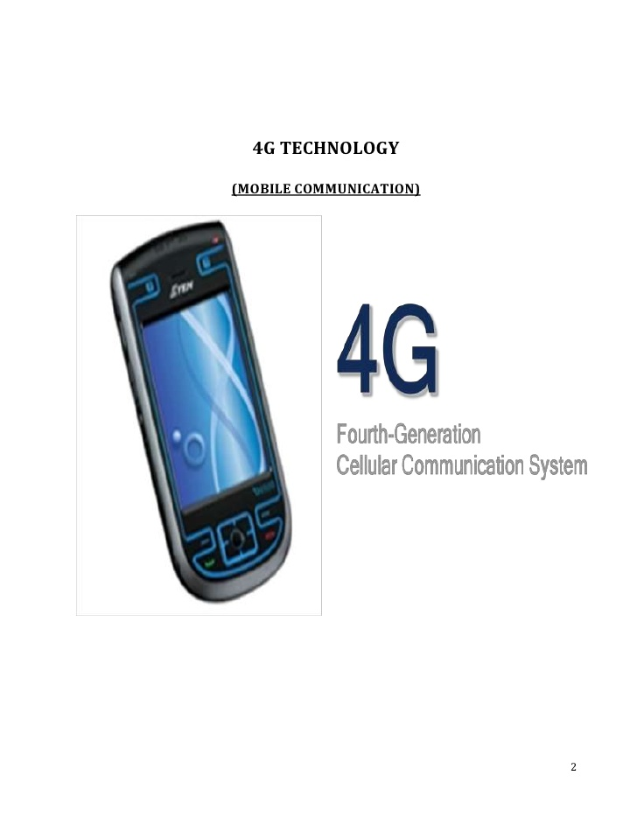 **RESHMA BORKAR. 1, KAMINI GHATOLKAR, SWATI PADOLE.**

reshmaborkar2@gmail.com,

COMPUTER ENGINEERING ,MPCOE ,BHANDARA

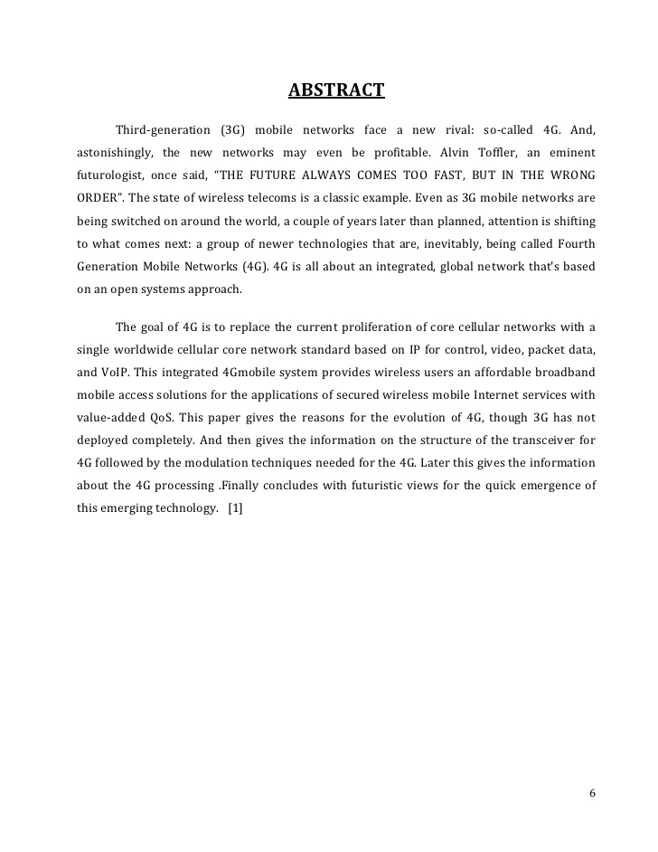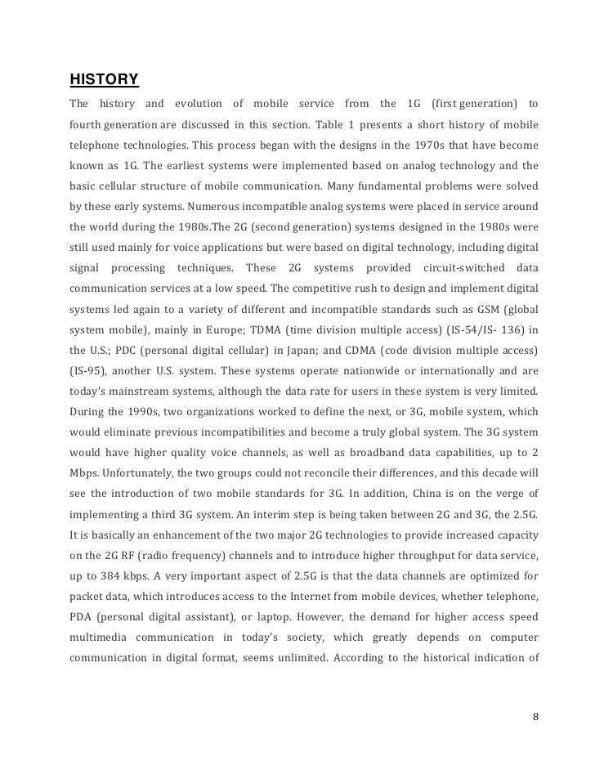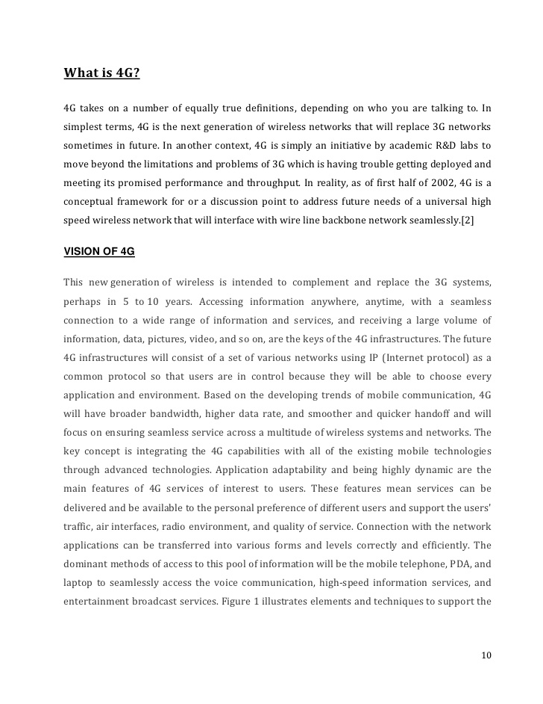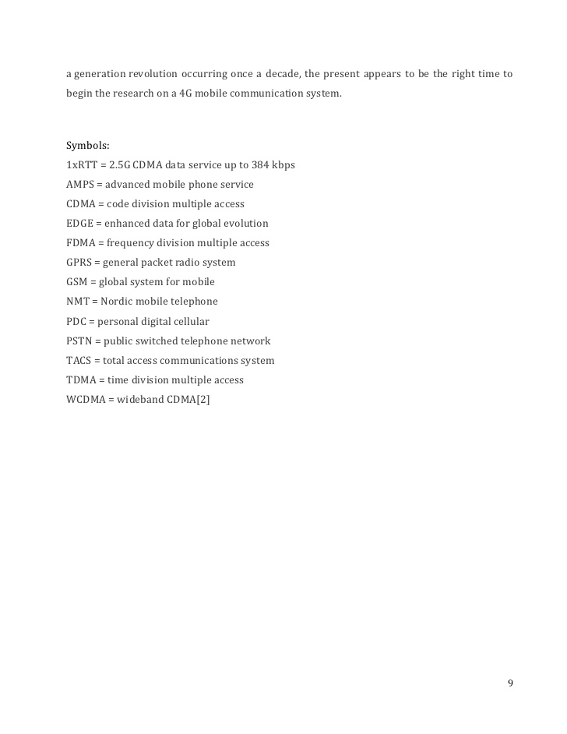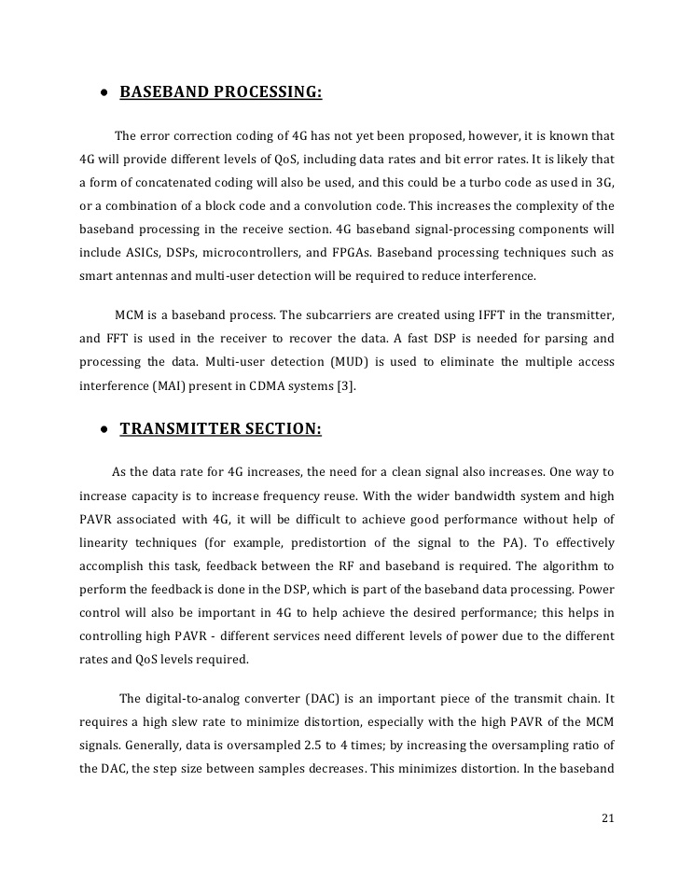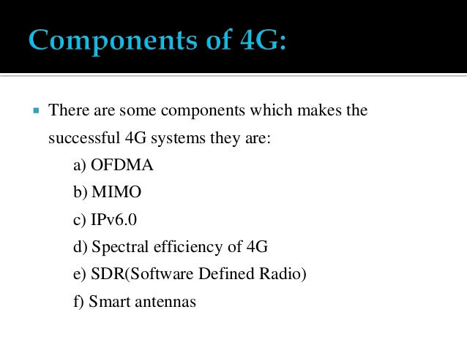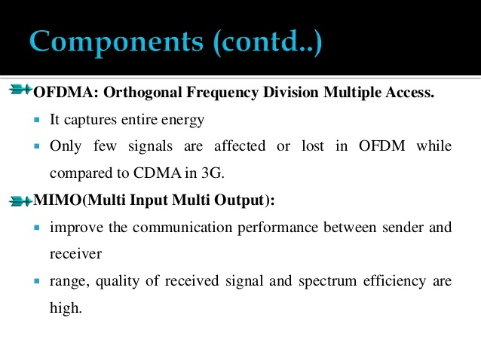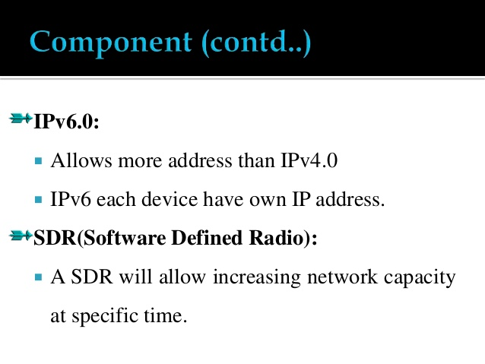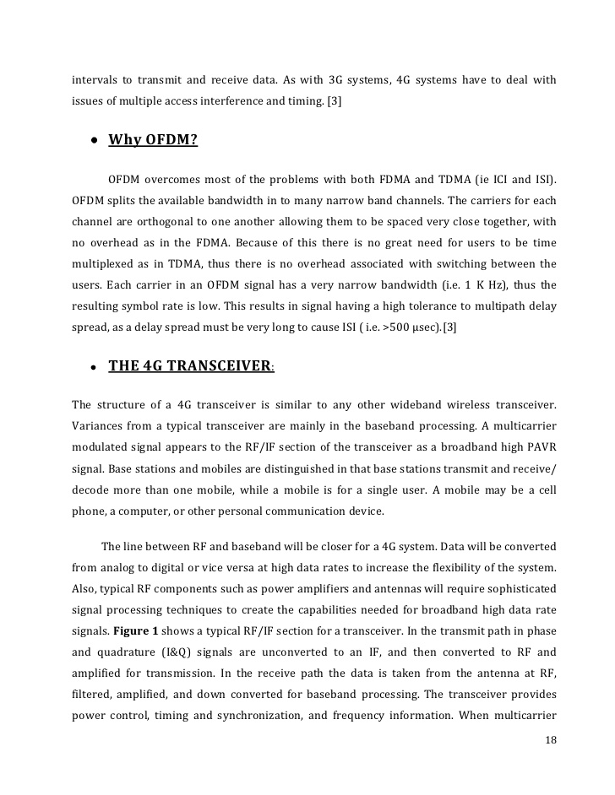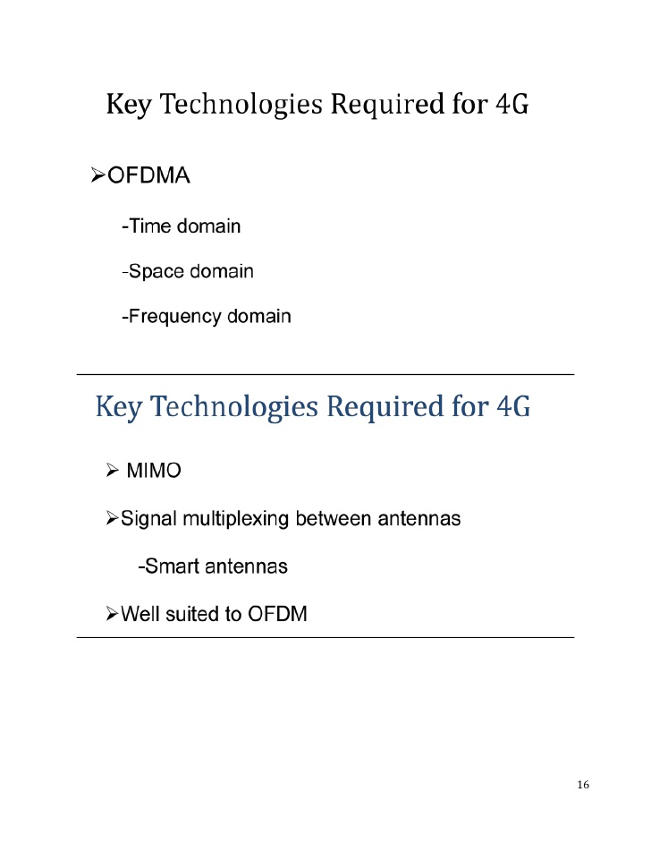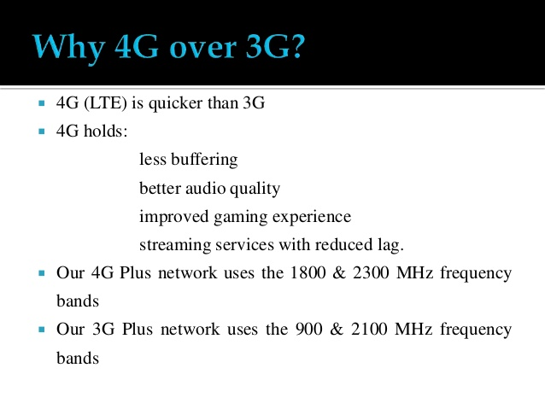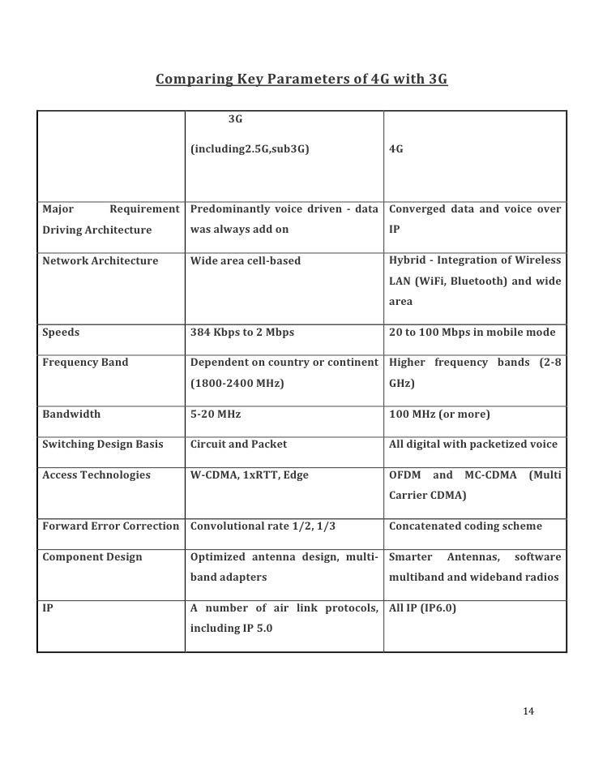

* Loading embed code…×

This activity has also been shared with your LinkedIn network

[Undo LinkedIn share](http://www.linkedin.com) [Settings](http://www.slideshare.net/MadhumithahIlango/4-g-technology-26501930)

* We have emailed the verification/download link to **""**.   
  Login to your email and click the link to download the file directly.

Top of Form

To request the link at a different email address, update it here.[Close](http://www.slideshare.net/MadhumithahIlango/4-g-technology-26501930)  
Validation messages.Success message.Fail message.

Bottom of Form

Check your bulk/spam folders if you can't find our mail.

* Loading Loading…

