Android Based Examination

Samyak R.Jagtap,Vishwas L.Wankhede,Vineet P.Sangani ,Rohit J.Jain,Aman R.Jain
Department of Computer Technology
KDK College of engineering,Nagpur

Abstract – Because of the wide possession of the handheld mobile devices,the application of the mobile technologies in enhancing learning activities attracts much research interest. This investigatation aims at implementing students faced mobile technologies into test and exam to simplify the exam management and performance assessment. So,this project is the combination of the various utilities like exam,attendance,students report and notes on the android based mobile application. This Examination an internet based questionnaire. The questions can be categorized according to subjects and branches.The test is compiled with questions from different lectures.Tests are created on a random basis per class with a particular time limit during which they are to be answered. It also provides the results immediately after the exam. The user can enter to application only with their valid username and password. Teachers can also take attendance of the students on the mobile and Students are able to access notes through that application.

Keywords – Android,client,server,wifi

I. INTRODUCTION
Our project is designed for educational institution like colleges, Schools, training centers. This project helps the management for conducting online examination and save resources. Examination helps the students for appearing the exam by online. It saves time as it allows number of students to give the exam at a time and displays the results as the test gets over, so no need to wait for the result, it is automatically generated by the server as well as it helps to access the notes which are provided by the subject teachers. It is also helpful for teachers to take attendance n generate the reports.
In the Login link a user have to login before entering for the exam in their mobile application. An already registered user can simply type in his\her valid username and password, and then click the "Login" button. Already registered user can only register a new user as a teacher. But those visitors who are not registered have to go to the registration page for registering only as a student before they login. In that page user have to enter Name, Address, Phone number, Role id and password; and also the user have to update the photo. About Link contains some information regarding Online Examination and its developers. After registration, if the user registered as a teacher can create the question and can conducting the exam can also publishing the results and reports. Otherwise the user registered as a student and he/she can answer the exam. The Login page contains several links according to whether the user is student or teacher.

If the user is a teacher, then he/she can create question paper. This is provided by Create Question Paper Link. In that page user have to enter Exam ID, No: of Series, No: of questions, No: of Options, Total time (in min), Marks per Question, Negative mark, Examination Password, Option type. Then go to the question paper page. In that page user have to enter the questions and options and the right answer. The Link Question Paper Preview shows already created question paper. If the user is a student, can answer the exam. This is provided by the Link Examination. The Link Rules and Regulations show some rules and regulations that should be followed by the user. Logout Link will help the user to logout.
There is no need to use of paper to take attendance just start ur mobile application, login into it and mark the roll nos. which r presents.that attendance will be saved in the database of the server.it leads to generate the report of attendance of per students on single click.Notes are provided by the particular teacher of the particular subject in the form of hyper media or text.which helps for better understanding of the students.

II. MODULES
Attendance
Our Attendance System simplifies the taking and maintenance of attendance through mobile devices. The system is installed on every facultys mobile and the faculty can take the attendance for their respective classes and store it in the server database. The software focus on the easy way of storing and uploading the attendance detail in the server with the use of mobile phones. Lecturers will login to the phone application and get connected to the server. After login, they will take attendance using mobile phone. Lecturers select the semester ,subject and date. After this session he enters in to attendance page. Here staff makes a mark on the presenters.

Notes
The notes section of project focuses on providing notes to the student. Student can acces to the notes through notes section. Teacher of their respective subject can upload notes, as soon as notes are uploaded to the server , student will get notification about the updated notes .
The notes provided to thre student can in various form ,such as text notes of pdf, doc, txt format .the other form of providing notes are through images and video lectures of subject on particular topic for better understanding of the concepts .
The student can open the notes by downloading them through their mobile browser. Once downloaded in mobile ,student can use it whenever it needed to make preparation for scheduled examination.

Exam
The application created for taking online test by students has following stages
- Login
- Test
- Result

Login:
The login Window provides the user to get access to examination .we provide separate login id and passwords to each and every students .Hence it is more secure andreliable than previously used on-line test simulator. For appearing the exam , user must login successfully. By logging in successfully , user will be able to access all educational material .the reading material provided for user could be used for preparing the schedule exam. On the other side, teacher login will give the access to schedule exam for students on particular date and on particular time. Other option provided to the teacher are of taking attendance of the students .the marked attendance of the student are recorded in the database.

Test:
Test page is the most creative and important page in this project. The user has to select the subject for currently appearing exam . The exam paper will be consisting of objective type of question .the provided question will appear randomly to the students. The question of the same paper will appear randomly to all connected device appearing for exam .

Subject selection:-
From the given choices the candidate can select hisfield (like C, C++ and JAVA etc) for taking on with the test.

Branch Selection :
From the given choice the candidate can select his/her field(like information technology ,computer technology etc).

Utilities:-
It includes that the user canSkip and come back to the question afterwards if he
needed. It also Gives the list of attempted and unattempted questionsand can go to any question directly and can eitherattempt or change the answer of the already attemptedquestion.

Exam Report:
The android examination system is very time consuming. It is very difficult to analyze the exam manually. To take exam of more candidates more invigilators are required but no need of invigilator in case of online exam. Results are not precise as calculation and evaluations are done manually. The chances of paper leakage are more in current system as compared to proposed system.

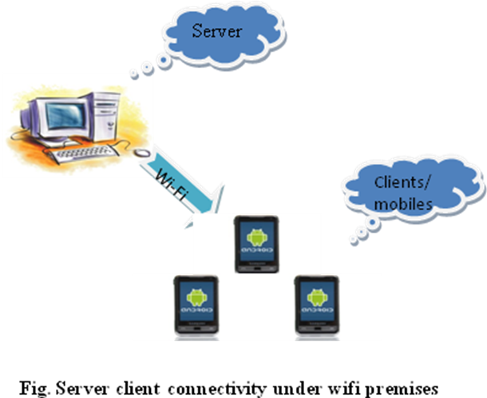

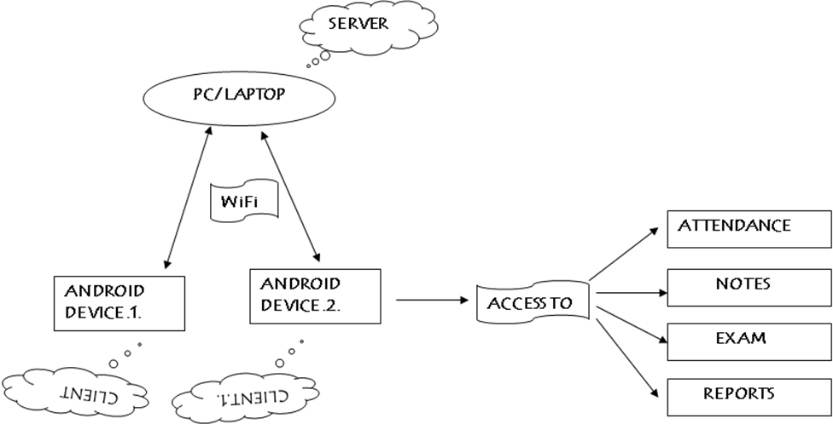
Fig:- System Structure

Conclusion
This Android Application provides facility to conduct online examination.It saves time as it allows number of students to give the exam at a time and displays the results as the test gets over, so no need to wait for the result.It is automatically generated by the server. Administrator has a privilege to create, modify and delete the test papers and its particular questions. User can register, login and give the test with his specific id, and can see the results as well. Teacher can provide notes to the student in form of Hyper media and Hyper text. This application also provide teacher to take the attendance and the attendance is automatically store in the server.

Reference
- Hello,Android :Introducing Google’s Development Platform By ED Burnette
- Beginning Android 4 Application Development (Paperback) By Wei-Meng Lee
- Android UI Fundamentals: Develop & Design (Develop and Design) by Jason Ostrander
- developer.android.com/‎
- http://en.wikipedia.org/wiki/Android_(operating_system)
- Client/Server Survival Guide, 3rd Edition [Paperback] By Dan Harkey.
- Bulun, M., Gulnar, B., & Guran, S. M. (2004). Mobil technologies in education. The Turkish Online Journal of Educational Technology – TOJET, 3, 23.
- Wang, C., Liu, B., Horng, J., & Chen, G. (2003). Using Mobile Techniques in Improving Information Awareness to Promote Learning Performance, In the IEEE International Conference on Advanced Learning Technologies, 106.
- Bodmann, S. M., & Robinson, D., H. (2004). Speed and performance differences among computer-based and paper-pencil tests. Journal of Educational Computing Research, 31, 51-60
- V. Jamwal, and S. Iyer, “Mobile Agent Based System for Distant Evaluation System,” In Proceedings of the IEEE International Symposium on Applications and Internet, Florida USA, Jan. 2003, pp. 362-369
- M. M. Aye, and M. M. Thet Thwin. “Mobile Agent Based Online Examination System,” 5th International Conference on Electrical Engineering/Electronics, Computer, Telecommunications and Information Technology. May 2008, Krabi, pp. 193-196
- N. Sudha Bhuvaneswari, S. Sujatha, C. Deepthi, “Proposal on Centralized Exam Assessment Apporation Using Mobile Agents,” In Proceedings of the International Conference on Communication and Computational Intelligence-2010, Erode India, 27-29 December, 2010, pp. 68-71 87
- www. Connectify.com/download
- http://www.eclipse.org/downloads/moreinfo/java.php
- http://www.heidisql.com/download.php
- www.amotlpaa.org/misc/sql.html‎
- www.tutorialspoint.com/plsql/plsql_records.htm‎
- www.epa.gov/ttn/airs/airsaqs/training/SQL%20Basics.pdf‎
- www.cemml.colostate.edu/assets/pdf/LCTASQL.pdf‎
- home.hit.no/~hansha/.../Structured%20Query%2llanguage.pdf‎

