KOOLSKOOL
LAN Based social networking app on java platform

Nikhil S. Parsutkar¹, Harshad A.Sonwane², Bhaskar S. Kurzekar³, Anuj A. Bukawan⁴
Department Of Computer Technology
K.D.K. College of Engineering
Nagpur

Abstract—A social networking software with ability to build a easy three step user profile which mainly focuses on secure data sharing between two users, minimizing data traffic cost, and ease of chatting with another user through LAN.

Introduction
KOOLSKOOL is a social networking app that runs on java only by LAN to connect a college, school or any educational institutes. It allow users to create their profile by entering their data and interests. It also allows users to share important files or notes securely. Once the profile is created the user can login by entering their passwords. User can also watch the albums or profile of the fellow user. Users can chat by using LAN connections. It gives notifications on reminding the birthday of fellow users. Users can search the name of other KS (KOOLSKOOL). Users just by searching their name on search box provided. Users can share their study notes in word format with each other.
.

work done

Comparative Study on Existing Systems
By studying the Existing System demerits were found that (1) all the social networking apps require live traffic connections (2) college or schools have network jammers that don’t allow us to use such sites (3) uploading a file/photo of your on such sites is always dangerous as it can also be misused (4) a lot of time and effort are wasted to transfer the notice by college authority and absence of student.

Overcoming over Existing Systems and New Features
Some of the main features includes- (1) No internet connections so no effect of jammers. (2) Uploading a file/photo becomes safer as college authority keeps complete track of IP address and students sitting on each pc. (3) Notice/Documents sharing becomes easier and efforts are also not wasted. (4) Even if students are absent message can be easily conveyed to them without failure.

Modules

- Server Module
It consist of a multi-threaded server. It collects IP’s of each client and saves it in an array for determining the chatting address and for security purpose. It works on a while (true) loop that is never ended and always connecting client to server by giving port and IP address. If a client strikes even before the server is executed then SERVER DOWN () class returns the message that server is down. All the passwords of the users are kept in a protected access file at the server. Server doesn’t store the chats but directly transfer it to the other client.

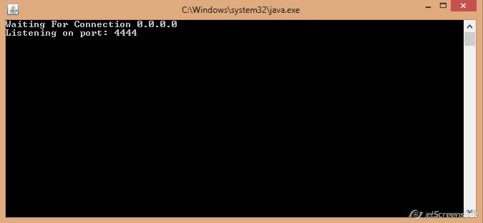

- Client Module
The client module is copied on each pc connected by the LAN. Each time KS file is run it provides a screen that allows user to login by entering password or create his new profile. Login_fail class allows user to re-enter the wrong password. View_profile class allows user to view the profile of other user. User can also search name of the other user in search box. Image_upload class allows user to upload or share images or pdf. Edit_profile class allows to edit the profile of current user.

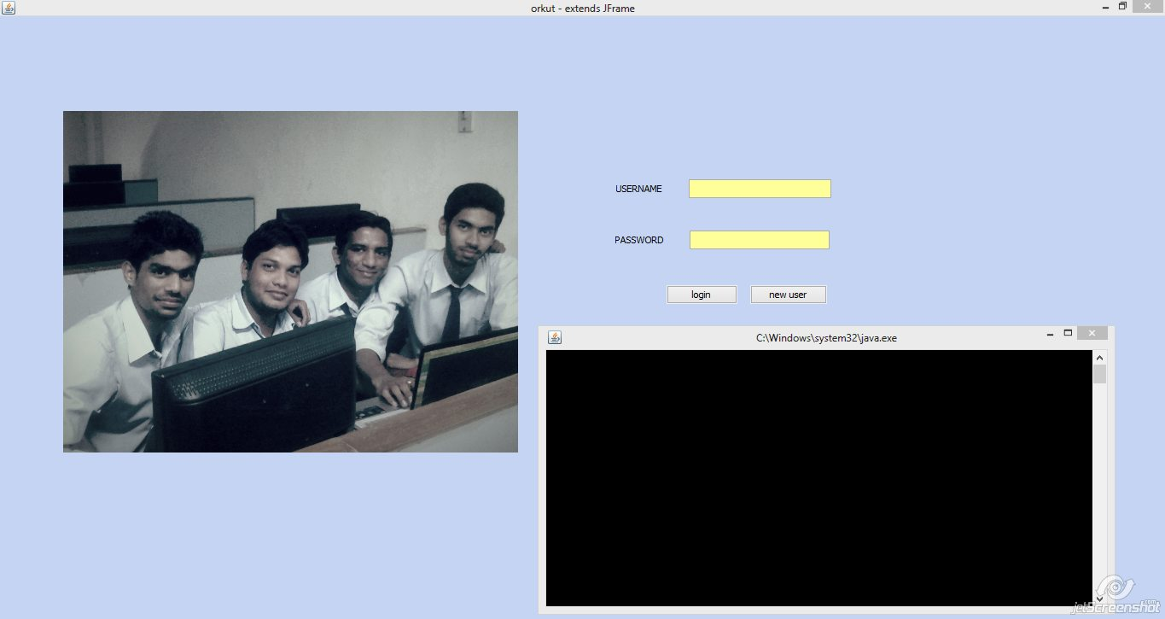

Working

The modules used are
- Server module
Basically the server is a standalone java program that uses multi-threading concept. The server uses the while true loop that runs continuously on the server pc it collects the IP address of the clients pc by extracting INET address class. It uses the getAdress () method which returns the IP address and hence we have to create an object of class INET address to collect the address. Here as we run both the server and the client on same pc hence local host is defined. As the host port address should also match both server and the host hence we used the same port address. Multi-threading ensures to begin a new thread of instance each time any client hits the server or try to make any contact with a server.
For example let’s take an ATM account with two cards if both the cards are entered at the same time then two different threads are activated as creating a single thread may cause a problem. As the name suggests it create a different thread for each new client. By extending our main class by thread class we can extract the methods of thread class. It becomes necessary to handle Exception created by this class. By using try catch throw block. We have to enter the main code on the run bock that should be run each time a new thread is created. It also ensures that many number of client to use the server at the same time.

- Client module
Let’s discuss various forms of our project Koolskool .But first of all let us know the meaning of modules (forms). FORMS are nothing but division of our source codes into manageable and logical pieces. All these pieces are nothing but java source files. This is done because if any logical error occurs during execution of program, we can correct these errors quite efficiently. Also it becomes very simple for new person to understand the code. Also if we define all these functions in a single source code, the source code becomes too big to manage.
Our project Koolskool is also divided into various forms .Lets discuss them one by one:

- Koolskool:
When user will run our project Koolskool ,then the first frame he will encounter is the ‘Koolskool’ homepage .There are various features on this page such as two text field, two label field and two buttons. The two text fields are of ‘username’ and ‘password’, where user can enter his username and password respectively. The two buttons are of ‘login’ and of ‘new user’. If the user is old one then he will type his username and password and hit the login button. If they match with the database values then the user’s homepage will be displayed .If they are not matching, then the frame ‘login_failed’ will be called .If the user is a new one then he will hit the ‘new user’ button ,then another frame called ‘login’ will be displayed. On the left side of this page is the label field where the traditional Koolskool home page with the photos of creators of Koolskool project are displayed!!!

- Login_failed ():
If the username and password typed by the user are not matching with the database values, then this frame is called. This frame has only two features namely one is the txt panel displaying the message “USERNAME OR PASSWORD ARE NOT MATHING. LEASE TRY AGAIN!!!!!!!!!!!!! ”. Below that an ‘ok’ button is present. On hitting that button control is passed to the earlier frame that is earlier frame will be displayed.

- Login ():
On hitting a ‘new user’ button in Koolskool frame, the login frame will be displayed. A message ‘welcome to Koolskool’ is displayed on top of screen .Various options are provided in this frame for filling personal details of the user .Lets go through all the fields in this frame. On top is the ‘username’ text field where the new user can type the username he wants. Also besides that that an option ‘check’ is provided to check whether the username does not matches with earlier database values. Then a ‘password’ field is present and immediately below that ‘confirm’ password field is present, where user has to confirm earlier written password. Then below that, a text field is provided to enter the gender of the user. Then comes the city text field, where user enters which city he belongs to. Then user has to enter his date of birth. Here a combo box is provided so that user can choose birth year from 1900 to 2006,birth month from January to December and birth date from 1 to 31.Immediately below that, user has to fill his interest. Here options such as friends, activity partner, business networking are provided, user just has to tick on that option. Then comes the language and the religion field, where user has to fill required information. They can be kept blank, if user wishes so. Next comes ‘humor’ field, where user chooses from options like campy/cheesy, clever/quick, raunchy, goofy/slapstick, dry/sarcastic, friendly, and obscure. This is also tick mark field, where user can tick any number of humor he prefers. Then comes three buttons ‘image’, ‘next’, ‘cancel’. On hitting the ‘image’ button, a new frame will appear where user can upload image of his choice. ‘Next’ button will take the user to the next page of login form. ‘Cancel’ button will cancel this registration process and will close the Koolskool window.

- Login2 ():
On hitting the next button from the ‘login’ frame, this ‘login2’ frame will be called. Various fields in this frames are described as follows. On the top of frame is the ‘first name’ and ‘last name’ field where user can enter his first and last name respectively. Then comes various text field one below the other such as ‘what I am’, ‘movies’, ‘passion’, ‘books’, it depend on user to fill these fields or not .Then a tick mark field is provided to fill up ‘living’ option to the user .Options such as ‘alone’, ‘with partner’, ‘with parents’ are provided. Then comes the ‘fashion’ tick mark field, where user is provided with options such as ‘urban’, ’classical’, ’contemporary’, ’alternative’ to choose from. Then comes combo box of pets, drinking and smoking, with an appropriate options provided. Then comes two buttons ‘back’ and ‘sign-up’. ‘back’ will take the user to the login frame(earlier one). While ‘sign-up’ will complete the registration process and take the user to the ‘welcome’ frame.

- Welcome ():
This is simplest frame in all from our project. In this a message ‘welcome to Koolskool’ will be displayed on the center of the screen. Then there is button ‘log in’ below it, which takes the user to his newly created homepage.

- Viewprofile ():
When user hits the ‘login’ button from the Koolskool’s frame, he will view this ‘viewprofile’ frame. This is homepage for the user. In the center, user’s profile information is displayed. Beside that a birthday reminder is present. If any of the user’s friend birthday is on that day then his photo block will appear on the screen. The position of this block is just besides the profile information. On top left hand corner there are three buttons ‘refresh’, ‘search’, ‘logout’. The ‘refresh’ button will refresh the user’s homepage and will incorporate if any changes done to his account. The search button will take the user to ‘searchname’ frame and search a given person from the database. The ‘logout’ button will close the account of the user.
Immediately below it, photo of user is displayed .Then below it again there are two buttons one below the other ‘editprofile’ and ‘scrapbook’. editprofile will take the user to ‘editprofile’ frame where the user can edit his personal information. Similarly on hitting the ‘scrapbook’ button will take the user to user’s scrapbook frame.
In the center there is a panel containing information about the user’s scrap. A message is displayed such as ‘No of scraps = x’ where ‘x’ are the number of scraps of user present in the database at that point of time. Also at the bottom right-hand corner a birthday reminder is present. If any of the user’s friend birthday fall on that day, then a block of photo of that friend will be displayed in this corner.
On the rightmost top of the screen, photos of user’s friends are displayed. At max only six photos can be displayed on screen. If any person wants to view all his friends then a button ‘view Friends’ is provided which will take that person to the ‘friend’ frame where all the friends are displayed on consecutive pages. Also on the ‘view friend’ button, the number of friends are displayed. On the bottom of frame a ‘next’ button is provided which will take the user to ‘viewprofile1’ frame, which will be discussed below.

- Viewprofile1 ():
In this frame all the fields which we discussed during ‘login2’ frame are present. This frame just displays the rest of profile information which was not displayed in the homepage.

- searchname ():
When the user hits the ‘search’ button on the Koolskool frame, this frame gets called. On top leftmost corner of this frame is ‘home’ button. On clicking this button ‘viewprofile’ frame will be displayed. Just below that a textfield and a ‘search’ button is present. User will type the ‘username’ of the person to be searched in the textfield and on clicking the ‘search’ button all the database will be searched for that username value. Accordingly the result will be displayed below it.

- editprofile ():
In this frame all the fields which we discussed during ‘login’ frame are present. This frame will enable the user to change the earlier written personal information. The various text fields in this frame are sex, city, date of birth, interest, language, religion, humor. The user can change any information he wants. At the bottom there are two buttons ‘image’ and ‘upload’. On clicking the ‘image’ button, control is transferred to the ‘imageupload’ frame. Hitting on ‘upload’ will take the user ‘editprofile2’ frame.

- editprofile2 ():
In this frame all the fields which we discussed during ‘login2’ frame are present. This frame will enable the user to change the earlier written personal information. The various text fields in this frame are first name, last name, about me, passion, books, movies, living, fashion, pets, drinking, and smoking. The user can change any information he wants. At the bottom there are two button namely ‘back’ and ‘update’. ‘back’ button will take the user to the earlier frame, while on licking the ‘upload’ button ,the updated information will be stored in database and the updated ‘viewprofile’ frame will be displayed.

- imageupload ():
‘imageupload’ frame will be called on clicking the ‘image’ button from ‘editprofile’ frame. There are two buttons leftmost top of the screen namely ‘back’ and ‘refresh’. ‘back’ button will take the user to the earlier frame. While the refresh button will incorporate the changes made to the database and display this frame with updated database values concerning this frame. One textfield allied as ‘browse’ is provided to give the file path of the image to be uploaded. After providing the file path when user will hit the upload button, the image will be uploaded to the database. Incorrect file path will lead to ‘serverdown’ frame. Also photo stored in database is always displayed on screen.

- friend ():
On hitting the ‘view friend’ button from the main Koolskool frame, we are guided to the ‘friend’ frame. All the frames are displayed in this frame. At max only six friends can be displayed on this page. If in case the number of friends for the user are more than six, then rest of friends are displayed on next page. On the ‘friend’ frame six friends are displayed, two friends per row. There are three buttons at the bottom, they are, ‘back’, ‘next’, ‘home’. The ‘home’ button will take the user to his homepage i.e. the ‘viewprofile’ frame. While the ‘next’ button will take the user to the next list of frame.

- view_others ():
On the user’s homepage, at max (if possible), six photos of the user’s friends are displayed on rightmost top of the screen .The user, if he want to, can directly view his friend’s profile. The user just has to click the button below the friend’s photo to view his profile. Then this frame ‘view_others’ will be displayed on the screen. This frame displays all the information of the user’s friend. This is just the replica of ‘viewprofile’ frame .It has three buttons at the top namely ‘home’, ‘search’, ‘friends’. User’s friend’s photo will be displayed on top leftmost part of screen and below that a ‘scrapbook’ button is present which gives the information on the number of scraps. On hitting the scrapbook button, ‘view_srapbook’ frame will be displayed. In the center of this frame is the profile information of the user’s friend. At the bottom a ‘next’ button is provided to view the remaining information of the friend’s profile. On right topmost corner the blocks of friend’s friend are displayed. Just below it ‘view friend’ button is there to display all the friends of user’s friend.
The above frame is displayed when user selects a friend to view his profile. This frame will also be displayed when user click the result of the searched item. The only difference is if the result of search is not a friend of the user then an additional button called as ‘add as friend’ button is placed just below his photo. The user if he want, can add him as his friend. It depends totally on user.

- serverdown ():
User will view this frame when any error occurs during execution of program. For example: If during image uploading no file path or wrong file path is specified then user encounters this frame. Two buttons are displayed on top leftmost part of the screen namely ‘home’ and ‘friends’. The ‘home’ button will take the user to his homepage .While the ‘friends’ button will display all the friends of user. Below that a panel is present displaying the message “NO DONUT FOR YOU.SORRY FOR INCONVINIENE FACED BY YOU. SERVER IS DOWN FOR THE TIME-BIENG. PLEASE TRY AGAIN LATER. ”

- view_scrapbook ():
This is the main and foremost feature provided by us. When a user hits the ‘scrapbook’ button on his homepage or also from another’s profile, this frame is called. The basic layout of this frame is as follows. On topmost left are the four buttons namely ‘home’, ‘friends’, ‘refresh’, ‘search’. On clicking the ‘home’ button user will view his homepage. Then on clicking ‘Friends’ button all the list of the friends will be displayed. ‘Refresh’ button will update the changes made to the user’s profile and will display the updated ‘scrapbook’ frame. The ‘search’ button will take the user to the searchname frame. Then below that, in the center an open text field is present for any person to write scraps. The person on writing the scraps will hit the ‘submit’ button. Then this scrap will be registered in the database and on hitting the refresh button changes made to the database will be displayed on this ‘scrapbook’ frame. Below this there are three panels one below the other .This panels displays the latest scraps the person has received. If the user has received more than three scraps then the ‘next’ button is made available at the bottom. It will take the person to the same frame, displaying next three scraps. It goes on till the end of scraps. Besides every scrap there may r may not be a ‘delete’ button. The availability of this button depends on following factor: The button is made available to the user only if he has written the scrap or the scrap has been written to him. In other words he can’t delete other’s scraps unrelated to him!!!

These are all the frames which we have incorporated in our project Koolskool.

Basic Software and Hardware Requirements

- Windows XP Operating System or Above
- JAVA JDK 1.6 and Above
- Pentium IV System with 2.8 GHZ Processor
- 1 GB RAM
- 40 GB Hard Disk
- Installed LAN drivers

Future Enhancements

Appropriate GUI: We have seen in constraints that why we went with frames instead of applets. We can also design our project with help of applets. Applets provide a very sleek and good-to-look form to our interface. Also if we plan to put our project on internet then Applets will be a preferred choice as they are HTML files only.

Group Chat: Group chat will also be added to increase fun of being social.

Time and efforts required for manual sharing of notices and notes can be reduced.

Creating a private group: User will be given facility of Creating a private group where teachers can post their notes or details about practicals to be performed and HOD’s can form group of department teachers and Principal can form group of respective HODs.

Conclusion

Hence KOOLSKOOL app is built to communicate in a newer way. It is an easy to use app that can also be used by teachers to share the notices or notes. It reduces the traffic data cost. Its working speed is constant as it is completely managed by the LAN. College Authority can easily control the whole time saving app.

References

- Korth,Database systems,2003,Fourth Edition Tata Macgraw hillsPublishers.
- Herbert Shieldt,Java Complete Reference,Fifth Edition,Macgraw hills publishers.
- Joel Murrach,Murachs Beginning Java 2 JDK,2002,Pearson educations publications.
- Herbert Shieldt,JDBC,Fourth Edition,Macgraw Hill publications.
- Also a lot of help was provided from Java doc index file by sun Microsoft and Google.comcience, 1989.

