ONLINE RECRUITMENT SYSTEM

NEHA LANJEWAR, APURVA RAMGIRWAR, AMITA RAUT, AKASH THENGRE

B.E 3rd YEAR

DEPARTMENT OF COMPUTER TECHNOLOGY, K.D.K.C.E., NAGPUR

[nehalanjewar9507@gmail.com](mailto:nehalanjewar9507@gmail.com)

[apurvaramgirwar6@gmail.com](mailto:apurvaramgirwar6@gmail.com)

[amitaraut718@gmail.com](mailto:amitaraut718@gmail.com)

[akash.thengare@gmail.com](mailto:akash.thengare@gmail.com)

**Abstract *- Online recruitment offers recruiters one of the most powerful and cost-effective ways to recruit staff for an organization. In this article we take you through the key aspects of online recruitment and how they fit into the recruitment process. It explains the benefits of this system in terms of time saving, cost saving and being the fastest means in which careers are advertised and applications received. It shows the determinants of recruitment as well the training necessary for the hotels staff depending on the size of the hotel as well its customers. The report shows the organizational chart of the HR function in this industry. The information has been collected from various journals, publications in both HR and hospitality management industry. The objective of these websites is to serve as a common meeting ground for jobseekers and employers, both locally and globally.***

**Keywords – recruitment, HR function, jobseekers.**

**I. INTRODUCTION**

Online Recruitment System provides online help to the users all over the world. Using web recruitment systems like recruitment websites or jobsites also play a role in simplifying the recruitment process. Such websites have facilities where prospective candidates can upload their CV’s and apply for jobs suited to them. Such sites also make it possible for recruiters and companies to post their staffing requirements and view profiles of interested candidates. Earlier recruitment was done manually and it was all at a time consuming work. Now it is all possible in a fraction of second. The system makes it friendly to distribute, share and manage the examination entities with higher efficiency and easiness. The objective of these websites is to serve as a common meeting ground for jobseekers and employers, both locally and globally, where the candidates find their dream jobs and recruiters find the right candidate to fulfill their needs.

**II. SYSTEM ANALYSIS**

**DEFINATION**

System Analysis is the detailed study of the various operations performed by the system and their relationships within and outside the system. System analysis is concerned with becoming aware of the problem, identifying the relevant and most decisional variables, analyzing and synthesizing the various factors and determining an optional or at least a satisfactory solution. During this a problem is identified, alternate system solutions are studied and recommendations are made about committing the resources used to the system.

**DESCRIBTION OF PRESENT SYSTEM**

Presently recruitment is done manually. That is if a company or organization needs employees they make an announcement through newspaper. People who are eligible send application to the organization or company. From these applications they are called for interviews or tests. After tests company has to do short listing manually. From these shortlisted candidates, they are called for interviews. After interview short listed candidates are employed. So it’s all a time consuming procedure.

**LIMITATIONS OF PRESENT SYSTEM**

Recruitment is done manually. These tasks are time consuming. . People around the world cannot apply. Online Recruitment system very convenient because in the manual system there are lot of difficulties in conducting and managing a recruitment exam, short listing, maintaining staff etc.

**III. PROPOSED SYSTEM**

Online Recruitment is aimed at developing a web-based and central recruitment Process system for the HR Group for a company. Some features of this system will be storing application data, and Interview process initiation, Scheduling Interviews, Storing Interview results for the applicant and finally hiring of the applicant. This project is an online website in which jobseekers can register themselves and then attend the exam. Based on the outcome of the exam the jobseekers will be shortlisted. The details of the examination & Date of the examination will be made available to them through the website. People all around the world can apply and register. It has made all the process easy.

**ADVANTAGES**

Online Recruitment System enables the users to have the typical examination facilities and features at their disposal. It resolves typical issues of manual examination processes and activities into a controlled and closely monitored work flow in the architecture of the application. This multi platform solution brings in by default, the basic intelligence and immense possibilities for further extension of the application as required by the user. The system makes it friendly to distribute, share and manage the examination entities with higher efficiency and easiness. It is a comprehensive resource for finding a job online.

**FLOWCHART**

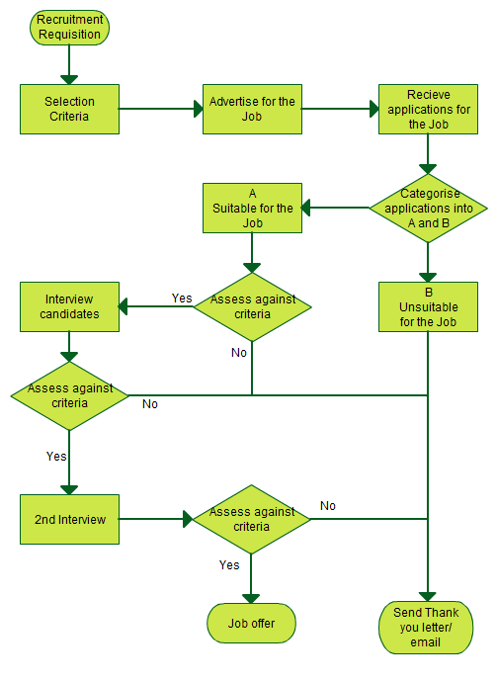

**FEASIBILITY STUDY**

A feasibility analysis usually involves through assessment of the operational (need), financial and technical aspects of a proposal. Feasibility study is the test of the system proposal made to identify whether the user needs may be satisfied using the current software and hardware technologies, whether the system will be cost effective from a business point of view and whether it can be developed with the given budgetary constraints Facts considered in the feasibility analysis were,

1. **TECHNICAL FEASIBILITY**

Technical feasibility includes whether the technology is available in the market for development and its availability. The assessment of technical feasibility must be based on an outline design of system requirements in terms of input, output, files, programs and procedures. This can be qualified in terms of volumes of data, trends, frequency of updating, cycles of activity etc, in order to give an introduction of technical system. Considering our project it is technical feasible.

1. **ECONOMIC FEASIBILITY**

The technique of cost benefit analysis is often used as a basis for assessing economic feasibility. This system needs some more initial investment than the existing system, but it can be justifiable that it will improve quality of service. Thus feasibility study should center along the following points:

* Improvement resulting over the existing method in terms of accuracy, timeliness.
* Cost comparison
* Estimate on the life expectancy of the hardware.
* Overall objective.

Our project is economically feasible. It does not require much cost to be involved in the overall process. The overall objective is in easing out the recruitment processes.

1. **BEHAVIORIAL FEASIBILITY**

This analysis involves how it will work when it is installed and the assessment of political and managerial environment in which it is implemented. People are inherently resistant to change and computers have been known to facilitate change. The new proposed system is very much useful to the users and therefore it will accept broad audience from around the world.

**IV. SYSTEM DESIGN**

**DEFINATION**

The most creative and challenging face of the system development is System Design. In designing a new system, the system analyst must have a clear understanding of the objectives, which the design is aiming to fulfill. The first step is to determine how the output is to be produced and in what format. Second, input data and master files have to be designed to meet the requirements of the proposed output. The operational phases are handled through program construction and testing.

**OUTPUT DESIGN**

In the output design, the emphasis is on producing a hard copy of the information requested or displaying the output on the CRT screen in a predetermined format. Most users now access their reports from either a hard copy or screen display. Computer’s output is the most important and direct source of information to the user, efficient, logical, output design should improve the systems relations with the user and help in decision-making.

As the outputs are the most important source of information to the user, better design should improve the systems relations and also should help in decision-making. The output device’s capability, print quality, response time requirements etc should also be considered. It’s very helpful to produce the clear, accurate and speedy information for end users.

**INPUT DESIGN**

In the input design, user-originated inputs are converted into a computer-based system format. It also includes determining the record media, method of input, speed of capture and entry on to the screen. Online data entry accepts commands and data through a keyboard. The major approach to input design is the menu and the prompt design. The data flow diagram indicates logical data flow, data stores, source and destination. Input data are collected and organized into a group of similar data for processing. In this software, importance is given to develop Graphical User Interface (GUI), which is an important factor in developing efficient and user friendly software.

**LOGICAL DESIGN**

Logical data design is about the logically implied data. Each and every data in the form can be designed in such a manner to understand the meaning. Logical data designing should give a clear understanding & idea about the related data used to construct a form.

**OVERVIEW OF LANGUAGE USED**

Java is a small, simple, safe, object oriented, interpreted or dynamically optimized, byte coded, architectural, garbage collected, multithreaded programming language with a strongly typed exception-handling for writing distributed and dynamically extensible programs.

Java is an object oriented programming language. Special programs called applets that can be downloaded from the internet and played safely within a web browser. Java a supports this application and the follow features make it one of the best programming language.

1. It is simple and object oriented
2. It helps to create user friendly interfaces.
3. It is very dynamic.
4. It supports multithreading.
5. It is platform independent
6. It is highly secure and robust.
7. It supports internet programming

**V. REFERENCES**

1. Human resource management international digest: ISSN: 0967-0734, 2006-11-10

2. Developing and assessing professional and managerial competence, G.M.McEvoy, J.C Hayton, volume 45 , issue 3, Autumn 2006-11-10

3. Human resource management, R. Marchington, Blackwell publishing, 2006.

4. The journal of Human resource, university of Wisconsin press, August, 2006.

5. Human resource journal, IPM (K), quarterly 2006.

**VI. CONCLUSION**

1. This software has attempted to solve the problem of traditional recruitment system and to a large extent it is successful.

2. It is one of the most powerful and cost-effective way to recruit.

3. The use of this system will greatly enhance the organization effectiveness, accuracy, speed, efficiency.

4. This method is convenience for applicant and administrator.

5. Recommendation for the further research can be carried out on this work to improve it functionality and increase its features.