*FAKE CURRENCY DETECTION*

*USING IMAGE PROCESSING*

SAGAR S. LAWADE, SAMEER V. RAMTEKE, GAYATRI S. HEDAU,

ASHISH J. SARDAR, AKSHAY G. BADGE

B.E. 3rd YEAR

DEPARTMENT OF COMPUTER TECHNOLOGY, K.D.K.C.E., NAGPUR

[sagarlawade@gmail.com](mailto:sagarlawade@gmail.com)

[sameerramteke1@gmail.com](mailto:sameerramteke1@gmail.com)

[gayatri.hedau@gmail.com](mailto:gayatri.hedau@gmail.com)

[ashishsardar95@gmail.com](mailto:ashishsardar95@gmail.com)

[akshaybadge007@gmail.com](mailto:akshaybadge007@gmail.com)

GUIDED BY: PROF. DEEPAK C. DHANWANI

Abstract - **Fake notes is a problem of almost every country but India has been hit really hard and has become a very acute problem. Therefore the issue of efficiently distinguishing counterfeit banknotes from genuine ones via automatic machines has become more and more important. Automated paper currency recognition system can be a very good utility in banking systems and other field of commerce. Paper currency recognition with good accuracy and high processing speed has great importance for banking system. This proposed system describes an approach for verification of Indian currency banknotes. The currency will be verified by using Image Processing techniques.**

Keywords *-* **Counterfeit notes, Image Processing, Image Segmentation.**

1. Introduction

Modernization of the financial system is a milestone in protecting the economic prosperity, and maintaining social harmony. The Reserve Bank of India is only one which has the full authority to issue bank notes in India. But some unsocial group of people are prone to make these fake currencies. Fake Indian Currency of 100, 500 and 1000 seems to have flooded the system and there is no proper way to deal with them for a common person. Common Person fall prey to this currencies. The value of money is increasing and Rs. 1000 and Rs. 500 is the highest value currency existing till date and maximum fake is done in them. From few years, along with the original currency, Fake Currency is also circulating in the society and unbalancing the social harmony of the society. Many of the transaction are also carried out with it.

Fake currency detection means finding fake currency from the currencies. With the advancement of the modern banking services, automatic methods for paper currency detection has become important in most of the applications such as in automated teller machines and automatic goods seller machines. Images are processed by using various techniques of image processing and further various features are extracted from the images. Automatic methods of banknotes recognition are required in many applications, such as automatic selling goods and vending machines, among others. The approach consists of a number of components including image processing, image segmentation, characteristic extraction, comparing images. The basic thing of approach is that we extract the features on the basis of which we are going to classify the fake note.

II. Proposed Work

The system will work on two images, one is original image of the paper currency and other is the test image on which verification is to be performed. The proposed algorithm for the discussed paper currency verification system is presented as follows-

1. Image of paper currency will be acquired by simple scanner in .jpg extension.
2. The image processing will be implemented on this image.
3. The various characteristics of the paper currency will be cropped and segmented.
4. After segmentation, the characteristics of the paper currency will be extracted.
5. The extracted characteristic of test image then undergoes classification.
6. On the basis of classification the result is generated.

In the proposed method characteristics of paper currencies are employed that are used by people for differentiating different banknote denominations. Basically, at first instance, people may not pay attention to the details and exact characteristics of banknotes for their recognition, rather they consider the common characteristics of banknotes such as the size, the background color (the basic color), and texture present on the banknotes. So we are implementing some different way or typical features of currency detection.

III.Methodology

Image processing based currency recognition technique consists of few basic steps like image acquisition, its pre-processing and finally recognition of the currency.

Image processing generally involves three steps:

1. [Import](http://www.webopedia.com/TERM/I/import.html) an image with an [optical scanner](http://www.webopedia.com/TERM/O/optical_scanner.html) or directly through [digital photography](http://www.webopedia.com/TERM/D/digital_photography.html).

2. Manipulate or analyse the image in some way.

3. Output the result. The result might be the image altered in some way or it might be a report based on analysis of the image. The Flow-chart of the steps involved in methodology is as follows:

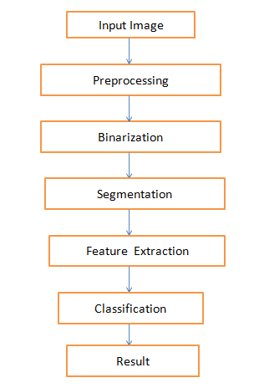

Fig. 1. Flow-chart of methodology

**Image Acquisition (Input Image) -**

Image acquisition in image processing can be broadly defined as the action of retrieving an image from some source, usually it is a hardware-based source, so it can be passed through whatever processes need to occur afterward. Performing image acquisition in the process of image processing is always the first step in the workflow sequence because, without an image, no processing is possible. The image that is acquired is completely unprocessed and is the result of scanner which was used to generate it, which can be very important in some fields to have a consistent baseline from which to work. One of the ultimate goals of this process is to have a source of input that operates within such controlled and measured guidelines that the same image can, if necessary, be nearly perfectly reproduced under the same conditions so anomalous factors are easier to locate and eliminate.

**Image pre-processing:-**

The aim of image pre-processing is to suppress undesired distortions or enhance some image features that are important for further processing or analysis. It includes:-

i) Image adjusting:-

The image we got from scanner or digital camera is too big. So calculations are going to be a bigger one. In order to reduce this calculation we are reducing the size of image. Image Adjusting is done with the help of image interpolation technique which is used for tasks such as zooming, rotating, shrinking, and for geometric corrections. Bilinear and bucolic are the two different types of image interpolation. In the first one concept of four nearest is used to estimate the intensity at a given location. Let (x , y) denotes coordinates of the location where we want to assign an intensity value and Z(x , y) denote that intensity value so to evaluate assigned value we use equation

$$Z\left(x,y\right)= ax+by+cxy+d$$

Where four coefficients can be obtained from the four equations from the four unknown can be written using four nearest neighbours of point.

ii) Image smoothening:-

When we capture image through digital camera or scan image through scanner, some noise will appear on the image. The removal of this noise is an important step in the image processing. In an [image processing](http://en.wikipedia.org/wiki/Image_processing), to smooth a [data set](http://en.wikipedia.org/wiki/Data_set) is to create an approximating [function](http://en.wikipedia.org/wiki/Function_(mathematics)) that attempts to capture important [patterns](http://en.wikipedia.org/wiki/Pattern) in the data, while removing [noise](http://en.wikipedia.org/wiki/Noise) or other fine-scale structures/rapid phenomena.  In smoothing, the data points of a signal are modified so individual points are reduced, and points that are lower than the adjacent points are increased leading to a smoother signal. Smoothing may be used in two important ways that can aid in data analysis by being able to extract more features from the image data. The algorithm use for smoothing is non linear algorithm which is called as median filter as described below.

Median filter - A median filter is based upon moving a window over an image and computing the output pixel as the median value of the brightness within the input window. If the window is J x K in size we can order the J*K pixels in brightness value from smallest to largest. If J*K is odd then the median will be the (J*K+1)/2 entry in the list of ordered brightness. Note that the value selected will be exactly equal to one of the existing brightness so that no round off error will be involved if we want to work exclusively with integer brightness values. The algorithm as it is described above has a generic complexity per pixel of O(J*K*log(J*K)). Fortunately, a fast algorithm exists that reduces the complexity to O(K) assuming J >= K. Thus we are done with the image pre-processing and output of this step are forward further.

**Image Binarization:-**

Document image binarization is usually performed in the pre-processing stage of different document image processing related applications such as optical character recognition (OCR) and document image retrieval. A gray-scale document image is converted into a binary document image and accordingly it facilitates the ensuing tasks such as document skew estimation and document layout analysis. As more and more text documents are scanned, fast and accurate document image binarization is becoming increasingly important.

**Image Segmentation-**

It determines region boundaries in an image. It can explore many different approches to an image sengmentatio & threshoulding.

Optimal Global Thresholding:

• A threshold is said to be globally optimal if the number of misclassified pixels is minimum

– Histogram is bimodal (object and background)

– Ground truth is known OR the histograms of the object and the background are known.

**Feature Extraction:-**

It is a challenging work in digital image processing. In any currency recognition system, feature extraction is one of the most challenging tasks. Here, the aim is to analyse and identify the unique and distinguishing features of each denomination under various challenging conditions such as old notes, worn out notes, also under different illumination and background. Some of the features of Indian paper currency are stated as below:-

Identification marks:

A special feature in intaglio is introduced to the left of the watermark window on all notes. This feature is in different shapes for various denominations Rs. 20-Vertical Rectangle( ), Rs.50-Square ( ), Rs.100-Triangle( ), Rs.500-Circle( ), Rs.1000-Diamond( ) and helps the visually impaired to identify the denomination.

8.jpg 2.jpg

Fig. 2. Identification marks

Intaglio Printing:

The portrait of Mahatma Gandhi, the Reserve Bank seal, guarantee and promise clause, Ashoka Pillar Emblem on the left, signature of RBI Governor are printed in intaglio means in raised prints, which can be felt by touch, in Rs.500 and Rs.1000 notes.

 

Fig. 3. Intaglio Printing

Latent Image:

On the obverse side of Rs.1000, Rs.500, notes, a vertical band on the right side of the Mahatma Gandhi’s portrait contains a latent image showing the respective denominational value in numeral. The latent image can be seen only when the note is held horizontally at eye level.

 

Fig.4. Latent Image

Security thread:

Rs.1000 notes introduced in October 2000 contain a readable, windowed security thread alternately visible on the obverse with the inscriptions ‘Bharat’ (in Hindi), ‘1000’ and ‘RBI’, but totally embedded on the reverse. The Rs.500 and Rs.100 notes have a security thread with similar visible features and inscription ‘Bharat’ (in Hindi).

 10.jpg

Fig. 5. Security Thread

Optically Variable Ink:

This is a new security feature which was incorporated in the Rs.1000 and Rs.500 notes with revised colour scheme introduced in November 2000. The numeral 1000 and 500 on the obverse of Rs.1000 and Rs.500 notes respectively is printed in optically variable ink viz., a colour-shifting ink. The colour of the numeral 1000/500 appears green when the note is held flat but would change to blue when the note is held at an angle.





Fig. 6. Optically Variable Ink

These features of Rs. 1000 Indian currency are shown below:-

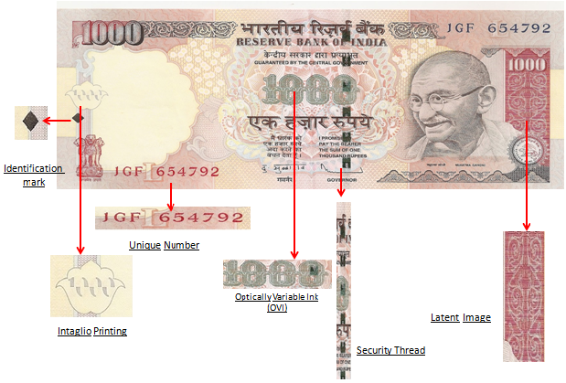

Fig. 7. Indian Rs. 1000 note

**Classification and Result:-**

Image classification analyzes the numerical properties of scanned image features and organizes data into categories. Algorithms used for classification typically employ two phases of classification:

1. Training.

2. Testing.

In the initial training phase, characteristic properties of scanned image features are separated and, based on these training class is created. The main important component of the classification process is the training class. The procedure of classification is as follows:-

1. Definition of Classification class

2. Selection of features

3. Sampling of training data

4. Estimation of universal statistic.

5. Classification.

Multi-level slice classifier, Minimum distance classifier, Maximum likelihood classifier are most popularly used technique for classification.

On the basis of classification the currency is examined whether it is fake or original.

IV**.** REFERENCES

1. Rubeena Mirza1, Vinti Nanda2 “Design and Implementation of Indian Paper Currency Authentication System Based on Feature Extraction by Edge Based Segmentation Using Sobel Operator “International Journal of Engineering Research and Development e-ISSN: 2278-067X, p-ISSN: 2278-800X, www.ijerd.com Volume 3, Issue 2 (August 2012), PP. 41-46.
2. Rubeena Mirza, Vinti Nanda, “Paper Currency Verification System Based on Characteristic Extraction Using Image Processing” , International Journal of Engineering and Advanced Technology (IJEAT) ISSN: 2249 – 8958, Volume-1, Issue-3, February 2012.
3. Kalyan Kumar Debnath, bSultan Uddin Ahmed, aMd. Shahjahan “A Paper Currency Recognition System Using Negatively Correlated Neural Network Ensemble”, JOURNAL OF MULTIMEDIA, VOL. 5, NO. 6, DECEMBER 2010 © 2010.
4. Reserve Bank of India - Security Features.