**Review of Web-Based Disease Diagnosis System using**

**Tabu Search**

**Rashmi Darode*$, Sharda Kakde*, Y.C. Pathak@, Sachin V.Solanki@ ,Dr. (Mrs.) S.P.Khandait #.**

***\*VIII sem Student , Department of Computer Technology,***

***$***[***rdarode@gmail.com***](mailto:rdarode@gmail.com)***,***

***@Asst. Professor, Department of IT,***

***# HOD, Department of IT,***

***K.D.K. College of Engineering Nagpur.***

***Abstract* - Under certain situations, the functioning of the affected organ or the system of the body has to be backed up; the patient also may require some specific type of support, for which the organ remedies are to be deployed, so disease diagnosis is very important. Human disease diagnosis is a complicated process. Any attempt of developing a web-based system dealing with human disease diagnosis has to overcome various difficulties. This paper describes a project work aiming to develop a web-based system for diagnosing human diseases using tabu search which is a most powerful technique to find the best solution. Result shows that the system facilitates the uses to diagnose his/her probable disease very quickly with tabu search methodology. It gives best solution according to the choice of symptoms user chooses or patient has. Practitioners can also use this web-based tool to corroborate diagnosis.**

**Keywords –** Tabu search, disease diagnosis, hybrid system.

1. Introduction

Computer-based methods are increasingly used to improve the quality of disease diagnosis. In today's world web-based disease diagnosis system can help to people at home or office and have an idea about the disease. It enables the patient to find out the diseases and medicine when no other help is possible at primary level. It also can help to doctor to diagnose the disease in fast and efficient manner.

It has been observed that none of the case, studied in [1] paper used genetic algorithm which means researcher missed the opportunity to take the advantages of genetic algorithm. It also explains that there is scope to implement clinical decision support system (CDSS) using genetic algorithm [1]. Whereas Tabu Search is proved to be more efficient than genetic algorithm [2] [3] , so indirectly there is opportunity to make CDSS using Tabu Search. From discussion on different methodologies used in CDSS, it can be concluded that a hybrid CDSS with two or more methodology can be better approach [1].

This paper addresses web based disease diagnosis system using tabu search, where rule based or evidence base as the knowledge base, tabu search for inference rule formation and web pages for communication mechanism is used. .0As there is hybrid system, which uses knowledgebase as well as tabu search, proposed in this paper; it gives the efficient and correct solution or diagnosis.

Rest of the paper is organized as follows: section 2 shows background study about disease diagnosis system and tabu search. Proposed web based disease diagnosis system using tabu search is presented in section 3 and evaluation of proposed system is shown in section 4, section 5 concludes the paper.

2. Background Study

This section discusses about previous disease diagnosis systems and the efficiency of tabu search in various cases in two sub sections.

2.1 Overview Of Disease Diagnosis System

Any computer program that help experts in making clinical decision, comes under the domain of CDSS. Thus, the disease diagnosis systems also come under the domain of CDSS. Various expert systems are developed for diagnosis of various types of diseases as neuromuscular disorders [4], eye diseases [5], heart diseases [6], children skin diseases [7], etc.

The first research article dealing with medicine and computers appeared in late 1950's (Ledley & Lusted, 1959's). Later an experimental prototype appeared in the early 60's (Warner et al., 1964)[10].

Artificial intelligence is an integral part of decision support systems. Fig 2.1 shows classification of clinical decision support systems:-

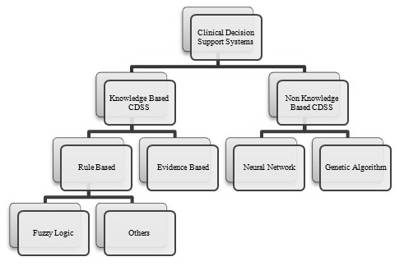

Fig 2.1: Representing different methodological branches of the clinical decision support systems [1].

2.2 Overview Of Tabu Search

Tabu search (TS) is a metahueristic method proposed by Glower in 1989 to solve combinatorial problem [8] [13]. Briefly TS is an iterative search procedure that moving from one solution to another looks for improvements on the best solution visited. The basic concepts of tabu search are movement and memory. A movement is an operation to jump from one solution to another while memory is used with different objectives such as to guide the search to avoid cycles. Using the concept of memory, specific movements are made forbidden or taboo (Tabu Movement) [13]. A basic algorithm of Tabu Search is based on the concepts of: Movement, Tabu list, Aspiration Criterion, Intensification and Diversification[13].

TS is kind of iterative search and is characterized by the use of a flexible memory[3]. In the conclusions of various research papers [3],[9],[2],etc, it is found that the tabu search is most powerful technique to find the best solution.

TS is an iterative procedure that starts from some initial feasible solution and attempts to determine a better solution. TS make several neighborhood moves and select the move producing the best solution among all candidate moves for current iteration. This best candidate solution may not improve the current solution. Selecting the best move is based on the supposition that good moves are more likely to reach the optimal or near optimal solution [9].

3. Proposed web based disease diagnosis system using tabu search

TS, its use in different fields, its effectiveness and efficiency, different diagnosis strategies and methods, different existing diagnosis systems have been studied in different papers and articles on web. Noted down important information about tabu search and disease diagnosis systems and also consulted with few doctors about disease diagnosis and available systems.

After studying and making comparative analysis, the conclusion is obtained that tabu search algorithm is not used in any of the disease diagnosis system. Also the information about the effectiveness of the tabu search is obtained and hence here tabu search is used in the disease diagnosis system which will be used by anyone on web anytime and anywhere.

The proposed system assist user to diagnosis disease, he/she might have, using tabu search method. Based on the selection of the symptoms category, system gives some symptoms from which the user needs to select symptoms. According to the symptoms selection system diagnose the disease based on its knowledge or database.

Fig 3.1 represents the flow chart of the proposed system.

Fig 3.2 shows different modules in the system are as follows:

1. Interface Module for Input
2. Processing Module
3. Database/ Rule base about disease
4. Diagnosis Module
5. Interface Module for Output

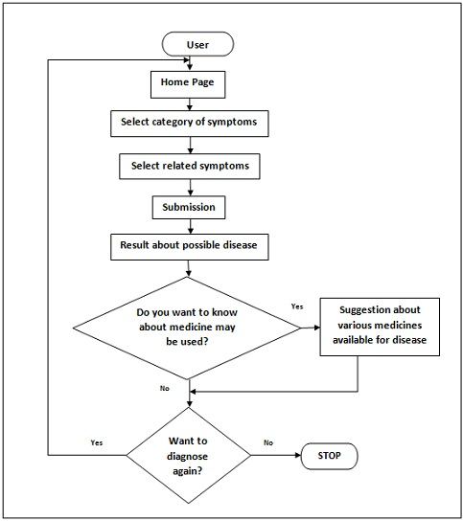

Fig 3.1 Flow chart of the proposed system.

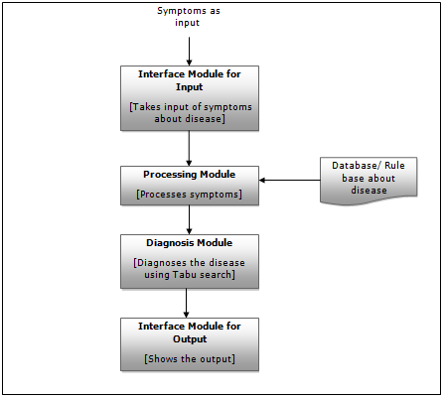

Fig 3.2 : Different modules in the system

**Interface Module for Input**

It takes the input from user and gives it to processing module for further processing.

**Processing Module**

It processes the symptoms and initializes them. It uses database or rule based for initializing and gives to diagnosis module.

**Database or rule-based**

Rule-based tend to capture the knowledge of domain experts into expressions that can be evaluated as rules. When a large number of rules have been compiled into a rule base, the working knowledge will be evaluated against rule base by combining rules until a conclusion is obtained. It is helpful for storing a large amount of data and information. For closing the gap between the physicians and Clinical Diagnosis Support Systems, evidence based appeared to be a perfect technique. It proves to be a very powerful tool for improving clinical care and also patient outcomes. It has the potential to improve quality and safety as well as reducing the cost. [10]

**Diagnosis Module**

This module uses Tabu Search to diagnose the disease. The use of Tabu Search algorithms has allowed us to obtain high quality solutions in very short computing times, in spite of the size of the problem and the complexity of data and objectives. [11] Tabu Search is a powerful algorithmic approach that has been applied with great success to many difficult combinatorial problems. [12]

**Interface Module for Output**

It shows the output to the user.

4. Evaluation of proposed system

A basic algorithm of tabu search is based on the concepts of movement, tabu list, aspiration criteria, and termination criteria. The memory structures used in tabu search can be roughly divided into two categories: short-term memory and long-term memory. The concept of intermediate memory also may use in some cases. Some set of solutions are taken from database into short memory, then form that initially current solution is assigned.

A natural choice for the next solution is to select the movement. One after another solution is taken in consideration but the better solution is only updated in long term memory. Comparing current solution with all the other solutions the aspiration criteria condition forming elements are calculated as number of correct match to required symptoms list. Then the aspiration criterion is applied when all solution in short tabu is used to calculate corresponding element which help to apply aspiration criteria. Then according to aspiration criteria best solution from short tabu is calculated and assigned to be current solution. Then it is compared with topmost element of long tabu. If the current solution is better, it is replaced or else simply ignored and again tabu short is updated with new solutions from database. This procedure goes on till a termination criterion is satisfied. Termination criteria applied here is the end of the database solutions that means when all the solutions are travelled then the result is declared according to the topmost element of long tabu.

5. Implementation Result

Implementation results are shown in various snapshots.



Figure 5.1 Home page where category of symptoms of patient has to be chosen



Figure 5.2 web page for selecting symptoms of particular category

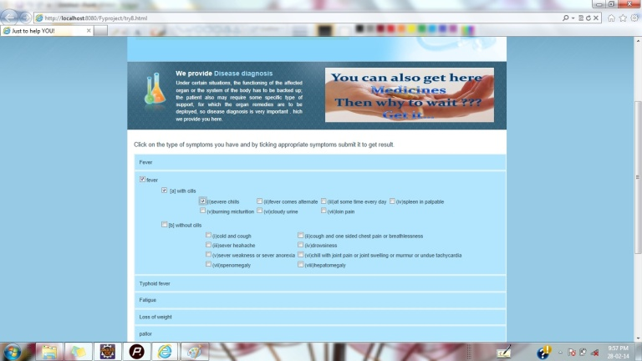

Figure 5.3 Web page showing selection of symptoms



Figure 5.4 Web page showing result

6. Conclusion

Web applications play a dominant role in this cyber era. Knowledge based applications are the features of latest online technology proposed web-based disease diagnosis system can play a vital role for the users of the system. The system facilitates the user to diagnose his/her probable disease very quickly with tabu search methodology. It gives best solution according to the choice of symptoms user chooses or patient has. As knowledge base is created on the basis of books of experts users can also relay on it. Practitioners can also use this web-based tool to corroborate diagnosis. The proposed system is experimented on various scenarios in order to evaluate its performance. In all the cases, proposed system exhibits satisfactory results.

References

1. *M.M.Abbasi, S. Kashiyarndi, ”Clinical Decision Support Systems: A discussion on different methodologies used in Health Care”, IEEE.*
2. *S.C.Chu, H.L.Fang, ”Genetic Algorithms vs. Tabu Search in Timetable Scheduling”, Third International Conference on Knowledge-Based Intelligent Information Engineering Systems, 31st Aug-1st Sept 1999, Adelaide,Australia,1999.*
3. *Poonam Garg, ”Genetic Algorithms, Tabu Search and Simulated Annealing: A Comparison between Three Approaches for The Cryptanalysis of Transposition Cipher”, Journal of Theoretical and Applied Information Technology,2005-2008.*
4. *Rajdeep Borgohain, Sugata Sanyal, ”Rule Based Expert System for Diagnosis of Neuromuscular Disorders”*
5. *Associate Prof., Samy S. Abu Naser, 1Abu Zaiter A. Ola, ”An Expert System for Diagnosing Eye Diseases using Clips”, Journal of Theoretical and Applied Information Technology,2005-2008.*
6. *Ali.Adeli, Mehdi.Neshat, ”A Fuzzy Expert System for Heart Disease Diagnosis”, Proceeding of the International Conference of Engineering and Computer Scientists 2010 Vol 1,IMECS 2010, March 17-19-2010, Hong Kong*
7. *Munirah M. Yusof, Ruhaya A. Aziz, and Chew S. Fei., ”The Development of Online Children Skin Diseases Diagnosis System”, International Journal of Information and Education Technology, Vol.3, No. 2, April 2013*
8. *Roberto Montemanni, Jim N. J. Moon, and Derek H. Smith, ”An Improved Tabu Search Algorithm for the Fixed-Spectrum Frequency-Assignment Problem”, IEEE Transactions on Vehicular Technology, Vol. 52, No. 3, May 2003.*
9. *Habib Youssef, Sadiq M. Sait, HakimAdiche, ”Evolutionary algorithms, simulated annealing and tabu search:a comparative study”, Engineering Applications of Artificial Intelligence 14 (2001) 167–181, 1 July 2000.*
10. *Fred Glover,” Tabu Search: A Tutorial” July-August 2000.*
11. *“A Tabu Search solution algorithm”, University of Pretoria etd – Joubert, J W (2007)*
12. *Fred Glover, ”Tabu Search And Adaptive Memory Programming, Advances, Applications And Challenges”, College of Business, CB, University of Colorado Boulder,CO.*
13. *Edson Luiz da Silva,Jorge Mauricio Areiza Ortiz,Gerson Couto de Oliviera,and Silvio Binato,”Transmission Network Expansion*

*Planning under a Tabu Search Approach”, IEEE Transactions on Power Systems,Vol.16, No. 1, February 2001.*