Anaerobic digestion of vegtable solid waste

ANAEROBIC DIGESTION OF VEGETABLR SOLID WASTE

Chandraprakash Umate, Rashmi bijwar
Parag Kokane, Kunal Tajane

(Final Year)

Civil Engineering Dept. Karmaveer Dadasaheb Kannamwar
College Of Engineering, Nandanwan,
Nagpur, India
kunaltajane@gmail.com

Abstract— one of the biggest problem facing worlds today is the management of waste and energy crisis. Vegetable market wastes contribute to a great amount of pollution; hence, there has been a strong need for appropriate vegetable waste management systems. India produces 150 million tones of fruits and vegetables and generates 50 million tones of wastes per annum. Therefore it becomes necessary to develop appropriate waste treatment technology for vegetable wastes to minimize green house gas emission. In an experimental work 4 kg of vegetable waste was taken and kept for anaerobic digestion in the digester provided with gas outlet and leachet outlet. Also thermometers were inserted for temperature measurement. Analysis work was carried out for pH, moisture content, organic matter, carbon content and lignin percentage. Samples were taken after interval of two days for analysis work.
Keywords— anaerobic digestion, vegetable waste, degradation profile

Introduction
Anaerobic digestion is described as a series of processes involving microorganisms to break down biodegradable material in the absence of oxygen. It involves biochemical decomposition of complex organic material by various biochemical processes with release of energy rich and nutritious effluents. There are many technologies such as incineration and refuse derived fuel (RDF) etc., for producing energy from solid wastes. Among them anaerobic digestion has become a promising technology particularly for recovery of energy from organic fraction of solid wastes. Many research works are being carried out for treating various types of organic solid wastes using anaerobic digestion process. It has become a major focus of interest in waste management throughout the world. Anaerobic Digestion is potential environment friendly technique produce energy in the form of biogas and residue which can be used as soil conditioner. The main objective of this research is to employ anaerobic digestion process as a sustainable technology for digesting the vegetable solid wastes. Anaerobic treatment provides a method of reducing pollution from agricultural and industrial operations while at the same time offsetting the operations’ usage of fossil fuels. Anaerobic digestion offers numerous significant advantages, such as low sludge production, low energy requirement, and possible energy recovery In anaerobic digestion, the acid forming and the methane forming microorganisms differ widely in terms of physiology, nutritional needs, growth kinetics, and sensitivity to environmental conditions.

II .Aims and objectives of project
- To evaluate the operational performance of anaerobic digester treating the vegetable solid waste.
- Analysis of physio-chemical characteristics of vegetable solid waste.
- To analyse the operational parameters, such as pH, temperature, moisture content, etc. for the stability of anaerobic digestion system.
- Study of degradation profile of organic matter, carbon, lignin etc.

- To estimate the quantity of methane (CH₄) and Hydrogen (H₂) gas evolved from the anaerobic digestion of vegetable solid waste.
- To get an understanding of the anaerobic digestion of the vegetable solid wastes under ambient temperature conditions by conducting a lab scale study and hence to investigate the biogas yield.

OUTLINE OF THE WORK

Experimental setup

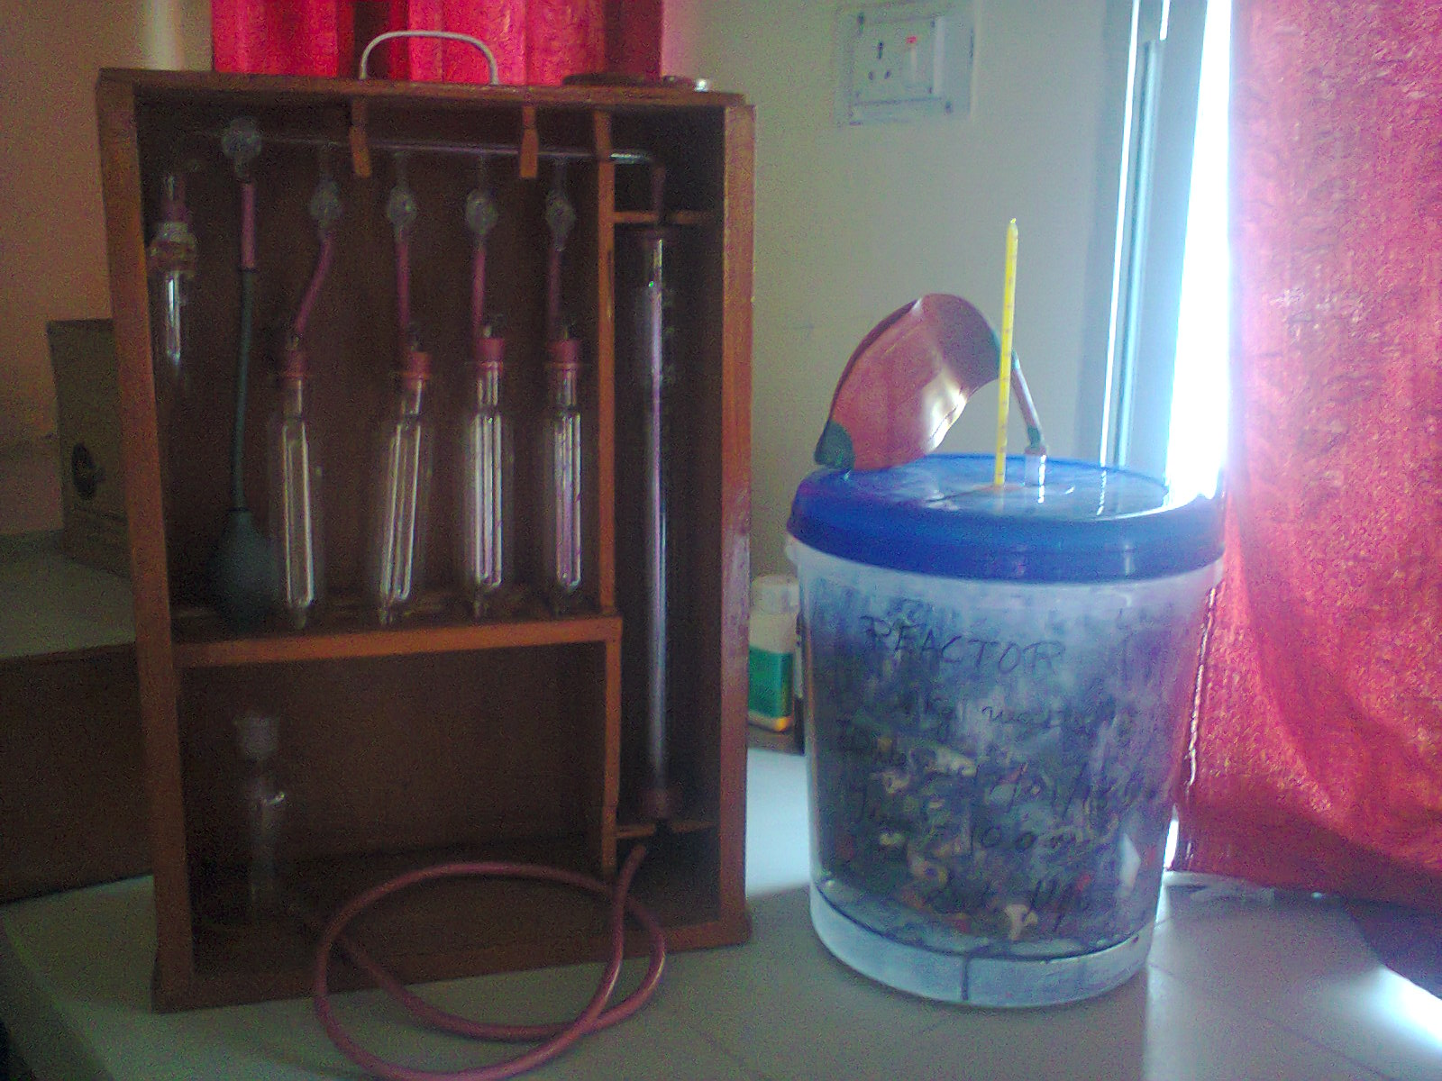

The plastic box was used as a digester with its top diameter of 26 cm and middle diameter of 24 cm and bottom diameter of 23 cm. At an height of 3 cm from bottom of the tank an iron ring was provided. An iron ring provided a platform for vegetable solid waste to retain over it. And the bottom space left provides an outlet for leachete generated in process. Soft pipe of diameter 1 cm was attached at the bottom for leachete outlet. Provision for temperature measurement inside the reactor was done by inserting thermometer from the upper lid of the reactor. Two thermometers were inserted in the reactor, one in the middle and other one at outer edge of reactor. Orsat apparatus used for flow measurement of gas. Also another set up with having vegetable waste mixed with cow dung was simultaneously kept under observation.

Wastes sources and characteristics
Vegetable waste was collected from kalmeshwar market (district Nagpur). All the waste collected was shredded properly and four kg of waste was used for experimental work. It was kept in digester for anaerobic reaction. Initial sample of waste was taken for its analysis and all the parameters like pH, moisture content, organic matter, lignin, carbon content were determined.

RESULTS AND DISCUSSION:

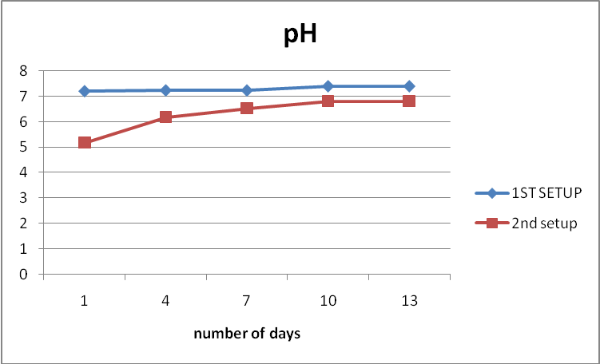

pH was measured as one of the indicator for monitoring the activity of different groups of organics. In anaerobic condition the pH of digester should be 6 to 8 to survive the methane forming microorganisms. If the pH falls below 6 unionized volatile acids become toxic to methane forming microorganisms and above pH-8 unionized aqueous. Ammonia (dissolved ammonia) becomes toxic to methane forming microorganisms. The pH values of digesters were remain within range of 7.2 to 7.39 for first setup and 5.18 to 6.18 for second setup.

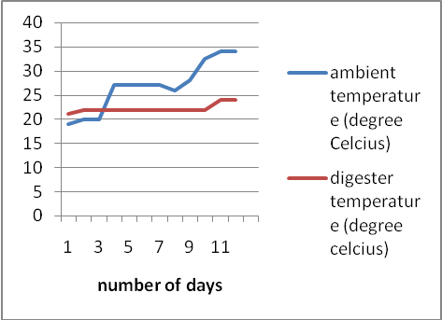

Temperature – The optimal temperature for mesophilic anaerobic digestion is 37oC. Although some variation is considered normal, digester temperature should be always maintained between 35oC and 40oC. Operating at temperatures outside the normal range will result in decreased biogas production and organic matter stabilization. In addition, long periods of time under these conditions may eventually stop biogas production and cause digester failure. Furthermore, the process will be generally more affected at higher temperatures than at lower ones. The mesophillic temperature was maintained in both the setups i.e. at 21⁰C to 24⁰C.

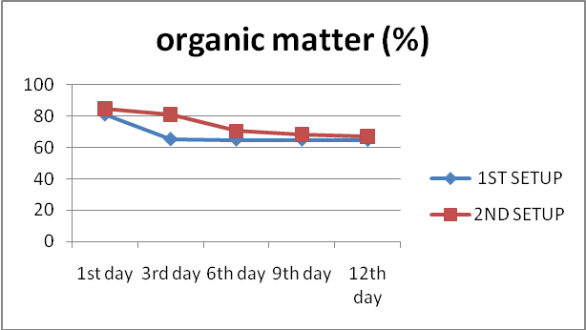
Organic matter- the test was performed to check the presence of organic matter in the waste. The initial organic matter was found to be 82 % and it was degraded to 62% at the end.

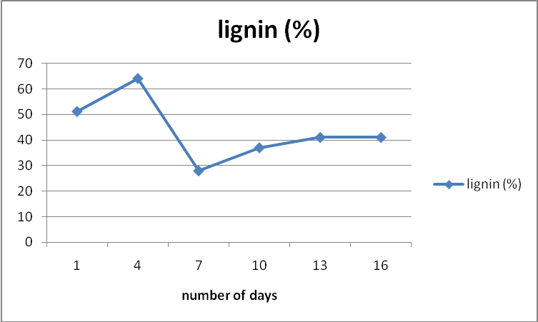
Lignin is one of the components of waste which is not degradable. Its value was found to be fluctuating from 51% to 28%.

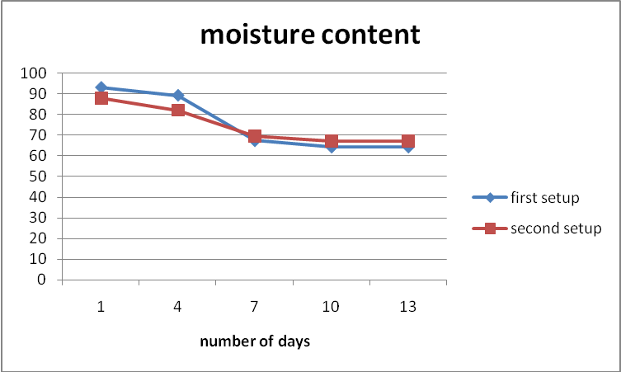

Moisture content was found to be 92% and 82% for first and second setup respectively. Later it was reduced to 62% and 70% respectively.

CONCLUSION
Anaerobic digestion under conditions offers a best waste treatment solution for waste treatment. It not only stabilize the waste but also it is energy producer. It reduces reduces pathogens,minimizes environmental impact from waste emissions and maximizes resource recovery. This technology is tolerant to variety of feedbacks and codigestion of organic waste is also possible. The size of anaerobic digester can be as per the applications required and as per the combination of organic waste also considering the economy.

Acknowledgment
This work was supported by Prof. Kiran Ingle , working as a Asst. Proffesor in Yashwantrao Chavan College of Engineering, Nagpur.

References
- Edgar Fernando Castillo M. *, Diego Edison Cristancho, Victor Arellano A., Study of the operational conditions for anaerobic, digestion of urban solid wastes, www.elsevier.com/locate/wasman
- Yen H W, Brune D E, 2007. Anaerobic co-digestion of algal sludge and waste paper to produce methane. Bioresource Technology, 98(1): 130–134.
- Anderson G K, Donnelly T, Mckeown K J, 1982. Identification and control of inhibition in the anaerobic treatment of industrial wastewaters. Process Biochemistry, 17(4): 28–32.
- Angelidaki I, Ahring B K, 1993. Thermophilic anaerobicdigestion of livestock waste – The effect of ammonia. Applied Microbiology and Biotechnology, 38(4): 560–564
- Raphael M. Jingura *, Rutendo Matengaifa, “Optimization of biogas production by anaerobic digestion for sustainable energy development in Zimbabwe, Elsevier
- ”CH4 EMISSIONS FROM SOLID WASTE DISPOSAl, Good Practice Guidance and Uncertainty Management in National Greenhouse Gas Inventories
- Anuradh Bankar a, Sandip T. Mali b, Dr. K.C. Khare c, Dr. A.H.Biradar ,” Anaerobic Digestion of Organic Fraction of Municipal Solid Waste
- Journal Of Environmental Science and Engineering Vol.50, No3,P. 191-196,July 2008.
- Anaerobic sludge digestion Edmund J. Cook and Paul H. Boening 5. Michael Stenstrom et. al. 1983. Journal Of Environmental Science and Engineering Vol.50, No3,P. 235 - 238.
- Dhanalakshmi Sridevi V.1 and Ramanujam R.A.2,” Biogas Generation in a Vegetable Waste Anaerobic Digester: An Analytical Approach, Research Journal of Recent Sciences
- Krishna Nand, Sumitra Devi S., Prema Viswanath S., Somayaji Deepak and Sarada R., Anaerobic digestion of canteen wastes for biogas production, process optimization. Process Biochemistry,
- Patil J.H., Molayan Lourdu Antony Raj, Bhargav S. and Sowmya S.R., Anerobic co-digestion of water hyacinth with primary sludge, Res.J.Chem.Sci,

