**Paper Presentation**

**on**

**Base Isolation Technology**

**Presented by Shantanu Shekhar1 & Yogita Pounikar2**

**(8th sem. Civil, K.D.K.C.E.)**

**ABSTRACT:**

The main objective of this work is to compare different base-isolation techniques, in order to evaluate their effects on the structural response and applicability limits under near-fault earthquakes. In particular, high-damping-laminated-rubber bearings are considered, in case acting in parallel with supplemental viscous dampers, or acting either in parallel or in series with steel sliding bearings. A numerical investigation is carried out assuming as reference test structure a base-isolated six-storey reinforced concrete (r.c.) framed building designed. A bilinear model idealizes the behaviour of the r.c. frame members, while the response of the elastomeric bearings is simulated by using a viscoelastic linear model; a viscous-linear law and a rigid-plastic one are assumed to simulate the seismic behaviour of a supplemental damper and a sliding bearing, respectively. The seismic analysis of the test structures,

subjected to strong ground motions recorded near faults, is carried out by using a step-by-step procedure.

**INTRODUCTION:**

The base-isolation techniques prove to be very effective for the seismic protection of new framed buildings as well as for the seismic retrofitting of existing ones. Design guidelines have been developed in

many countries with a high seismic hazard (e.g., United States, Japan, New Zealand)

and, lately, suitable code provisions have been drafted also in Europe. However, under near-fault ground motions, even base-isolated structures designed according to recent seismic codes can undergo unforeseen structural damages.

The near-fault ground motions are characterized by long duration pulses, with displacements so large that an oversizing of the isolation system could be required.

Moreover, the frequency content of the motion transmitted by the isolators to the superstructure can become critical when the pulse intensity is such that the superstructure undergoes plastic deformations.

In addition, it is possible an amplification of the structural response due to the long duration of the Pulse into account for buildings of importance class I (e.g., hospitals and nuclear plants) located at a distance less than 15 km from the nearest potentially active fault with a magnitude Ms*≥*6.5. To overcome the above mentioned problems many authors proposed solutions based on different kinds of isolators and dampers. The main objective of the present work is to compare some of the base-isolation techniques more frequently adopted in literature with reference to framed buildings subjected to far-fault in order to evaluate their effects on the structural response and applicability limits under near-fault earthquakes. To this aim, a numerical investigation is carried out with reference to typical base-isolated six-storey r.c. framed buildings designed. The dynamic response of the test structures isolated at the base by elastomeric bearings, in case acting in combination with supplemental dampers or sliding bearings.

**BASE ISOLATION SYSTEMS:**

The base isolation systems are usually realized by elastomeric and sliding bearings,. The main typologies of isolation systems proposed in literature to provide an acceptable seismic performance of framed structures are outlined below.

The elastomeric-type bearings, e.g. those of a high-damping type (i.e., like the “High-Damping-Laminated-Rubber Bearing, HDLRB) or fiber-reinforced filter the ground motion so that the effects on the response of the superstructure are reduced. A lead core may be inserted in the laminated bearing (like the “Lead-Rubber Bearing”, LRB) to increase both the initial stiffness, so limiting the base displacement under seismic actions of moderate intensity and wind actions, and the hysteretic energy dissipation. On the other hand, for the frictional-type bearings (e.g., sliding bearings with steel interface or rolling bearings like the “Friction-Pendulum”, FP) the maximum acceleration transmitted to the superstructure is limited through a frictional force proportional to the supported weight. However, the structure behaves like a fixed-base structure during the stick-phases. Moreover, residual base displacements are expected for the frictional bearings, because no restoring force is provided. The horizontal force-displacement law of an elastomeric bearing can be idealized using the viscoelastic linear model in the case of a HDLRB or the bilinear model in the case of a LRB. But the above law has to be properly modified to take into account the hardening effects at large strains levels; while the rigid-plastic model can be adopted to represent a frictional bearing.

Moreover, different are expected when elastomeric and frictional bearings or isolation and supplemental damping systems at the base are combined. Of course, more sophisticated laws can be found in the scientific literature, requiring the identification of the parameters characterizing the behaviour of the isolators and dampers, but the simplified models shown above are generally preferred to carry out extensive numerical investigations. The large base displacement due to strong near-fault ground motions can be enabled adopting large elastomeric bearings (e.g., increasing the dimensions of the rubber layers, for the HDLRB, and also the lead plug, for the LRB); analogous considerations apply to frictional bearings (e.g., gradually increasing the curvature and the roughness of the sliding surface, for the FP).

In alternative, it is possible to combelastomeric and steel sliding bearings acting in series (e.g., as in the HDLRBs placed on different layers and connected by steel plates. A different approach is that based on the reduction of the base displacement taking advantage of the hardening response that a HDLRB exhibits for a strain amplitude greater than that commonly considered in the a seismic design, or through an in-parallel combination of a HDLRB and a supplemental damper. Actually a wide variety of energy dissipating devices is available, differing by the way of dissipating energy: friction, metallic-yielding, visco elasticity and viscosity of elastomers or fluids.Moreover, particular devices are those based on electrorheological and magnetorheological fluids with aviscous-plastic behaviour or those made of nickel-titanium shape memory. At last, elastomeric and frictional bearings can be also combined in parallel. However, all these systems have the problem of increasing the contribution of the higher vibration modes of the superstructure.

**Types of isolation system:**

1. **Isolation bearings**

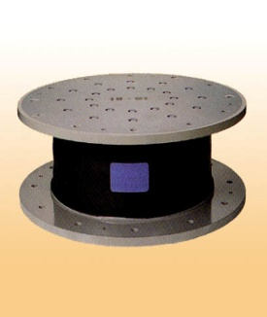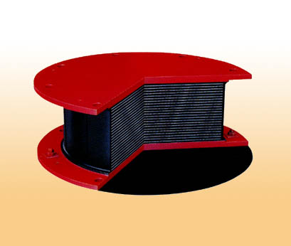

Laminated rubber bearing



FP-DC bearing

1. **Isolation dampers**

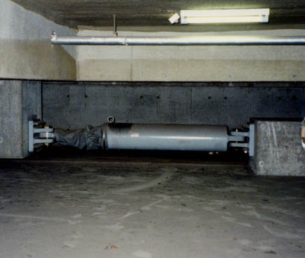

Oil damper


07-5鉛.jpg                                                     0374ED61Macintosh HD                   AFCDE834:

Lead damper

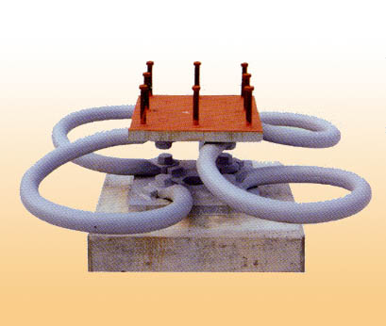

Steel damper

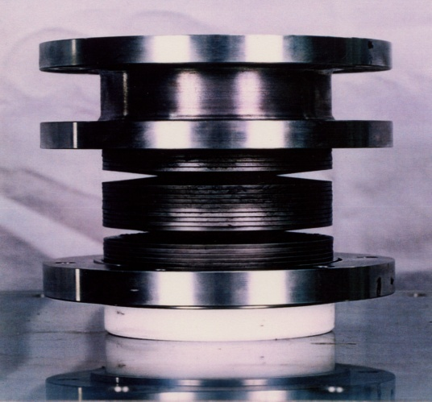

Friction damper with coned disc spring

**Application of isolation system in building structures:**

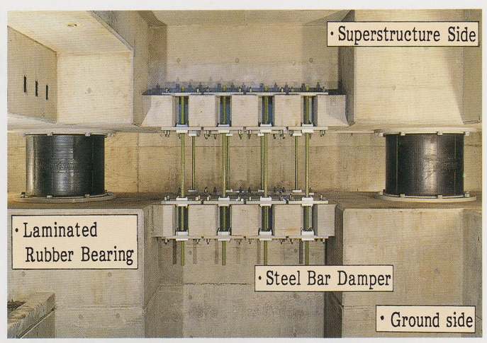

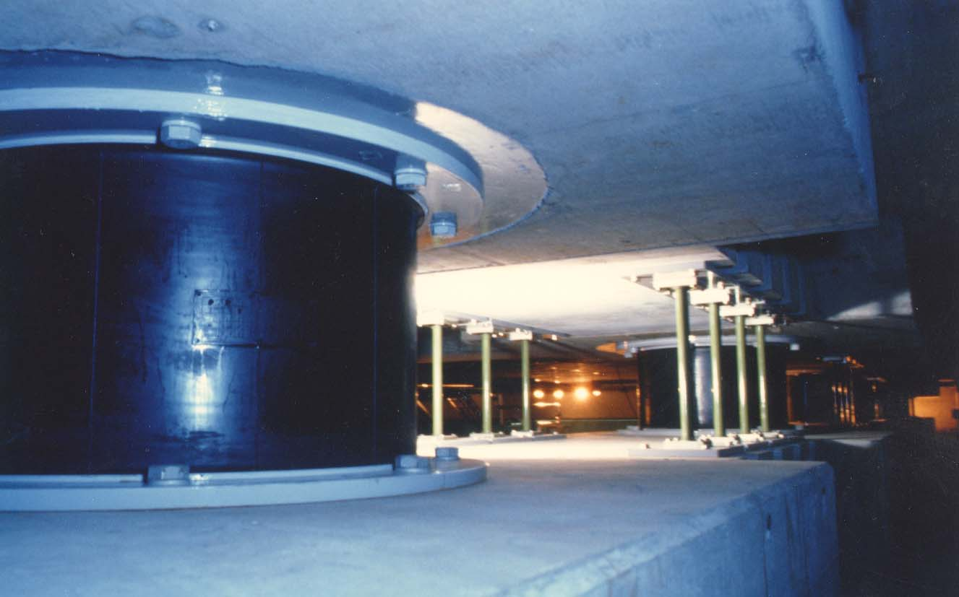

**CONCLUSIONS:**

The nonlinear response of a typical five-storey r.c. framed building with different base-isolation systems has been studied under strong near-fault ground motions. In particular, a first solution with HDLRB-type isolators has been compared with different solutions obtained by means of the addition of viscous dampers (acting in parallel) or steel sliding bearings (acting either in parallel or in series), assuming different values of the parameters characterizing the behaviour of the supplemental seismic devices. The following conclusions can be drawn from the results.

The in-parallel combination of isolators and viscous dampers, as well as the analogous one with isolators and sliding bearings proved to be favourable for controlling the relative displacement of the isolators: the choice of increasing the equivalent damping ratio (ξD), for the system, or the sliding ratio (αS), for the system, corresponds to a reduction of the isolator displacement, even though, for a same increase of ξD or αS, this effect has been ever-smaller. However, the use of the system can need re-centring after an earthquake, in case the elastic restoring force produced by the elastomeric isolators does not exceed the friction threshold imposed by the sliding bearings. The in-series combination of isolators and sliding bearings is not always favourable, for increasing values of αS, in reducing the residual displacement of the isolation system. Moreover, the re-centring of this system may present some difficulty when the residual displacement is a combination of out-of-phase movements between the isolators and the sliding bearings placed on them. With reference to the ductility demand for the r.c frame members, the adoption of the system or the one does not guarantee in all the cases a better performance for increasing values of ξD or αS, respectively. However, the system proves to be generally effective for controlling the structural and non-structural damages of the framed building, producing an amplification of the fundamental vibration period and limiting the maximum acceleration transmitted to the superstructure.

**REFERENCES**

1. Eurocode 8. “European Standard, Design of structures for earthquake resistance. Part 1: General rules, seismic actions and rules for buildings.” Draft no. 6, 2003.
2. Kelly JM. “The role of damping in seismic isolation.” Earthquake Engineering and Structural Dynamics 1999; 28: 1717-1720.
3. Mazza F, Vulcano A. “Seismic response of buildings with isolation & supplemental dissipation at the base.” Proceedings of the 5th World Congress on Joints, Bearings and Seismic Systems for Concrete Structures, Rome, Italy, 2001, CD-ROM.
4. Vestroni F, Vulcano A, Di Pasquale G. “Earthquake response analysis of a nonlinear model of a base-isolated structure.” Proceedings of the International Meeting on Earthquake Protection of Buildings, Ancona, Italy, 1991; 181/C-190/C.
5. Jangid RS, Kelly JM. “Base isolation for near-fault motions.” Earthquake Engineering and Structural Dynamics 2001; 30: 691-707.
6. Makris N, Chang S-P. “Effect of viscous, viscoplastic and friction damping on the response of seismic isolated structures.” Earthquake Engineering and Structural Dynamics 2000; 29: 85-107.
7. Dolce M, Cardone D, Nigro D, Ponzo FC, Nicoletti M, La Monaca B. “Experimental comparison between conventional and innovative base isolation systems on a 1:2:5 scaled reinforced concrete

frame.” Proceedings of the 12th European Conference on Earthquake Engineering, London, UK. Paper no. 746. Elsevier Science Ltd, 2002.