**Subimitted by: Harshal Paradeshi1 ,Pratiksha Mate2 ,Bomri Riram 3**

**TECHNOLOGY FOR AVERSION OF DISASTER MANAGEMENT**

**Abstract**:

Natural disasters are inevitable, and it is almost impossible to fully recoup the damage caused by the disasters. But it is possible to minimize the potential risk by developing disaster early warning strategies, preparing and implementing developmental plans to provide resilience to such disasters, and helping in rehabilitation and post disaster reduction. Technology plays a crucial role in efficient mitigation and management of disasters. This paper describes the emerging technologies for the aversion of disaster management.

**Introduction:**

Disaster management" can be defined as the range of activities designed to maintain control over disaster and emergency situations and to provide a framework for helping at-risk persons to avoid or recover from the impact of the disaster. The term "disaster management" encompasses the complete realm of disaster-related activities. Traditionally people tend to think of disaster management only in terms of the post-disaster actions taken by relief and reconstruction officials; yet disaster management covers a much broader scope, and many modern disaster managers may find themselves far more involved in pre-disaster activities than in post-disaster response. This is because many persons who work in the development field, or who plan routine economic, urban, regional or agricultural development projects, have disaster management responsibilities. For example, housing specialists planning a low-income housing project in a disaster-prone area have the opportunity (and an obligation) to mitigate the impact of a future disaster if the houses incorporate disaster resistant construction technologies. In the same manner, agricultural development projects must be planned in such a way that they help stem environmental degradation and thus lower the farmer's vulnerability to losses from droughts, floods, cyclones, or other natural hazards. In fact, in dealing with natural hazards, the vast majority of disaster management activities are related to development projects; only a small portion are related to emergency response.

**The Objectives of Disaster Management**

The objectives of disaster management are:

• To reduce or avoid the human, physical, and economic losses suffered by individuals, by the

society, and by the country at large

• To reduce personal suffering

• To speed recovery.

**Disaster Management Cycle**

**RESPONSE**

Response measures are usually those which are taken immediately prior to and following disaster impact.

Typical measures include :

1.Implementation of plans

2.Activation of the counter-disaster system

3.Search and Rescue

4.Provision of emergency food, shelter, medical assistance etc.

5.Survey and assessment

6.Evacuation measure

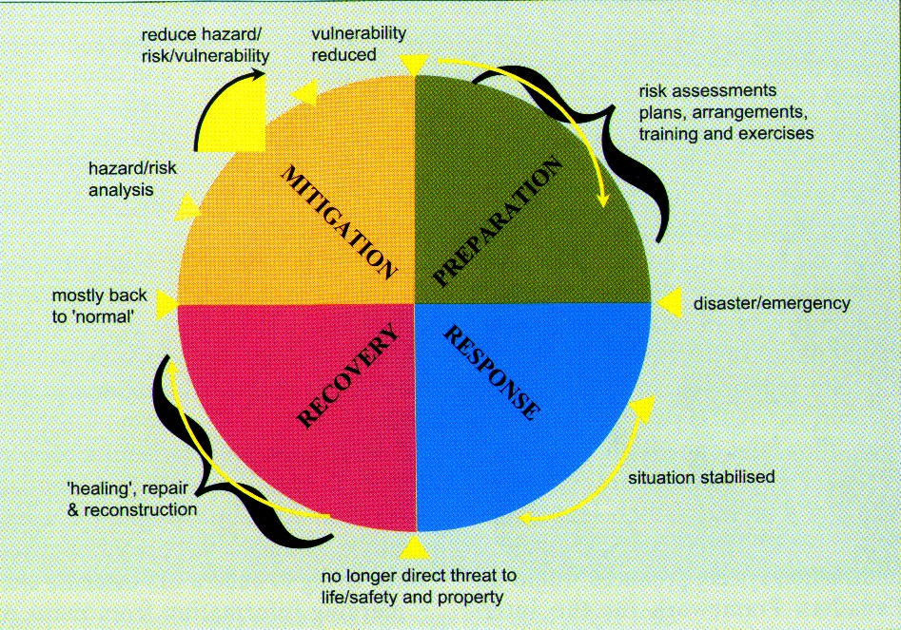

**RECOVERY**

Recovery is the process by which communities and the nation are assisted in returning to their proper level of functioning following a disaster.

Three main categories of activity are normally regarded as coming within the recovery segment:

1.Restoration

2.Reconstruction

3.Rehabilitation

**PREVENTION & MITIGATION**

**Prevention** : Action within this segment is designed to impede the occurrence of a disaster event and/or prevent such an occurrence having harmful effects on communities or key installations.

**Mitigation :** Action within this segment usually takes the form of specific programs intended to reduce the effects of disaster on a nation or community. For instance, some countries regard the development and application of building codes (which can reduce damage and loss in the event of earthquakes and cyclones) as being in the category of mitigation.

**PREPAREDNESS**

Preparedness is usually regarded as comprising measures which enable governments, organizations, communities and individuals to respond rapidly and effectively to disaster situations

**Elements of Disaster Management**

A disaster manager must deal with six distinct sets of activities in order to affect successfully the course of events related to disasters. Known as the elements of disaster management, these include risk management, loss management, control of events, equity of assistance, resource management, and impact reduction.

**1.Risk Management:**Risk management consists of identifying threats(hazards likely to occur),determining their probability of occurrence, estimating what the impact of the threat might be to the communities at risk, determining measures that can reduce the risk, and taking action to reduce the threat.

In natural disasters, risk management includes:

• hazard mapping

• vulnerability mapping

• estimation of potential losses, which can include:

- losses of housing and physical structures

- agricultural losses

- economic losses

- losses to physical infrastructure (such as roads, bridges, electric lines, etc.)

• development of appropriate disaster prevention and mitigation strategies.

**2.Loss Management:**Losses in a disaster include human, structural, and economic losses. Loss management addresses each of these through both pre and post-disaster actions designed to keep losses to a minimum. The most effective loss management activities occur prior to the disaster and are focused on reducing the society's vulnerability to the disaster.

Actions include:

• Improving the resistance of buildings and physical structures in the event of disaster

• Providing improved safety for the occupants of buildings or settlements situated in

hazardous areas

• Increasing and/or diversifying the network of social support (or coping) mechanisms available to victims and communities in threatened areas.

Post-disaster loss management focuses on improving the response and broadening the range of support given to victims. This includes facilitating relief delivery and stimulating a rapid recovery. These are accomplished through emergency preparedness, which consists of :-

1) The estimation of post-disaster needs and development of approaches and programs to speed relief, response, warning and evacuation of persons known to be at risk from an immediate threat,

2) The provision of emergency assistance to help reduce the impact of losses, and

3) Reconstruction, to lessen the economic burden of long-term recovery .

**3.Control of Events:** The critical element of disaster management is the control of events during and after the emergency. It is important that disaster managers control a situation rather than respond to it. Control is maintained through the following measures:

• Anticipation of a disaster and the cause-and-effect relationships generated by each type of event

• Mitigation, or reduction, of the scope of a disaster. Mitigation is the most important function in bringing disasters under control. The more that can be done to reduce the effects of disaster, the fewer problems a disaster manager will face in the aftermath.

• Preparedness. By reviewing the anticipated scope of a disaster, managers can plan adequate responses, develop organizational procedures, and prepare to meet the needs that are going to arise.

• Accurate information collection and assessment. Once a disaster has commenced, the manager needs to have reliable data upon which to base priorities and to guide response.

• A balanced response. Each type of disaster will require a different set of responses. The disaster manager must review the different strategies and approaches for meeting disaster needs and develop an appropriate mix of responses, so that all sectors of the community can be equitably assisted. More than one approach may be necessary in order to meet a variety of needs in the same sector.

• Action. Once a problem has been identified and a response strategy selected, the action must commence immediately. Appropriate action must be phased in a timely manner and undertaken before demands and needs escalate. Action delayed means lost opportunities and a lessening of control, which add to the suffering of the victims.

• Leadership. Disaster management should lead, rather than follow, public action. If programs are timely, the first element of leadership is attained. Rapid response and timely aid give people hope and encourage them to take positive actions themselves to help meet their needs. A delayed response leads to confusion and frustration and may force disaster managers to choose alternative courses that are ultimately less desirable.

• Discipline. Disaster managers, disaster management systems and organizations, and all key personnel in the relief and disaster management system must operate in an orderly, precise, and disciplined manner. The appearance of discipline and self-assuredness will reassure the public and promote compliance. The success of a disaster manager relates directly to the leadership exercised and the ability to coordinate the actions required to bring order out of chaos.

**4.Equity of Assistance:**All disaster assistance should be provided in an equitable and fair manner. Assuring that all disaster victims are treated fairly and equally is an important element of disaster management. This is especially important at the national level when a variety of different relief agencies, each with different constituencies and demands by their management and donors, are trying to provide assistance. Doctrines of fairness must underlie uniform relief and reconstruction policies in order to insure that disaster victims receive fair treatment and obtain adequate access to the resources available.

**5.Resource Management:**Few disaster managers have adequate resources to meet all the competing needs and demands of a post-disaster environment. Thus, resource management becomes a critical element of disaster response. The disaster manager must be familiar with the resources available. He or she must know how to form them into a balanced package of assistance and how to maximize their use to the greatest advantage. For example, in the aftermath of a flood a relief agency may receive seeds that will enable 1,000 farmers to replant the crops that were destroyed by the flood. Yet disaster assessment surveys indicate that 2,000 farmers need replacement seeds. The manager who decides to give away all the seeds and reinvest the proceeds from the crop sales to purchase additional seeds can expand the number of persons serviced and thus maximize the contribution.

**6.Impact Reduction:** Disasters can have an impact far beyond the immediate human, physical, or economic losses. In a very real sense, disasters represent a loss of opportunity, not only to individuals, but also to entire societies. They can also be a serious setback to the country's entire development program. The impact of the disaster on individuals and their society should be reduced to a minimum. For a nation struck by a disaster, this means managing the disaster in such a way that recovery is accomplished quickly and that the recovery efforts contribute to the overall development needs of the country and all its citizens.

**Technologies of Disaster Management**

Disaster managers should be familiar with certain technologies or sets of information used in disaster management. Among the more important are mapping, interpretation of aerial photography, communications, information management, logistics and computer applications, epidemiology and preventive medicine.

**Mapping**

Disaster management relies heavily on the use of maps and mapping techniques for control of disasters and for managing response. At a minimum, disaster managers must be familiar with a variety of different types of maps including topographic maps, land-use maps, hazard maps, geologic maps, vegetation maps, population distribution maps, seismic maps, and hurricane tracking maps. Disaster managers must know how to read maps. They must also know how to plot information accurately on the maps and how to interpret trends through map reading. The introduction of microcomputers to disaster management will increase the use of computer generated maps. Schematic maps generated through computer graphics are being used to provide updated information about disaster situations as they develop. For example, these maps can be used to monitor flooding and guide a disaster manager who must decide when to evacuate certain areas. By monitoring the stream flow and water level at an upstream location, a disaster manager can map the expected flood zone and predict threatened areas, the extent of the flooding, and areas that should be evacuated on a priority basis. The manager can likewise determine where to focus flood control activities. Computer-generated maps are used in risk analysis, vulnerability analysis, evacuation planning, flood monitoring, damage assessment, and reconstruction planning.

**Aerial Photography And Remote Sensing**

**Aerial photography**used wisely is a valuable tool for disaster managers. It can be an expensive tool if misused. Disaster managers must know how to interpret aerial photography and how to apply it to both pre-disaster planning and post-disaster response activities. Possible uses of aerial photography include hazard analysis and mapping, vulnerability analysis and mapping, disaster assessment, reconstruction planning and management.

**Remote sensing**is the acquisition of information about a subject that is at a distance from the information-gathering device. Weather radar, weather satellite, seismographs, sono buoys, and videotape are examples of remote sensing systems. Aerial photography is a form of remote sensing, but in disaster management the term generally refers to the use of satellites with imaging systems that produce a computer-generated image resembling a photograph and with other electronic monitoring devices. For example, meteorological satellites track hurricanes by remote sensing. The "picture" of the hurricane is a computer- generated image made by the satellite's sensors. The use of remote sensing in disaster management is increasing. Pre-disaster uses include risk analysis and mapping; disaster warning, especially cyclone tracking, drought monitoring, volcanoes, large-scale fires and agricultural production; and disaster assessment, especially flood monitoring and assessment, estimation of crop and forestry damages, and monitoring of land-use changes in the aftermath of a disaster. Meteorological satellites monitor weather patterns, detect and track storm systems, and monitor frosts and floods.

**Communications**

Electronic communications are an important technology of disaster management. Electronic communications are used for coordination and control, assessment, reporting, monitoring and scheduling logistics, and reunification and tracing separated families. A disaster manager must be familiar with communications equipment and their limitations. He or she must understand the effective use of communications networks both prior to and in the aftermath of a disaster. A disaster manager must above all know how to communicate, what to communicate, and with whom to communicate, using the different technologies available. Electronic communications too often give disaster managers the impression that they can control a situation simply by communicating. The information that comes in through electronic communications can often overwhelm and/or misinform a manager. Thus the manager must be knowledgeable about the systems, but he or she must also know how to structure the communications systems. Structuring will allow rapid communication of vital information and accurate assessment of a developing situation.

**Information Management**

Disaster management is highly dependent on accurate information collection and interpretation. Disaster managers must therefore be familiar with how to collect, structure, and evaluate information in emergency situations. This is usually done by establishing an information management system. In recent years microcomputers have provided disaster managers with a new tool for structuring information and data and analyzing information patterns and trends. Microcomputers are now routinely used for program planning, project scheduling and monitoring, management of logistics, damage assessment, casualty management, communications, and cost accounting management.

**Logistics**

Every disaster manager eventually becomes involved in logistics. Therefore, he or she must be familiar with basic logistics planning, inventory management, warehousing and stock control procedures, materials distribution methods, and accounting procedures. Logistics planning can include, for example, evaluating the capability and capacity to move supplies through the relief system identifying bottlenecks and developing alternate solutions. Logistics planning in a country struck by a disaster might include the estimation of the capacity to receive supplies at air and sea ports and to unload the supplies and reload into trucks. It might include determining the sufficiency of trucks of the right size and type, and the availability of parts and fuel for the trucks. Other considerations might be adequate roads to the site of relief, adequate warehouses at collection points, and a distribution system with the administrative capability and the methods to deliver the goods to the final point of utilization.

**Epidemiology**

Epidemiology is the branch of medicine that investigates the causes and control of epidemics. In relation to disasters epidemiology has come to mean the evaluation of all the causes of the occurrence or nonoccurrence of a disease (and more broadly of the death and injuries) resulting from a disaster. Epidemiologic surveillance after disasters and refugee crises includes identification of diseases to include in the surveillance; the collection, interpretation and utilization of data; laboratory diagnosis of samples; development of policies and plans for a public health program; and establishment of a program for the control of communicable disease. The last two points coincide with programs in environmental health management and preventive

medicine.

**Emerging technologies that will impact emergency management**

Emergency Management sought out emerging technologies that will positively impact the field and possibly change how people think tech fits into preparedness, response and recovery.

**1. INTELLISTREETS**:- Intellistreets using smart lamp post to collect the emergency data and direct evacuation efforts.

Intellistreets is “flexible wireless solution for integrating energy efficient lighting, audio, digital signage and more into your city, campus or sporting venue.” The preliminary advantage of the system is the [adaptive energy & luminaire/bulb conservation feature](http://intellistreets.com/press.php?id=isEnglish), whereby the system lighting intensity fades with increased ambient light or lower traffic and pedestrian, for less energy consumption and longer bulb life. Additionally, the smart lamppost system, originally intended as [an energy-efficient lamppost for entertainment purposes](http://intellistreets.com/press.php?id=2011-02-16-01), has many uses in different industries, particularly for emergency operations.

* The sensory capacity of the lamppost allows emergency-essential functions detection of rising flood waters
* Bi-directional communications within a cluster or series of light poles is achieved by RF radio, and an Ethernet or Cellular gateway within a thousand feet of the first pole links that group to a central emergency operations room or an adjacent mobile device, sending sensory data and receiving necessary instructions it can equipped with speakers for emergency announcements, including evacuation instructions, and with digital signage for visual displays of routes
* control of the lampposts can be done from central Emergency Operations Centers, or an iPad in a nearby emergency vehicle

**2.iDAWG(edgeware)**

iDAWG - Intelligent Deployable Augmented Wireless Gateway technology.The iDAWG is highlighted for its ability to provide interoperable communications channels between many different first-responder agencies at disaster scenes.

The iDAWG works on a new type of software application, called edgeware. Through the lab’s cognitive radio interfaces and the abilities of the edgeware software, iDAWG is intended to integrate with the Federal Emergency Management Association’s (FEMA) Integrated Public Alert and WarningSystem.(IPAWS). IPAWS is the communication system used by most police and fire agencies and emergency management responders.

**Conclusions**

In conclusion, due to the need for displaying and analyzing a huge volume of the spatial as well as non-spatial environmental hazards and exposure data in a fast and accurate way, and also due to the progressive increase in the g-Readiness of the users, software applications elements of management and technologies of management would continue to serve as powerful tools for effective environmental risk assessment and management.