**TITLE- Discharge prediction model in trapezoidal channel for simple cylinder flume using HEC-RAS software and experimental method.**

**(Prathama Dolas, Nikhil Ikhar, Sandeep Wasnik ,Sankalp Shelare)**

(Final year)

Civil Engineering Dept. KDKCE, Nagpur.

**Abstract**

Consumption of water can be optimized by metering it. In irrigation systems, many lined irrigation canals have trapezoidal cross sections. A simple portable device for measurement of discharge in small trapezoidal agricultural canal has been analyzed in this paper. Measuring flume consists of a cylinder positioned axially in nearly horizontal prismatic trapezoidal channel which can be quickly fixed and removed for short-time use in trapezoidal channels. The cylinder placed in the flow reduces the cross section for flow, thus creating critical flow conditions. In this paper, a new mathematical model has been developed to predict the discharge through a trapezoidal canal by simple cylindrical flume using experimental data available in literature for trapezoidal canal having 1:1 side slope. Dimensional analysis has been carried out to achieve the objective of prediction of more accurate discharge than that calculated by a model developed by using Hec-Ras software. The resulting non-dimensional parameters have been used to develop the proposed mathematical model and the results of the proposed model have been compared with the results of the model developed by using Hec-Ras software.

**Keywords:**Flume, Discharge Measurement, Open Channel Flow, Dimensional Analysis.

1. **INTRODUCTION**

Water is vitally important natural resource for mankind and is a valuable national asset. Efficient development and optimum utilization of water resources is of great significance to the overall development of the country. Accurate measurement of irrigation water results in more

Intelligent use of this valuable natural resource. Such measurement reduces excessive waste and allows the water to be distributed among users according to their needs and the importance. Various approaches exist to measure discharge in canals. The usual discharge measurement in canals is based on the critical flow concept. Most of previous works for discharge measurement structures were carried out in canals with rectangular cross sections. However, in irrigation systems, especially the lined canals have trapezoidal cross sections. Hence an attempt is made to develop a refined mathematical model for prediction of discharge through trapezoidal canal, using experimental data on simple cylindrical flume.

In the past after introduction of Parshall flume (Parshall 1926), attempts have been made to simplify its construction and also to develop the flow measuring devices in open channels. This attempts led to the development of different forms of venturi flumes viz. Cut throat flume (Robinson and Chamberlain 1960 and Skogerboe et al 1967) and RBC flume (Replogel 1975). Hager (1986) used the vertically immersed cone for discharge measurement for rectangular channel. A modified discharge prediction model using dimensional analysis for trapezoidal canal, with inserted simple portable cylinders to be used as a flume was proposed by A.M. Babar et al (2012) by using vertical pipe (cylinders), prism or cone, to form a throat section within a channel section leads to an advantage of measuring discharge at any desired section of open channel flow. A simple mobile flume in the form of cylinder inserted axially across the channel flow, may be referred as simple cylindrical flume, can be used for field measurement of discharge on small agricultural channel, at any location.

In our study, experiments are performed in the laboratory (KDK COLLEGE OF ENGINEERING) on a simple cylindrical flume consisting of a vertically inserted cylinders of various diameters of 140, 160 and 182.3mm in a trapezoidal channel cross section with width of 20 cm and for different discharges, the flow depth on the cylinder at the upstream side are observed. The result of experimental observations have been used for the regression analysis to develop experimental discharge prediction model for simple cylindrical flume and it has been used to compare and test the results obtained from the corresponding discharge prediction model developed using HECRAS software. Experimental calibration of flumes is time consuming task especially when it is required to cover a wide range of geometric proportions of the flume elements with a view to overcome this limitations, it was decided to apply the HECRAS software for flow simulation of simple cylindrical flume and obtain the depth of water on the upstream side of cylinder. Maintaining the same flow and the geometric conditions as those used in the experiments. The results of HECRAS model runs are also used for the development of discharge prediction model and comparative study of both the discharge prediction models has been presented in this paper.

**2.HEC-RAS MODEL DEVELOPMENT**

The hydrologic engineering Centre’s river analysis system (HECRAS) software has been developed by the U.S.ARMY CORPS of engineers and is made available for public use, free of cost. Software package HECRAS allows user to perform 1 dimensional river analysis components for steady flow water surface profile computations in addition to unsteady flow simulations, movable boundary sediment transport computations and water quality analysis. HECRAS is one of the most commonly used software to calculate the water surface profiles and energy grade lines in 1-D, steady state, and gradually varied flow analysis. In 1-D, STEADY STATE gradually varied flow analysis, assumptions include dominant velocity I the flow direction, constant hydraulic characteristic of flow for the time interval under consideration and that the streamlines are practically parallel and therefore, hydrostatic pressure distribution prevails over channel section. Water surface profile is computed from one cross section t the next by solving the energy equation with an iterative procedure called the standard step method. The energy loss between cross section comprises of the frictional losses, and contraction and expansion losses.

In order to simulate the flume, a schematic diagram of channel reach with simple cylindrical flume was drawn first (fig 1). It shows HECRAS schematic plan of the channel showing the location of vertical cylinder inserted. HECRAS requires the geometry of cross sections to define the channel. The cross sections needed to be adequately refined to describe the cross sections shape and the reach above and below the cross section. Channel roughness value were assigned for each cross section in the model. For the present study channel roughness (0.0140958) was assumed and same was used for HECRAS model development. There were 11 cross sections spaced at 0.5m each represented by dark brown line on the schematic diagram.

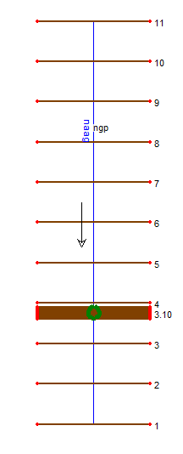

Fig 1. HECRAS schematic plan of channel

A part from this the contraction and expansion loss coefficients were also required as input data. These values were taken as 0.1 and 0.3 resp. for the cross section from 3.01 to 3.21.

**Table 1. DESCRIPTION OF THE FLUME**

|  |  |  |  |  |
| --- | --- | --- | --- | --- |
| Length of channel (m) | Base width B (m) | Dia. Of cylinder (m) | Throat width Wc (m) | Contraction ratio (%) |
| 4.9 | 0.2 | 0.14 | 0.06 | 70 |
| 4.9 | 0.2 | 0.16 | 0.04 | 80 |
| 4.9 | 0.2 | 0.1823 | 0.0177 | 91.15 |

Ineffective flow area option is available in cross section editor of the software that allows the user to define areas of cross section that will contain water that is not actively being conveyed (ineffective flow). By using this option the cylinder was positioned in the channel. The position of the cylinder was coaxial in the channel and was located at 1.38m from downstream end. Thus, inserted cylinder was created using ineffective flow area approach as indicated in Fig 2&3.

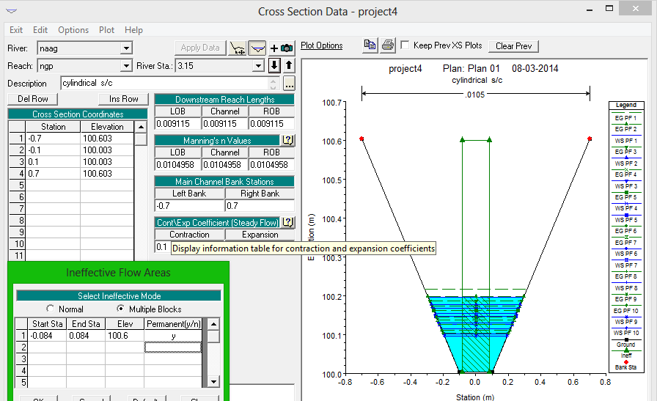

**Fig. 2 geometric properties table for cross section**

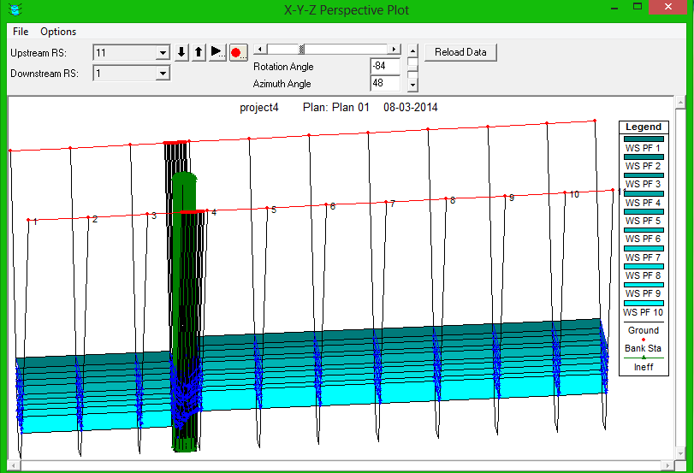

**Fig. 3 perspective view of simple cylindrical flume**

Flow data in HEC-RAS model consists of flow rate and boundary condition. After entering the geometric data and before the study flow simulation, the flow data (same as used in laboratory experimentation) and the boundary conditions were entered. The boundary condition of normal depth options were defined at all of the external ends of the system. The data fed into study flow data editor is as shown in the fig 4.

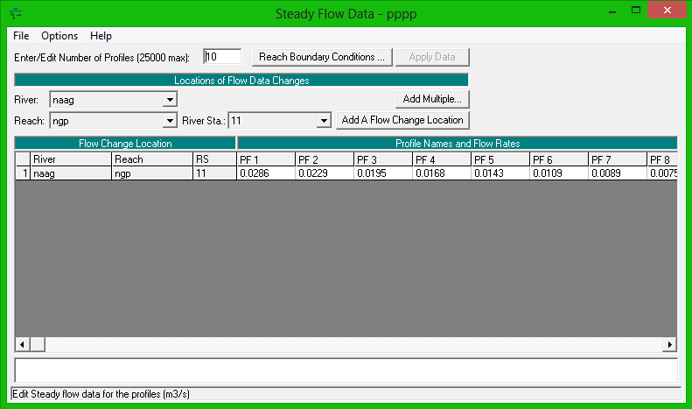

**Fig. 4. Steady flow data editor of HECRAS**

As a mixed flow regime was considered, both upstream and downstream boundary conditions were required to be provided. This were taken as normal depth and average energy slope as 0.0004. Initially, the software computes a subcritical water surface profile with initial value of downstream boundary condition. Location with critical depth are marked for the further analysis. After that subcritical profile is calculated starting from the upstream condition, the software checks to monitor if it has a greater specific force than the previously computed subcritical water surface at the location. If it has a greater specific force, then software begins searching downstream, to find the defaulted critical depth. After locating the critical depth the software uses it as a boundary condition to commence supercritical profile calculations.

In the present study, a cylindrical flume of diameter 0.14, 0.16 and 0.1823m was investigated in trapezoidal channel of base width 0.2m i.e. providing contraction ratio 70%, 80%, 91.15% with discharge ranging from 0.003752 m3/sec to 0.0286 m3/sec.

**3.FORM OF STAGE-DISCHARGE RELATIONSHIP**

For a simple cylindrical flume, the relationship between the upstream energy head ‘H’& the discharge ‘Q’ for a trapezoidal flume having horizontal bottom, formed by contracting the flow by placing a cylinder of diameter ‘D’ centrally at the canal bottom with width ‘B’, can be expressed as -

|  |  |
| --- | --- |
| http://article.sapub.org/image/10.5923.j.ijhe.20120105.02_008.gif | (1) |

Total number of variables is 5.

There are only two fundamental dimensions involved i.e. L & T.

Therefore, there are 3 dimensionless Π terms.

According to the Π theorem of dimensional analysis, the functional relationship given by Equation (1) can be expressed by using only three dimensionless groups.

|  |  |
| --- | --- |
| http://article.sapub.org/image/10.5923.j.ijhe.20120105.02_009.gif | (2) |

Where Π1, Π2& Π3 are dimensionless groups whose expressions have to be determined.

Let B and g be the repeating variables.

Π terms have een grouped as follows:

|  |  |
| --- | --- |
| http://article.sapub.org/image/10.5923.j.ijhe.20120105.02_010.gif | (3) |

|  |  |
| --- | --- |
| http://article.sapub.org/image/10.5923.j.ijhe.20120105.02_011.gif | (4) |

|  |  |
| --- | --- |
| http://article.sapub.org/image/10.5923.j.ijhe.20120105.02_012.gif | (5) |

Where a, b, c, d, e and l are numerical constants.

Substituting the measurement units of each variable in Equations (3), (4) and (5)

|  |  |  |  |
| --- | --- | --- | --- |
|  |  | |  |
|  | | (6) |  |
|  |  | |  |

|  |  |
| --- | --- |
| http://article.sapub.org/image/10.5923.j.ijhe.20120105.02_014.gif | (7) |
|  |  |

|  |  |
| --- | --- |
| http://article.sapub.org/image/10.5923.j.ijhe.20120105.02_016.gif | (8) |

Substituting Equations (6), (7), (8) into Equation (1),

|  |  |
| --- | --- |
| http://article.sapub.org/image/10.5923.j.ijhe.20120105.02_017.gif | (9) |

Similarly, from the permutations and combinations, following equations can be obtained

|  |  |
| --- | --- |
| http://article.sapub.org/image/10.5923.j.ijhe.20120105.02_018.gif | (10) |

|  |  |
| --- | --- |
| http://article.sapub.org/image/10.5923.j.ijhe.20120105.02_019.gif | (11) |

Thus the stage discharge relationship for simple cylindrical flume in rectangular channel can be expressed in the form:

$\frac{Q}{B^{\frac{5}{2}}*g^{\frac{1}{2}}}=f\left(\frac{H}{D}\right)=a{(\frac{H}{D})}^{n}$ (12)

1. **EXPERIMENTAL MODEL**

Experimental runs on simple cylindrical flume were carried out at the laboratory of K.D.K College of Engineering, Nagpur, India; for a set of discharges. The depths on the cylinder at upstream side ($H_{exp}$) were observed for each of the flow rate and these depth were used for the development of experimental mathematical model for simple cylindrical flume. A graph is plotted between dimensionless discharge and dimensionless head (experimental) as shown in Fig 5. (5.1, 5.2, 5.3.)

**Fig.5.1. for dia. 140mm**

**Fig.5. Relationship between dimensionless head ($\frac{H_{exp}}{D}$) and dimensionless discharge $\frac{Q}{B^{\frac{5}{2}}*g^{\frac{1}{2}}}$**

For the consideration contraction ratio (n=70, 80, and 91.15%), the regression analysis showed a well-fitting power relationship between $H_{exp}$/D and $\frac{Q}{B^{\frac{5}{2}}*g^{\frac{1}{2}}}$ and the resulting equation is as follows:

For 140mm dia.: $\frac{Q}{B^{\frac{5}{2}}*g^{\frac{1}{2}}}$**= 0.2553() 2.297** (13)

For 160mm dia.:**=0.3112() 2.4389** (14)

For 182.3mm dia.:**=0.3095() 2.6036** (15) The computation required for the development of experimental mathematical model (Eq. 13, 14, 15) for simple cylindrical flume using observations of

Experimental runs and predicted discharge by using experimental mathematical model (Eq. 13, 14, 15) are shown in table 2.

**Table 2: computations for development of experimental mathematical model and predicted discharge**.

For dia. 140mm:



For dia 160mm:



For dia 182.3 mm:

**5.HEC-RAS CALLIBRATION MODEL**

For the considered contraction ratio (n=70,80,91.15%) and for different discharges, flow depths on cylinder (HEC-RAS) at upstream side have been determined by using the developed HEC-RAS soft model of simple cylindrical flume, as explained earlier.

These flow depth on cylinder at upstream side (Hhecras) have also been used for development of another calibration model for the simple cylindrical flume, as has been done while developing the experimental model. A graph is plotted between dimensionless head and dimensionless discharge (HECRAS based) as shown in Fig 6. **Fig 6.1 For dia. 140mm**

**Fig 6.2 For dia. 160mm**

**fig. 6.3 for dia. 182.3 mm**

**Fig 6. Relationship between dimensionless head ($\frac{H_{HECRAS}}{D}$) and dimensionless discharge $\frac{Q}{B^{\frac{5}{2}}*g^{\frac{1}{2}}}$**

The regression analysis showed a well-fitting power relationship between $H_{HEC-RAS}$/D and $\frac{Q}{B^{\frac{5}{2}}*g^{\frac{1}{2}}}$ and the resulting equation is as follows:

For 140mm dia.: $\frac{Q}{B^{\frac{5}{2}}*g^{\frac{1}{2}}}$**= 0.2632() 2.5215** (16)

For 160mm dia.:**=0.2412() 2.2437** (17)

For 182.3mm dia.: **=0.3577() 2.4979** (18)

The computation for development of HEC-RAS based calibration model and predicted discharge by using HEC-RAS based calibration model (Eq. 16, 17 and18) are shown in the table 3. For prediction of discharge, the depth on the cylinder at upstream side is taken as the actual depth measured in the laboratory (i.e. Hexp) and substituted in Eq. (16,17and18). Percentage error between discharge input to the HEC-RAS model, which is same as measured discharged during experimentation, and the predicted discharge by HEC-RAS model (eq.16, 17and18) is shown in Table 3. A graph is plotted between predicted discharge and percentage error based on HEC-RAS based calibration model and is shown in fig. 6.

**Table no 3. Computations for development of HECRAS based calibration model and predicted discharge**.

For 140mm dia.



For 160mm dia.:



For 182.3mm dia.:



**6.RESULT**

It is noted that the experimental mathematical model (Eq 13, 14, 15) predicted the discharge well, with percentage error lying within -2.97% to 3.50% for all discharges and has been used for comparing the result obtained by HEC-RAS based calibration model. The depth on upstream side of cylinder obtained from the soft model, is used for the development of HEC-RAS mathematical model for prediction of the discharge. It is found that HEC-RAS mathematical model is valid for predicting the discharge, as percentage error is within general acceptance limit of +-5% i.e. twenty-six values out of twenty-nine values of predicted discharges are found to be within an accepted range of percentage error. A graph is plotted between dimensionless discharge and percentage error for HEC-RAS based calibration model and also experimental mathematical model.

**Fig. 7. Graph between dimensionless discharge and % error.**

**7. CONCLUSION**

For a trapezoidal channel section with a simple cylindrical obstruction used as a flume, the experimental mathematical model predicted the discharge more accurately and percentage error was within an acceptable limit of 5%. The same hydraulic and geometric data of the experiment have been used for the development of HEC-RAS based calibration model. The HEC-RAS based calibration model has been used to predict the discharge with reference to the experimental observed flow depth on upstream side of cylinder of the simple cylindrical flume, it is found that in flow range of 0.003752 m3/sec to 0.0286 m3/sec HEC-RAS model performs well. Twenty six out of twenty nine readings show almost same results as that of experimental model with acceptable error lying below +-5% between predicted discharges and measured discharges. The remaining three values show results in the error that are not acceptable. So after this study we conclude that both the methods are useful but experimental methods show more satisfactory and relevant results. This is evidently explained from Fig.7.

**8. REFERENCES**

|  |  |
| --- | --- |
| [1] | Samani, Z., and Magallanez, H. (1993). ‘‘Measuring water in trapezoidal Canals,’’ Journal of Irrigation and Drainage Engineering, ASCE, Vol –119, No -1,Pg.-181–186. |
| [2] | Skogerboe, G. V., and Hyatt, M.L., (1967), “Rectangular cut throat flumes”, Journal of Irrigation and Drainage Engineering Div., 98(4), 569-583. |
| [3] | Replogle, J.A. (1975) “Critical flow flumes with complex cross sections.” Proc., Irrig. Drain. Div. Spec. Conf., ASCE, New York, N.Y., 336-338. |
| [4] | Hager, W. H. (1985). “Modified Venturi Channel,” Journal of Irrigation and Drainage Engineering., ASCE, Vol– 111, No - 1, Pg. - 19-35 |
| [5] | Hager, W. H. (1988).“Mobile Flume for Circular Channel,” Journal of Irrigation and Drainage Engineering., ASCE, Vol – 114, No - 3, Pg. - 558-566. |
| [6] | Baiamonte, G., and Ferro, V., (2007). “Simple flume for measurement in sloping open channel”, Journal of Irrigation and Drainage Engineering, ASCE, V01-113, No.-1, Pg -71-  [7] International journal of hydraulic engineering 2012, 1(5) : 37-42, Doi:10.5923 /j.Ijhe. 2012105.02  [8] Dr. R.K. BANSAL, “fluid mechanics and hydraulic machines”.  [9 ] Samani, z., And magallanez, H. (2000).“Simple flume for flow measurement in open channel.”Journal of irrigation and drainage engineering, ASCE, vol – 126, no. 2, pg. No.127–129.  [10] Baiamonte, g., And ferro, V., (2007). “Simple flume for measurement in sloping open channel”, journal of irrigation and drainage engineering, ASCE, V01-113, no.-1, pg -71-78  [11]Http://www.Ceaeq.Gouv.Qc.Ca/documents/publications/echantillonnage/debit_conduit_ouv_c7_ang.Pdf  [12] Http://www.Codecogs.Com/library/engineering/fluid_mechanics/weirs/index.Php |