**SEISMIC RETROFITTING TECHNIQUES FOR RC FRAMED BUILDING**

**Submitted by**

***Akshay V. Raut***

*M. Tech final year student,* K.D.K. College of Engineering

*Email-* [*vikiy2k@gmail.com*](mailto:vikiy2k@gmail.com)

***Anant A. Kapse***

*M. Tech final year student,* K.D.K. College of Engineering

*Email- [anna241984@gmail.com](mailto:anna241984@gmail.com)*

**ABSTRACT**

Many existing structures located in seismic regions are inadequate based on current seismic design codes. In addition, a number of major earthquakes during recent years have underscored the importance of mitigation to reduce seismic risk. Seismic retrofitting of existing structures is one of the most effective methods of reducing this risk. In recent years, a significant amount of research has been devoted to the study of various strengthening techniques to enhance the seismic performance of RC structures. However, the seismic performance of the structure may not be improved by retrofitting or rehabilitation unless the engineer selects an appropriate intervention technique based on seismic evaluation of the structure. Therefore, the basic requirements of rehabilitation and investigations of various retrofit techniques should be considered before selecting retrofit schemes. In this report, the characteristics of various intervention techniques are discussed and the relationship between retrofit and structural characteristics is also described. In addition, several case study structures for which retrofit techniques have been applied are presented.

**INTRODUCTION**

Since the several major earthquakes have caused heavy damage in India and in the rest of world. Those have brought raised awareness everywhere about the need of Seismic retrofitting. Design codes now includes seismic provisions, and building build today are designed to withstand earthquakes, but many structures that were build before the 1970’s need to be retrofitted. Attention needs to be given to the both steel and concrete structures but this paper will focus on concrete structures and their retrofit methods. After earthquakes, survey have analyzed damaged and collapsed structures to understand their failure mechanism. There are two major types of retrofit methods that can be used . The first are local methods that focus on member level. This include an analysis of the structure to retrofit elements. Local method includes the addition of concrete , steel and composites. The second method is global approach that retrofit the entire structure to improve it’s overall behaviour . These methods includes addition of shear walls or steel bracings, or the use of base isolation. In this paper, attention to the retrofit techniques, their description and advantages, as well as example of their application. The local methods will presented first followed by Global ones.

1. **LOCAL METHOD**

**1.1** **SECTION ENLARGMENT**

Section enlargement consisting placing additional concrete around an existing structural element to increase its seismic resistance. This is the oldest method of seismic retrofitting. Typical application include bridge deck, column wrapping and joint strengthening. This method is economically effective but labour intensive.

**1.1.1 TRADITIONAL CONCRETE**

Addition of traditional concrete has been used for many years. It is used to reinforce column either by themselves. It can also be used for other structural features like foundations. It is use mainly when strengthening is needed. As was discussed, column is one of the structural element that to need retrofit in both building and bridges. This method has been used for number of years. Numerous studies have been done in the past but this method has been prove and research has been moved on to the other materials. As per research, Different detailing and different situations (pre



Fig. 1- Strengthened by concrete jacketing

damage vs. Non- damage) were tested and the results showed that the retrofitted column exhibited higher strength, durability as well as stiffness and very good energy dissipation. They also showed that neither the detailing nor the original state of column,had much influence but that what was important was surface preparation. Another variation of the column retrofitting is to wrap the column with the concrete jacket with added longitudinal and transverse reinforcement and in post-tensioned of the new longitudinal reinforcements

* + 1. SHOTCRETE

It is mortar or concrete pneumatically projected at high velocities on surfaces. It was introduce in 1911 and has been used in retrofitting applications for over 50 years. The innovation of shotcrete gun attributed to Carl E. Akeley. Shotcrete comes in both dry and wet mixed forms. Its main advantage is it eases of application especially in hard to access areas which results in construction time and cost. It has dense composition and low shrinkage results in good durability. The main disadvantage is that special attention and procedure is required in order to achieve good quality.

1.1.2 POLYMER CONCRETE COMPOSITES

PC are made from a polymer binder ( usually a thermosetting polymer ) mixed with a mineral filler, either sand ( for mortar ), or aggregate, gravel or crushed stone (for concrete). The material has several advantages such as high strength, low permeability, excellent resistance to chemical and abbration. Andgood adhesive properties. However its disadvantages are cracking due to volume changes, creep at high temperature and additional cost. It is use in resurfacing detoriated structures and as a compound in repair of concrete structures.

1.1.4 FIBRE REINFORCED CEMENT COMPOSITES

These are high performance materials which can be defined as material exhibiting post-peak strain hardening response associated with multiple cracks and high energy dissipation. Advantages of using such material are improvement in energy absorption, toughness, ductility and cracking shear resistance. They are also good in thermal expansion and a good crack distribution in small width. However they come in high initial price due to their labor intensity. Best example of the fiber reinforced cement composite is SIMCON ( slurry infiltrated mat concrete). It is the pre-placed continuous stainless steel fiber mat infiltrate with a cement based slurry. The mat are pre- fabricated and brought tosite in large rolls.

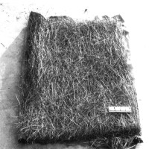

Fig. 2- Simcon

* 1. **ADDITION OF STEEL**

Addition of steel is often applied in the form of plates or jackets. Steel tendons can also be used in external prestressing.

* + 1. STEEL JACKET- COLUMN

Steel jacket can be used to retrofit. Reinforced columns that to be needed more attention. Retrofit of columns using steel jackets has been extensively studied in 1990’s. Mainly in bridge column, this technique provided a good overall behavior with increase ductility, shear strength and energy dissipation. This method is now widely use in US and JAPAN.

The principle behind this technique is steel jacket acts as passive confinement reinforcement. The jacket will prevent the concrete from dilating, lateral compression and increasing in compressive strength as well as its ductility. For circular column, the method uses two semicircular half sections that are field welded along the entire height of the jacket. A gap about 1inch (2.5 cm) is left between the column and the jacket. It is filled with cement based grout that will ensure good bonding and composite behavior. A gap of 2 inches ( 5 cm) is also left between bottom of columns and the top of the footing to avoid possible bearing of the jacket on the footing. For rectangular columns, rectangular or elliptical jackets are use .the design and requirements of steel jackets is depend up on mode of failure i.e. flexural or shear.

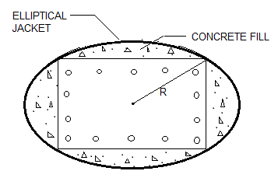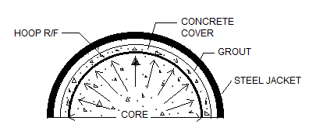

Fig. 3- Confining action of steel casing

* + 1. STEEL JACKET-CONNECTIONS

It is the one proposed rehabilitation technique for connection is to confine the weak connection in corrugated steel jacket. Similarly to column retrofit, the jacket would be constructed to in two halves and field welded. The gap would then be filled with grout to provide both continuity and a good composite behavior. The main advantage of using corrugated steel jacket rather than a normal jacket.

When an member reinforced with flat steel jacket, the jacket does not provide confinement until the concrete expands i..e. .the concrete core becomes plastic. For the jacket to be effective, the steel jacket should be extended in the column above and below the joint for a minimum distance equal to the joint length. This method can also be used for confining beams and column. In case of beams, A gap needs to be provided between the beam and jacket to minimize flexural strength. (This gap has also to provide for joint reinforcement.)

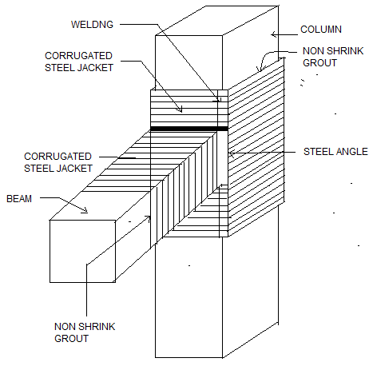

1.2.3 STEEL PLATES

During 1960’s in Switzerland and Germany, a method for strengthening concrete structure by applying bonded steel plates was developed. The method is simple; a steel plate is bonded to the concrete surface by epoxy adhesive creating concrete-glue-steel composite section.

* + - 1. BEAMS

Research and field application have shown that attaching steel plate to the tension side of a beam will increase flexural capacity and its flexural stiffness as well as decrease its deflection and cracking.

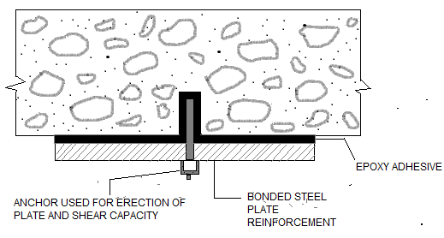

Fig. 4- Beam retrofits using steel plate

* + 1. STEEL CABLE

Steel cables can be used in two kinds of retrofits. The first use of cables is to prevent structure from moving from their support, the second is as an external pre-stressing. The first method involves placing steel cables across hinges of segmental bridge. The idea is the separation of adjacent segments across the hinge to prevent the bridge superstructure from falling off its support. In external prestressing, tensile stresses in concrete are entirely obviated by having sufficient high prestress in members. Advantages are : involves less grouting problem and can be inspected and, if necessary, replaced throughout the life of structure. This methods is widely use for strengthen existing structures. It will also provide additional resistance to cracking and fatigue.

1. **GLOBAL METHODS**

**2.1** **SHEAR WALLS**

A shear wall is vertical element that resists lateral loads in their plane, they receive those lateral forces from diaphragms and transfer to them foundation. They are subjected to both shear and bending forces and they resist an overturning moment Shear walls have been used for over half a century in seismic retrofit and in design. They are sometimes made from steel plates or masonry infill but are most often made of concrete (either pre-cast panel or infill walls) with steel reinforcement in a regular rectangular pattern.

* 1. **STEEL BRACES**

Steel braces are added to a non-ductile reinforced concrete structure to improve the strength, stiffness, and resistance to story drift. Steel braces have been used for 50 years. It has been showed that it is an effective system since the total strength of concrete frame or steel brace system is more. The advantages of using steel braces include the possibility of accommodating openings, The small added weight (especially when compared with concrete shear walls). The main disadvantage of steel brace system is its initial cost and its continued need for maintenance especially form exposed to the weather. Several different bracing systems exist: concentric (X-shaped), eccentric (K-shaped). They are made up of double angles, L-sections, or tubular sections.

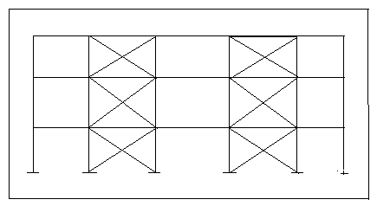

Fig. 5- Typical bracing system

**2.3 BASE ISOLATION**

Isolation is an idea based on preventing interaction between two systems. Base isolation when applied to seismic, The idea becomes to prevent the ground motion from entering structure by using isolation system which is achieved by using bearings Those are generally located at the basement level between the foundation and the superstructure. They are placed underneath each column in frame structure. The system has the following goals to accomplish.

* The fundamental frequency of the structure has to be changed or moved away from dominant seismic excitation frequency. This implies flexibility at the base of the structure ( In horizontal direction) which will avoid resonance and reduce floors acceleration
* Energy has to be dissipated to reduce the damaging effect on the structure.







* + 1. **SEISMIC ISOLATION DEVICE**

2.2.2.1 ELASTOMETRIC SYSTEM

They are made up of layers of thin rubber sheets bonded to steel plates. The steel plates help to carry the vertical forces by providing load capacity and stiffness in vertical direction. The rubber sheets provide the horizontal flexibility.

The lateral stiffness of the bearing can be increased by increasing the number of rubber layers.

1. **CONCLUSION**

Concrete structures built before 1970’s need to be retrofitted to withstand earthquakes. Several methods

Of retrofit divided into two major categories, local and global, were presented. Local method includes addition of concrete, steel and composites to improve its response in seismic event. All techniques are effective each also has some disadvantages : concrete is labor intensive, steel requires high maintenance during the life of structure, and composite have high initial cost. Global methods retrofit entire structure at once by adding shear walls or steel braces, or by using base isolation .shear walls are labor intensive and expensive. Steel braces can be easier to implement but present some connection problems. Base isolation is effective and work well, but can not be applied to all type of structures.

The choice is depend upon the building, on its specific requirements, as well as its condition, location, and geometry

.

1. **REFERENCES**

1. FEMA156. Typical costs for seismic rehabilitation of existing buildings. Volume 1: Summary. Second edition. Hart consultant group Inc. Santa Monica CA, (1994).

2. FEMA157. Typical costs for seismic rehabilitation of existing buildings: Volume 2:Supporting documentation. Second edition. Hart consultant group Inc. Santa Monica CA, (1995).

3. FEMA172. NEHRP handbook of techniques for the seismic rehabilitation of existing buildings. Building seismic safety council. Washington D.C, (1992).

4. Murty CVR, (2002), quantitative approach to seismic strengthening Of RC frame building, Seminar on seismic assessment and retrofitting buildings, pp 19-27.

5. Sudhir K. Jain, Srikant T, (2002), analysis for seismic retrofitting of buildings, The Indian concrete journal, pp 479-484.

6. Lakshmanan D, (2006), seismic evaluation of retrofitting of building and structures, ISET journal of earthquake technology, 43(1-2), pp 31-48.

7. Shailesh Kr. Agrawal, Ajay Chourasia, (2003), “Nonlinear static analysis for seismic evaluation and retrofit of RC buildings”, Workshop on rertofitting of structures, pp 116-124.

8. Abhijit Mukherjee, Amit R. Kalyani, (2004), “Seismic retrofitting of reinforced concrete frames with fiber reinforced composites”, Workshop on seismic evaluation and retrofitting of building, pp 74-82.

9. Chandrasekaran S, Saurab lahari, Kumar V, (2003), “Study of seismic vulnerability and retrofitting techniques for heritage buildings in Banaras”, Recent trends in concrete technology and structures, Kumaraguru College of Technology, Coimbatore, pp 699-707.

10. Suneja BP, (2003), “Structural Control Concept: A possible avenue for seismic retrofitting of historic monuments”, Recent trends in concrete