**“OPTIMIZATION OF BRACING FOR STAGING OF ELEVATED STEEL WATER TANK**

R.G.Bali*1,S.S. Punjarwar*2,H.B.Pawankar *3 (*-Final year, Civil dept., K.D.K.C.E, Nagpur)

**ABSTRACT:**

In this study, Wind Force acting on an Elevated steel water tank with different bracing systems e.g. Cross bracing, K-bracing, V-bracing & Knee bracing are studied. Wind forces acting on the tank are considered of two different zones i.e. NAGPUR & BHUJ and calculated with reference IS: 875-1987(Part III) for wind load on each of the bracing systems. Elevated water tank has different vibratory characteristic compared with ordinary structure, because ‘water’ affect the vibratory behavior therefore water pressure is also considered in analysisand the wind load estimation will be taking into account the random variation of wind speed with time but available theoretical methods have not matured sufficiently at present for use in the code. For this reason, static wind method of load estimation which implies a steady wind speed, which has proved to be satisfactory for normal, short and heavy structure. However, a beginning has been made to take account of the random nature of the wind speed by requiring that the along-wind or drag load on structure which are prone to wind induced oscillation, in this accordance the staging of elevated steel water tank analyze by using the software STAADPRO.And Optimizethe bracing for elevated steel water tank.

**INTRODUCTION –**

Water tank structures differ substantially, in their response to earthquakes, from the more normal form of multi-storey building structure.

The specified seismic design coefficients for water tower are of the order of twice those listed for buildings but this reflects uncertainty rather than the results of analysis by a rational design procedure. The code provisions are somewhat arbitrary and an improve design approach requires an understanding of both the dynamic interaction of the elements comprising a water tower and the overall behaviour of the structural system under earthquake loading.

Steel is one of the most widely used materials for building construction. The inherent strength and toughness of steel are characteristics that are well suited to a variety of applications, and its high ductility is ideal for seismic design. To utilize these advantages for seismic applications, the design engineer has to be familiar with the relevant steel design provisions and their intent and must ensure that the construction is properly executed.

These brace members can be grouped into several patterns: X-type, K-type, V-type and inverted V-type etc. Steel braces are generally used as an economic means of providing lateral-load resistance to steel structures.

**OBJECTIVE**

1. To determine which type of bracing is suitable for the given height.
2. Different bracing systems are analyzed.
3. Two different locations are taken which will have distinct wind speed and are in different earthquake zone.
4. At last the most economical system of bracing is selected.

**LITERATURE REVIEW-**

**Khatib et al (1989)**.-He suggested adding a column between the beams connected at same joints where the braces connect; where it will be redistributed to its braces. As a consequence, the compression brace will be subjected to an even greater compression, triggering buckling . The propagation of buckling and yielding seems similar to a “zipper” from which this system derived the name of “zipper frame”.

**Memari & Madhkhan (1999),** which deals with the optimization of structures under seismic. Allowable stress design of two-dimensional braced and unbraced steel frames based on AISC specifications subject to gravity and seismic lateral forces is formulated as a structural optimization problem. The objective function is the weight of the structure, and behavior constraints include combined bending and axial stress, shear stress, buckling, slenderness and drift. Cross-sectional areas are used as design variables.

**Kameshki & Saka (2001),** which uses genetic algorithm for the optimum design of bracing. In this study, the serviceability and stress constraints given in BS 5950 (1990) is used. The algorithm is used to design tall frames with bracings such as X, V and Z bracing. The main difference from our study is that the frames were planar. It is shown that X- bracing system with pinned beam-column connections produces lightest frame.

**A. Niknam, A. Sharfaei (2011),** “ Comparison between Seismic Behavior of Suspended Zipper Braced Frames and Various EBF Systems” concluded that Zipper frames are intended to improve on the behavior of conventional inverted-V-braced frames, which show poor performance taking place from the early buckling of braces in the lower story

Seismic response of frames subjected to near-fault ground motions (LA21) has been studied through dynamic analysis, considering nonlinearity of geometry and materials. For this purpose, SAP2000 has been used.

**METHODOLOGY**

* **Modeling of water tank staging in STAAD / SAP**

For the computational time advantages, the structural analyses are made in SAP2000. The software is automated to interact with SAP2000 v7.4 structural analysis program for generating and screening the structural models of the problems under consideration as well as carrying out a displacement based finite element analysis for each solution sampled during optimization process. Therefore the models of the structures are created in SAP2000.

* **Bracing system**

A steel frame can be strengthened in various types to resist lateral forces. These systems are, moment-resisting beam-column connections , braced frames with moment-resisting connections , braced frames with pin-jointed connections and braced frames with both pin-jointed and moment-resisting connections . Hence, the main concern is to select the appropriate bracing model and to decide the suitable connection type.

Bracing systems are used in structures in order to resist lateral forces. Diagonal structural members are inserted into the rectangular areas so that triangulation is formed. These systems help the structure to reduce the bending of columns and beams and the stiffness of the system is increased.

There are lots of advantages of the bracing systems so that they are widely used. These are:

-Braced frames are applicable to all kind of structures like bridges, aircrafts, cranes, buildings and electrical transmission towers.

- Braced frames are easy to fabricate and construct. No lots of knowledge or skills are needed.

- If the bolted connections are used, there is no deformation problem at the connections.

- The design of the braced systems is simple because the system can be separated in two parts such that the vertical loads resisting parts and horizontal loads resisting parts.

The proposed bracing are adopted as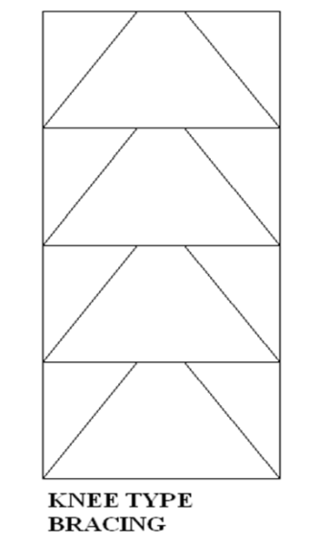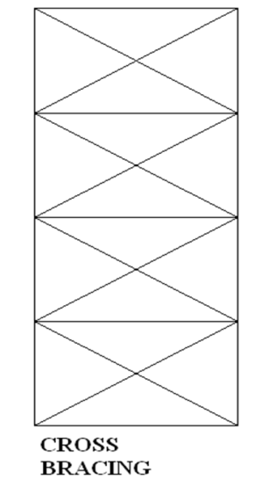

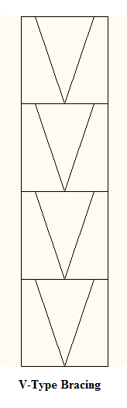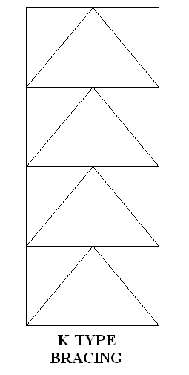

Load calculation as per IS 875 1-3

IS 875 part 1: dead load

* Dead loads consists of the weight of all materials of construction incorporated in the building including, walls, floors, roofs, ceilings, stairways, built-in partitions, finishes, cladding and other similarly incorporated architectural and structural item

IS 875 part 2: live load

* Live loads, or imposed loads, are temporary, of short duration, or [moving](http://en.wikipedia.org/wiki/Moving_load). These [dynamic](http://en.wikipedia.org/wiki/Dynamics_(mechanics)) loads may involve considerations such as [impact](http://en.wikipedia.org/wiki/Impact_(mechanics)), [momentum](http://en.wikipedia.org/wiki/Momentum), [vibration](http://en.wikipedia.org/wiki/Vibration), [slosh dynamics](http://en.wikipedia.org/wiki/Slosh_dynamics) of fluids, [fatigue](http://en.wikipedia.org/wiki/Fatigue_(material)), etc.
* Live loads, sometimes also referred to as probabilistic loads include all the forces that are variable within the object's normal operation cycle not including construction or environmental loads.
* IS 875 part 3: wind load
* The design of buildings must account for wind loads, and these are affected by wind shear.Typically, buildings are designed to resist a strong wind with a very long return period, such as 50 years or more. The design wind speed is determined from historical records using [extreme value theory](http://en.wikipedia.org/wiki/Extreme_value_theory) to predict future extreme wind speeds.

**Analysis for wind speed**

We have considered two zones i.e. Nagpur & bhuj

* Wind speed of Nagpur-44 m/s
* Wind speed of Bhuj-50 m/s

**GEOMETRY OF WATER TANK**

Dimension

1. Capacity of water tank=140.63 m3
2. Height of staging=20m
3. No. Of bays 4 Nos @ 5m
4. Total height of structure above

ground level =20+2.5

=22.5 m

1. Length of one horizontal member=7.5m

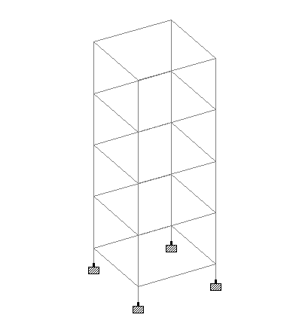

* Fig. steel structure without bracing.

Modeling of water tank staging in STAAD / SAP

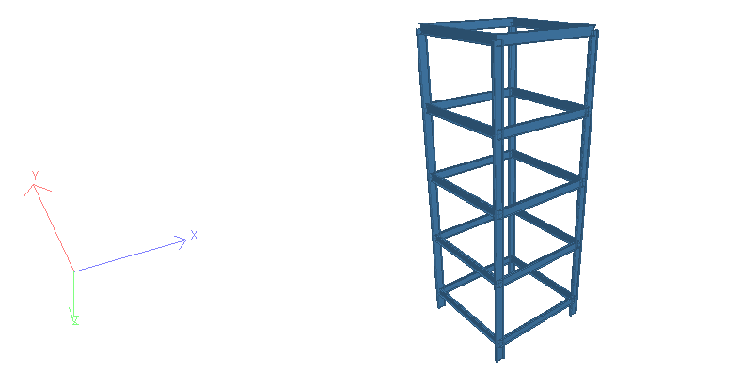

Fig. 3D view of structure in staadpro.

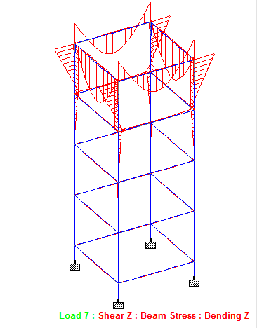

Fig. SFD & BMD of structure.

**REFERENCES**

1. . Khatib IF, Mahin SA, Pister KS., (1998), “Seismic behavior of concentrically braced steel frames ,” UCB/EERC-88/01. Berkeley: Earthquake Engineering Research Center, University of California.
2. Kameshki, E. S., & Saka, M. P. (2001). Genetic algorithm based optimum bracing design of non-swaying tall plane frames. Journal of Constructional Steel Research, 1081-1097.
3. Robert Reitherman (2003),The Anatomy of Seismically Designed Structures adapted from the 2003 CUREE Calendar illustrated essays, Consortium of Universities for Research in Earthquake Engineering.
4. 4.Pavlovic, L., Krajnc, A., & Beg, D. (2004). Cost function analysis in the structural optimization of steel frames. Struct. Multidisc. Optim., 286-295.
5. 5.Hasançebi, O. (2008). Adaptive evolution strategies in structural optimization: Enhancing their computational performance with applications to large-scale structures. Computers and Structures, 119-132.