PRE ENGINEERED BUILDING
Prafulla D. Dandekar Sanket A. Kadam
Chandrashekhar R. Mohije Paramveersingh Rathore
Students, VIII SEM (B),
Dept. Civil Engg.
K.D.K.C.E, Nagpur

ABSTRACT
Buildings & houses are one of the oldest construction activities of human beings. The construction technology has advanced since the beginning from primitive construction technology to the present concept of modern house buildings. The present construction methodology for buildings calls for the best aesthetic look, high quality & fast construction, cost effective & innovative touch. The pre-engineered steel building system construction has great advantages to the single storey buildings, practical and efficient alternative to conventional buildings, the System representing one central model within multiple disciplines.
PEB concept has been very successful and well established in North America, Australia and is presently expanding in U.K and European countries. PEB construction is 30 to 40% faster than masonry construction. PEB buildings provide good insulation effect and would be highly suitable for a tropical country like India. PEB is ideal for construction in remote & hilly areas.
The paper drafted covers in detail about the Pre-Engineered Building, its necessity, types, components and advantages.

INTRODUCTION
Buildings & houses are one of the oldest construction activities of human beings. India being a developed country massive house building construction is taking place in various parts of the country. Since 30% of Indian population lives in towns and cities; hence construction is more in the urban places. The requirement of housing is tremendous but there will always be a shortage of house availability as the present masonry construction technology cannot meet the rising demand every year. Hence one has to think for alternative construction system for steel or timber buildings, but timber is anyway not suitable to tropical countries like India.
In pre-engineered building concept the complete designing is done at the factory and the building components are brought to the site in CKD (Completely knock down condition). These components are then fixed / jointed at the site and raised with the help of cranes. The pre-engineered building calls for very fast construction of buildings and with good aesthetic look sand quality construction. Pre-engineered Buildings can be used extensively for construction of industrial and residential buildings.

WHAT IS PEB
Pre-Engineered Steel Buildings use a combination of built-up sections, hot rolled sections and cold formed elements which provide the basic steel frame work with a choice of single skin sheeting with added insulation or insulated sandwich panels for roofing and wall cladding. The concept is designed to provide a complete building envelope system which is air tight, energy efficient, optimum in weight and cost and, above all, designed to fit user requirement like a well fitted glove.
These Pre-Engineered Steel Buildings can be fitted with different structural accessories including mezzanine floors, canopies, fascias, interior partitions, crane systems etc. The building is made water-tight by use of special mastic beads, filler strips and trims. This is a very versatile building system and can be finished internally to serve any required function and accessorized externally to achieve attractive and distinctive architectural styles. It is most suitable for any low-rise building and offers numerous benefits over conventional buildings.

Pre-engineered buildings are generally low rise buildings; however the maximum eave heights can go up to 25 to 30 meters. Low rise buildings are ideal for offices, houses, showrooms, shop fronts etc. The application of pre-engineered concept to low rise buildings is very economical and speedy. Buildings can be constructed in less than half the normal time especially when complimented with other engineered sub-systems.
Necessity of PEB
The construction process actually needs lot of time for making of a building whether it is made of concrete or steel or wood. The time is considered as the major aspect by most of the companies in the construction processes and it has been proven that time is more important thing which need to be monitored apart from the money. Hence the idea of pre- engineered buildings has brought out on the field. In the case of pre-engineered buildings, the shed and the other parts of the buildings are manufactured in a factory and later on assembling at the site of construction.
The concept of pre engineering in the construction industry has brought a strong focus on people to look for such previously manufactured buildings which are also reliable and durable. It is also proven that pre-engineered buildings are also lighter than the normal steel buildings with more or less 30 to 35 percent and they can also be set up at the construction site easily. Nowadays many companies which depend on the strength and efficiency of the steel buildings will prefer to opt for pre-engineered buildings now days.
In the other hand the main aim of the farm sheds is helping the farmers in building big storage houses. Other than this, farm sheds are also giving a retro look if used properly during the roofing of homes.

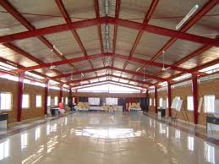

Types of PEB
Pre engineered building consist following types
- depth built-up –‘I’ section, with the large depths in areas of higher stress according to the Bending Moment Diagram;
- Secondary structural members (roof purlins, eave struts and wall girts) which are light weight cold-formed ―Z‖ and ―C‖ shaped members or open web steel joists;
- Roll formed profiled sheeting (roof and wall panels).

PRIMARY FRAMING
Clear Span
Building without interior columns – maximum practical width = 90 m
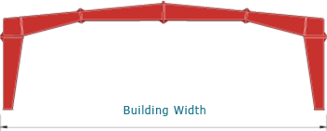
Clear-Span (Arched)
Arched Clear-Span – maximum practical width = 90 m
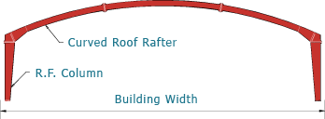
Lean-To
Maximum practical width = 24 m
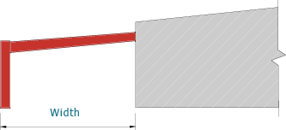

Multi Gable
Maximum practical module width = 80 m
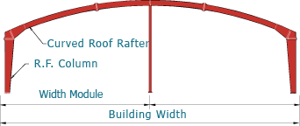

Multi-Span I
Building with one interior column maximum practical module width = 70 m
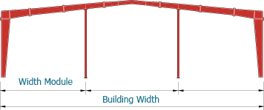

Multi-Span III
Building with three interior columns – maximum practical module width = 70 m
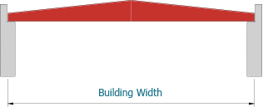

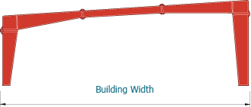
Single Slope Building without interior columns – maximum practical width = 50 m

SECONDARY FRAMING
Secondary members have two other functions:
- Act as struts that help in resisting part of the longitudinal loads that are applied on the building such as wind and earthquake loads
- Provide lateral bracing to the compression flanges of the main frame members thereby increasing frame capacity.Purlins, girts andeave struts are available in high grade steel conforming to ASTM A 607 Grade 50 or equivalent, available in 1.5 mm, 1.75 mm. 2.0 mm, 2.25 mm, 2.5 mm and 3.0 mm thickness. pre-They come with a pre-galvanized finish, or factory painted with a minimum of 35 microns (DFT) of corrosion protection primer.

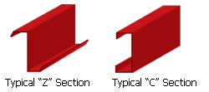

COMPONENTS OF PEB
A typical assembly of a simple metal building system is shown below to illustrate the Synergy between the various building components as described below:

- ·Primary components
- ·Secondary components
- ·Sheeting (or) cladding
- ·Accessories

PRIMARY COMPONENTS

Main framing
Main framing basically includes the rigid steel frames of the building. The PEB rigid frame comprises of tapered columns and tapered rafters (the fabricated tapered sections are referred to as built-up members). The tapered sections are fabricated using the state of art technology wherein the flanges are welded to the web. Splice plates are welded to the ends of the tapered sections. The frame is erected by bolting the splice plates of connecting sections together. All rigid frames shall be welded built-up "I" sections or hot-rolled sections. The columns and the rafters may be either uniform depth or tapered. Flanges shall be connected to webs by means of a continuous fillet weld on one side. All end wall roof beams and end wall columns shall be cold-formed "C" sections, mill-rolled sections, or built-up "I" sections depending on design requirements. Plates, Stiffeners, etc. All base plates splice plates, cap plates, and stiffeners shall be factory welded into place on the structural members. Built- up I section to build primary structural framing members (Columns and Rafters)

Columns
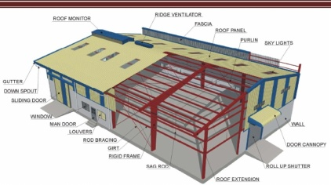
The main purpose of the columns is to transfer the vertical loads to the foundations. However apart of the horizontal actions (wind action) is also transferred through the columns. Basically in pre-engineered buildings columns are made up of I sections which are most economical than others. The width and breadth will go on increasing from bottom to top of the column. I section consists of flanges and web which are made from plates by welding.

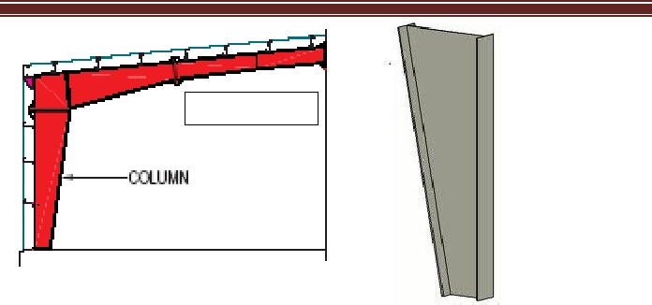

Rafter
A rafter is one of a series of sloped structural members (beams) that extend from the ridge or hipto the wall-plate, down slope perimeter or eave, and that are designed to support the roof deck and its associated loads.

SECONDARY COMPONENTS
Purlins, Grits and Eave struts are secondary structural members used as support to walls and roof panels. Purloins are used on the roof; Grits are used on the walls and Eave struts are used at the intersection of the sidewall and the roof. They are supplied with minimum yield strength of 34.5KN/m. Secondary members act as struts that help in resisting part of the longitudinal loads that are applied on the building such as wind and earthquake loads and provide lateral bracing to the compression flanges of the main frame members for increasing frame capacity. Purloins, Grit sand Eave struts are available in high grade steel conforming to ASTM 607 Grade 50 or equivalent, available in 1.5 mm, 1.75 mm. 2.0 mm, 2.25 mm, 2.5 mm and 3.0 mm thickness. They come with a pre-galvanized finish, or factory painted with a minimum of 35 microns (DFT)of corrosion protection primer. Purlins and girts shall be cold-formed "Z" sections with stiffened flanges. Flange stiffeners shall be sized to comply with the requirements of the latest edition of AISI.
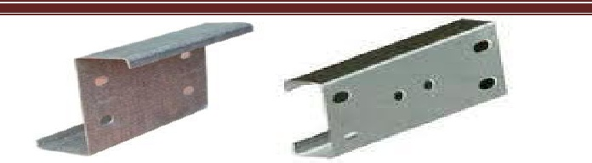
Purlins and Girts:
Purlins and girts shall be roll formed Z sections, 200 mm deep with 64 mm flanges shall have a16 mm stiffening lip formed at 45 to the flange. Purlins and girts shall be cold-formed "Z" sections with stiffened flanges. Flange stiffeners shall be sized to comply with the requirements of the latest edition of AISC .Purlin and girt flanges shall be unequal in width to allow for easier nesting during erection. They shall be pre punched at the factory to provide for field bolting to the rigid frames. They shall be simple or continuous span as required by design. Connection bolts will install through the webs, not flanges
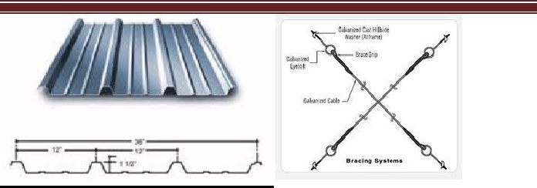

Eave Struts
Eave Struts shall be unequal flange cold-formed "C" sections. Eave struts are 200 mm deep with a 104 mm wide top flange, a 118 mm wide bottom flange, both is formed parallel to the roof slope. Each flange has a 24 mm stiffener lip.

Bracings
The Cable bracing is a primary member that ensures the stability of the building against forces in the longitudinal direction such as wind, cranes, and earthquakes. Diagonal bracing in the roof and sidewalls shall be used to remove longitudinal loads (wind, crane, etc.) from the structure. This bracing will be furnished to length and equipped with bevel washers and nuts at each end. It may consist of rods threaded each end or galvanized cable with suitable threaded end anchors.

SHEETING OR CLADDING
The sheets used in the construction of pre- engineered buildings are composed of the fallowing: Base metal of either Galvalume coated steel conforming to ASTM A 792 M grade 345B or aluminum conforming to ASTM B 209M .Galvalume coating is 55% Aluminum and about45% Zinc by weight. An exterior surface coating on painted sheets of 25 microns of epoxy primer with a highly durable polyester finish. An interior surface coating on painted sheets of 12 microns of epoxy primer and modified polyester or foam. The sheeting material is cold-rolled steel, high tensile 550 MPA yield stress, with hot dip metallic coating of Galvalume sheet.

ACCESSORIES

Anchor bolts:
Bolts used to anchor the structural members to the concrete floor, foundation or other support. This usually refers to the bolts at the bottom of all columns. Anchor bolts are manufactured with circular steel rods having threading portion at the top for bolting and bent up at the bottom for Foundation.
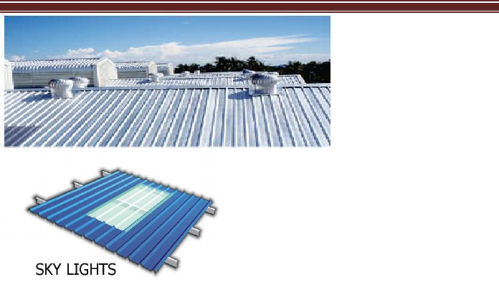
Turbo ventilators
A Turbo Ventilator is a free spinning roof ventilator that works on free wind energy. When there is a difference in thermal or wind pressure between the inside and outside of the building, the air is forced to move through the opening of the Turbo Ventilator in order to maintain an equilibrium condition. The benefits of using turbo ventilators are that it improves air circulation and cuts off the suffocation. Eco friendly turbo ventilator involves no operating cost, are free from maintenance and are has trouble free operations.
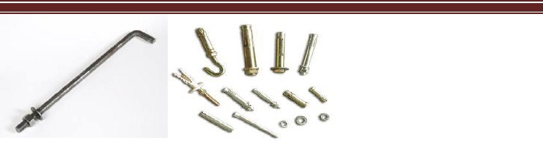

Sky lights (or) wall lights
Sky lights may consists of poly carbonate sheets which is translucent sheet that allows maximum light and minimum heat. High strength translucent panels are glass fiber reinforced polyester, high strength and may be either and it provides with an estimated light transmitting capacity of 60%. High strength translucent panels match standard panel profiles, are 1/16 thick, weigh 8ounces per square foot, and are white with a granulized top surface Insulated translucent panels are available in type 1, "R" panel and standing seam profiles only. Damper, Standard size is 3000 mm long with a throat opening of 300 mm.

Louvers
Standard Louvers shall have a 26 gauge galvanized steel frame, painted, with 26 gauge blades. Heavy Duty Louver frames shall be 18 gauge galvanized steel frame, painted, with 20 gauge blades. Both Standard and Heavy Duty louvers shall be self-framing and self flashing. They shall

Be equipped with adjustable or fixed blades as specified. Nominal sizes shall be 2-0" x 20" x 2'-0", 3'-0" x 3'-0" 4'-0" x 3'-0", and 3'-0" x 4'-0

Walking doors
Walk doors are generally 915 mm or 1830 mm wide x 2134 mm high made of 20 gauge electro galvanized steel with a core of polyurethane insulation. Door fixture is provided.

Aluminum windows
Designed for installation with wall panel, double slide, self flashing with pre-glazed clear glass and removable half insect screen. Standard size is 1 m x 1 m. multiple windows can be formed by joining the jamb fins together.

Roof curbs
Enclosure for ducts or other roof projections. These are 2 mm thick glass fiber reinforced plastic fitting roof panels and available in opening sizes 600 mm, 900 mm and 1200 mm square.

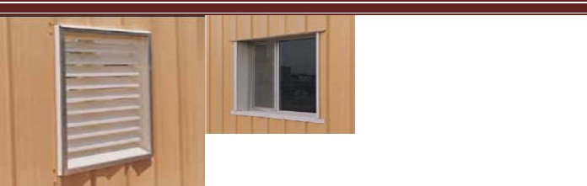
Fasteners
Standard fasteners shall be self drilling screws with metal and neoprene washers. All screws shall have hex heads and are zinc plated.

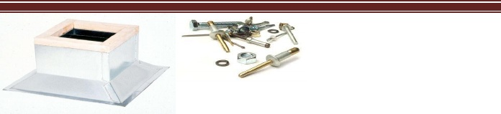

ADVANTAGES:
Reduction in Construction Time: Buildings are typically delivered in just a few weeks after approval of drawings. Foundation and anchor bolts are cast parallel with finished, ready for the site bolting. In India the use of PEB will reduce total construction time of the project by at least50%. This also allows faster occupancy and earlier realization of revenue.
Lower Cost: Due to the systems approach, there is a significant saving in design, manufacturing and on site erection cost. The secondary members and cladding nest together reducing transportation cost.
Flexibility of Expansion: Buildings can be easily expanded in length by adding additional bays. Also expansion in width and height is possible by pre designing for future expansion.
Larger Spans: Buildings can be supplied to around 80M clear spans.
Quality Control: As buildings are manufactured completely in the factory under controlled conditions the quality is assured.
Low Maintenance: Buildings are supplied with high quality paint systems for cladding and steel to suit ambient conditions at the site, which results in long durability and low maintenance costs.
Energy Efficient Roofing and Wall Systems: Buildings can be supplied with polyurethane insulated panels or fiberglass blankets insulation to achieve required U values.
Architectural Versatility: Building can be supplied with various types of fascias, canopies, and curved eaves and are designed to receive pre cast concrete wall panels, curtain walls, block walls and other wall systems.
Single Source Availability: As the complete building package is supplied by a single vendor, compatibility of all the building components and accessories is assured. This is one of the major benefits of the pre engineered building systems.

CONCLUSION
Steel is a preferred material for construction, due to its various advantages like quality, aesthetics, economy and environmental conditions. This concept can have lot of scope in India, which can actually fill up the critical shortage of housing, educational and health care institutions, airports, railway stations, industrial buildings & cold storages etc. Pre-engineered Metal building concept forms an unique position in the construction industry in view of their being ideally suited to the needs of modern Engineering Industry. It would be the only solution for large industrial enclosures having thermal and acoustical features. The major advantage of metal building is the high speed of design and construction for buildings of various categories.
REFERENCES
1.A explanatory handbook on proposed IS 875 (part3) Wind Loads on Buildings and structuresby Department of Civil Engineering IIT Roorkee

2. Design of Steel Structures by R.Sathish Kumar and A.R. Santhakumar

3. Design Concept of Pre Engineered Building by Syed Firoz, Sarath Chandra kumar, S.kanakamba rao International Journal of Engineering Research and Applications, vol2 pp 267-272.

4.Design Flexibility of steel by Rajesh Maheshwari, Head Technical Marketing (Coated Steel) atTata BlueScope Steel Limited.

5. Pre Engineered Steel Buildings a promising Future by Dr. Abhay Gupta, Vice President (Engineering) Era Building Systems Ltd.

6. Unicon Pre Engineered Buildings brochure
7. PEB a boon for Building Industry by Steel building systems India.

8. Fiberglass Wool Insulation for PEBs and Metal Roofs.

9. Design of Long span structures and Hangars by Amit Bharana ERA buildings ltd.

10. Pre Engineered for Success: Tracking Growth of PEB Steel buildings in India.

