**CIVIL ENGINEERING DEFECTS BEHIND UTTARAKHAND FLOOD CRISIS**

**D.M.SAINIS AND S.S.KAWALE**

K.D.K College of Engineering, Nandanwan, Nagpur

Department of Civil Engineering

**Abstract:** The topic Civil Engineering Defects Behind Uttarakhand Flood Crisis regards with the engineering faults which causing havoc. The main reasons behind the destruction are discussed in the following topic. The calamities such as landslides, flashfloods, excessive construction of hydroprojects, improper planning of locality, watersheds and deforestation are discussed in the topic. Since there are too many rivers in the state the number of irrigation schemes are enormous this resulting in the variation of the properties of the soil. The destruction caused huge amount of property and human loss.

**Keywords:** *Excess construction, landslides, flashfloods, improper planning, watershed, deforestation, destruction, soil, brittle.*

**Introduction**

The topic ‘CIVIL ENGINEERING DEFCTS BEHIND UTTARAKHAND FLOOD CRISIS’ covers all the defects causing the destruction in the state of Uttarakhand. This covers major faults as well as minor faults which are ignored, causing enormous amount of loss of public property and human life.

The rainfall in the state started from 12 June 2013. The information of heavy rainfall was given by Indian Metrological Department. The cloud bursted on 15 June 2013. Since then the destruction in the state started. The cloudburst resulted in flashfloods. The flashfloods destroyed many houses and roads in the state. The flooded rivers are Ganga, Yamuna, Mandakini, Bhagirathi, Alaknanda etc.

The cities such as Uttarkashi, Barkot, Tehri, Pauri, Hrishikesh, Rudraprayag, Srinagar, Gochar, Joshimath ,Badrinath, Kedarnath, Gangotri, Yamunotri, Chamoli etc. are affected by the flood. More than 4000 villages were affected by flood. According to state government, 147 bridges have been washed away completely in the state. More than 1,300 roads in different locations have suffered extensive damage blocking most of the places in four districts of Rudraprayag, Chamoli, Uttarkashi, Pithoragarh. More than 550 person died and more than 22,000 stranded and more than 330 person are missing.

The massive road rehabilitation programme has already been taken up by Border Road Organization (BRO).The BRO has already pressed 4,000 men into action at various areas with bulldozers and other equipments.

**CAUSES OF DESTRUCTION**

There are many types of causes of destruction of property and human life. But by Civil Engineering point of view there are six main reasons of the havoc caused they are:

1. Excess Construction
2. Improper planning
3. Deforestation
4. Landslides
5. Watersheds
6. Flashfloods
7. **Excess Construction**

The excess construction refers to excessive construction of dams and hydro electric power projects. This directly or indirectly have an effect on the soil. The types of soil available in the state of Uttarakhand which are susceptible to soil erosion. In the north, the soil ranges from gravel (debris from glaciers) to stiff clay. Brown [forest](http://www.britannica.com/EBchecked/topic/213461/forest) soil often shallow, gravelly, and rich in organic content is found further to the south. Some of the areas are characterized by soils that are coarse-textured, sandy to gravelly, highly porous, and largely infertile. In the extreme southeastern part of the state, the soils are mostly rich, clayey loams, mixed to varying degrees with fine sand and humus.

The excessive construction of dam which lead to diversion of the natural course of river, blasting to make tunnels and construction of roads and townships that result in deforestation. These factors increase the vulnerability of the mountainous regions to landslides.

Uttarakhand has a total installed hydro-electric power capacity of 3,426 Mw. Another 95 projects with a total capacity of 12,235 Mw are in various stages of development.

According to the data available with Uttarakhand Jal Vidyut Nigam Limited (UJVNL), the state government is developing 32 projects with a total capacity of 2,815 Mw, PSUs like NTPC and NHPC are developing 25 projects with a total capacity of 7,302 Mw and the private sector is working on 38 projects of 2,118 Mw capacity. Incidentally, Uttarakhand has the potential to produce 25-30,000 Mw of power.

There are 42 projects are commissioned and another 203 are underway. This caused adversely on soil resulting in brittleness. There are 54 proposed, 13 under construction and 16 commissioned hydro projects on river Ganga itself. Some of the commissioned projects are Pilangad, Tehri stage, Tapovan etc.

1. **Improper Planning**

Since Uttarakhand lies in hilly area, the area required for construction is very less. The tragedy in the state is named as ‘man made’. The**rampant development and poor disaster planning has exacerbated flood damage.** Projects like earthquakes, flood and landslide risk mitigation have been in cold storage despite being approved way back in 2007. Due to improper planning, projects are abandoned midway or are lying incomplete. The poor planning and worse implementation with respect to settlements, infrastructure and tourism is the another reason of the destruction.

The state of Uttarakhand lies in Seismic Zone 5 which is most prone to calamities such as Earthquakes etc. and still the construction is increasing rapidly. The first important factor is the unregistered and improper buildings that were build all around the mountains and rivers. Large townships have grown on, or too close to, river banks.

The Unplanned Construction of roads is also the serious cause. The road network across the state has also grown up rapidly since a decade. The road are constructed by breaking the hills across the state for tourism purpose. This caused internal vibrations in the hills. The stability of the slopes and the ground surfaces was done improperly. Some of the region has long been known for its poor road infrastructure, even in comparison with the other region of Uttarakhand, a story of neglect and backwardness that questions the logic of a new hill state. Now roads have certainly been built, especially along the yatra routes and linking major towns. But the roads are of poor quality, the road-cutting leaving already the normal rains, and proper measures for stabilization of the slopes are not taken. Unstable hillsides even more bare and unstable, prone to landslips even during Blasting and other such techniques are often used unscientifically and without due precautions, damaging not only hill slopes but also nearby habitations. Material from roadworks or other civil works such as in tunnels, dams etc are routinely simply dumped into the rivers flowing beneath, especially by private contractors while authorities are least bothered. This has significantly raised the river bed, making the rivers more prone to flooding even with a little additional or sudden rush of waters.

The growing road infrastructure, urban centers and their commercial facilities, and yatra tourism have all grown far beyond the carrying capacity of these fragile mountainous areas of Himalayas, or at least have not been planned and executed keeping this carrying capacity in mind.

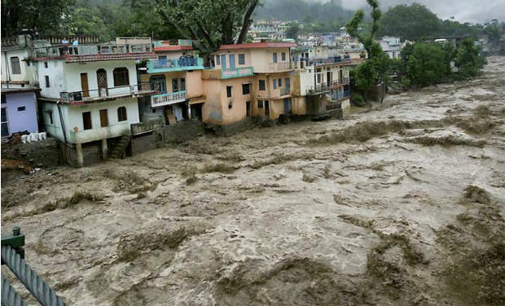

**Fig 1. Houses in Uttarakhand**

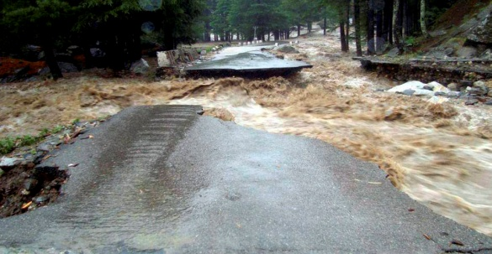

**Fig 2. Roads in Uttarakhand**

1. **Deforestation**

The deforestation is the major problem in the state of Uttarakhand. Large-scale deforestation for the construction of massive construction projects, especially large dams and hydro power projects, have weakened the ecosystem of the region and the accompanying effects of climate change is further galvanizing the destruction. The cutting of trees allowed soil erosion to happen and blocked the path of water. The deforestation is going on over longer period of time.

Deforestation as a commercial activity began during the British Empire and has continued unabated after independence. While official estimates say forest cover has increased in the Himalaya, a number of credible independent studies have found significant discrepancies in this claim. The fact is that forests have been diverted for a host of land use activities such as agriculture, human settlements and urbanization. Massive infrastructure development such as hydropower construction and road building has taken place. The high rate of deforestation had gave rise to Global Warming causing in uneven rainfall.

Vegetative cover slows the speed of falling rain and prevents soil erosion and gully formation the precursors to landslides and floods. Dense vegetation, by evapotranspiration, also stops nearly 30-40 per cent of rainwater from falling to the ground, thereby significantly reducing run-off. Besides holding the soil together, forests and soil soak water from the rain, release it slowly and prevent water flowing as run-off. So, deforestation brings about slope destabilisation, landslides and floods. Given that the Himalayan range is geologically young and still rising, it makes the area vulnerable to erosion and instability. Therefore, it is all the more necessary to take land use change more seriously.

There is mounting evidence that global warming is fast catching up with the Himalaya. In a recent study, we reported that Himalayan ecosystems have experienced faster rates of warming in the last 100 years and more than the European Alps or other mountain ranges of the world. In such a scenario, we expect faster melting of glaciers causing higher water discharges in the Himalayan rivers.

1. **Landslides**

The landslide is the gravitational movement of a mass of rock, earth or debris down a slope. The landslides are hazardous form of calamity. The Uttarakhand is highly disaster prone area. The enormous rate of deforestation resulted in loosening of soil. Since there are many hydro projects the water level is always on the higher side. This resulting in the saturation of sloping material forming debris. The type of landslide occurred in the state of Uttarakhand was debris landslide. The debris slide is caused by the saturation of thickly vegetated slopes which results in an incoherent mixture of broken timber, smaller vegetation and other debris. The debris slide is usually a cause of lower cohesion. Due to the fragile ecosystem the landslides in the state of Uttarakhand are frequent.

The landslides caused by the instability of the slopes. Frequent blasting of detonetors for the construction of roads has caused the vibrations in the hill slopes. Resulting in the cracks in the slopes. While construction of road the instability of soil was not taken into account. The slopes are just stable under dry conditions and on water saturation, the slopes become unstable. The landslides in the state are also caused due to the pore water pressure due to high water levels. The landslides caused by the change of gradient. A combination of factors such as degraded forest cover, change of moderate debris-laden slopes into near vertical slopes during road widening and building construction without adequate and appropriate engineering measures made the slopes vulnerable to the onslaught of torrential rainfall in the region.

In the urban clusters obstruction of natural drainage was responsible for slope destabilization and diversion of the debris-laden waters into the habitation areas. The unscientific urban development speaks volumes about the poor governance and lack of urban development policy. The landslides had caused heavy loss of human life and property.

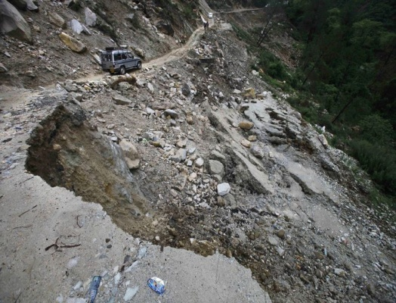

**Fig 3. Landslides in Badrinath**

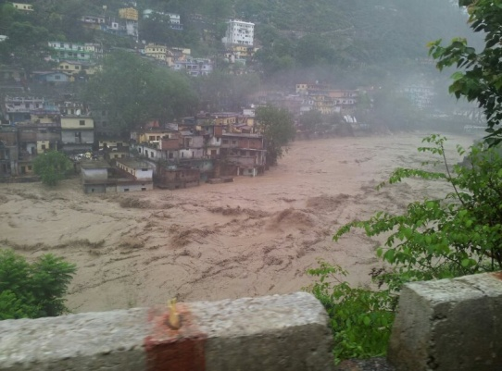

**Fig 4. Flashfloods in Rambada**

**Fig 4. Flashflood in Rambada**

1. **Watersheds**

A watershed is a landform defined by high point and ridge line that descend into lower elevations and valleys, and as a result precipitation is carried as runoff from the area towards one focused output point. Land elevation defines watershed which is easier to see in mountain regions, but much more difficult to perceive in the plains and in low rolling hills. Several smaller watersheds are usually located within larger ones, and are termed as sub-watersheds. In mountain areas a watershed covers usually small area, while in plains a single watershed can cover several thousand of square kilometer. The watersheds are formed by the melting of glaciers in the mountainous regions. The defining feature is that precipitation in watershed finds its way into the soils, ground water, springs and streams and ultimately into larger channel downstream.

In mountainous regions watersheds are defined by unique blend of climate, geology, hydrology, soils vegetation etc. Minerals from weathering of rocks, from the decay of vegetation and from groundwater, create localized but sometimes large and dramatic landforms, which characterize the landscape of different watersheds. The watershed sustain aquatic biota.

Uttarakhand State is well endowed with forest and water resources. More than 12,000 glaciers and 8 major river catchments act as the lifeline for the entire hydrological system of Indo-Gangetic plain. The Himalayan Watersheds are under constant threat of mass wasting and erosion caused by depletion of forest cover, unscientific agronomic practices, hydrologic imbalances and natural calamities. There are 8 main watersheds, 116 sub-watersheds and 1110 micro-watersheds in the state of Uttarakhand. Out of which 50% are untreated.

The watersheds in the state are not properly managed. There are frequent droughts in the State as mainstays of agriculture in the hills are mainly rains. Each year many districts face drought like conditions which result in failure of the crops. When drought like conditions prevails most of the remotely located springs in the hills start drying up or the discharge is reduced to such a level that they are unable to fulfill the basic requirement of the residents. There is also a drastic reduction in the flow of major rivers in the State.

The watershed management has become very important in the state. The proper management of watershed will results in the conservation of soil and water harvesting. The vegetation in the watershed catchment has cut down which caused the ecological imbalance. This has also caused soil erosion. The infiltration rate has reduced significantly. This has caused the swelling of rivers and streams and ultimately to the failure of the watershed.

1. **Flashfloods**

The flashfloods are the floods with very high discharge. Flash floods can occur under several types of conditions. Flash flooding occurs when precipitation falls rapidly on saturated soil or dry soil that has poor absorption ability. The runoff collects in gullies and streams and, as they join to form larger volumes, often forms a fast flowing front of water and debris. Flash floods most often occur in normally dry areas that have recently received precipitation, but may be seen anywhere downstream from the source of the precipitation, even many miles from the source. In areas on or near [volcanoes](http://en.wikipedia.org/wiki/Volcano), flash floods have also occurred after eruptions, when [glaciers](http://en.wikipedia.org/wiki/Glacier) have been melted by the intense heat.

Flash floods are known to occur in the highest mountain ranges of the [United States](http://en.wikipedia.org/wiki/United_States) and are also common in the arid plains of southwestern United States. Flash flooding can also be caused by extensive rainfall released by [hurricanes](http://en.wikipedia.org/wiki/Tropical_cyclone) and other [tropical storms](http://en.wikipedia.org/wiki/Tropical_storm), as well as the sudden thawing effect of [ice dams](http://en.wikipedia.org/wiki/Ice_dam). Human activities can also cause flash floods to occur. When [dams](http://en.wikipedia.org/wiki/Dams), constructed for hydro-electricity, have failed, large quantities of water can be released and can destroy everything within its path.

The flashflood caused in the state by cloud bursting. The discharge of the flood was 3,511 cumec and further increased to 5,097 cumec as the rainfall increased. The flashflood caused due to the environmental disequilibrium resulting in havoc. The discharge accumulates due the breaking of dams.

**CONCLUSION**

The destruction caused in the state of Uttarakhand is due to heavy road construction, poor planning of houses resulting in heavy damage to the houses.

The destruction was also due to the enormous amount of construction of dams, reservoirs etc. due to which the soil turned brittle and lost its cohesion to a very large extent. The faulty engineering techniques ultimately causing instability of the slopes. Large amount of deforestation causing Global Warming and environmental imbalance. Environmental causes such as cloud bursting is also a major cause of destruction.

This concludes that destruction caused in the state of Uttarakhand is the man-made disaster “**Blind Development Race Instead of Planned Scientific Development has caused Destruction”.**

**REFRENCES**

1. Raj Vir Singh “watershed planning and management”, Yash Publishing House, 2000.
2. Engineering and General Geology by Prabin singh
3. [www.jagranjosh.com](http://www.jagranjosh.com)
4. [www.thehindu.com](http://www.thehindu.com)
5. [www.iwmp-uttarakhand.com](http://www.iwmp-uttarakhand.com)