REPORT
ON

ESTIMATION OF SCOUR DEPTH AROUND THE DIFFERENT PIER USING INTERNAL OPENINGS

Submitted by-

Brijesh Bagde Riya Mandal Sanket Dangore Nikhil Shrikhande
B.E. 8th Sem. B.E. 8th Sem. B.E. 8th Sem. B.E. 8th Sem.
CIVIL ENGG. CIVIL ENGG. CIVIL ENGG. CIVIL ENGG.
KDKCE KDKCE KDKCE KDKCE

Guide
Prof. Mrs. N. R. Dhamge
Asst. professor

Date of Presentation – 14/03/2014



DEPARTMENT OF CIVIL ENGINEERING
K.D.K. COLLEGE OF ENGINEEING, NAGPUR
2013-2014

AIM
To observed scour reduction around pier using internal opening through the pier.
INTRODUCTION
Scour around solid pier was studied. In this paper scour around bridge pier provided with internal openings were experimentally studied. Result ensure that the construction openings through the pier reduces more than happens in the solid ones. Scour is the hole left when sediment is washed away from bottom of river. Scouring is defined as erosion of stream bed around any obstruction in flow field. “Man who overlooks the water under bridge will find the bridge underwater”. This anonymous citation highlights the detrimental effects that river flow can have on the stability of piers and abutments that support a bridge founded in river. The main cause of concern in stability of bridges founded in river-beds is the lowering of river-bed level caused by river flow around bridge elements such as piers, abutments and spur dikes and is termed ‘local scour’. An accurate estimation of scour depth below stream-bed during design is important since this determines the foundation levels of the bridge elements such as pier, abutment, guide bank, spur, groyene, etc.
OBJECTIVES
- To determine and study the scour depth around circular bridge pier, nature of the depth, sand particles distribution during scouring and deposition.
- Estimation of scour depth also around bridge pier placed in river, and is recommended for design by the IRC and Indian railway.
- Evaluate existing and proposed bridge for susceptible to scour related to failure.
- To determine the foundation level of bridge elements such as pier abutment, bank, spur.
- Considerably cost would be saved in the construction of bridge foundation if the more. Scour depth is realistically estimated during design.
- To find the range of be material size when lacey’s equation applicable apart from the part that the lacey’s equation does not cover other parameter except discharge and size of bed material.
METHODOLOGY
- SIEVE ANALYSIS
Sieve analysis is carried out for 2000gm of sand.
- DETERMINATION OF SCOUR DEPTH
- The bed sediment is gradually saturated to release air voids.
- Now the flume is gradually filled with water by using the hose until an initial tail water depth is reached.
- Then the pump motor is turned on and valve is released gradually to obtain the required discharge.
- The weir at the end of the flume was adjusted to maintain the water depth at 20cms.
- Water flow is recirculated till an equilibrium scour hole is practically achieved.
- The Flume is emptied gradually at each run to avoid the effect of sudden lowering of flow depth on the performed scour hole.
- The levels of scour hole are measured around the pier in both longitudinal and transversal directions.
- Then the difference between the readings before and after the run setup provides the change in elevation which will give the depth of scour.
- TO DETERMINE THE DISCHARGE
- We take initial depth h1.
- Start the pump for 30mints.
Continues flowing the water for constant
depth h2 and find the height i.e. h=h1-h2

- Time (t) recorded from initial depth of water to constant depth of water in sump (water depth is decrease and constant at one depth).
- measured the area of sump A=LxB
- Actual discharge Qact = V/ t
- Volume (V) = Axh = 1.128*0.087 = 0.098136m²
Qact = 0.098136/78 = 1.26x10⁻³
Actual discharge (Qact) = 0.00126 m³/sec
- TO DETERMINE SCOUR DEPTH AROUND PIER:
- The bed sediment is gradually saturated to release air voids.
- Fill the flume with the fine sand to a depth of 17cm & place the coarse aggregate next to baffle wall to insure laminar flow.
- Place the pier according to cases & note down bed level reading also called as initial reading for that case.
- Start the pump, regulate the discharge & allow the water to flow over the notch then measure head over the notch & allow water to flow for minimum 30 mints.
- After 30 mints stop the pump, allow water to drain completely & carefully measure the depth of sour. Note down the reading.
- Plot the graph accordingly for scour depth & also draw counter.
- THE FOLLOWING CASES WERE TAKEN INTO CONSIDERATION WHILE OBSERVING THE SCOUR AROUND THE BRIDGE PIER
- Case 1: Pier of size 10.5cm:
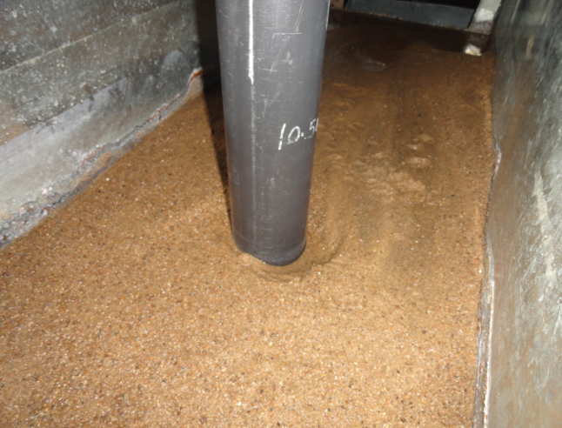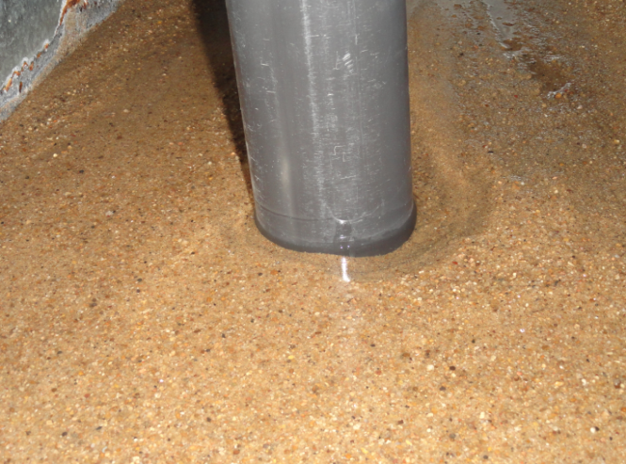
Fig no 2 scour around pier of 10.5cm dia.
- Case 2: Pier of size 7.5cm
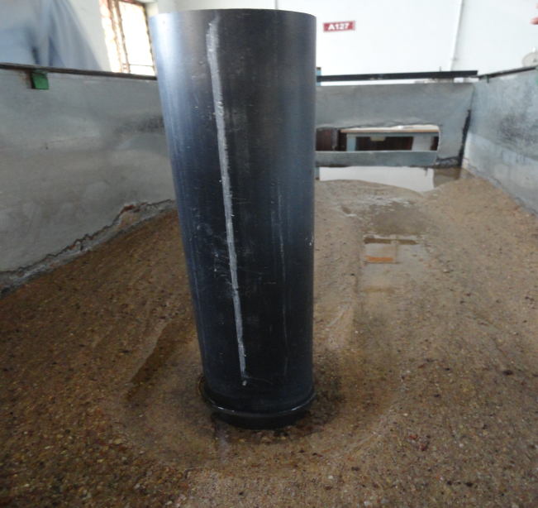
Fig no 3. Scour around pier of 7.5cm dia.
- Comparison of scour depth for case-1 and case-2
- Case-1
- In case-1 discharge is calculated as 0.00126m3/sec.
- The scour depth around the pier is found to be 2.7cm from bed level.
- The large no granular size particle is deposited near the pier.
- Case -2
- In case-2 discharge is calculated as 0.00126m3/sec.
- The scour depth around the pier is found to be 3.8cm from bed level.
- The large no. of finer size particle is deposited near the pier.

OPENING PROVIDED
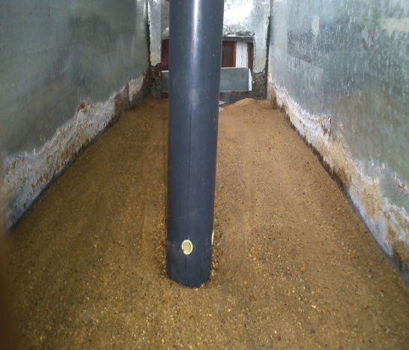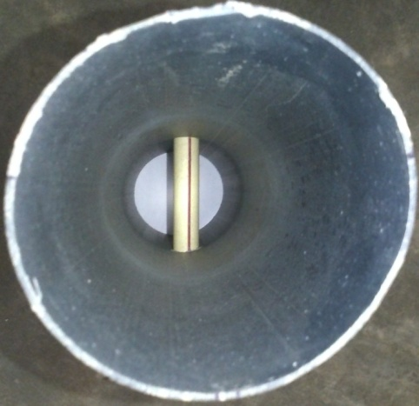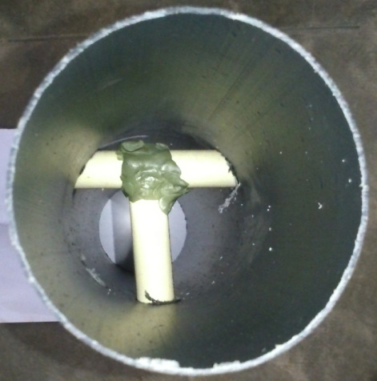
PIER OPENING STRIGHT OPENING T-SHAPE OPENING
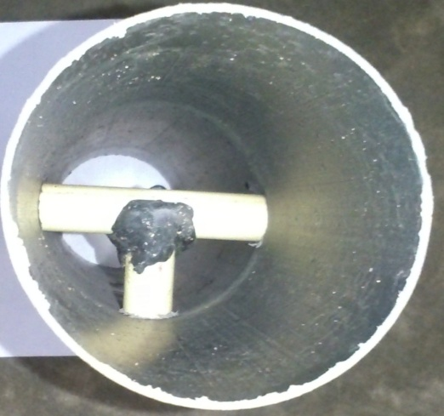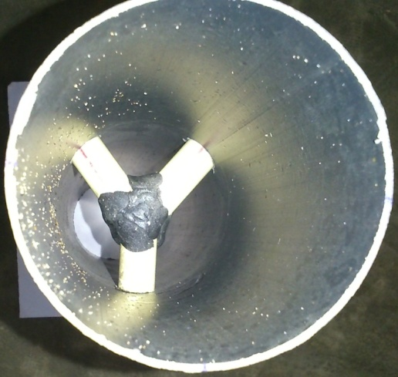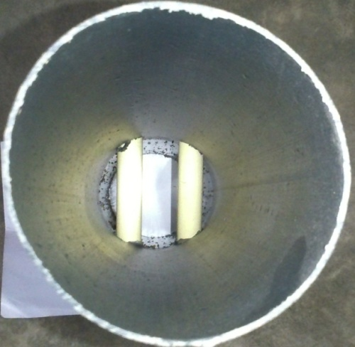
T-SHAPE OPENING Y-SHAPE OPENING DOUBLE STRIGHT OPENING
IMAGES RELATED TO INTERNAL OPENINGS
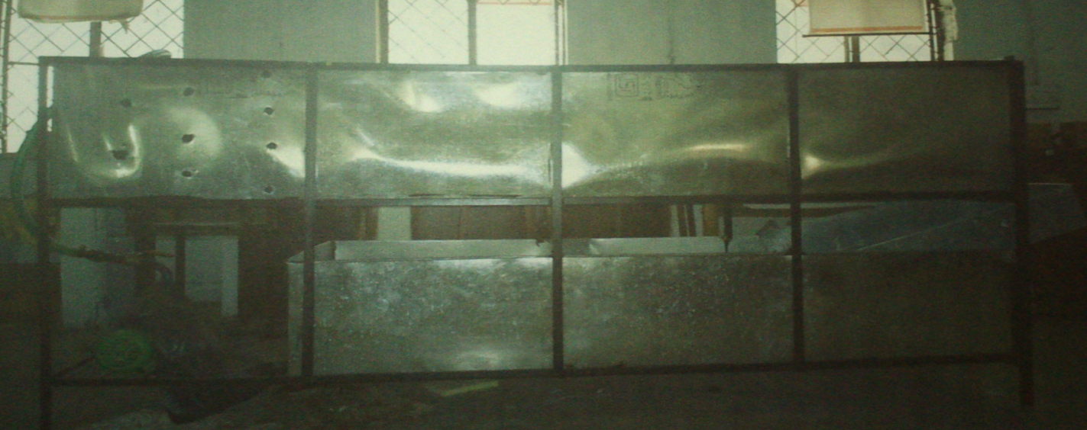

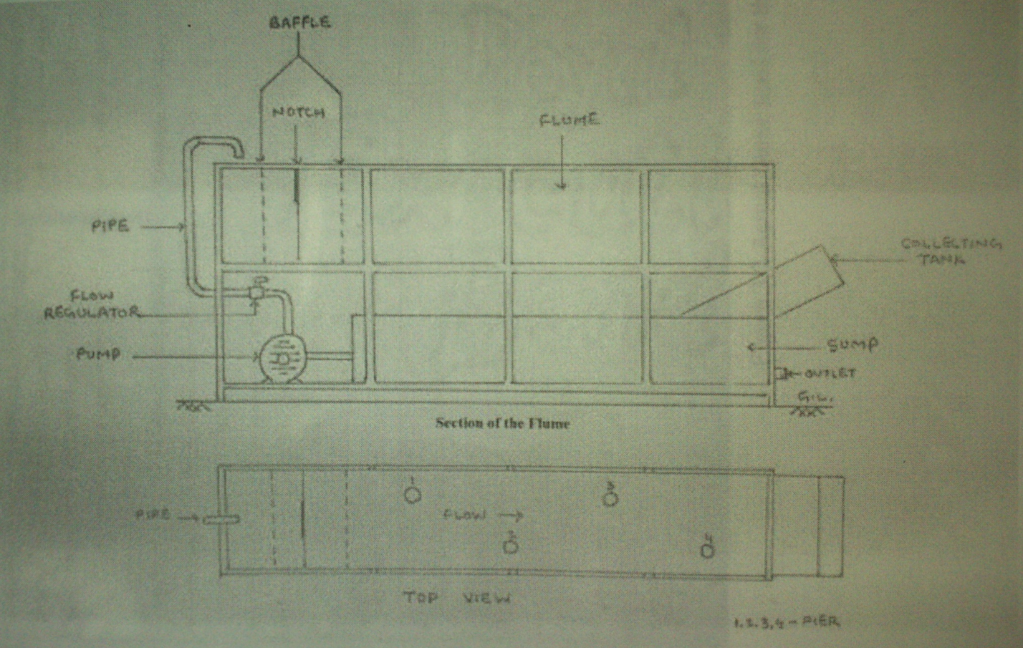
Actual flume used for the project

EXPERIMENTAL SETUP
Size of Flume: The experiment in this project is conducted in circulating flume. The flume had a length of 8ft. width of 2ft.,and depth 5ft.working section of the form of a recess, which is filled with sand at a uniform thickness of 16cm.The sand bed consist of 5.5ft.long and 2ft.wide.
Sump: the sump measures about 6ft. long, 2ft. wide, and 1.75 ft. depth. The water from the sump was pumped out and was circulated over the flume throughout the entire experiment.
RFESULT
SIEVE ANALYSIS
Sieve analysis of 2000gm sand of Kanhan River is done in soil mechanics lab. It is done using sieve shaker machine and different Sieve analysis of 2000gm sand of Kanhan River is done in soil mechanics lab. It is done using sieve shaker machine and different type of sieve size for 10mint. From the analysis it is found that sand used in this project is Fine sand
By using different opening in pier we get less amount of scour.
REFRANCES
- Abd El-Razek M, Abd El- Motaleb M, and Bayoumy M, “Scour reduction around bridge piers using internal opening through piers”.pp,241-248
- Kothyari U. C. June 2007, “Indian practice on estimation of scour around bridge piers—A comment Sadhana, Vol. 32, Part 3, pp. 187–197.
- M.S. Guney, A.O. Aksoy and G. Bombar “Experimental Study of Local Scour Versus Time Around Circular Bridge Pier” 6th International Advanced Technologies Symposium (IATS’11), 16-18 May 2011, Elazığ, Turkey pp 135to 137
- Emanuele Defanti, Giancarlo Di Pasquale1 & Davide Poggi “ An experimental studies of scour at bridge piers: collars as a countermeasure” Dipartimento di Idraulica, Trasporti ed Infrastrutture Civili, Politecnico di Torino, Torino, ITALY
- Kothyari U. C. 2003 Bridge pier scour in gravel – cobble and cohesive bed rivers, Report submitted to the IRC – sub-committee to review the aspects of scour around bridge foundations
- N. Talebbeydokhti and M. Asadi Aghbolaghi “Investigation of scour depth at bridge Piers using bri-stars model” April 30, 2005; final revised from November 5, 2005.
- Dr. B.C. Punmia 2005, “Soil mechanics and foundation”, page no. 41-43
- R W P May, J C Ackers, & A M Kirby, “Manual on scour at bridge and other hydraulics structure” criteria c551 2002.

