**K.D.K. COLLEGE OF ENGINEERING, NAGPUR**  
**DEPARTMENT OF CIVIL ENGINEERING**

2013-2014

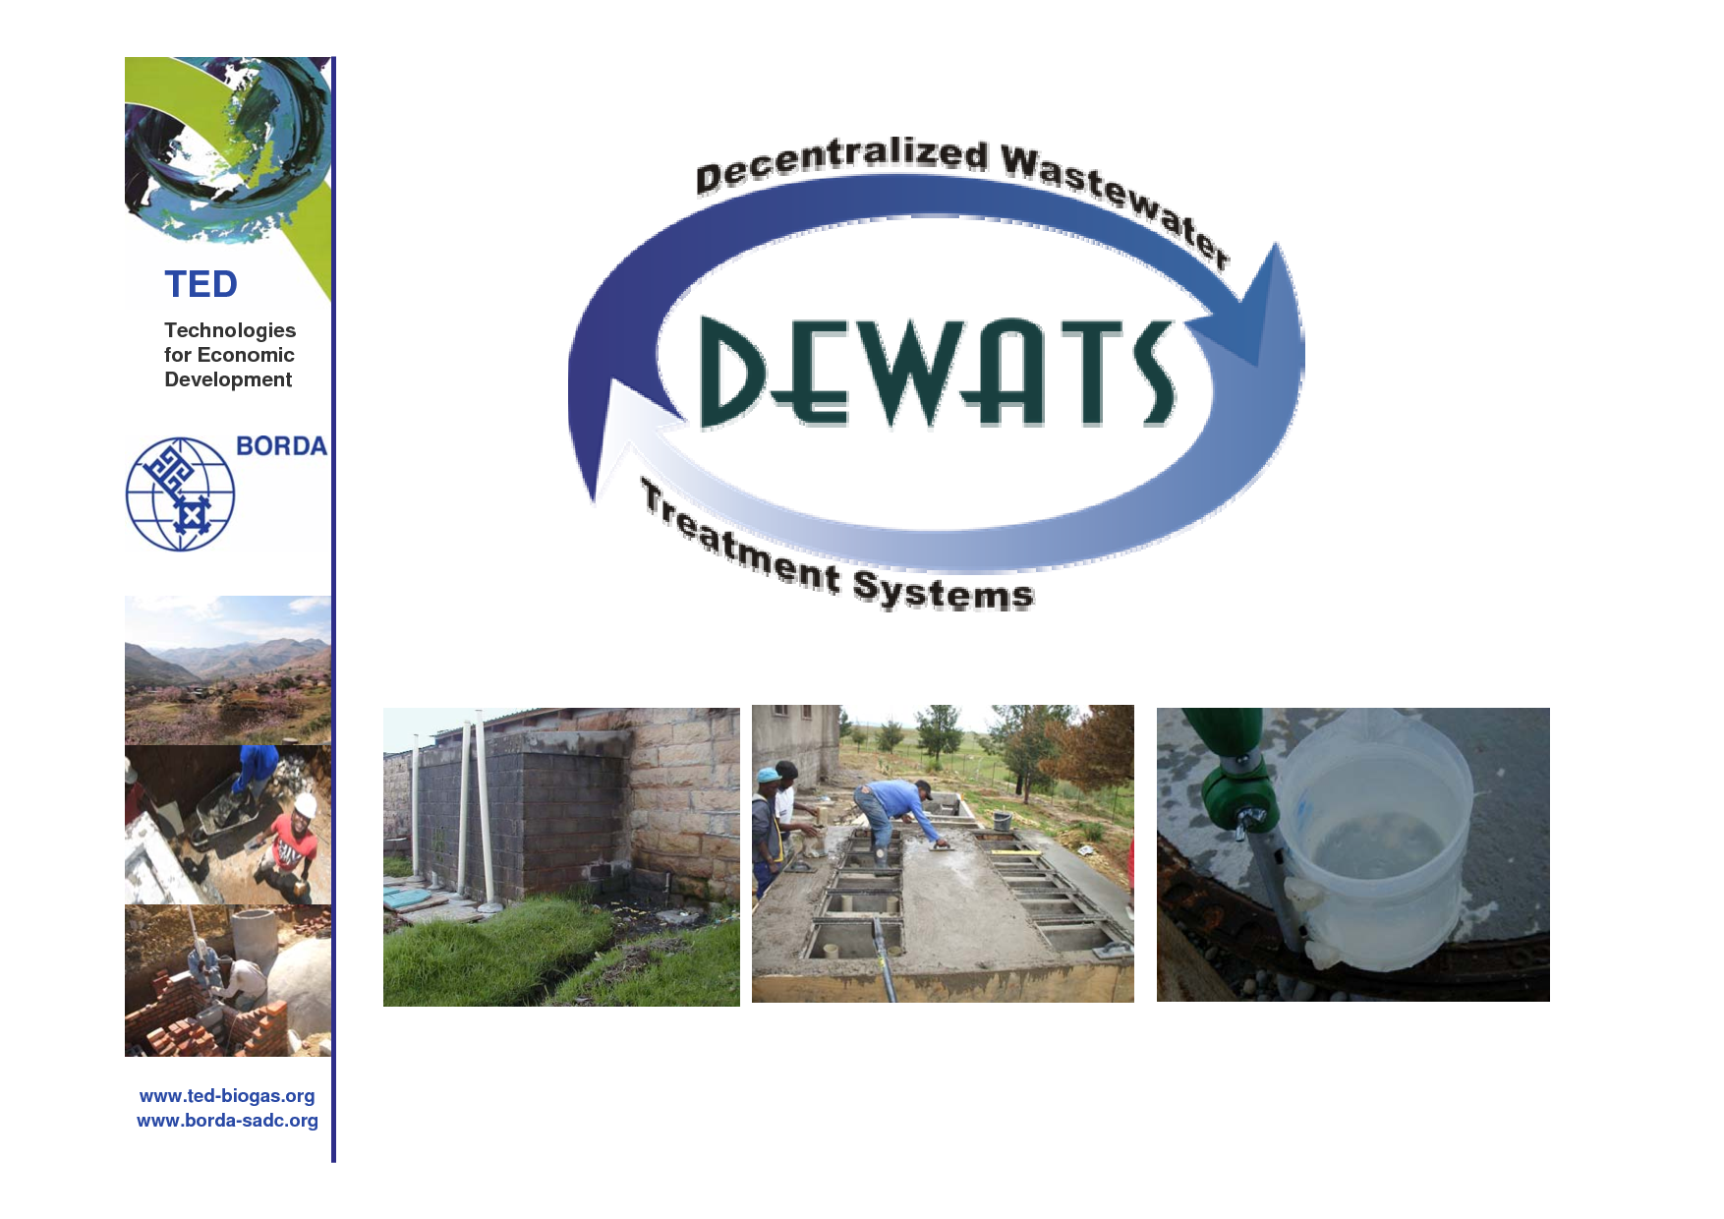

Presented by

Miss. Radhika P. Boargaonkar Mr. Akshay Badge

VIII Sem (civil engg.) VIII Sem (civil engg.)

**ABSTRACT**

This paper demonstrates that the use of decentralized systems such as DEWATS (Decentralized Wastewater Treatment Systems) approach to wastewater treatment have had more success and there is a need to make wastewater treatment people-centric and effective through the “waste to resource”- approach. The paper explores a few initiatives implemented which uses natural methods DEWATS for use in Sewage Treatment Plants (STPs) with household, urban and rural effluents. Such decentralized initiatives succeeded after broad issues of funding were taken into consideration. There is a need for capacity building of community institutions and participation by rural bodies in order to become aware, scale up and improvise these innovative approaches in the future at rural centers.

Key words: DEWATS systems, “waste to resource”, bio-remediation.

**INTRODUCTION**

Decentralized Wastewater Treatment Systems (DEWATS) is rather a technical approach than merely a technology package. Generically, DEWATS are locally organized and people-driven systems that typically consist of a settler, anaerobic baffled septic tank , filter bed of gravel, sand, plantation-beds and a pond. The open pond or the polishing tank stores the remedied water and keeps it available for re-use. The system operates without mechanical means and sewage flows by gravity through thedifferent components of the system. Up to 1,000 cubic metre of domestic and non-toxic industrial sewage can be treated by this system (TencyBaetens, 2004). DEWATS applications are based on the principle of low-maintenance since most important parts of the system work without electrical energy inputs and cannot be switched off intentionally (BORDA). DEWATS applications provide state-of-the-art-technology at affordable prices because all of the materials used for construction are locally available. DEWATS approach is an effective, efficient and affordable wastewater treatment solution for not only small and medium sized enterprises (SME) but also for the un-served (rural and urban) households in developing countries, especially South Asia. For instance, DEWATS can operate in individual households, at the neighborhood level and even in small and big factories not connected to sewage lines. DEWATS can also treat municipal waste. The recycled water is used for irrigation or for growing plants and is absolutely safe for human use. In certain urban areas the processed water is taken for use as flush- water in toilets.

Decentralized Wastewater Treatment Systems (DEWATS) is rather a technical approach than merely a technology package. Generically, DEWATS are locally organized and people-driven systems that typically consist of a settler, anaerobic baffled septic tank , filter bed of gravel, sand, plantation-beds and a pond.

The decentralized wastewater treatment system (DEWATS) is a simple design, non-dependent on energy, reliable, long-lasting, tolerant towards inflow fluctuation, and low in costs. It can treat organic wastewater from domestic and industrial sources. DEWATS is based on different natural water treatment techniques which are combined according to requirements such as the characteristics of wastewater, desired effluent quality and technical specifications.

The team of highly experienced engineers based at the offices in Bangalore (Karnataka) and Nagpur (Maharashtra) provide technical support for DEWATS design and implementation. The CDD Network has so far implemented more than 350 DEWATS projects in South Asia.

**AIM OF STUDY**

* **DEWATS structure, design, analysis of whole design.**
* **DEWATS efficiency, uses, working, characteristics, importance in today’s life.**
* **Important aim of it is to aware people about the system.**

**WORKING OF DEWATS**

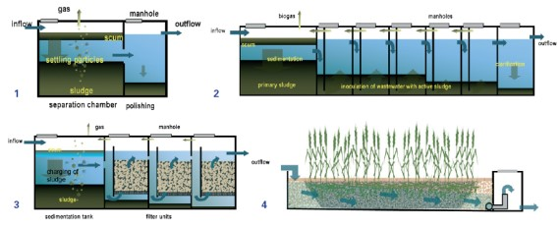

**Main DEWATS modules for physical and biological wastewater treatment**

**1. Settler**

**2.Anaerobic Baffled Reactor**

**3.Anaerobic Filter**

**4.Planted Gravel Filter**

**WORKING OF EACH FILTER OF DEWATS**



**The need for decentralized initiatives in wastewater treatment**

In India, many rural and urban households do not have access to latrines and defecate in the open. Some households use community latrines and others use shared latrines. But still a large number of households do not have access to a drainage network and are connected to natural surface drains. The assessment of open- defecation takes a different dimension which is not discussed in this paper. Thus it is evident that a large amount of human excreta generated is unsafely disposed. This imposes significant effect on public health, working- man days and environmental costs resulting in loss in National revenues. Impacts of poor sanitation are especially significant for the rural and urban poor, women, children and the elderly. Inadequate and un-safe discharge of untreated domestic/ municipal wastewater has resulted in contamination of 75 % of all surface water i.e at the rivers, ponds and lakes across India. The Millennium Development Goals (MDGs) enjoin upon the signatory nations to extend access to improved sanitation to at least half the population by 2015, and 100% access by 2025. Thiscalls for providing improved sanitation,and with facilities in public places at both rural and urban habitats also make the spaces free of open-defecation. Baffled Septic Tank Multi- Baffled Septic Tank with upflows Multi- Baffled Filter Reactor with upflows Planted filters with cross-flows of water.

Main DEWATS componentsThe quantity of wastewater is increasing in Rural-India because ofthe reasons as below:

i) Rapid mechanization with the use of piped water supply , continuously widening the gap between waste water generation and its process and treatmentii) Rural electrification is on the rise and with semi-urbanization of rural households. iii) Inadequate financial resources and capacity for infrastructure required for treating wastewater through a centralized approach.Specifically in India, domestic wastewater, including sewage that is often not even collected, is a major source of pollution of surface water. This contributes to contamination of groundwater which is an important or only source of drinking water for many rural and peri-urban areas. In addition, the economies of scale required for using conventional technologies would not be achieved in all settlements for various reasons, including: i) different climatic conditions; ii) topography; iii) geological conditions and water tables; iv) levels of livelihood and v) population densities and size of settlements.In selected locations, small-scale decentralized plants are also found frequently at community level. Numerous initiatives have been developed, in particular, as a result of the unbearable and poor waste- water treatment. Such initiatives have been taken up at small- city levelsimilar to rural conditions and have yielded satisfactory results. The waste water processed is

considered for reuse for local landscaping and also for irrigating agricultural fields.

**About DEWATS**

• DEWATS applications provide treatment for both, domestic and industrial sources

• DEWATS applications provide treatment for organic wastewater flows from 1-1000 m3per day

• DEWATS applications are reliable, long lasting and tolerant towards inflow fluctuation

• DEWATS applications do not need sophisticated maintenance Without considering facilities for

necessary chemical pre-treatment of wastewater from industries,

**DEWATS applications are based on four basic technical treatment modules which are combined according to demand:**

• Primary treatment: sedimentation and floatation

• Secondary anaerobic treatment in fixed-bed reactors: baffled upstream reactors or anaerobic filters

• Tertiary aerobic treatment in sub-surface flow filters

• Tertiary aerobic treatment in polishing ponds

DEWATS applications are designed and dimensioned in such a way

that treated water meets requirements stipulated in environmental laws and regulations.

DEWATS stands for “Decentralized Wastewater Treatment Systems”. DEWATS is rather a

technical approach than merely a technology package.

DEWATS applications are based on the principle of low-maintenance since most important parts of the system work without technical energy inputs and cannot be switched off intentionally.

DEWATS applications provide stateof-the-art-technology at affordable prices because all of the materials used for construction are locally available.

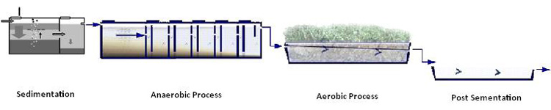

**THE CHALLENGE**

The demand for reliable, efficient and low-cost wastewater treatment systems is increasing around the world, especially in densely populated urban regions. In these areas, adequate wastewater treatment systems often do not exist and uncontrolled discharge of wastewater endangers health and pollutes local water resources.

Many governments have passed new environmental regulations stipulating that dischargers of wastewater, such as small and medium enterprises and housing estates, will be held responsible for wastewater pollution. Therefore these entities should treat wastewater adequately on-site before it is discharged or released into the environment.

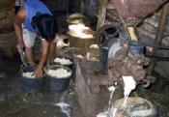

**Many SME are not able to pay high investment and maintenance costs required for sophisticated wastewater treatment systems**.

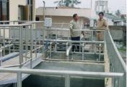

**Maintenance of sophisticated wastewater treatment systems requires high-skilled personnel**.

**THE DEMAND**

For many small and medium enterprises and housing estates, conventional wastewater treatment systems are too technically sophisticated and costly. These conventional systems often require high energy inputs for operation and rely on extensive maintenance services to ensure continuous operation.

For these potential clients, BORDA and its network of partner organisations started in 1994 to develop reliable and cost-efficient wastewater treatment systems which efficiently treat non-toxic organic wastewater according to environmental standards. Efforts to standardize main components of the DEWATS approach, such as a multi-stakeholder approach, modular design of systems, project planning, implementation and quality control have resulted in a significant increase of implementation capacity and dissemination of technical know-how.

Today, more than 1000 stakeholders from the private sector, governments and NGOs have been trained by the BORDA-Network to facilitate the dissemination, implementation and maintenance of DEWATS systems. This has resulted in the sustainable operation of more than 250 DEWATS plants. The success of DEWATS has fostered partnerships with numerous government ministries, municipalities and international donor agencies to improve capacities and increase technical implementations.

[**DEWATS ensures state of the art treatment results at an affordable cost, with low maintenance and limited space requirements.**](http://www.borda-sea.org/typo3/show_item.php?table=%2Fhome%2Fstrato%2Fwww%2Fbo%2Fwww.borda.de%2Fhtdocs%2Ftypo3%2Ffileadmin%2Fborda-net%2FBNS_Services%2FDEWATS%2FDemand1.jpg)

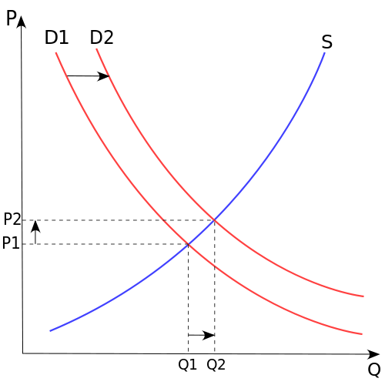 P - price

* Q - quantity of good
* S - supply
* D - demand

**USES OF DEWATS**

**DEWATS FOR HOSPITALS**

**Characteristics**  
• 250 beds with outpatient department  
• untreated wastewater discharge into nearby stream  
• complaints of neighbouring communities  
• limited funds  
• limited technical skills of staff  
• sufficient space

**Technical Solution**  
• Treatment system for 150 m3 wastewater/day  
• Sedimentation + anaerobic filter + horizontal sandfilter + purification pond  
• Pumping chamber after anaerobic filter  
• Total construction cost: $ 50.0000  
• Training of maintenance staff and 1 year guarantee

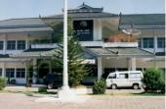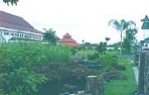

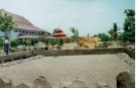

**DEWATS FOR AGROINDUSTRIES**

**Characteristics**  
• More than 100 cattle slaughtered per day  
• Extreme fluctuation of wastewater composition  
• extremely high organic load  
• limited space for construction near stream  
• unreliable responsibility and maintenance

**Technical Solution**  
Separation of wastewater components:• De-watering, sedimentation & floatation  
Treatment system components:  
• Screening  
• Sedimentation  
• Composting  
• fully-mixed digestion in biogas reactor  
• Anaerobic filter

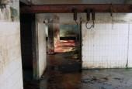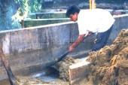

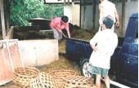

**DEWATS FOR COMMUNITIES**

**Characteristics**  
• Open waste water lagoon within community  
• 6 public toilets/6 bathrooms for 500 people  
• Unwillingness of landlords to upgrade sanitation infrastructure  
• Willingness to provide lagoon space  
• Willingness of people to pay for use of proper sanitation infrastructure  
• People willing to manage sanitation infrastructure

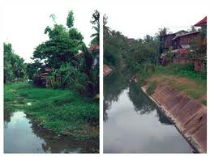**Technical Solution**  
• Fully mixed digester (fixed dome biogas plant)  
• Baffled reactor  
• Landscaping  
• rehabilitation of WW ditches  
• MOU between NGO and CBO regarding maintenance of Sanitation/DEWATS infrastructure.

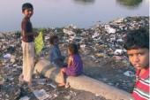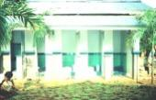

**BENEFITS OF DEWATS**

• Establishment of multi-stakeholder networks to combat water pollution

• Increases implementation capacity on various levels

• Provides treatment for both, domestic and industrial wastewater at affordable price

• Fulfillment of discharge standards and compliance with environmental laws

• Wastewater pollution reduction by up to 90% from pre-DEWATS levels.

• Provides treatment for wastewater flows up to 1000 m3 / day

• Reliable and long lasting applications

• Tolerant towards inflow and load fluctuation

• Materials/ inputs used for construction are locally available

• Minimal maintenance and long de-sludging intervals

• Low operation and maintenance costs

• Resource efficiency and non-dependence on energy

• Resource recovery through wastewater re-use and biogas generation

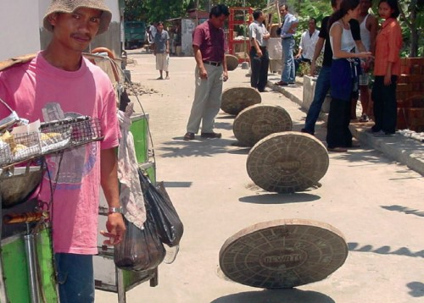

**PROS & CONS OF DEWATS**

|  |  |  |  |  |
| --- | --- | --- | --- | --- |
| **type** | **kind of**  **treatment** | **used for type**  **of wastewater** | **Advantages** | **disadvantages** |
| **septic tank** | sedimentation,sludgestabilisation | wastewater of  settleable solids,  especially domestic | simple, durable, little space because of being underground | low treatment efficiency |
| **Imhoff**  **tank** | sedimentation,sludge  stabilisation | wastewater of settleable solids,  especially domestic | durable, little space  because of being  underground, odourlesseffluent | less simple than septic tank, needs very regulardesludging |
| **anaerobic**  **filter** | anaerobic  degradation of  suspended and  dissolved solids | pre-settled domestic and industrial  wastewater of  narrow COD/BOD ratio | simple and fairly durable if well constructed and  wastewater has been  properly pre-treated, high treatment efficiency, little  permanent space required because of being underground | costly in construction  because of special filter material, blockage of filter  possible, effluent smells slightly despite high treatment |
| **baffled**  **septic tank** | anaerobic  degradation of  suspended and  dissolved solids | pre-settled domestic and industrial wastewater of  narrow COD/BOD ratio, suitable for  strong industrial  wastewater | simple and durable, high treatment efficiency, little  permanent space required because of being underground, hardly any blockage, relatively cheap compared to anaerobic filter | requires larger space for construction, less efficient with weak wastewater, longer start-up phase than  anaerobic filter |
| **horizontal**  **gravel**  **filter** | aerobic facultative anaerobicdegradation of  dissolved and fine suspended solids, pathogen removal | suitable for domestic and  weak industrial  wastewater  where settleable  solids and most  suspended solids  already removed  by pre-treatment | high treatment efficiency when properly constructed,  pleasant landscaping  possible, no wastewater above ground, can be cheap in construction if filter material is available at site, no nuisance of odour | high permanent space  requirement, costly if right quality of gravel is not available, great knowledge and care required during  construction, intensive maintenance and  supervision during first 1 – 2 years |
| **anaerobic**  **pond** | sedimentation,  anaerobic degradation and sludge  stabilisation | strong and medium  industrial wastewater | simple in construction,flexiblein respect to degree  of treatment, little  maintenance | wastewater pond occupies open land, there is always some odour, can even be  stinky, mosquitoes are difficult to control |
| **aerobic**  **pond** | Aerobic degradation,  Pathogen removal | weak, mostly pre-treated wastewater from domestic and  industrial sources | simple in construction, reliable in performance if  proper dimensioned, high pathogen removal rate, can  be used to create an almost natural environment, fish  farming possible when large in size and low loaded | large permanent space requirement, mosquitoes and odour can become a nuisance if undersized, algae can raise effluent BOD |

**AREA REQUIREMENT**

Depending on total volume, which influences tank depth, nature of wastewater andtemperature, the following values may indicate permanent area requirement for setting up a treatment plant:septic tank, Imhoff tank:0,5 m2/m3daily flowanaerobic filter, baffled septic tank:1 m2/m3daily flowconstructed wetland:30 m2/m3 daily flowanaerobic ponds:4 m2/m3 daily flow Facultative aerobic ponds:25 m2/m3 daily flow. These values are approximate figures forwastewater of typical strength, however, therequired area increases with strength. Theremight be no waste of land in case of closedanaerobic systems as they are usually constructed underground. Area for sludge drying beds is not included; this may come to0,1 - 10 m2/m3daily flow, according tostrength and desludging intervals.

**SCOPE**

**REUSE OF WATER**

Effluent from anaerobic units is characterised by foul smell, even at low BOD values.Irrigation in garden areas should then better be underground. Effluent from aerobicponds or constructed wetlands is suitablefor surface irrigation, even in domestic gardens. However, the better the treatment effect of the system, the lower is the fertilising value of the effluent. Although most pathogens are removed in aerobic ponds, domestic or agricultural effluent can never be labelled “guaranteed free of pathogens”. Irrigation of crops should therefore stop 2 weeks prior to harvesting.It is best not to irrigate vegetables and fruits,which are usually consumed raw after flowering treated wastewater can be used for fish farming when diluted with fresh river water

or after extensive treatment in pond systems. Integrated fish and crop farming is possible.

**REUSE OF SLUDGE**

Each treatment system produces sludge which must be removed in regular intervals, which may reach from some days or weeks (Imhoff tanks) to several years (ponds). Aerobic systems produce more sludge than anaerobic systems. Desludging should comply with agricultural requirements because sludge although contaminated by pathogens is a valuable fertiliser. Consequently sludge requires careful handling. The process of composting kills most helminths, bacteria and viruses due to the high temperature that it generates.

**USE OF BIOGAS**

Conventionally, DEWATS do not utilise the biogas from anaerobic processes because of the cost and additional attendance factors. Devices for collection, storage, distribution and utilisation of biogas add to the cost to be recovered from the energy value of biogas. However, under certain circumstances the use of biogas may actually reduce the cost of treatment. Biogas utilisation makes economic sense in the case of strong wastewater, and especially when biogas can be regularly and purposefully used on-site. Approximately 200 litres of biogas can be recovered from 1 kg of COD removed. A household normally requires 2 to 3 m3 of biogas per day for cooking. Thus, biogas from 20 m3 of wastewater with a COD concentration of not less than1000 mg/l would be needed to serve the requirements of one household kitchen

**COSTS OF DEWATS**

Total costs, described as annual costs, include planning and supervision costs, running costs, capital costs, and the cost of construction inclusive of the cost of land. As is evident, it is not easy to provide handy calculations on the total cost of wastewater treatment. The comparison of costs is also made difficult, by the fact while a particular system may be cheaper it may not necessarily be the most suitable, while other systems might be expensive at one location but cheaper at another due to differential land prices. However, in general it can be confidently saidthat DEWATS has the potential of beingmore economical in comparison to otherrealistic treatment options. This is true on account of the following:

* DEWATS may be standardised for certain customer-sectors, which reduces planningcost.
* DEWATS does use neither movable partsnor energy, which avoids expensive butquickly wearing engineering parts.
* DEWATS is designed to be constructedwith local craftsmen; this allows to employ less costly contractors which causeslower capital cost, as well, and later lesserexpenses for repair.
* DEWATS may be combined with naturalor already existing treatment facilities sothat the most appropriate solution maybe chosen.

**DESIGNING PROCEDURE**

If the planning engineer knows his craft and recognises his limitations, designing DEWATS is relatively simple. Performance of treatment systems cannot be precisely predicted and therefore calculation of dimensions should not follow ambitious procedures. In case of small and medium scale DEWATS, a slightly oversized plant volume would add to operational safety. Based on local conditions, needs and preferences plants of varying sizes could be chosen to become fixed standard designs. On-site adaptation can then be made by less qualified site supervisors or technicians. Individual cases have to be calculated and designed individually; the structural details of the standard plants may be integrated. A simplified, quasi standardised method has been developed for calculation of dimensions Co-operative plant systems that require interconnecting sewerage must be designed individually by an experienced engineer who is able to placeplants and sewers according to contours and other site requirements.

DEWATS site visit 1

1. Attended presentation on dewats by consortium of dewats dessimination CDD society.

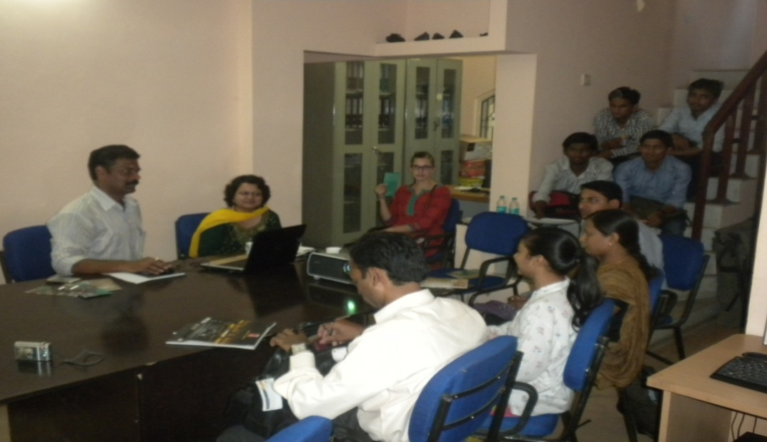

We attended the presentation on dewats in which working of dewats was explained to us by Mr. Shekhar Diwale in trimurti nagar Nagpur. Various construction plans and working procedures according to various capacities were explained to us.

1. Site visited at Kaikade Nagar, Nagpur

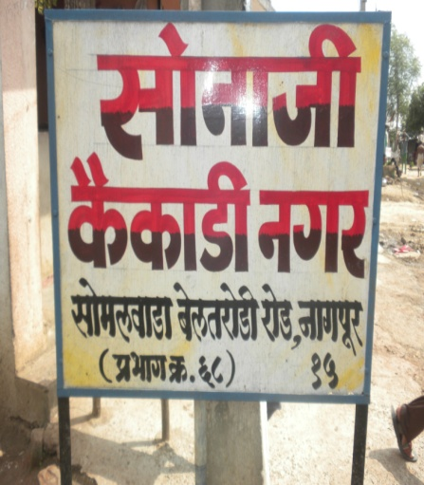

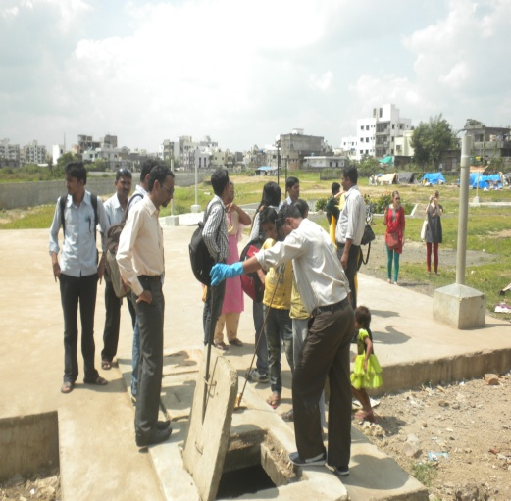

On the same day after presentation we visited the site at sonaji kaikade nagar, somalwada beltarodi road nagpur. This system of dewats was made for the population of around 5000 peoples colony. The system was having the capacity of around 40 cumec.

1. Collected sample from various inlets/outlets of each chamber.

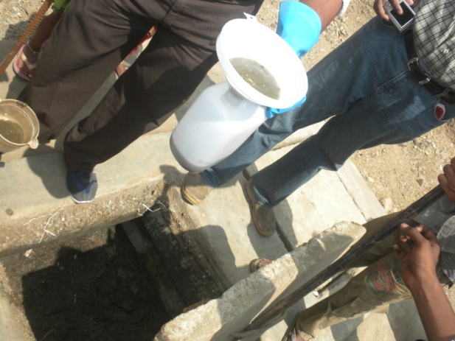 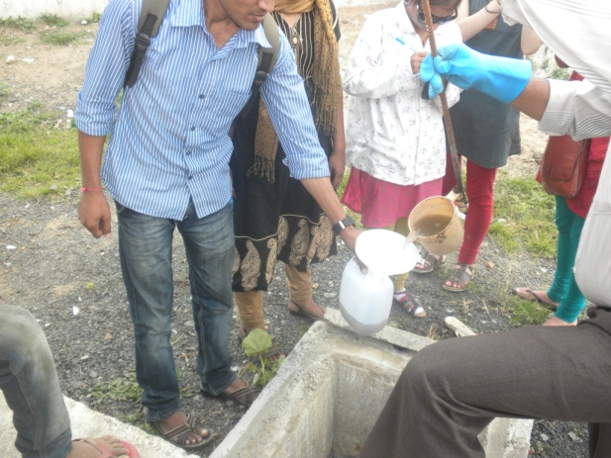

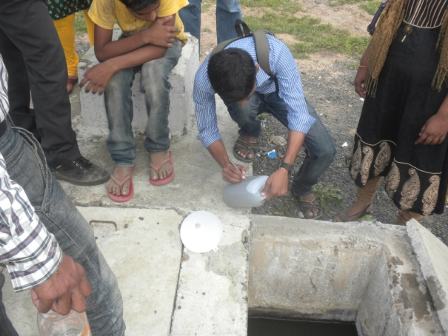 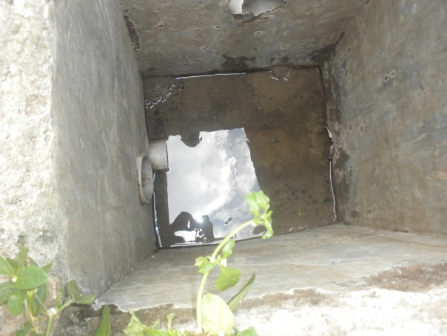

First we collected the sample 1 from the septic tank. The waste product is primarily collected in this tank. Sample 2 was then collected from inlet of anaerobic baffled reactor. In which the anaerobic process is carried out. Sample 3 was collected from the outlet of this tank. And sample 4 from the outlet of planted gravel filter which gave us the final product in the form of clear water. This was the final collected sample of the complete dewats process.

1. Test done on the sample.

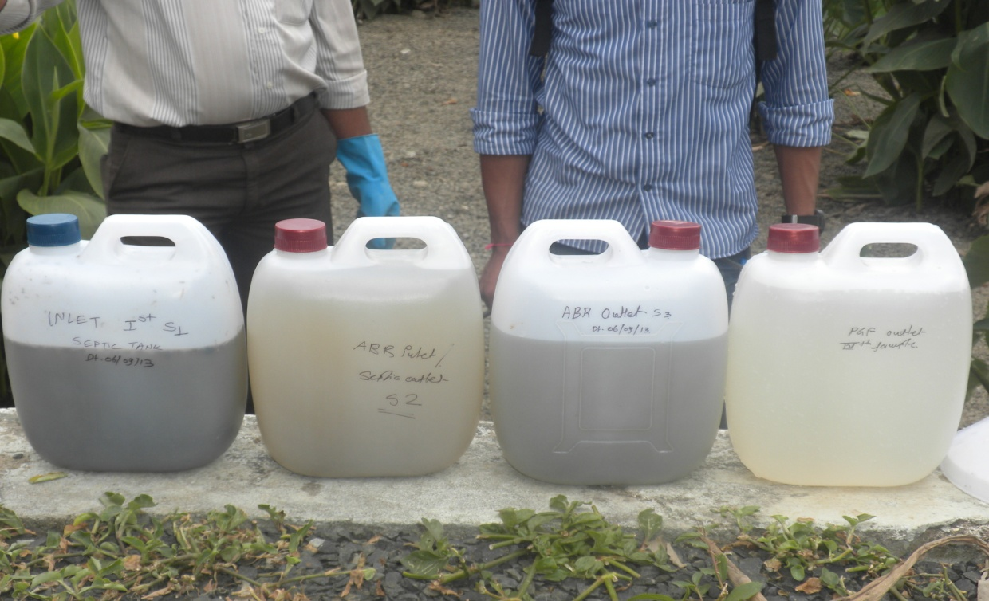

We collected the samples in 2ltr container and as exact sample quantity was not collected so we did the tests on 1 ltr of sample. The samples were carried to the EARTH CARE LABS PRIVATE LTD. Laboratory and tests were carried out. The samples were taken to the lab in 1hr after collection so that temperature variations shall not take place.

In this way the whole site visit was done under guidance of CDD society members.

**Results of TEST**

|  |  |  |  |  |  |  |
| --- | --- | --- | --- | --- | --- | --- |
| **Sr.**  **No.** | **Parameters** | **Norms** | **Locations** | | | |
|  |  |  | Effluent taken  from Inlet 1st  Septic tank  **(S1)** | Effluent taken  from ABR  Inlet Tank  **(S2)** | Effluent taken  from ABR  Outlet Tank  **(S3)** | Effluent taken  from PGF  Outlet Tank  **(S4)** |
| 1. | Temperature (oC) | -- | 25 | 27 | 27 | 27 |
| 2. | Ph | 5.5 to 9 | 5.86 | 7.06 | 7.17 | 7.39 |
| 3. | Biochemical Oxygen Demand  (3 days/27oC) mg/l | 100.0 | 3500.0 | 80.0 | 68.0 | 10.0 |
| 4. | Chemical Oxygen Demand,  mg/l | 250.0 | 9446.4 | 275.5 | 236.1 | 39.3 |
| 5. | Total suspended solids, mg/l | 100.0 | 6670.0 | 138.0 | 116.0 | 12.0 |
| 6. | Phosphate, mg/l | -- | 15.9 | 0.1 | 0.05 | BDL |
| 7. | Ammonia, mg/l | -- | 77.7 | 55.1 | 53.7 | 50.6 |

**PROCEDURE OF CONDUCTING TESTS**

**Temperature:-**

For each sample, insert thermometer into jar and then record temperature in the Worksheet Temperature section under the column marked “Test”. In the same section, copy the river temperature (which the collector wrote on the jar) to the column marked “Collection”. Always specify celsius or fahrenheit. To avoid cross-contamination, rinse thermometer with ordinary distilled water and gently shake dry after each reading.

**pH:-**

Measure the pH of each sample:

a. For each sample, submerge electrode in jar. After the reading stabilizes (20-30 seconds), record it on the worksheet. River samples are unbuffered solutions, so if the reading continues to fluctuate slightly, record a median value. Readings will normally be between 6.9 - 8.1, and should never exceed 7.0 ± 1.5. (Note that pH < 7.0 indicates acidity and pH > 7.0 indicates alkalinity.)

b. To avoid cross-contamination, rinse the bottom of the pH meter with ordinary distilled water and gently shake dry after each reading.

c. After the last sample, rise with ordinary distilled water and gently shake dry.Turn pH meter off and recap when dry.

**Phosphorus:-**

**Procedure:**

1. Enter the program number for phosphorus by pressing. 2. The display will read “dial nm to 890”. Rotate the wavelength dial until display reads “890 nm”. When the correct wavelength is dialed in, display will read “ Zero Sample”, then“mg/L PO4 3- PV”.3. Insert the small, black, plastic 10 mL cell riser into the spectrophotometer.4. Prepare all cells:a. Add 10 mL of ultra-pure distilled water to a cellb. Add 10 mL of Phosphate Standard Solution to a cell. c. For each river sample: add 2 mL of river water to a cell and then fill to 10 mL with ultra-pure distilled water add 10 mL of river water to a cell, undilutedd. Add one PhosVer 3 Phosphate Reagent powder pillow to each of the cells in 4a-4cand swirl immediately to mix.5. a two-minute reaction period will begin. A blue color will form if phosphorus is present.6.After the timer beeps, the spectrophotometer and close the lid. spectrophotometer is now calibrated. 7.Close the lid the Phosphorus section of the worksheet, write the reading on the line marked “Standard”. If the reading is greater than 1.10 or less than 0.90, consider re-doing the entire test.8. Insert each river sample into the spectrophotometer, close the lid, 9. On the worksheet, perform the specified arithmetic and write the answer in the column marked “Result” and also in the log book.10. Rinse the 10 ml cells with ordinary distilled water until they are perfectly clean. A Q-tip will remove reagent sediment stuck to the bottom.11. Remove the small, plastic 10 ml cell riser from the spectrophotometer and set aside.

**Ammonia:-**

**Procedure:**

Do not allow more than 5 minutes to elapse between steps 3f and 7.

1. Enter the program number for ammonia. 2. The display will read “dial nm to 425”. Rotate the wavelength dial until display reads“425nm”. When correct wavelength is dialed in, display will read “Zero Sample”, then “mg/L NH3 -N Ness”.3. Prepare all cells: a. Add 25 ml of ultra-pure distilled water to a cell. b. Add 25 ml of Nitrogen Ammonia Standard Solution to a cell. c. For each river sample: All sites: add 25 ml of river water to a cell, undiluted d. Add 3 drops of Mineral Stabilizer to each of the cells in 3a-3c. Cap with a black rubber stopper and invert several times to mix. e. Add 3 drops of Polyvinyl Alcohol Dispersing Agent to each of the cells in 3a-3c. Cap with a black rubber stopper and invert several times to mix. f. Using its eyedropper, add l ml of Nessler. Reagent to each of the cells in 3a-3c. The “1 ml” marking on the glass eyedropper may be difficult to see; typically, 1 ml is drawn into the eyedropper if the rubber is pinched fully and released. Cap each cell with a black rubber stopper and invert several times to mix. 4. a one-minute reaction period will begin. A yellow color will form if ammonia is present. 5. After the timer beeps, close the lid. the display will read “Zeroing” then “0.00 mg/L NH3 -N Ness”.The spectrophotometer is now calibrated. 6. close the lid, In the Ammonia section of the worksheet, write the reading on the line marked “Standard”. If the reading is greater than 1.10 or less than 0.90, consider re-doing the entire test. 7. Insert each river sample into the spectrophotometer, close the lid, write the reading on the worksheet. Ideally, all river readings should fall between and the method’s upper limit (2.50). If not, consider re-doing the sample, or contact the test coordinator.8. Rinse the 25 ml cells and rubber stoppers with ordinary distilled water until they are perfectly clean.

**The BOD5:-**

There are two commonly recognized methods for the measurement of BOD.

**Dilution method**

This standard method is recognized by [EPA](http://en.wikipedia.org/wiki/EPA), which is labeled Method 5210B in the Standard Methods for the Examination of Water and Wastewater. In order to obtain BOD5, dissolved oxygen (DO) concentrations in a sample must be measured before and after the incubation period, and appropriately adjusted by the sample corresponding dilution factor. This analysis is performed using 300 ml incubation bottles in which [buffered dilution water](http://en.wikipedia.org/w/index.php?title=Buffered_dilution_water&action=edit&redlink=1) is dosed with seed microorganisms and stored for 5 days in the dark room at 20°C to prevent DO production via photosynthesis. In addition to the various dilutions of BOD samples, this procedure requires dilution water blanks, [glucose glutamic acid](http://en.wikipedia.org/w/index.php?title=Glucose_glutamic_acid&action=edit&redlink=1) (GGA) controls, and seed controls. The dilution water blank is used to confirm the quality of the dilution water that is used to dilute the other samples. This is necessary because impurities in the dilution water may cause significant alterations in the results. The GGA control is a standardized solution to determine the quality of the seed, where its recommended BOD5 concentration is 198 mg/l ± 30.5 mg/l. For measurement of carbonaceous BOD(cBOD), a nitrification inhibitor is added after the dilution water has been added to the sample. The inhibitor hinders the [oxidation](http://en.wikipedia.org/wiki/Oxidation) of ammonia nitrogen, which supplies the nitrogenous BOD (nBOD). When performing the BOD5 test, it is conventional practice to measure only cBOD because nitrogenous demand does not reflect the oxygen demand from organic matter. This is because nBOD is generated by the breakdown of proteins, whereas cBOD is produced by the breakdown of organic molecules.

The main advantages of this method compared to the dilution method are:- simplicity: no dilution of sample required, no seeding, no blank sample. Direct reading of BOD value. continuous display of BOD value at the current incubation time.

**Chemical Oxygen Demand (COD):-**

**Procedure:-**

The Chemical Oxygen Demand (COD) test measures the oxygen equivalent consumed by organic matter in a sample during strong chemical oxidation.  The strong chemical oxidation conditions are provided by the reagents used in the analysis.  Potassium dichromate is used as the oxygen source with concentrated sulfuric acid added to yield a strong acid medium.  Several reagents are added during the set up of the analysis to drive the oxidation reaction to completion and also to remove any possible interference.  Specifically, these reagents are mercuric sulfate, silver sulfate and sulfamic acid.  Mercuric sulfate is added to remove complex chloride ions present in the sample.  Without the mercuric sulfate the chloride ions would form chlorine compounds in the strong acid media used in the procedure.  These chlorine compounds would oxidize the organic matter in the sample, resulting in a COD value lower than the actual value.  Silver sulfate is added as a catalyst for the oxidation of short, straight chain organics and alcohols.  Again, without the silver sulfate the COD of the sample would be lower than the actual value. Sulfamic acid is added to remove interferences caused by nitrite ions.  Without sulfamic acid the COD of the sample would measure higher than the actual value. Even with the use of these additional reagents the oxidation of the organic matter is not always 100% complete. Volatile organics, ammonia and aromatic hydrocarbon are not oxidized to any great degree during the procedure.

The major disadvantage of the COD test is that the results are not directly applicable to the 5-day BOD results without correlation studies over a long period of time.  The samples used for the COD analysis may be grab or composite.  Preservation of the sample can be accomplished by adding sulfuric acid to depress the pH to 2 and the holding time with preservation is 7 days.

**Total Suspended Solid:-**

**Procedure**

a. Preparation of glass-fiber filter disk: If pre-prepared glass fiber filter disks are used, eliminate this step. Insert disk with wrinkled side up in filtration apparatus. Apply vacuum and wash disk with three successive 20-mL portions of reagent-grade water. Continue suction to remove all traces of water, turn vacuum off, and discard washings. Remove filter from filtration apparatus and transfer to an inert aluminum weighing dish. If a Gooch crucible is used, remove crucible and filter combination. Dry in an oven at 103 to 105°C for 1 h. If volatile solids are to be measured, ignite at 550°C for 15 min in a muffle furnace. Cool in desiccator to balance temperature and weigh. Repeat cycle of drying or igniting, cooling, desiccating, and weighing until a constant weight is obtained or until weight change is less than 4% of the previous weighing or 0.5 mg, whichever is less. Store in desiccator until needed.

b. Selection of filter and sample sizes: Choose sample volume to yield between 2.5 and 200 mg dried residue. If volume filtered fails to meet minimum yield, increase sample volume up to 1 L. If complete filtration takes more than 10 min, increase filter diameter or decrease sample volume.

c. Sample analysis: Assemble filtering apparatus and filter and begin suction. Wet filter with a small volume of reagent-grade water to seat it. Stir sample with a magnetic stirrer at a speed to shear larger particles, if practical, to obtain a more uniform (preferably homogeneous) particle size. Centrifugal force may separate particles by size and density, resulting in poor precision when point of sample withdrawal is varied. While stirring, pipet a measured volume onto the seated glass-fiber filter. For homogeneous samples, pipet from the approximate midpoint of container but not in vortex. Choose a point both middepth and midway between wall and vortex. Wash filter with three successive 10-mL volumes of reagent-grade water, allowing complete drainage between washings, and continue suction for about 3 min after filtration is complete. Samples with high dissolved solids may require additional washings. Carefully remove filter from filtration apparatus and transfer to an aluminum weighing dish as a support. Alternatively, remove the crucible and filter combination from the crucible adapter if a Gooch crucible is used. Dry for at least 1 h at 103 to 105°C in an oven, cool in a desiccator to balance temperature, and weigh. Repeat the cycle of drying, cooling, desiccating, and weighing until a constant weight is obtained or until the weight change is less than 4% of the previous weight or 0.5 mg, whichever is less. Analyze at least 10% of all samples in duplicate. Duplicate determinations should agree within 5% of their average weight. If volatile solids are to be determined, treat the residue according to 2540E. The standard deviation was 5.2 mg/L (coefficient of variation 33%) at 15 mg/L, 24 mg/L (10%) at 242 mg/L, and 13 mg/L (0.76%) at 1707 mg/L in studies by two analysts of four sets of 10 determinations each. Single-laboratory duplicate analyses of 50 samples of water and wastewater were made with a standard deviation of differences of 2.8 mg/L.

**LABORATORY TEST RESULTS**

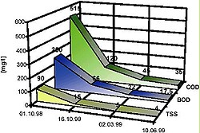

**Effluent Quality during first month of DEWATS operation**

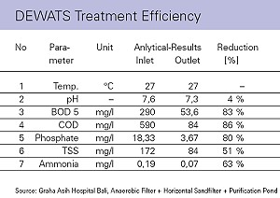

**CONSTRUCTION**

DEWATS are relatively simple structures that can be built by reasonably qualified craftsmen or building contractors with the ability to read technical drawings. If this were not the case, almost daily supervision by a qualified technician would be required. The construction of watertight tanks and tank connections would require craftsmanship of a relatively high order. Control of construction quality is of utmost importance if biogas is to be stored within the reactor.

Technical details of a design, which has been adapted to local conditions, should be based on the material that is locally available and the costs of such material. Important materials are:

* concrete for basement and foundation
* brickwork or concrete blocks for walls
* water pipes of 3“, 4“ and 6“ in diameter
* filter material for anaerobic filters, such as cinder, rock chipping, or specially made plastic products
* properly sized filter material for gravel filters (uniform grain size)
* plastic foils for bottom sealing of filters and ponds

Gate valves of 6" and 4" diameter are necessary to facilitate de-sludging of tanks regularly.

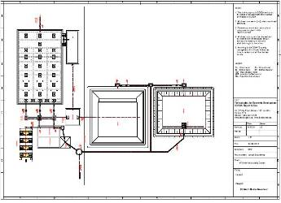

**MAINTANANCE**

The more a standard design has been adapted or modified to fit local conditions, the greater the likelihood of operational modification during the initial phase. It is therefore important that the contractor or design engineer keeps a close eye on the plant, until the expected treatment results have been achieved. Despite faultless implementation, it may be necessary to extend such attendance up to as long as two years. Permanent wastewater treatment that does not include some degree of maintenance is inconceivable. DEWATS nonetheless reduces maintenance to the nature of occasional routine work. Anaerobic tanks would need to be de-sludged at calculated intervals (usually 1 to 3 years) due to the sludge storage volume having been limited to these intervals. Treatment is not interrupted during de-sludging. Normally, sludge is drawn from anaerobic digesters with the help of portable sludge pumps, which discharge into movable tankers. Direct discharge into adjacent sludge drying beds may be possible in the case of Imhoff tanks with short desludging intervals. Anaerobic filters tend to clog when fed with high pollution loads, especially when of high SS content. Flushing off the biological film is possible by back washing. This will require an additional outlet pipe at the inlet side. In practice, what is usually done is to remove the filter media, wash it and clean it outside and put it back after this cleaning. This may be necessary every five to ten years. Constructed wetlands gradually loose their treatment efficiency after 5 to 15 years, depending on grain size and organic loadsolution. The case might be different for hospitals or housing colonies that usually have a permanent staff. If a large number of DEWATS are to be implemented the aim should be to standardise the maintenance service. This is likelyto be possible because of local standardisation of plant design, with similar characteristics for operation.

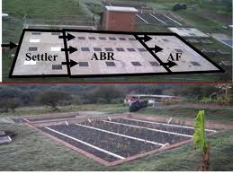

**ADVANTAGES OF DEWATS TECHNOLOGY**

• Providing treatment for domestic and industrial wastewater

• Low primary investment costs as no imports are needed

• Efficient treatment or daily wastewater flows up to 1000m3

• Modular design of all components

• Tolerant towards inflow fluctuations

• Reliable and long-lasting construction design

• Expensive and sophisticated maintenance not required

• Low maintenance costs

Hence, DEWATS technology is an effective, efficient and affordable wastewater treatment solution for small and medium sized enterprises (SME).

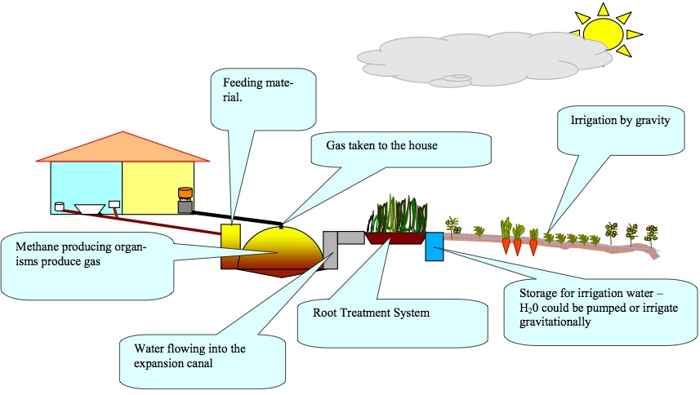

**DEWATS IN NAGPUR**

As a consequence of these continuous lobbying efforts towards amendment of the Development Control Rules (DCR)at Municipal Corporation level, the Nagpur Municipal Corporation (NMC) decided to amend their Development Control regulations  for recycling and reuse of wastewater. On 9th April 2010, a notification was issued by NMC to amend the DCR for wastewater recycling in Nagpur City. This was approved by General Body of NMC. The main aim of amending the DCR was to make wastewater and recycling of treated wastewater compulsory for large and medium townships, apartments, hospitals and commercial buildings within NMC limits.

After the amendment in the DCR, NMC and Nagpur Improvement Trust (NIT) issued notices to builders and developers to integrate wastewater treatment options in their construction plans. No plan will be approved without the provision of a wastewater recycling plan. As a result of strict implementation of the bye laws from development authorities now, a few like-minded construction companies have begun to realize the need of the hour.

 The first enquiry for implementation of DEWATS was received from   **“SumangalBuilders”** for their upcoming Township **“SumangalVihar”** in Nagpur.  The enquiry was received on 8th October 2012 and a proposal submitted to the client on 11thOctober 2012.  The data collected during the initial feasibility study of the construction site is as follows:

The total volume of wastewater generation in the first phase :   182 cum.

Total no. of users from SumangalVihar   :  2140

Total no. of users in Phase- I  : 800

Per capita water consumption  :  100 lpcd

Total water consumption : 2,14,000 liters

Total wastewater generation from SumangalVihar  : 182 cum (settler+anaerobic baffled reactor+anaerobic filter)

Total wastewater generation from Phase I : 68 cum (planted gravel filter)

On 13th February 2013, the proposal was accepted by the client and on 14th February an agreement was entered into for implementation of DEWATS for **“SumangalVihar “**Township. The final design of DEWATS is as follows:

·         Total wastewater generation               :           182 Cum

·         Primary treatment settler                      :           182 Cum

·         Secondary Treatment ABR / AF           :           182 Cum

·         Tertiary treatment PGF                           :           68   Cum

The treated water (68 cum)  will be reused for irrigation of the landscape and garden developed in the township and 114 cum treated water after secondary treatment will be disposed into the lake in the vicinity. This project will be a milestone in Nagpur for a big township and will demonstrate and convince other builders and developers in Nagpur City that wastewater treatment can be done effectively through decentralized systems at town level. All the construction drawings and structural drawings of the DEWATS prepared at RCO  and drawing of the primary treatment settler were submitted to client to  facilitate the construction work.

On 28th March 2013, the layout for construction of settler was given to client and excavation work for the construction of settler was initiated.Soling, PCC and laying of raft for settler is completed and construction of walls is in progress. Construction of all the DEWATS units will be completed by the end of July 2013.

On 1st November 2012, a second enquiry was received from the **Ramnath Group,**a reputed company involved in construction of large townships, for their envisaged township named **Ramnath City on Koradi** Road, Nagpur.  Detail initial feasibility study was conducted at the **Ramnath** City site and a proposal was submitted to the client for treatment of 250 cum of wastewater**.**  Consequent to the submission of the proposal, meetings were held with the client to finalise the concept for **Ramnath City**. This took about 3 months before the final concept emerged. In March 2013, based on the space available, it was decided that instead of a single large DEWATS unit of 250 cum, 2 DEWATS plants of 192 cum and 70 cum would be preferred. On 13th March 2013, an agreement was entered into with Ramnath City Life Space Private Limited**”** for the design of DEWATS plant at Ramnath City**,**an upcoming large township in Nagpur.

On 8th March 2013, a detailed feasibility study was conducted and data collected from the site in discussion with the General Manager, Environment, Ramnath Group. The data considered for designing DEWATS is as follows

**Concept: 1**

**70 cum DEWATS plant:**

·      Total no. of users from Ramnath City Extension    :           600

·      Water consumption per capita                                   :           135 lpcd

·      Total water consumption                                             :           81,000 liters

·      Total wastewater generation                                      :           68.85 cum

·      Total Wastewater Generation                                     :          70 cum (Sett+ABR+AF+PGF )

Concept: 2

**Design data considered for 192 cum DEWATS plant:**

Total no. of users from Ramnath City Extension       :          1680

Water consumption per capita                                      :          135 lpcd

Total water consumption                                                :          226800 liters

Total wastewater generation from (85%)                    :          192 cum

Total wastewater generation                                         :       192 cum (Settler+ABR+AF+PGF)

The concepts prepared and submitted to client envisages 2 DEWATS units for Ramnath City Extension. According to concept 1 DEWATS treatment plant will be  **70 cum** for **600**users and the area required for construction will be 550sqm. The treated water, after tertiary treatment, will be reused for irrigation during landscaping and gardening and after further treatment through carbon and sand filter, **27,000 l**iters water will be reused each day for toilet flushing. As per **concept**2, DEWATStreatment plant will be constructed for 192 cum for 1680 users and the area required would be 1542 Sq.mt**.**The treated water will be reused for irrigation during landscaping, gardening and toilet flushing. For toilet flushing, after tertiary treatment, the water will be further treated through a carbon and sand filter.

After the approval of concept by the client, all the construction drawings were prepared at RCO for both the projects and forwarded to a Structural Engineering consultant for providing inputs on structural aspects. On receipt of the drawings from the Structural Engineer consultant, the the approval will be given to commence construction. As per discussion held with the client and the Structural Engineer consultant, construction of both the plants will commence before 15th May 2013.Strategically speaking, construction of 3 DEWATS plants with reputed construction companies in Nagpur, will create a way forward for other builders and developers to adopt decentralize systems for treatment of wastewater.The Initiative taken by Sumangal Buiders and the Ramnath Group is a step forward to reduce environmental pollution and save water bodies from pollution.

**CONCLUSION**

* DEWATS stands for “Decentralized Wastewater Treatment Systems”. DEWATS represents a technical approach rather than merely a technology package.
* DEWATS applications are designed to be low-maintenance: most important parts of the system work without technical energy inputs and cannot be switched off intentionally.
* DEWATS applications provide state-of-the-art technology at affordable prices because all of the materials used for construction are locally available.
* DEWATS applications are designed and dimensioned in such a way that treated water meets requirements stipulated in environmental laws and regulations.
* DEWATS technology is an effective, efficient and affordable wastewater treatment solution for small and medium sized enterprises (SME).
* DEWATS applications provide treatment for organic wastewater flows from 1‐1000 m3 per day
* DEWATS applications are reliable, long lasting and tolerant towards inflow fluctuation
* DEWATS applications do not need sophisticated maintenance
* Community managed DEWATS can be effective for serving poor communities where:

• appropriate type is built well in the right location

• number of users optimized and sustained

• shared responsibility with Government for operation and maintenance as part of broader sanitation plan and where the community have the will to make it work !

**REFERENCE**

* Pandey, G.N. and Carney, G.C., “Environmental Engineering”, Tata McGraw-Hill Publishing Company Ltd, Delhi, 1992
* Pedersen, P., „Ecology and Urban Planning“, Working Paper No.1, Dept. Of Human Settlements, The Royal Danish Academy of Fine Arts, Copenhagen, 1991
* Authors: Bernd Gutterer, Ludwig Sasse, Thilo Panzerbieter and Thorsten Reckerzügel
* Economic Impacts of Sanitation in Lao PDR, A five-country study conducted in Cambodia, Indonesia,
* Lao PDR, the Philippines and Vietnam under the Economics of Sanitation Initiative (ESI), Research report.
* <http://rainwaterharvesting.wordpress.com/2008/11/23/dewats-decentralized-wastewater-treatment-systems/>