**Automatic Train Protection By Using RF Signal**

Priyanka Khoke1, Shriniwas Gaddamvar2, Mangesh Hatwar3, Akshay Borajwade4, Pooja Kherdikar4

VIII Sem1, VIII Sem2, VIII Sem3, VIII Sem4, Asst. Professor4

[Khokepriya@gmail.comHYPERLINK "mailto:Khokepriya@gmail.com1"1](mailto:Khokepriya@gmail.com1) , [Shrinivas2020@gmail.comHYPERLINK "mailto:Shrinivas2020@gmail.com2"2](mailto:Shrinivas2020@gmail.com2)

Department of Electrical Engineering, KDKCE, Nagpur

***Abstract -* There is an increase in the number of accidents at railroad railings. Collisions with train are generally catastrophic, in that the destructive forces of a train usually are no match to any other type of vehicle. Train collisions form a major catastrophe, as they cause severe damage to life and property. Train collisions occur frequently eluding all the latest technology.Automatic Train Protection (ATP) is the term for a general class of train protection systems for railways that involves some sort of speed control mechanism in response to external inputs. ATP systems continuously monitor all movements of the trains on lines and at stations and provide safe signaling. A large number of automatic functions support the high speeds possible and enabling the line and network resources to be utilized to maximum capacity. ATP is used to schedule multiple trains between two stations with small meter gap between adjacent trains, so the railway department can run more trains by using the same track without accident. Population explosion has resulted in a series of problems, such as traffic jam, environment pollution, and energy crisis.**

Keyword: ATP, CR, ECU,

I. Introduction

Nowadays, the train accidents are increasing day by day. There are numbers of reasons behind these accidents. These accidents may occur due to collision between two trains, due to derailment of the train. When the train gets derail from its track, accident will occur. Similarly when object like vehicle or any living like animal come across the train then it may collide with them causing hazardous to life.

Due to train accidents the loss of human life and the loss of properties increase. So to prevent this damage advance technology is needed to protect the train. By using the advance technology we can control train by detecting the object in front of it. It is also used to synchronize the speed between the two trains; and to detect the fault occurring on the track.

The primary objective of this system is to reduce accidents, deaths, injuries, and property damage related to track and other infrastructure failures.

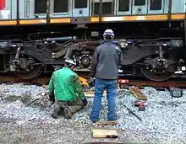

Fig 1: Broken rail derailment

The objective of this project concept is to design such type of railway track where it would be easier to find any fault in the path of the railway track. As we all know that in today’s life how these types of problems occur. So with the help of this concept it can be easier to find any fault in the railway tracks and stop the train, and hence we can save the train from being accidental by the implementation of this concept**.**

II. Need of Rail track fault detection system

The need of this project is to design such type of railway track where it would be easier to find any fault in the path of the railway track or broken rail. As we all know that in today’s life how these types of problems occur, we know that in India trains contribute a major part in our economy, most of the transportation takes place due to trains which connect all over India. In India still there is no technique to find out faulty railway track or broken railway. There are many examples of train accidents. After the accident many problems occur, this leads to more expenses, loss, injuries. So with the help of this concept it can be easier to find any fault in the railway tracks and we can save the train from being accidental by the implementation of this concept. We are going to introduce here a new concept in our Railway as “Railway Faulty Track Detection”. It works on the principle of communication systems as because we are using transmitter and receiver as chief component. As well as we are using electronics components also. With this concept we will find a

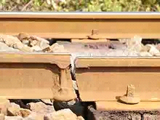

Fig 2: Example of faulty track

new facility for our railway services. For detecting the track broken, there are two methods:-

a) Using Controller

b) Without Controller

Both methods are same except that, in using controller, signal inject into the track through control room (CR), whereas in using without controller train itself generate the signal using ECU and inject into the track. Using with controller method, because this method is more advantageous, for both working also same:-

Signal from CR inject into the track through line communication. Signal from track is send to the transmitter. Transmitter transmits the Signal to the receiver. Receiver is in train, which receives the signal and code of the received signal will be generated and code will be given to the microcontroller. The code will be predefined in the microcontroller. Microcontroller will receive the code and will show the output whether the track is broken or not. When the received codes match with the predefined code in the Microcontroller, microcontroller shows output for track is not faulty. And when the received codes not match with the predefined code, then microcontroller shows output for track is faulty. If track is ok, display the Blue signal, which is track signal. And for faulty track display flashing Red signal and at the same time Buzzer will also activate, which is in the train. Warning signal will be continuously displayed, and all operations controlled by the Electronic Control Unit (ECU).After detecting the track broken, train automatically first slow down and then stops. This track detecting process continuously repeated.

III. Experimental Setup

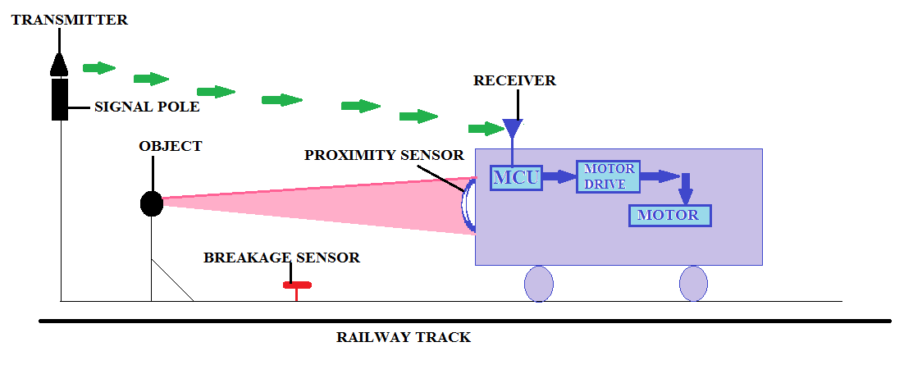Fig 3: Block diagram showing track fault and obstacle detection system

The block diagram represents the working and overview of automatic railway protection by using RF signal. It mainly consist of transmitter, receiver, Microcontroller, motor drive, obstacle sensor, breakage sensor, signal pole and the tracks on which sensors are mounted. With the help of this block diagram we can synchronize the speed of train, detect the fault and object in track.

IV. Circuit Diagram

It consist of transmitter, receiver and signal pole circuit. The supply of 6V is supplied by the battery. The circuit requires 5V which is maintained by the voltage regulator IC7805. The transmitter and receiver are mounted in the train engines separately and another transmitter is mounted on pole.

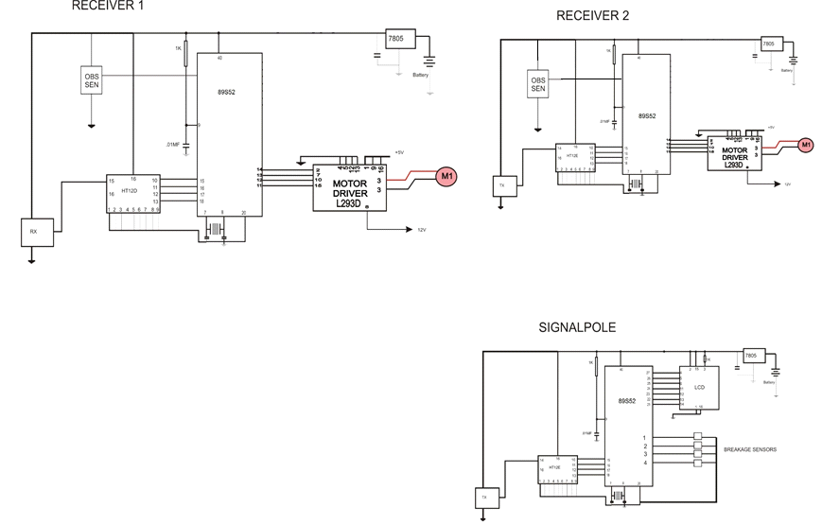

Fig 4: Showing the circuit for synchronisation of trains, faults and object detection in tracks

The transmitter on the pole emits the RF signal continuously, which is received by the receiver in the train. The breakage in the track is detected by breakage sensor. In case of breakage, the signal from the pole circuit the signal is not received by the receiver and the train will automatically come in halt position with the help of motor driver ICL293D.The detection of any obstacle is done by the proximity sensor which is again connected to the breaking system.

V. Equipments Used

V.1. Microcontroller

The AT89S52 is a low-power, high-performance CMOS 8-bit microcontroller with 8K bytes of in-system programmable Flash memory. The device is manufactured using Atmel’s high-density non-volatile memory technology and is compatible with the industry-standard 80C51 instruction set and pin out. The on-chip Flash allows the program memory to be reprogrammed in-system or by a conventional non-volatile memory programmer. By combining a versatile 8-bit CPU with in-system programmable flash on a monolithic chip, the Atmel AT89S52 is a powerful microcontroller which provides a highly-flexible and cost-effective solution to many embedded control applications.

The AT89S52 provides the following standard features: 8K bytes of Flash, 256 byte of RAM, 32 I/O lines, Watchdog timer, two data pointers, three 16-bit timer/counters, a six-vector two-level interrupt architecture, a full duplex serial port, on-chip oscillator, and clock circuitry . In addition, the AT89S52 is designed with static logic for operation down to zero frequency and supports two software selectable power saving modes.

The Idle Mode stops the CPU while allowing the RAM, timer/counters, serial port, and interrupt system to continue functioning. The Power-down mode saves the RAM con tents but freezes the oscillator disabling all other chip functions until the next interrupt or hardware reset.

V.2. Driver

The Device is a monolithic integrated high voltage, high current four channel driver designed to accept standard DTL or TTL logic levels and drive inductive loads (such as relays solenoids, DC and stepping motors) and switching power transistors. To simplify use as two bridges each pair of channels is equipped with an enable input. A separate supply input is provided for the logic, allowing operation at a lower voltage and internal clamp diodes are included. This device is suitable for use in switching applications at frequencies up to 5 kHz.

The L293D is assembled in a 16 lead plastic package which has 4 centre pins connected together and used for heat sinking The L293DD is assembled in a 20 lead surface mount which has 8 center pins connected together and used for heat sinking.

V.3. Power Supply (7805)

It is used to give a constant power supply of 5 volt to all the electronics circuits. In this we are using a regulator IC which converts a 12V dc to constant 5 volt irrespective of any fluctuations in input voltage between 6V to 12V.

V.4. Decoder

The212decoders are a series of CMOS LSIs for remote control system applications.They are paired with Holtek’s 212 series of encoders (refer to the encoder/decoder cross reference table). For proper operation, a pair of encoder/decoder with the same number of ad- dresses and data format should be chosen.

The decoders receive serial addresses and data from a programmed 212 series of encoders that are transmitted by a carrier using an RF or an IR transmission medium. They compare the serial input data three times continuously with their local addresses. If no error or unmatched codes are found, the input data codes are de- coded and then transferred to the output pins. The VT pin also goes high to indicate a valid transmission.

The 212 series of decoders are capable of decoding information that consist of N bits of ad- dress and 12-N bits of data. Of this series, the HT12D is arranged to provide 8 address bits and 4 data bits, and HT12F is used to decode 12 bits of address information.

V.5. Encoder

The 212 encoders are a series of CMOS LSIs for remote control system applications. They are capable of encoding information which consists of N address bits and 12-N data bits. Each ad- dress/data input can be set to one of the two logic states. The programmed addresses/data are transmitted together with the header bits via an RF or an infrared transmission medium upon receipt of a trigger signal. The capability to select a TE trigger on the HT12E or a DATA trigger on the HT12A further enhances the application flexibility of the 212 series of encoders. The HT12A additionally provides a 38 kHz carrier for infrared systems.

V.6. LCD

V.6. LCD

Liquid crystal display (LCD) is a flat panel display, electronic visual display, or video display that uses the light modulating properties of liquid crystals (LCs). LCs do not emit light directly.

The LCD is more energy efficient and offers safer disposal than a CRT. Its low electrical power consumption enables it to be used in battery-powered electronic equipment. It is an electronically modulated optical device made up of any number of segments filled with liquid crystals and arrayed in front of a light source (backlight) or reflector to produce images in colour or monochrome. Liquid crystals were first developed in 1888.

V.7. Capacitors

A capacitor (originally known as condenser) is a passive two-terminal electrical component used to store energy in an electric field. The forms of practical capacitors vary widely, but all contain at least two electrical conductors separated by a dielectric (insulator); for example, one common construction consists of metal foils separated by a thin layer of insulating film. Capacitors are widely used as parts of electrical circuits in many common electrical devices.

V.8. Resistors

A resistor is a passive two-terminal electrical component that implements electrical resistance as a circuit element. The current through a resistor is in direct proportion to the voltage across the resistor's terminals. Thus, the ratio of the voltage applied across a resistor's terminals to the intensity of current through the circuit is called resist- ance. Practical resistors have a series inductance and a small parallel capacitance; these specifications can be important in high-frequency applications. In a low-noise amplifier or pre-amp, the noise characteristics of a resistor may be an issue. The unwanted inductance, excess noise, and temperature coefficient are mainly dependent on the technology used in manufacturing the resistor. A family of discrete resistors is also characterized according to its form factor, that is, the size of the device and the position of its leads (or terminals) which is relevant in the practical manufacturing of circuits using them.

V.9. D.C Motor

Constructional wise there is no basic difference between a dc generator and a dc motor. In fact the same dc machine is used interchangeably as a generator or as a motor. D.C motor are also like generator, shunt wound or series wound or compound wound.

When its field magnets are excited and its armature conductors are supplied with the current from the supply main, the experience a force tending to rotate the armature. Armature conductors under the N poles are assumed to carry downward and those under S poles to carry current upward by applying Fleming’s left hand rule, the direction of the force on each conductor can be found. It will be seen that each conductor experience a force F which tend to rotate the armature in anticlockwise direction. This force collectively produces a driving torque which set the armature rotating

VI. Conclusion

We are using RF signal for the wireless communication. The sensors like pressure sensor and proximity sensor are used for detection of faulty rail track and object detection. By using RF signal control and protection of train can be done easily.

It improves the service reliability on time performance. Also it increase the safety through speed-limit enforcement. The additional protection is provided to the trackside workers. It may use for data signal transferring and get the warning. It can be used for the faults detection in cables as well as in bus bar.

VI. References

[1] Charles A.Reibeling,”An overview of the train management system”, IEEE Vehicular technology magazine, 2009, pp-35 to 44, 2009.

[2] Ronald Lindsey, “Positive train control in America”, IEEE Vehicular technology magazine, 2009, pp-22 to 26.

[3] Satish Chandra and MM Agrawal, “Railway Engineering”, Oxford publication, pp-537 to 553.

[4] John G Proakis, Masoud Salehi, “Communication System Engineering”, Pearson Education, pp-696 to 699.

[5] B.L. Thereja, A.K. Thereja, “Electrical Technology”, S. Chand Publication, pp-1031 to 1090.

[6] Ministry of Indian Railway, “Operation manual for Indian Railways”, 2008, pp-340 to 370.