Abstract
Navneet Pazare¹, Dipti Rakhde² , Neha Sonkusare³ ,Apeksha Waghmare⁴
Email Id : navneetpazare@gmail.com, dipsrakhade@gmail.com, nehasonkusare@yahoo.com apwaghmare17@gmail.com
VIth Sem Dept. of Electrical Engineering, RTMNU.
KDKCE, Nandanwan, Nagpur.

Genearation of electricity from rice husk
This paper presents the main technical and economic issues related to the study of a rice husk small-scale thermal power generation from a Southern Brazilian Rice Processing Cooperative Agriculture. In this study, a case study energy co- generation associated with rice processing is presented with the estimated cost of operation and maintenance of a small pilot plant. It is also considered the impact of carbon credits sale inflow funds, which can reduce production costs related to electricity consumption. It will be presented also that the possibility of selling carbon credits, increases the project economic viability by 50%, allowing a reduction in the investment return time by 20%.

Keywords-

Alternative energy sources, electricity, rice husk, environmental impact.

- INTRODUCTION

The discussion of the impacts caused by reliance on fossil fuels contributes to global concern for sustainable solutions in the generation of electricity using clean and renewable sources. For many years the advantages, disadvantages and technical difficulties that other primary sources (wind, solar, tidal, etc.) have when applied to the commercial electricity production have been discussed. A substitute for fossil fuels to generate electricity has been biomass, which is a renewable energy source, and has contributed to reducing emissions of greenhouse effect gases. However, it should be understood that for the efficient use of biomass in thermal generation, a Technology assessment should be realized, together with an economic and financial analysis.

Along with a detailed study on the environmental impact of the activities involved. The South of Brazil is characterized by being an agricultural region with a high level of food production, emphasizing mainly the production of grains (rice, soy, corn). In this sense, substantial quantities of agricultural wastes (with the potential for electricity generation) are produced, highlighting the rice husk. Where it is generated, rice processing industries, the bark is applied to the drying of grain and parboiling. Moreover, also used in industries that are generating with synchronous motors with reciprocating piston beyond the recent thermoelectric, using steam turbine (Rankine cycle) whose viability is proven. According to 2008 data from IBGE (Brazilian Institute of Geography and Statistics), the states of Rio Grande do Sul and Santa Catarina have a production of paddy, of 8.3 million tons per year [t/year]. It is also known that 22% of the gross weight of the grain, after processing, results in the shell which has a good potential for energy conversion, having a lower calorific value of 13.4 MJ / kg [2]. However, the viability of installing a micro power station (MPS) in the processing industries should be evaluated, serving as a tool for decision making deployment. Thus, the inflow of funds from the sale of carbon credits obtained by this type of project, certainly positively affects the economic viability of the enterprise, so as to contribute to the appropriate destination for the rice husk.

- RICE HUSK

The outermost layer of the paddy grains is the rice husk, also called rice hull. It is separated from the brown rice in rice milling. Burning rice husk produced rice husk ash (RHA), if the burning process is incomplete carbonized rice husk (CRH) is produced.
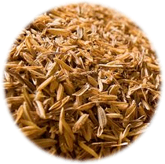

Fig 1 : Rice Husk
3. IMPORTANCE OF RICE HUSK
Around 20% of the paddy weight is husk. In 2008 the world paddy production was 661 million tons and consequently 132 million tons of rice husk were also produced. While there are some uses for rice husk it is still often considered a waste product in the rice mill and therefore often either burned in the open or dumped on wasteland. Husk has a high calorific value and therefore can be used as a renewable fuel.

4. CHARACTERICSTICS OF RICE HUSK AND RICE HUSK ASH

Rice husk is difficult to ignite and it does not burn easily with open flame unless air is blown through the husk. It is highly resistant to moisture penetration and fungal decomposition. Husk therefore makes a good insulation material.

Rice husk has low bulk density of only 70-110 kg/m³, 145 kg/m³ when vibrated or 180kg/m³ in form of pellets. It thus requires large volumes for storage and transport, which makes transport over long distances un-economical.

When the ash content burned is 17-26%, a lot higher than fuels (wood 0.2-2%, coal 12.2%). This means when used for energy generation large amounts of ash need to be handled.
Rice husk has a high average calorific value of an 3410 kcal/kg and therefore is a good, renewable energy source.

5 .CONSTRUCTION

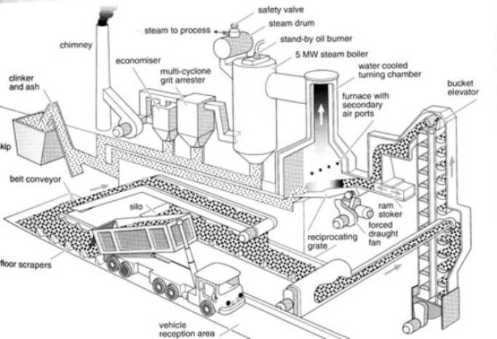

Fig 2 : Running plant of rice husk

6 .MAIN COMPONENTS

- BOILER
A boiler is a close vessel in which water, under pressure, is converted into steam. A boiler is always design to absorb maximum amount of heat release in the process of combustion. This heat is transferred to the boiler by all the three modes of heat transfer i.e., conduction, convection, radiation.

- BELT CONVEYOR
Belt conveyor for conveying the husk to bucket elevator and bucket elevator move the rice husk from belt conveyor to furnace.

- STEAM TURBINE
A steam turbine converts heat energy of steam into mechanical energy and drives the generator. With help of generator mechanical energy converted into electrical energy.

- CONDENSER
A condenser does the job of condensing the steam exhausted from turbine. Thus, it helps in maintaining the low pressure at the exhaust, thereby permitting expansion of steam in the turbine to a very low pressure. This improves the plant efficiency. The exhaust steam is condensed and use as feed water for the boiler.

- ECONOMISER
Flue gasses coming out of the boiler carry lot of heat. An economiser extracts a part of this heat from the flue gasses an uses it for heating feed water. The use of economiser saving in rice husk consumption and higher boiler efficiency but needs extra investment and increasing maintenance cost and floor area require for the plant. Economiser is used in all modern plant.

7. WORKING
In order to meet the energy demand, Fig. 1 shows the proposed system of co-generation and the rice husk power plant. The system consists of a boiler for burning rice husk and for producing superheated steam. The effective pressure steam is extracted from the turbine and the rest of the steam leaves the turbine at low pressure, reaching the condenser. The condensate is then connected to the main tank, along with water to compensate for losses. The mixture is then pumped from the tank to the main boiler, closing the t hermal cycle. Then generator convert mechanical energy to electrical energy and produced the electricity.
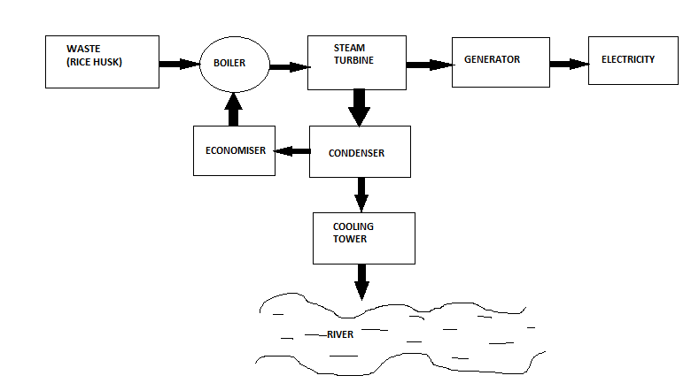
Fig 4 : Block diagram of the plant
8. PRODUCTION OF RICE HUSK AND RICE

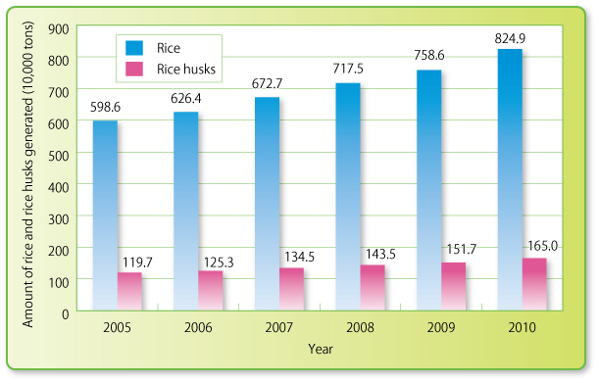
Fig 3 : Statistics of Production of rice husk 2005-10

9. COMPARISON
PARAMETERS | THERMAL POWER PLANT | RICE HUSK POWER PLANT
FUEL USE | COAL | RICE HUSK
POLLUTION | MORE | LESS
MAN POWER | MORE | LESS
ASH PRODUCTION | LESS | MORE
INITIAL COST | HIGH | LESS

Table No.1: Comparison of plant

10. CONCLUSIONS

Agricultural waste does not produce much more electricity than hydroelectricity or thermo-electricity plants, but it does not pollute the environment.
Based on the analysis presented in this paper the biomass should be a priority, given the proven environmental benefits, and a substantial financial return, especially with the investment obtained from the sale of carbon credits. The use of rice husk as a source of electric power can provide substantial savings to the cooperatives of rice. Its viability is fundamentally linked to the ability to internalize the environmental benefits provided by it, as the benefits obtained through the sale of carbon credits. The investment project studied for this sector allows savings in power, since this type of spending is a significant cash outflow. Thus, saving the consumer pays less, reflecting future cash inflows. The results analysis of both methods showed that the proposed investment to install MPS is an economically viability, even without input of carbon credits.

REFERENCES

1. GENERATION OF ELECTRICAL ENERGY
B.R. GUPTA

2. NON-CONVENTIONAL ENERGY SOURCES
G.D.RAI

3.R. Pretz, Potencial bioenergético do setor arrozeiro do rio Grande do Sul: uma abordagem termelétrica, Tese de Doutorado, PROMEC/UFRGS, Porto Alegre, Brasil, 2001.

4. NOGUEIRA, Luiz Augusto Horta. Energia: Conceitos e Fundamentos. Conservação de Energia eficiência energética de instalações e equipamentos. Itajubá: Editora da EFEI, 2001.

