**A PROTOTYPE (Model) OF HYBRID POWER GENERATION BY SOLAR & HYDRO ENERGY**

Miss. Geraldine Matthew1 Gaurav Gulhane2, Akshay Haste3, Chandra Prakash4 Ass. Professor 1[gulhanegaurav7@gmail.com](mailto:gulhanegaurav7@gmail.com), 2 nd2012nik @gmail.com Department of electrical engineering KDKCE, Nagpur Department of electrical engineering KDKCE, Nagpur

*Abstract*— This paper proposes a unique standalone hybrid power generation system, applying advanced power control techniques, fed by three power sources: hydro power, solar power and storage battery, and which is not connected to a commercial power system. Different power sources can be interconnected anywhere on the same power line, leading to flexible system expansion. It is anticipated that this hybrid power generation system, into which natural energy is incorporated, will contribute to global environmental protection on isolated islands and in rural locations without any dependence on commercial power systems. It is merely one time investment and has very low maintenance cost. This hybrid solar-water power generating system is extensively used to illustrate electrical concepts in hands-on laboratories and demonstrations in the Industrial Technology curriculum.

***Keywords***— **hybrid power generation system, commercial power system, Industrial Technology curriculum.**

1. INTRODUCTION

In this paper, a system is proposed in which hydro and solar based hybrid power generation system is connected with the utility grid. In the peak summer, solar energy is abundantly available, but in rainy days it is difficult to generate the electrical power using the solar energy. Similarly the power generation using the hydro energy gives better efficiency in rainy seasons. Hence, the parallel combination of these two energy systems has been adopted, and for the continuous power flow grid is also connected [1]. In the summer, the grid connected solar system supplies the power to the load, and hydro system will be disconnected. In rainy days the grid connected hydro system supplies the power to the load, and solar system will be disconnected. In other seasons, grid connected the solar and hydro systems are able to deliver the power to the consumer. Hence, it is good option to adopt the proposed system for supplying continuous power to the consumer [2].

The renewable energy systems (RESs) are an attractive option to electrify the community as they are environment friendly, free of cost, and all-pervading. The efficiency of these energy systems is very low and can be improved by integrating them in parallel. In this paper, hydro and solar systems are taken as RESs and connected with the utility grid. Due to the intermittent nature of both the hydro and photovoltaic energy sources, utility grid is connected to the system for ensuring the continuous power flow [3]. The hydro power generation system uses hydro turbine, DC generator and the solar generation system is the combination of PV array and tracking system. The supply of both the hydro and solar power sources is provided through the constant current booster (Darlington pair) to the battery. The analysis has been done to verify the existence of the proposed system. Results demonstrate that the proposed system is able to be put into service and can feed the community. Here concept of tracking is used in this project to increase the efficiency of the overall assembly to a sufficient margin. Tracking makes the prototype a ‘closed loop’ system [4]

1. LITERATURE REVIEW

Conventional energy sources are depleting rapidly and falling short in supplying global need of electrical energy. As for sustainable development we must balance our industrial development with environmental pollution. The only solution over this is to use renewable energy sources as an alternative method of generation. Because of the disadvantages involved in using individual sources, a hybrid system which avoids the individual advantages will become more famous in coming years. This provides reliable, uninterrupted and well regulated supply to the locality and also helps in keeping a check over ecological balance.

Energy is vital for sustaining life on earth. Energy was, is and will remain the basic foundation which determines the stability of economic development any nation. It is needed to increase the quality of life at present the power shortage is a major hurdle in progress of the nation. Hence there is a need optimally and economically design and develop all the possible non-conventional energy resources to reduce the void between supply and demand of electrical power. The detailed study of electrical power systems is a key element of many curricula in Industrial Technology. The set-up consists of a photo-voltaic solar-cell array, a mast mounted water generator, lead-acid storage batteries, etc. This hybrid solar-water power generating system is extensively used to illustrate electrical concepts in hands-on laboratories and demonstrations in the Industrial Technology curriculum. These systems give better reliability, reduce pollution and are a good tool for the utility for demand side management.

The Institute of Electrical and Electronics Engineers (IEEE) has done significant work on the definition, detection, and mitigation of power quality events and non-conventional energy sources.

1. HYBRID POWER

Hybrid power systems combine two or more energy conversion devices, or two or more fuels for the same device, that when integrated, overcome limitations inherent in either. This can address limitations in terms of fuel flexibility, efficiency, reliability, emissions and / or economics. The hybrid power system is a complete electrical power supply system that can be easily configured to meet a broad range of remote power needs. It is basically a sum-total arrangement of two or more energy sources in such a way that they can switch on to one-another easily whenever required. The word “HYBRID” refers to clubbing two renewable input sources for a better output result. There are three basic elements to the system - the power source, the battery, and the power management centre. The power sources are a water turbine and solar arrays. The battery allows autonomous operation by compensating for the difference between power production and use. The power management centre regulates power production from each of the sources, controls power use by classifying loads, and protects the battery from service extremes.

1. BLOCK DIAGRAM

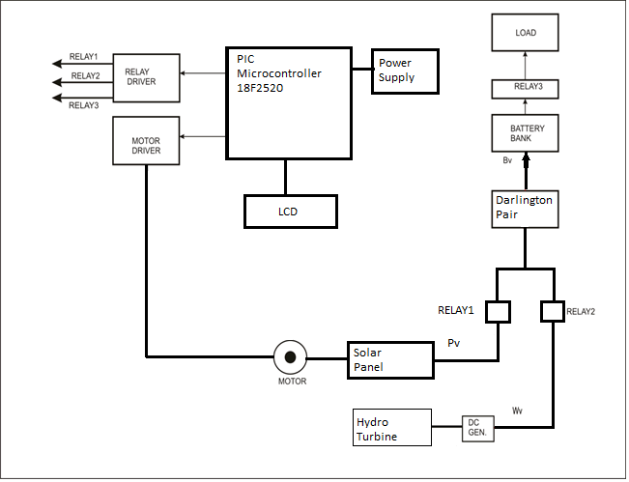

Figure 1 Block Diagram of Prototype (Model) of Hybrid Power Generation by Solar and Hydro Energy

The main components used in the block diagram are solar panel, hydro turbine, permanent magnet DC generator, lead-acid battery and DC gear motor etc. The hydro power generation system uses hydro turbine, DC generator and the solar generation system is the combination of PV array and tracking system. The supply of both the hydro and solar power sources is provided through the constant current booster (Darlington pair) to the battery. The analysis has been done to verify the existence of the proposed system. Results demonstrate that the proposed system is able to be put into service and can feed the community

Solar cells convert light energy into electrical energy either indirectly (by first converting it into heat) or through a direct process known as the photovoltaic effect. Flowing water is directed on to the blades of a turbine runner, creating a force on the blades. Since the runner is spinning, the force acts through a distance (force acting through a distance is the definition of work). In this way, energy is transferred from the water flow to the turbine. Permanent-magnet DC machines are widely found in a wide variety of low-power applications. The field winding is replaced by a permanent magnet, resulting in simpler construction. Chief among these is that they do not require external excitation and its associated power dissipation to create magnetic fields in the machine the space required for the permanent magnets may be less than that required for the field winding, and thus machine may be smaller.

1. CIRCUIT DIAGRAM

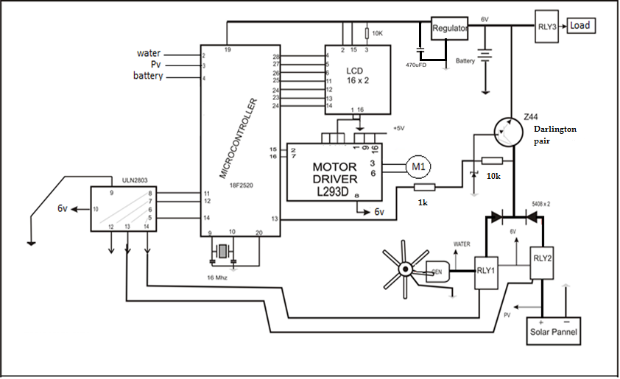

Figure 2 Circuit Diagram of Prototype (Model) of Hybrid Power Generation by Solar and Hybrid Energy

The aim of our project is to introduce an alternative supply system to the existing conventional system. So in order to create a hybrid power generating system we are clubbing two sources. To do this we use PIC microcontroller, relay driver IC, motor driver IC, relay, LCD screen, and Darlington pair etc. We also have introduced tracking in our project which will somehow increase the efficiency of the generation. The regulator IC is provided for maintaining the voltage across microprocessor, display and battery constant, whereas the Darlington pair in the circuit fulfills the purpose of fast battery charging. As we know that to charge a battery we must have to give it a greater magnitude of current or a greater span of time. So if we have to charge a battery in a short time span then we have to provide a greater magnitude of current and this is where we need Darlington pair. It is the two or more transistor connected in parallel and by multiplying their current gain they will increase the current rating. A motor driver also provided for the interfacing between microprocessor and the tracking motor. This motor receives digital signals from the microprocessor and sends it to motor after converting it in suitable form.

We can replace the conventional stepper motor by a DC motor by providing a suitable gear ratio to reduce the jerk in the shaft rotation. A digital display is connected in the circuit to keep an eye over all the parameter in the prototype. These all parameter when work in a synchronism they gives rise to an assemble which is a system working on renewable energy sources an alternative to the conventional power supply system.

1. CONCLUSION

In coming years, man will have to increasingly depend on renewable energy sources. Because of the disadvantages involved in using solar or water energy individually, a hybrid system which avoids the individual advantages will become more famous in coming years. Also the renewable energy equipment’s will become cheaper and efficient with modern technology. Hybrid power systems can offer solutions and value to customers that individual technologies cannot match. Hybrids offer market entry strategies for technologies that cannot currently compete with the lowest-cost traditional options. Renewable hybrid power systems are commercially available today. The proposed system reduces the complexity of the electrical system, having less cost as compared to other RESs and reliable operation

ACKNOWLEDGEMENT

With profound feeling of immense gratitude and affection, we would like to thank our guide Miss. GERALDINE MATHEW, Dept. of Electrical Engineering for his continuous support, motivation, enthusiasm and guidance. Her encouragement, supervision with constructive criticism and confidence enabled us to complete this paper.

REFERENCES

[1] Seul-Ki Kim, Jin-Hong Jeon, Chang-Hee Cho, Jong-Bo Ahn, and Sae-Hyuk Kwon, Member, IEEE “Dynamic Modeling and Control of a Grid-Connected Hybrid Generation System With Versatile Power Transfer” IEEE TRANSACTIONS ON INDUSTRIAL ELECTRONICS, VOL. 55, NO. 4, APRIL 2008

[2] Carmen L.T. Borges, Senior Member, IEEE, and Roberto J. Pinto “Small Hydro Power Plants Energy Availability Modeling for Generation Reliability Evaluation” IEEE TRANSACTIONS ON POWER SYSTEMS, VOL. 23, NO. 3, AUGUST 2008

[3] H.P. Garg & J. Prakash – solar energy - fundamentals & application, Tata McGraw hill, pp.2, 3

[4] Hossain, M.I.; Khan, S.A.; Shafiullah, M., "Power maximization of a photovoltaic system using automatic solar panel tracking along with boost converter and charge controller," IEEE TRANSACTIONS ON Electrical & Computer Engineering (ICECE), 2012 7th International Conference on , vol., no., pp.900,903, 20-22 Dec. 2012

[5] Muhammad Ali Mazidi and Janice Gillespie Mazidi-The 8051 Microcontroller and embedded system

[6] Gaurav S.Gadge- Elements Of Power System, Publish By Mrs Shubhangi K. Hukeri and Mrs. Prakta N. Hukeri for Electrtech, 2009, Chapter 6.