**Power System Stability Enhancement by**

**Simultaneous AC-DC Power Transmission**

Mayur Khadse1, Rajesh Kullarkar2 Mr.C.J.Sharma3

Dept. Of Electrical Engg. Dept. Of Electrical Engg.

KDK College Of Engg. KDK College Of Engg.

Nagpur. Nagpur.

[mdkhadse04@gmail.com](mailto:mdkhadse04@gmail.com)

***Abstract—*This paper presents the concept of simultaneous ac-dc power transmission. Long extra high voltage (EHV) ac lines cannot be loaded to their thermal limits in order to keep sufficient margin against transient instability. With the scheme proposed in this paper, it is possible to load these lines very close to their thermal limits. The conductors are allowed to carry usual ac along with dc superimposed on it. The added dc power flow does not cause any transient instability. This paper presents the feasibility of converting a double circuit ac line into composite ac–dc power transmission line to get the advantages of parallel ac–dc transmission to improve stability and damping out oscillations. No alterations of conductors, insulator strings, and towers of the original line are needed. Substantial gain in the load ability of the line is obtained.** **Simulation has been carried out in MATLAB software package (Simulink Model). The results show the stability of power system both for natural response when compared with only ac transmission.**

***Index Terms—*Extra high voltage (EHV) transmission, flexible ac transmission system (FACTS), MAT Lab , simultaneous ac–dc power transmission.**

I. INTRODUCTION

**I**N RECENT years, environmental, right-of-way, and economic concerns have delayed the construction of a new transmission line. The demand of electric power has shown steady growth but geographically it is quite uneven. The power is often not available at the growing load centres but at remote locations. Often the regulatory policies, environmental acceptability, and the economic concerns involving the availability of energy are the factors determining these locations. Now due to stability considerations, the transmission of the available energy through the

existing ac lines has an upper limit. Thus, it is difficult to load long extra high voltage (EHV) ac lines to their thermal limits as a sufficient margin is kept against transient instability & dynamic stability as well as to damp out oscillations in power system. The present situation demands for the fact that there is full utilization of available energy applying the new concepts to the traditional power transmission theory keeping in view the system availability and security.

Simultaneous ac–dc power transmission was earlier proposed through a single circuit ac transmission line i.e. uni-polar dc link with ground as return path was used. The limitations of ground as return path is due to the fact that the use of ground may corrode any metallic material if it comes in its path. The instantaneous value of each conductor voltage with respect to ground becomes higher due to addition of dc voltage, hence more discs have to be added in each insulator string so that it can withstand this increased voltage. The conductor separation distance was kept constant, as the line-to-line voltage remains unchanged. This thesis gives us the feasibility of converting a double circuit ac line into composite ac–dc power transmission line without altering the original line conductors, insulator strings and tower structures.

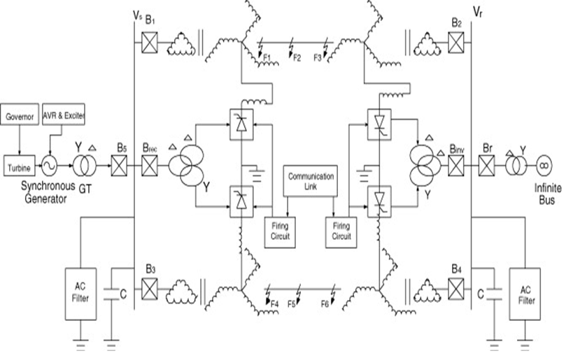

Fig. 1.Basic scheme for composite ac–dc transmission.

The main object is to gain the advantage of parallel ac–dc transmission and to load the line close to its thermal limit.

II. SIMULTANEOUS AC–DC POWER TRANSMISSION

Fig. 1 depicts the basic scheme for simultaneous ac–dc power flow through a double circuit ac transmission line. The dc power is obtained through line commutated 12-pulse rectifier bridge used in conventional HVDC and injected to the neutral point of the zigzag connected secondary of sending end transformer and is reconverted to ac again by the conventional line commutated 12-pulse bridge inverter at the receiving end. The inverter bridge is again connected to the neutral of zig-zag connected winding of the receiving end transformer. The double circuit ac transmission line carriers both three-phase ac and dc power. Each conductor of each line carries one third of the total dc current along with ac current. Resistance being equal in all the three phases of secondary winding of zig-zag transformer as well as

the three conductors of the line, the dc current is equally divided among all the three phases. The three conductors of the second line provide return path for the dc current. Zig-zag connected winding is used at both ends to avoid saturation of transformer

due to dc current. Two fluxes produced by the dc current(Id/3)flowing through each of a winding in each limb of the core of a zig-zag transformer are equal in magnitude and opposite in direction. So the net dc flux at any instant of time becomes zero in each limb of the core. Thus, the dc saturation of the core is avoided. A high value of reactor Xd is used to reduce harmonics in dc current. In the absence of zero sequence and third harmonics or its multiple harmonic voltages, under normal operating conditions, the ac current flow through each transmission line will be restricted between the zigzag connected windings and the three conductors of the transmission line. Even the presence of these

components of voltages may only be able to produce negligible current through the ground due to high value of Xd.

III. EXPERIMENTAL VERIFICATION

The feasibility of the conversion of the ac line to composite ac–dc line was verified in a laboratory-size model. The basic objective was to verify the operation of the transformers, particularly, the effect on core saturation, with the superimposed ac–dc current flow. The transmission line was modeled as a three-phase –network and transformers having a rating of 6 KVA, 400/75/75 Volts were used at each end. The secondary of these transformers were connected in

zig-zag fashion. A supply of 3-ph, 400 V, 50 Hz was given at the sending end and 400 V, 0–5.25 kW variable resistive load was connected at the receiving end. A 10-Amp, 23-mH dc reactor was used at each end with the 230 V zig-zag connected neutral. Two identical line-commutated six-pulse bridge converters were used for rectifier and inverter. The dc voltages

of rectifier and inverter bridges were adjusted to vary dc current between 0 to 6 A. Ac filters were not connected at converter ac buses. The power transmission with and without dc component was

found to be satisfactory. There was no saturation of the transformers core with and without dc component. Experimental results for 3-A ac current with superimposed 2/3-A dc current in each line are depicted. The shape and magnitude of primary current of the zig-zag connected transformer remains unchanged with and without injection of dc current. The wave shape of line-line voltage, which has no dc offset as theoretically predicted.

IV. CONCLUSION

The feasibility to convert ac transmission line to a composite ac–dc line has been demonstrated. For the particular system studied, there is substantial increase (about 83.45%) in the load ability of the line. The line is loaded to its thermal limit with the superimposed dc current. The dc power flow does not impose any stability problem. The advantage of parallel ac–dc transmission is obtained. Dc current regulator may modulate ac power flow. There is no need for any modification in the size of conductors,

insulator strings, and towers structure of the original line. The optimum values of ac and dc voltage components of the converted composite line are 1/2 and times the ac voltage before conversion, respectively.

REFERENCES

[1] H. Rahman and B. H. Khan, Senior Member, IEEE, “Power Upgrading of Transmission Line by Combining AC–DC Transmission”, IEEE Transactions on Power Systems, Vol. 22, No. 1, February 2007

[2] Hurng-LiahngJou, Jinn-Chang Wu, “Analysis of Zig-Zag Transformer Applying in the Three-Phase Four-Wire Distribution Power System” in IEEE Trans. Power Del, VOL. 20, NO. 2, APRIL 2005.

[3] Arief Hernadi, and Makbul Anwari , “ Modeling and Simulation of 6-Pulse and 12-Pulse Rectifiers” in Second Asia International Conference 6/08 2008 IEEE

[4] Electrical power system By CL wadhwa, New Age International Publisher, New Delhi ,6th edition

[5] A.Chakrobarti, M.L.Soni, P.V.Gupta,U.S.Bhatnagar, “A Textbook on Power System Engineering”. Dhanpat Rai& Co, 2012