WIRELESS POWER TRANSFER USING MAGNETIC COUPLING

Rahul Kamadi1, Ashwin Ade2, Sujata Gajbhiye3 ,Dr.G.H.Agrawal4

1VIIIth Sem, 2VIIIth Sem, 3VIIIth Sem, 4Professor

[2rahulkamadikdkce@yahoo.in](mailto:2rahulkamadikdkce@yahoo.in)

Department of Electrical Engineering,KDKCE,Nagpur

Refer Receipt no.307

Abstract**—**Recent interest and current optimism regarding battery-charging wireless power-transfer technology are driven by the ubiquity of cell phones and other mobile communication devices. In some ways, this is to make a dream come true: a truly wireless mobile or portable communication device, completely free from being tethered in any way. The concept of wireless power transfer is not new, even for charging batteries. Cellular service users and customers may be annoyed by or do not want to be bothered with having to plug the mobile device into an electrical outlet. If this is true – as appears to be the case – then time may well provide a fi x to the grief. Aside from not having to plug in the mobile phone or laptop,a more probable cause for the sudden interest in battery charging through wireless power transfer may come from the potential for mobile communication devices to get their electrical power the same way they get their data. Unlike wireless communication uses, the level of transmitted electromagnetic power required for large-scale or commercial implementation of wireless power transfer could be substantial. A key feature of the system design and research effort should be consideration of biological effects and human safety.

***Index Terms*—**Inductive coupling, wireless power transfer.

**I Introduction:**

Wireless power or wireless energy transmission is the transmission of electrical energy from a power source to an electrical load without man-madeconductos. Wireless transmission is useful in cases where interconnecting wires are inconvenient, hazardous, or impossible. The problem of wireless power transmission differs from that of wireless telecommunications, such as radio. In the latter, the proportion of energy received becomes critical only if it is too low for the signal to be distinguished from the background noise [1].With wireless power, efficiency is the more significant parameter. A large part of the energy sent out by the generating plant must arrive at the receiver or receivers to make the system economical.

The most common form of wireless power transmission is carried out using direct induction followed by resonant magnetic induction Other methods under consideration are electromagneti induction in the form of microwaves or laser[2] and electrical conduction through natural media.[3]

The idea of transmitting power through the air has been around for over a century, with Nikola Tesla’s pioneering ideas and experiments perhaps being the most well-known early attempts to do so [1]. He had a vision of wirelessly distributing power over large distances using the earth’s ionosphere. Most approaches to wireless power transfer use an electromagnetic (EM) field of some frequency as the means by which the energy is sent. At the high frequency end of the spectrum are optical techniques that use lasers to send power via a collimated beam of light to a remote detector where the received photons are converted to electrical energy.

**II System Description:**

Across an application space that spans power levels from less than a watt to multiple kilowatts, a wireless energy transfer system based on HR-WPT often has a common set of functional blocks. A general diagram of such a system is shown in Figure 1. Progressing from left to right on the top line of the diagram, the input power to the system is usually either wall power (AC mains) which is converted to DC in an AC/DC rectifier block, or alternatively, a DC voltage directly from a battery or other DC supply. In high power applications a power factor correction stage may also be included in this block. A high efficiency switching amplifier converts the DC voltage into an RF voltage waveform used to drive the source resonator. Often an impedance matching network (IMN) is used to efficiently couple the amplifier output to the source resonator while enabling efficient switching-amplifier operation. Class D or E switching amplifiers are suitable in many applications and generally require an inductive load impedance for highest efficiency. The IMN serves to transform the source resonator impedance, loaded by the coupling to the device resonator and output load, into such an impedance for the source amplifier. The magnetic field generated by the source resonator couples to the device resonator, exciting the resonator and causing energy to build up in it. This energy is coupled out of the device resonator to do useful work, for example, directly powering a load or charging a battery. A second IMN may be used here to efficiently couple energy from the resonator to the load. It may transform the actual load impedance into an effective load impedance seen by the device resonator which more closely matches the loading for optimum efficiency. For loads requiring a DC voltage, a rectifier converts the received AC power back into DC.

In the earliest work at MIT, the impedance matching was accomplished by inductively coupling into the source resonator and out of the device resonator [3]. This approach provides a way to tune the input coupling, and therefore the input impedance, by adjusting the alignment between the source input coupling coil and the source resonator, and similarly, a way to tune the output coupling, and therefore the output impedance, by adjusting the alignment between the device output coupling coil and the device resonator. With proper adjustment of the coupling values, it was possible to achieve power transfer efficiencies approaching the optimum possible efficiency. Figure 1 shows a schematic representation of an inductive coupling approach to impedance matching. In this circuit is adjusted to properly load the source resonator with the generator’s output resistance. The device resonator is similarly loaded by adjusting , the mutual coupling to the load. Series capacitors may be needed in the input and output coupling coils to improve efficiency unless the reactances of the coupling inductors are much less than the generator and load resistances. It is also possible to directly connect the generator and load to the respective resonators with a variety of IMNs. These generally comprise components (capacitors and inductors) that are arranged in “T” and/or “pi” configurations. The values of these components may be chosen for optimum efficiency at a particular source-to-device coupling and load condition (“fixed tuned” impedance matching) or they may be adjustable to provide higher performance over a range of source-to-device positions and load conditions (“tunable” impedance matching). The requirements of the particular application will determine which approach is most appropriate from a performance and cost perspective.

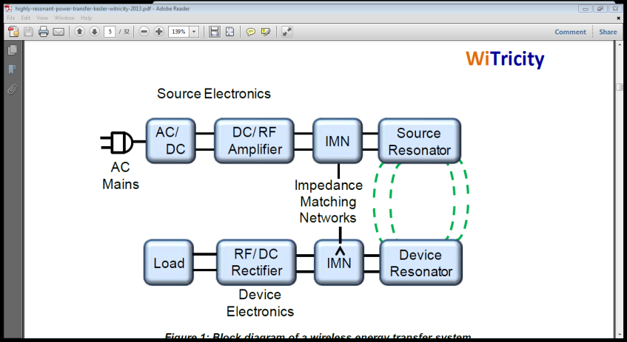

Fig 1. Impedace Matching Network

A common question about wireless charging is: How efficient is it? The end-to-end efficiency of a wireless energy transfer system is the product of the wireless efficiency (see sidebar for an explanation) and the efficiency of the electronics (RF amplifier, rectifier and any other power conversion stages, if needed). In high power applications, such as charging of plug-in hybrid vehicles, end-to-end efficiencies (AC input to DC output) greater than 90% have been demonstrated.

**III Block diagram:**

Actual block diagram being used with refrence to the above diagram.

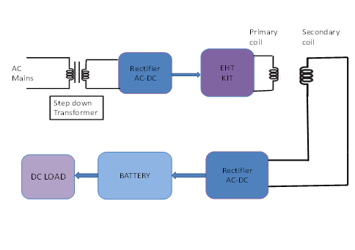

Fig 2. Block Diagram

The a.c. supply is given from AC mains or wall power i.e. 230 V, 50 Hz This voltage is further given to Bridge rectifier which converts AC to DC, but before giving the ac input to the rectifier the ac is stepped down. In fig 2, EHT kit which is connected in series with the rectifier works on the voltage of 12 to 18 V, the rectifier output given to the EHT kit will be according to the formula : 2Vm/π, and the result comes out to be 16.28V, EHT kit works at a voltage of 16.28V, and will give the output of 15-18KV, at 1500Hz frequency.

This value obtained from an EHT kit is given to the primary of the coil, this primary consists of a permanent magnet which will generate strong magnetic lines of force, this will excite the secondary coil and energy will build up in it. The output of primary coil obtained at the secondary will be AC and less than the input of primary losses due to losses. This output of secondary will be then again given to the rectifier which will convert AC into DC, DC being stored in the battery can be utilized for charging more than one devices.

**IV EHT KIT:**

Extra High Tension kit i.e EHT kit is a device that we can find in television set’s, this EHT kit takes the voltage of 12 V, may be AC or DC and gives the output of near about 1 KV, the electrical field can also be found working around EHT kit, hence this becomes easy to transfer 1 KV output at the frequency of 1500 Hz. This EHT kit is placed at the primary side, this will energise the primary winding.



To obtain such a high voltage by stepping up the mains voltage with a transformer is

almost impossible and prohibitive in cost. A novel method used for obtaining EHT source is illustrated in Fig. 8.12. During retrace intervals of horizontal scanning, high voltage pulses of amplitude between 6 to 9 kV are developed across the primary winding of the horizontal output transformer. As shown in the figure these are stepped up by an autotransformer winding to about 10 to 15 kV and then fed to a high voltage rectifier. The output of the rectifier is filteredto provide required dc voltage.Such an arrangement does not load very much the horizontal output stage because thecurrent demand from this high voltage source is less than 1 mA.The horizontal output circuit is so designed, that in addition to providing EHT source,the energy stored in the horizontal deflection coils during retrace is tapped through a diodecalled damper diode to charge a capacitor. The voltage thus developed across the capacitor,actually adds 200 to 300 volts to normal B + voltage to give a boosted B + supply of 400 to 700volts. This voltage is also suitable for first and second anodes of the picture tube. Thisarrangement makes the horizontal deflection circuit very efficient.

**V Coupled Resonators:**

The increase in amplitude of oscillation of an electric or mechanical system exposed to a periodic force whose frequency is equal or very close to natural undamped frequency of the system. If two resonators are placed in proximity to one another such that there is coupling between them, it becomes possible for the resonators to exchange energy. The efficiency of the energy exchange depends on the characteristic parameters for each resonator and the energy coupling rate, κ, between them. The dynamics of the two resonator system can be described using coupled-mode theory [3], or from an analysis of a circuit equivalent of the coupled system of resonators. One equivalent circuit for coupled resonators is the series resonant circuit shown infig.3



Fig3.Equivalent Circuit for Coupled Resonator System

**VI Conclusion:**

Wireless power transfer is on the edge of gaining popularity with its wide area of applications ‘s , where the chords cannot reach in practicality, as on war front, biological applicatons etc. With this project we will throw light on a very small area of application i.e. charging of more than one device would soon in future be able to power the whole office buildings, charge laptops and cell phones, and would illuminate the building at the same time. Hence, it will not be wrong to conclude that wireless technology is slowly gaining momemtum and will soon be used in various fields of work a reduced power loss and greater efficiency.

We hereby would like to conclude that it is possible to transfer power of about 60 Watt wirelessly to its destination which is kept at about 1 meter away from the source that will transmit the energy.

**REFERENCES**

1] Nicola Tesla, “The transmission of electrical energy without wires”, Electrical World and Engineer, March 1905. http://www.tfcbooks.com/tesla/1904-03-05.htm, (acc. Dec. 08).

[2] William C. Brown, “The history of power transmission by radio waves”, Microwave Theory and Techniques, IEEE Transactions, 32(9):1230-1242, September 1984.

[3] A.B. Kurs, A. Karalis, R. Moffatt, J.D. Joannopoulos, P.H. Fisher, and M. Soljacic, “Wireless Power Transfer via Strongly Coupled Magnetic Resonances”, *Science*, 317, pp. 83-86, (2007).

[4] A. Karalis, J.D. Joannopoulos, and M. Soljacic, “Efficient Wireless Non-radiative Mid-range Energy Transfer”, *Ann. Phys*., 323, pp. 34-48, (2008); published online April 2007.

[5] A. Karalis, A.B. Kurs, R. Moffatt, J.D. Joannopoulos, P.H. Fisher, and M. Soljacic, “Wireless Energy Transfer”, U.S. Patent Numbers 7,825,543 and 8,097,098

[6] Farouk Balouchi and Bob Gohn, “Wireless Power: Mobile Devices, Consumer Electronics, Industrial Devices, Wireless Power Infrastructure, and Wireless Charging of Electric Vehicles: Technology Analysis, Environmental Impact, and Market Forecasts,” Pike Research Report, Published 2Q 2012.

[7] “IEEE Standard for Safety Levels with Respect to Human Exposure to Radio Frequency Electromagnetic Fields, 3 kHz to 300 GHz”, IEEE Std. C95.1-2005.

[8] “IEEE Recommended Practice for Measurements and Computations of Radio Frequency Electromagnetic Fields With Respect to Human Exposure to Such Fields, 100 kHz-300 GHz”, IEEE Std C95.3-2002.

[9] “IEEE Recommended Practice for Measurements and Computations of Radio Frequency Electromagnetic Fields With Respect to Human Exposure to Such Fields, 0-100 kHz”, IEEE Std C95.3.1-2010

[10] MONOCHROME AND COLOUR TELEVISION by R. R. Gulati, Page no.147,472,483

.