Single phase and three phase fault analysis Using Superconducting Fault Current Limitter in Simulink

Ajay bodade mithilesh jabhulkar ,Vaibhav ghormare

VIIIth sem k.d.k.c.e Nagpur

ajaybdd1@gmail.com

**Abstract**

**In this paper, the effects of a superconducting fault current limiter (SFCL) installed in loop power distribution systems on voltage sags are assessed and analyzed. The power distribution system will be operated to a type of loop. In this case, voltage drops (sags) are severe because of the increased fault current when a fault occurs. If SFCL is installed in the loop power distribution system, the fault current decreases based on the location and resistance value of the SFCL, and voltage sags are improved. In this paper, the improvement of the voltage sag is analyzed according to the fault location, resistance value of SFCL, and the length of the loop power distribution system. First, a resistor-type SFCL modeled is used using the MATLAB. Next, the loop power distribution system is modeled. Finally, when the SFCL is installed in the radial or loop power distribution system with various lengths, voltage sags are evaluated according to various fault locations. The results of voltage sag analysis in the loop system are compared with the voltage sags in radial power distribution system.**

**Key Terms—Fault current, supercon-ducting fault current limiter,voltage sags.**

**I. INTRODUCTION**

The fault analysis of a power system is required in order to provide information for the selection of switchgear, setting of relays and stability of system operation. A power system is not static but changes during operation (switching on or off of generators and transmission lines) and during planning (addition of generators and transmission lines). Thus fault studies need to be routinely performed by utility engineers (such as in the CEB).

Faults usually occur in a power system due to either insulation failure, flashover, physical damage or human error. These faults, may either be three phase in nature involving all three phases in a symmetrical manner, or may be asymmetrical where usually only one or two phases may be involved. Faults may also be caused by either short-circuits to earth or between live conductors, or may be caused by broken conductors in one or more phases. Sometimes simultaneous faults may occur involving both short-circuit and brokenconductor faults (also known as open-circuit faults).

1

. Mrs.V.B.HARDAS

Assitance Professor

Fault analysis is usually carried out in per-unit quantities (similar to percentage quantities) as they give solutions which are somewhat consistent over different voltage and power ratings, and operate on values of the order of unity. In the ensuing sections, we will derive expressions that may be used in computer

Balanced three phase faults may be analysed using an equivalent single phase circuit. With asymmetrical three phase faults, the use of symmetrical components help to reduce

the complexity of the calculations as transmission lines and components are by and large symmetrical, although the fault may be asymmetrical.

simulations by the utility engineers.Up to now, there were some research activities discussing the fault current issues of smart grid. But the applicability of a SFCL into micro grid was not found yet. Hence, solving the problem of increasing fault current in micro grids by using SFCL technology is the main concern of this work. In this paper, the effect of SFCL and its position was investigated considering a wind farm integrated with a distribution grid model as one of typical configurations of the smart grid. The impacts of SFCL on the wind farm and the strategic location of SFCL in a micro grid which limits fault current from all power sources and has no negative effect on the integrated wind farm was suggested.

**II. SIMULATION SET-UP**

Matlab/Simulink/SimPowerSystem was selected to design and implement the SFCL model. A complete smart grid power network including generation, transmission, and distribution with a load(RLC) also implemented in it. Simulink/SimpowerSystem has number of advantages over its contemporary simulation software (like EMTP, PSPICE) due to its open architecture, a powerful graphical user interface and versatile analysis and graphics tools. Control systems designes in Simulink can be directly integrated with SimPowerSystem models.

To simulate single phase system a simple a.c three phase source has been simulated with a balanced three phase load over which a single line to ground fault has been introduced with a time range. Also current measurement blocks are used to measure respective line currents which further fed for next calculation process.

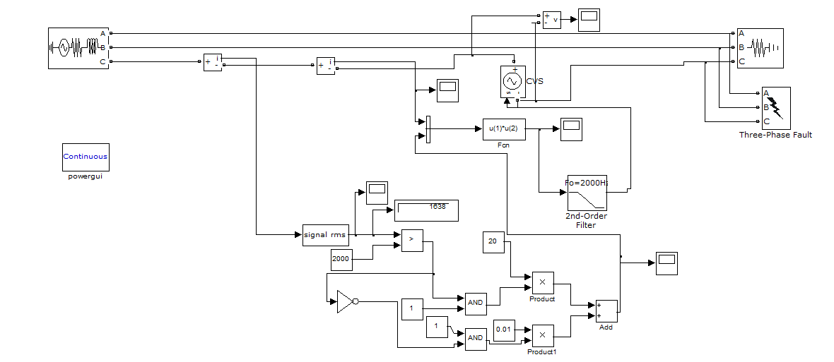

Fig. 1.Single Phase Power system model designed in Simulink/SimPowerSystem. Fault and SFCL location are indicated in the diagram.

**A. Single Phase Power System Model**

A resistive type SFCL was modeled considering

four fundamental parameters of a resistive type SFCL . These parameters and their selected values are: 1) transition or response time(0-0.5sec),2)minimum impedance and maximum impedance(0.01-20ohms , 3) triggering current(2000Ampears and 4) recovery time . Its working voltage is 22.9 kV. Fig. 2 shows the SFCL model developed in Simulink/Sim- PowerSystem. The SFCL model works as follows. First, SFCL model calculates the RMS value of the passing current and then compares it with the characteristic table. Second, if a passing current is larger than the triggering current level, SFCL’s resistance increases to maximum impedance level in a pre-defined response time. Finally, when the current level falls below the triggering current level the system waits until the recovery time and then goes into normal state.Fig. 3 shows the result of verification test of SFCL model conducted on power network model depicted in Fig. 1

**B. SFCL Model**

The single phase resistive type SFCL was modeled con-sidering four fundamental parameters of a resistive type SFCL [9]. These parameters and their selected values are: 1) transition or response time 0.5, 2) minimum impedance 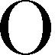 and maximum impedance , 3) triggering current 200 and 4) recovery time . Its working voltage is 22.9 kV.

The SFCL model works as follows. First, SFCL model calculates the RMS value of the passing current and then compares it with the characteristic table. Second, if a passing current is larger than the triggering current level, SFCL’s resis-tance increases to maximum impedance level in a pre-defined response time. Finally, when the current level falls below the triggering current level the system waits until the recovery time and then goes into normal state.

Fig. 3 shows the result of verification test of SFCL model conducted on power network model depicted in Fig. 1. SFCL.

2

**TYPES OF FAULTS**

A fault in a circuit is any failure that interferes with the normal system operation A fault in a circuit is any failure that interferes with the normal flow of current to the load. In most faults, a current path forms between two or more phases, or between one or more phases and the neutral (ground). Since the impedance of a new path is usually low, an excessive current may flow. High-voltage transmission lines have strings of insulators supporting each phase. The insulators must be large ht lines Fundamentals of Power Engineering Spring 2010 enough to prevent flashover – a condition when the voltage difference between the line and the ground is large enough to ionize the air around insulators and thus provide a current path between a phase and a tower

.

1. **SYMMETRICAL THREE PHASE FAULTS**

The networks that are balanced, in which the three voltages (and three currents) are identical but for exact120◦ phase shifts. Unbalanced conditions may arise from unequal voltage sources or loads. It is possible to analyze some simple types of unbalanced networks using straightforward solution techniques and wye-delta transformations.

However, power networks can be come quite complex and many situations would be very diﬃcult

to handle using ordinary network analysis

1. **UNSYMMETRICAL FAULTS**

Unsymmetrical faults cause unbalance in the system. Symmetrical components can therefore be used in the analysis of the faults**.** Most faults that occur in a power system are

Unsymmetrical.

These include:

➢Single line – ground

➢Line – line

➢Double line - ground

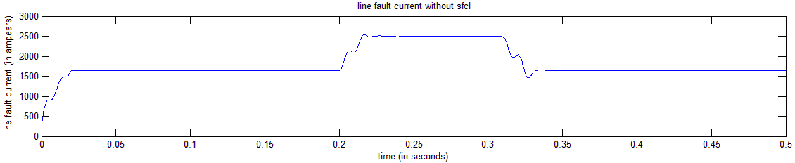

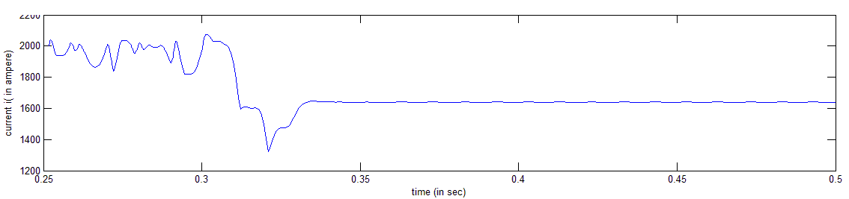 Fig:- showing line fault current without sfcl

Above figures shows the effect of faults on system currents. As we can see that the current has reached above a very dangerous level which may damage down system equipment and as well as dangerous to humans. Thus saftey for such systems is most important. In this project we have first modeled for a single phase, running succesfully over L-G fault. Thereafter we have simulated for three phase system as shown below.

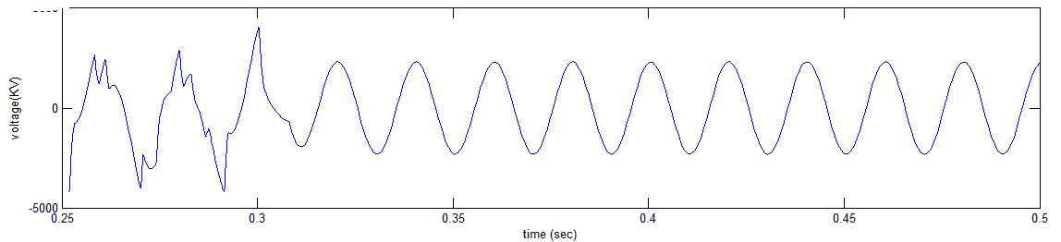

Fig:- current with sfcl

Fig:sag improved using SFCL

From figures shown above it shows the effect of fault, over the line voltage & current parameters. It shows a sudden increase in fault current as well as a drop in voltage soon as fault has occurred. And this drop in voltage is termed as ‘voltage sag’.

THREE PHASE FAULT ANLYSIS USING SFCL

CONCEPT OF THREE PHASE

In electrical engineering, **three-phase** electric power systems have at least three conductors carrying alternating current voltages that are offset in time by one-third of the period. A three-phase system may be arranged in delta (∆) or star (Y) (also denoted as wye in some areas). A wye system allows the use of two different voltages from all three phases, such as a 230/400V system which provides 230V between the neutral (centre hub) and any one of the phases, and 400V across any two phases. A delta system arrangement only provides one voltage magnitude, however it has a greater redundancy as it may continue to operate normally with one of the three supply windings offline, albeit at 57.7% of total capacity.[1] Harmonic currents in the neutral may become very large if non-linear loads are connected.

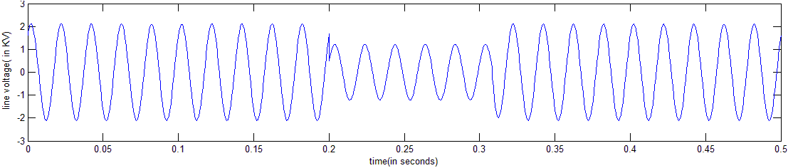Fig:- showing line fault voltage without sfcl

**3**

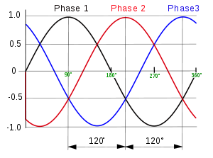

Fig:-. Balance three phase wavaform

**II. SIMULATION SET-UP**

. A complete smart grid power network including generation, transmission, and distribution with a load(RLC) also implemented in it. Simulink/SimpowerSystem has number of advantages over its contemporary simulation software (like EMTP, PSPICE) due to its open architecture, a powerful graphical user interface and versatile analysis and graphics tools. Control systems designes in Simulink can be directly integrated with SimPowerSystem models.

To simulate single phase system a simple a.c three phase source has been simulated with a balanced three phase load over which a single line to ground fault has been introduced with a time range. Also current measurement blocks are used to measure respective line currents which further fed for next calculation process.

|  |
| --- |
|  |



Figure:-Simulation for three phase system developed in simulink/simpower system

In this also a resistive type SFCL was modeled considering

four fundamental parameters of a resistive type SFCL . These parameters and their selected values are: 1) transition or response time(0-0.5sec),2)minimum impedance and maximum impedance(0.01-20ohms , 3) triggering current(2000Ampears and 4) recovery time . Its working voltage is 22.9 kV. Fig. 2 shows the SFCL model developed in Simulink/Sim- PowerSystem. The SFCL model works as follows.

4

First, SFCL model calculates the RMS value of the passing current and then compares it with the characteristic table. Second, if a passing current is larger than the triggering current level, SFCL’s resistance increases to maximum impedance level in a pre-defined response time. Finally, when the current level falls below the triggering current level the system waits until the recovery time and then goes into normal state .Fig. 3 shows the result of verification test of SFCL model conducted on power network model depicted in Fig. 1

The single phase resistive type SFCL was modeled con-sidering four fundamental parameters of a resistive type SFCL [9]. These parameters and their selected values are: 1) transition or response time 0.5, 2) minimum impedance  and maximum impedance ,

3) triggering current 200 and 4) recovery time . Its working voltage is 22.9 kV.

The SFCL model works as follows. First, SFCL model calculates the RMS value of the passing current and then compares it with the characteristic table.

Second, if a passing current is larger than the triggering current level, SFCL’s resis-tance increases to maximum impedance level in a pre-defined response time. Finally, when the current level falls below the triggering current level the system waits until the recovery time and then goes into normal state.

Fig. 3 shows the result of verification test of SFCL model conducted on power network model depicted in Fig. 1. SFCL.

Various waveforms were obtained at various conditions as shown below

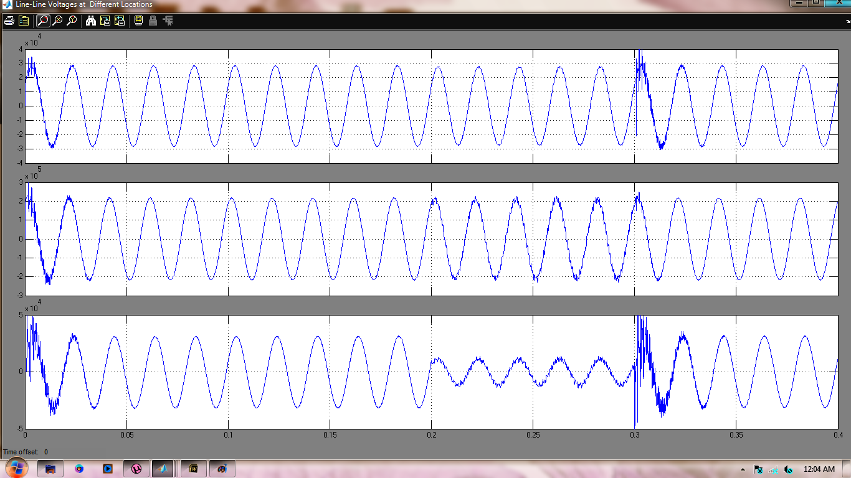

Fig:- three phase waveforms without sfcl

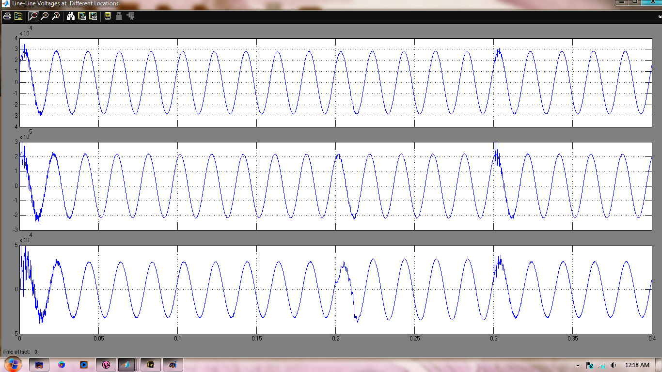

Fig:- three phase waveforms with sfcl resistance of 20ohms 5 IV.CONCLUSION

This paper presented a feasibility analysis of positioning of the SFCL in rapidly changing modern power grid. A complete power system along with a micro grid (having a wind farm con-nected with the grid) was modeled and transient analysis for three-phase-to-ground faults at different locations of the grid were performed with SFCL installed at key locations of the grid. It has been observed that SFCL should not be installed directly at the substation or the branch network feeder. This placement of SFCL results in abnormal fault current contribution from the wind farm. Also multiple SFCLs in micro grid are inefficient both in performance and cost. The strategic location of SFCL in a power grid which limits all fault currents and has no negative effect on the DG source is the point of integration of the wind farm with the power grid.

References

1. T. Jamasb, W. J. Nuttall, and M. G. Pollitt*, Future Electricity Tech-nologies and Systems*. Cambridge: Cambridge Univ. Press, 2006, pp.83–97, 235–246.
2. B. C. Sung, D. K. Park, J. W. Park, and T. K. Ko, “Study on a series resistive SFCL to improve power system transient stability: Modeling, simulation and experimental verification,” *IEEE Trans. Industrial Elec-tron.*, vol. 56, no. 7, pp. 2412–2419, Jul. 2009.
3. Litos Strategic Communication, “The Smart Gird: An Introduction,” 2008 [Online]. Available: http://www.oe.energy.gov/SmartGridIntro-duction.htm, Prepared for U.S. Department of Energy.
4. R. Strzelecki and G. Benysek*, Power Electronics in Smart Electrical* *Energy Networks*. London, U.K.: Springer-Verlag London Ltd.,2008, pp. 203–213. .
5. W. Friedl, L. Fickert, E. Schmautzer, and C. Obkircher, “Safety and re-liability for smart-, micro-, and islanded grids,” presented at the CIRED Seminar: SmartGrids for Distribution, Jun. 2008, Paper 107.
6. L. Dessaint, K. Al-Haddad, H. Le-Huy, G. Sybille, and P. Brunelle, “A power system tool based on simulink,” *IEEE Trans. Industrial Elec-tron.*, vol. 46, no. 6, pp. 1252–1254, Dec. 1999.
7. K. Maki, S. Repo, and P. Jarventausta, “Effect of wind power based distributed generation on protection of distribution network,” in *IEEE* *Developments in Power System Protection*, Dec. 2004, vol. 1, pp.327–330.