**400 KILOVOLTS(KV) SWITCHYARD EQUIPMENT’S**

Akhil Thakre1,Kamalshish Dande2,Parish Pathrabe3,Dr.G.H.Agrawal4

VIIIthsem1, VIIIthsem2, VIIIthsem3,Professor4

1[akhilthakre1992@gmail.com](mailto:akhilthakre1992@gmail.com)

2[kamalshishdande@gmail.com](mailto:kamalshishdande@gmail.com)

Department of Electrical Engineering, KDKCE, Nagpur

***ABSTRACT*:**Switchyard is basically used of switching, protection & control of electrical power. Switchyard is basically an electrical block which connects a generator transformer & grid i.e. outgoing line.

KEYWORDS:

Transmission Lines, Electrical Circuit, Isolator, Circuit Breaker, Earth Switch, Transformer.

**II SWITCHYARD EQUIPMENTS:**

Equipments commonly used in EHV switchyard

1. Bus bars

2. Current transformer

3. Capacitive voltage transformer

4. Circuit breakers

5. Isolator

6. Earth switch

7. Insulators

8. Wave traps

9. Lightning arrestor

**2.1 Bus bars:**

(a) Function:

Bus bars receive power from incoming circuits and deliver power to the outgoing circuits. [1]

(b) Types of bus bars:

(i) Rigid bus bars:

Are Tubular Aluminum or copper bus bars, supported on post top insulators.

(ii) Flexible bus bars:

Are ACSR, Standard conductors, supported on either end by strain insulators as shown in fig. No .2.1.

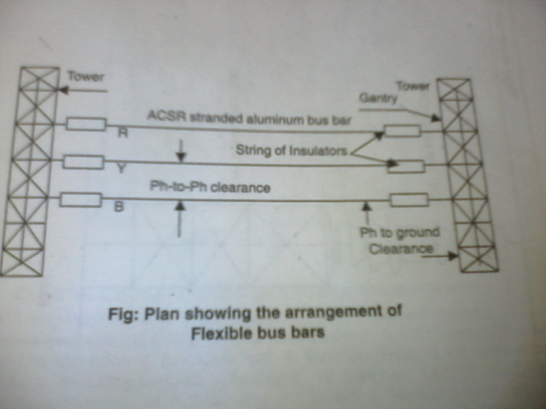

Fig. no. 2.1: Arrangement of Flexible bus bars

**2.2 Current transformer (C.T.):**

(a) Function:

(i) Stepping down the current in the main circuit to a value suitable for measurement & Protection purposes as shown in fig. no. 2.2. [1]

(ii) Electrical Isolation of Relays.

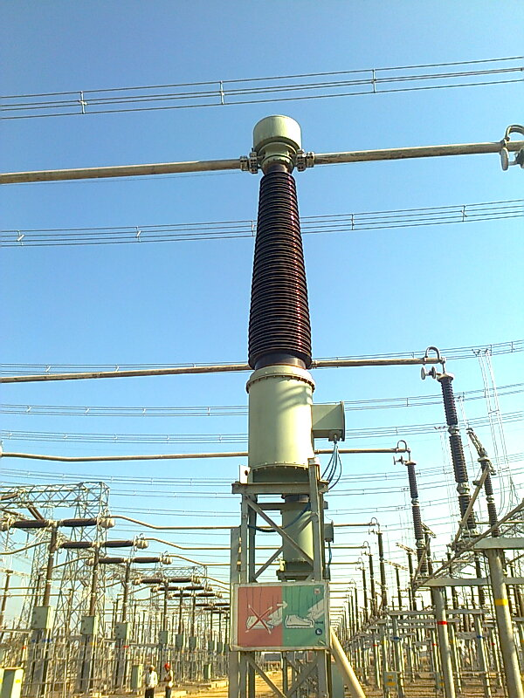

Fig. no. 2.2: Current transformer

Types:

(a) Based on the function, the C.T.’s can be classified as

(i) A Measuring C.T.

(ii) A Protective C.T.

(b) Based on insulating medium used.

(i) Oil filled C.T.

(ii) SF6 gas filled C.T.

(c) Classification based on construction.

(i) Dead tank type/ or Bottom Head type:

(ii) Live tank type on Invented type C.T.

**2.3 Capacitive voltage transformer:**

CVT’s are typically single phase devices used for measuring voltages in excess of one hundred kilovolts where the use of wound primary voltage transformer’s would be uneconomical.[1]

The CVT’s is also useful in communication systems. CVT’s in combination with wave trap’s are used for filtering high frequency communication signals from power frequency as shown in fig. no. 2.3.

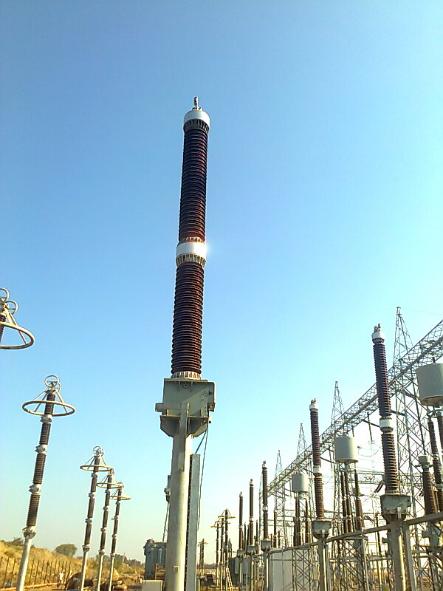

Fig. no. 2.3: Capacitive voltage transformer

This forms a carrier communication network throughout the transmission network.

**2.4 Circuit breaker :**

(a) Function :

Closing, opening & Auto reclosing of an Electrical circuit during normal & abnormal operating conditions (under fault condition) as shown in fig. no. 2.4. [1]

Types:

Depending on the medium of are quenching, circuit breakers are classified as:

(a) Minimum oil circuit breakers.

(b) Air blast circuit breakers.

(c) SF6 circuit breakers.

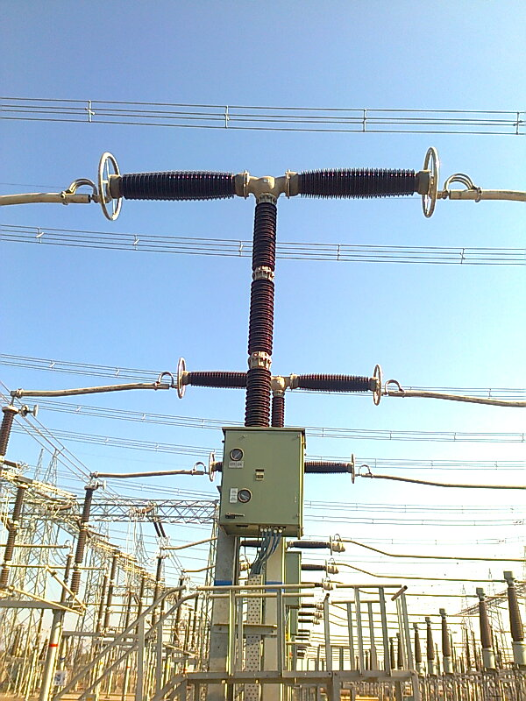

Fig. no. 2.4: Circuit breakers

**2.5 Isolators:**

(a) Functions:

To provide isolation from live parts for the purpose of maintenance as shown in fig. no.2.5. [1]

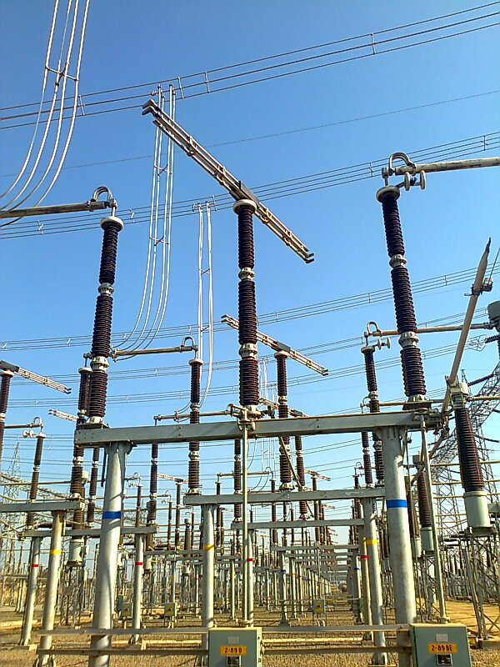

Fig. no. 2.5: Isolator

(b) Types:

(i) Horizontal central break type.

(ii) Center rotating, Horizontal break type.

(iii) Pantograph type.

(c) Location:

On either side of a circuit breaker.

**2.6 Earth switch:**

(a) Functions:

Discharge the voltage on the circuit to the earth for safety as shown in fig. no.2.6. [1]

(b) Location :

Mounted on the frame of the isolator. Generally used for each incoming / outgoing feeder.

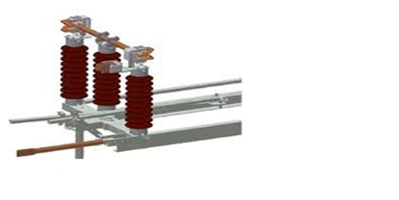

Fig. no. 2.6: Earth switch

(7) Insulators:

Function:

To isolate the live parts from earthed parts. [1]

Types:

Porcelain / glass insulations can be used as

(a) Post insulators

(b) Tension Insulators

(c) Suspension Insulators

Locations:

To support all live Electrical parts.

(8) Wave traps:

(a) Function:

Used for communication signaling protection etc. between different substations & main control room as shown in fig. no. 2.8. [1]

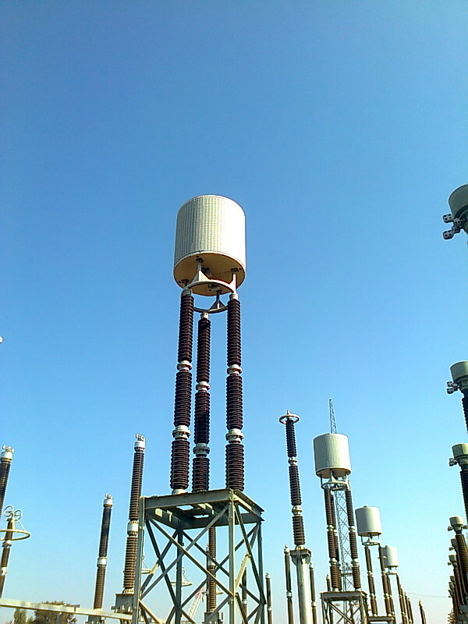

Fig. no. 2.8: Wave traps

Main components of carrier communication equipment are:

(i) Coupling Capacitor:

The coupling capacitor connects the carrier equipment to the line.

This unit prevents high frequency carrier signals from entering the neighboring lines.

(9) Lightning arrestor:

Function:

Used to protect the electrical system from lightning over voltages as shown in fig.no.2.9.[10]

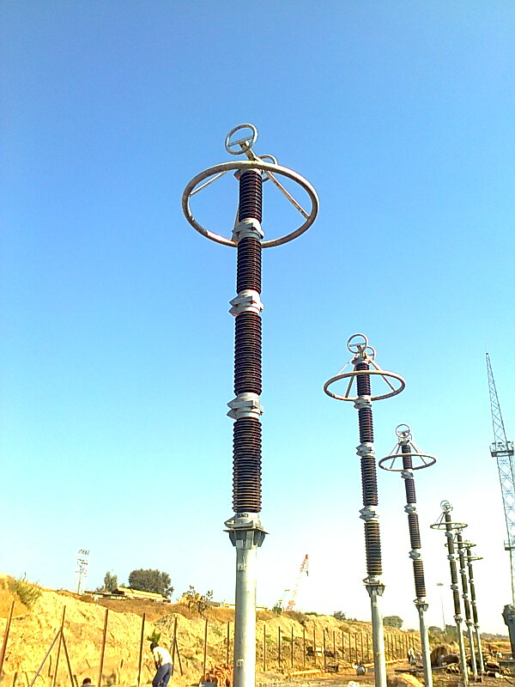

Fig. no. 2.9: Lightning arrestor

Types:

i) Silicon carbide (Gapped) type:

The non linear lightning arrestor basically consists of set of spark gaps in series with the silicon carbide non linear resistor elements.

ii) Metal Oxide Arrestor:

The MOV arrestor is the arrestor usually installed today. The metal oxide arrestors are without gaps, unlike the SIC arrestor.

III CONCLUSION:

Under this project we understood the importance and necessity of 400 KV switchyard.

We learnt about the switchyard schemes and various equipments used in switchyard their ratings, protection of alternator, transformer, bus, transmission lines, & interlocks along with its advantages and disadvantages.

In this project we came to know about standards of switchyard equipments, types of grounding of system, layout of switchyard & system used in switchyard.

**IV REFERENCES:**

[1]. N. MADHUKAR RAO, “O & M OF EHV SUB-STATIONS”, Technical manual for switchyard, PP. 5-156.

[2]. D.P. KOTHARI & I.J. NAGRATH, “MODERN POWER SYSTEM ANALYSIS”, Fourth Edition, Tata McGraw Hill, PP. 1-10.

[3]. SHREEMAT PANDE, “Construction Manual For Sub-stations”, Rajasthan Rajya Vidyut Prasaran Nigam Ltd., PP. 20-35.

[4]. http//www.abb.com/scada, SCADA offering in switchyard.

[5]. CEA, “Manual for switchyard standards: 2010”.

[6]. CEA, “Manual for safety procedures at 400 KV switchyard: 2009”.

[7]. V.K. MUTREJA, “POWER PLANT FAMILISATION”, 2006 Edition, PP.258-479.

[8]. Ashfaq Hussain, “electrical power system”, Fifth edition, CBS Publishers and Distributors, PP. 418-424.

[9]. SREENU GUTTA, “400 KV SWITCHYARD PROTECTION”, Manual for protection of Switchyard, PP.3-14.

[10]. M.S.NAIDU & V KAMARAJU, “High Voltage Engineering”, Third Edition, Tata McGraw Hill Publication, PP. 2-218.