**DESIGN OF LOW COST SOLAR TRACKING SYSTEM BY USING GEAR REDUCTION MOTOR**

Amit Kumar Rohan Shahir Asst. prof. S.G.Kewte

amitkumar@gmail.com engg.shahir@gmail.com shashi.kewte@gmail.com

Department Of Electrical Engineering, KDKCE, Nagpur*.*

***ABSTRACT***

***Solar energy is rapidly gaining notoriety as an important means of expanding renewable energy resources. As such, it is vital that those in engineering fields understand the technologies associated with this area. My project will include the design and construction of reduction gear motor solar panel tracking system. Solar tracking allows more energy to be produced because the solar array is able to remain aligned tothe sun. This system builds upon topics learned in this course. A working system will ultimately be demonstrated to validate the design.***

**Keywords: - Solar Tracker, PV cells, Azimuth &Zenith angle, Light Sensor, P-V Curve,LDR(lightdependent resistors).**

**I** **INTRODUCTION**

Renewable energy solutions are becoming increasingly popular. Photovoltaic (solar) systems are but one example. Maximizing power output from a solar system is desirable to increase efficiency. In order to maximize power output from the solar panels, one needs to keep the panels aligned with the sun. As such, a means of tracking the sun is required. This is a far more cost effective solution than purchasing additional solar panels. It has been estimated that the yield from solar panels can be increased by 30 to 60 percent by utilizing a tracking system instead of a stationary array. This project develops an automatic tracking system which will keep the solar panels aligned with the sun in order to maximize efficiency. The objective of this project is to control the position of a solar panel in accordance with the motion of sun. Brief Methodology: This project is designed with solar panels, LDR, gear reduction motor.

**II IMPORTANCE OF TRACKING**

In order to ensure maximum power output from PV cells, the sunlight’s angle of incidence needs to be constantly perpendicular to the solar panel. This requires constant tracking of the sun’s apparent daytime motion, and hence develops an automated sun tracking system which carries the solar panel and positions it in such a way that direct sunlight is always focused on the PV cells. This paper is about moving a solar panel along with the direction of sunlight; it uses a gear motor to control the position of the solar panel.[1]

**III EXPERIMENTAL WORK**

Two light dependent resistors (LDR) is used for each degree of freedom. LDRs are basically photocells that are sensitive to light. Software will be developed which would allow the PIC to detect and obtain its data from the two LDRs and then compare their resistance. The two LDRs will be positioned in such a way, so that if one of the two comes under a shadow, the MCU will detect the difference in resistance and thus actuate the motor to move the solar panel at a position where the light upon both LDRs is equal. Two separate but identical circuits will be utilized for both axes.

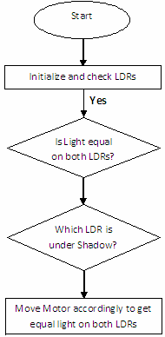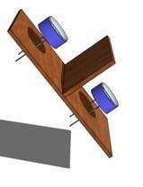

Fig 2 : Flow Chart Of The Operation Of Sensor Module

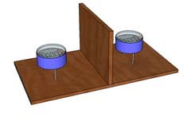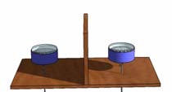Sensor Module Operation of sensor module LDR come under shadow

Fig 1: Operation Of Sensor Module

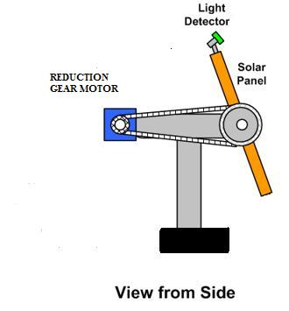

Fig 3 : Model Diagram For Project

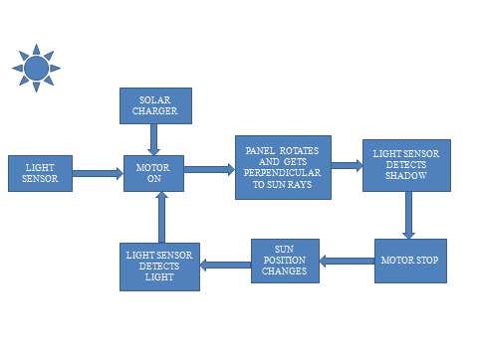

Fig 5 : Block Diagram Of Solar Tracking System

**IV DESCRIPTION**

Firstly on board light sensor is installed across mobile frame and over the panel inside the hollow pipe.Sun follows a particular path along its orbit.This is being sensed by light sensor.Sensor actuates the motor accordingly move the panel in allignmentwith the sun exact position.The alignment of sun and the light sensor is to be perpendicular with each other.When the position of sun changes the motor trips and panel will acquire the position exactly perpendicular to the sun.This will provide maximum efficiency at that instance.Again the sun comes perpendicular to light sensor and again the process repeats till dark.

EQUIPMENT USED

Solar Panel(17.6 v,0.58 amp,10 watt,1.5 kg )

Gear Reduction Motor (12v,60ma,10 rpm)

LDR(1kΩ)

**V SOLAR TRACKING AND PV PANEL EFFICIENCY**

Compared to a fixed panel, a mobile PV panel driven by a solar tracker is kept under the best possible insolation for all positions of the Sun, as the light falls close to the geometric normal incidence angle. Automatic solar tracking systems (using light intensity sensing) may boost consistently the conversion efficiency of a PV panel, thus in this way deriving more energy from the sun. Technical reports in the USA have shown solar tracking to be particularly effective in summer, when the increases in output energy may reach over 50%,while in autumn they may be higher than 20%, depending on the technology used.

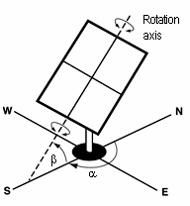Solar tracking systems are of several types and can be classified according to several criteria. A first classification can be made depending on the number of rotation axes.[4]. Thus we can distinguish solar tracking systems with a rotation axis, respectively with two rotation axes. Since solar tracking implies moving parts and control systems that tend to be expensive, single-axis tracking systems seem to be the best solution for small PV power plants. Single axis trackers will usually have a manual elevation (axis tilt) adjustment on the second axis which is adjusted at regular intervals throughout the year. A single-axis solar tracking system uses a tilted PV panel mount and a single electric motor to move the panel on an approximate trajectory relative to the Sun’s position.[4]

Fig:6 Tilt angle $α\&β$ of PV array

**VI LIGHT SENSOR THEORY**

A light sensor is the most common electronic component which can be easily found. The simplest optical sensor is a photo resistor or photocell which is a light sensitive resistor these are made of two types, cadmium sulfide (CdS) and gallium arsenide (GaAs). The sun tracker system designed here uses the cadmium sulphide (CdS) photocell for sensing the light. This photocell is a passive component whose resistance is inversely proportional to the amount of light intensity directed towards it. It is connected in series with capacitor. The photocell to be used for the tracker is based on its dark resistance and light saturation resistance. The term light saturation means that further increasing the light intensity to the CdS cells will not decrease its resistance any further.The average value called the solar constant E0 which is given in eqn no. 1.In the solar photovoltaic array the short circuit current generated is given by eqn 2.Maximum output power is measured by connecting the variable resistor R which will be given by RLOAD.The output signal is maximum output power of the solar PV array which will be given by PMAX in eqn no 3.[2]

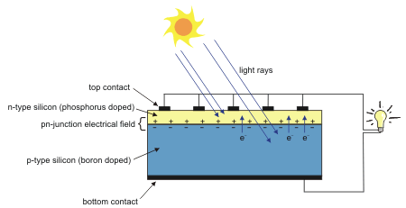

Fig 7:PV cell structure and operation schematic

**FORMULAE**

1.The solar irradiance level:

E0=1.3672W/m2  .............................................................(1)IPH≈ISC=C0E .............................................................(2)

Where,

E0=solar constant

E=irradiation level

2.Maximum output power:



RLOAD=

VMPP=maximum output power voltage

IMPP= maximum output power current

PMAX=IMPPVMPP .............................................................(3)

**VII TRACKER TYPES**

Solar trackers are devices used to orient photovoltaic panels, reflectors, lenses or other optical devices toward the sun. Since the sun’s position in the sky changes with the seasons and the time of day, trackers are used to align the collection system to maximize energy production. There are many types of solar trackers of varying costs, sophistication, and performance. The two basic categories of trackers are (1)single axis and (2)dual axis.

Single axis Solar trackers can either have a horizontal or a vertical axis. The horizontal type is used in tropical regions where the radiation of sun gets very high at noon, but the days are short. The vertical type is used in high latitudes where the sun does not get very high, but summer days can be very long. In concentrated solar power applications, single axis trackers are used with parabolic and linear Fresnel mirror designs.[6]

Dual axis solar trackers have both a horizontal and a vertical axis and thus they can track the sun's apparent motion virtually anywhere in the world. CSP applications using dual axis tracking include solar power towers and dish (Stirling engine) systems. Dual axis tracking is extremely important in solar tower applications due to the angle errors resulting from longer distances between the mirror and the central receiver located in the tower structure. Many traditional solar PV applications employ two axis trackers to position the solar panels perpendicular to the sun’s rays. This maximizes the total power output by keeping the panels in direct sunlight for the maximum number of hours per day.[5]

**VIII P-V Curve:**



Graph -Power versus voltage (p-v) characteristics of the PV module in sunlight.

The power output of the panel is the product of the voltage and the current outputs. In Figure, the power is plotted against the voltage. Notice that the cell produces no power at zero voltage or zero current, and produces the maximum power at voltage corresponding to the knee point of the i-v curve. This is why PV power circuits are designed such that the modules operate closed to the knee point, slightly on the left hand side. The PV modules are modelled approximately as a constant current source in the electrical analysis of the system.[8]

**IX AZIMUTH AND ZENITH ANGLE**



Fig 8:Azimuth and Zenith angle

The Zenith angle is the angle between the direction of the sun (direction of interest) and the zenith (straight up or directly overhead). The program calculates the Zenith angle in degrees and stores it in register SPA_ZENITH. This would be the TILT angle with 0° being horizontal. The suns elevation or altitude is the angle from the horizontal plane and the Suns central ray or just the compliment of the Zenith angle (90° - Zenith angle).The Azimuth angle is measured clockwise from true north to the point on the horizon directly below the object. The program calculates the local (from observer) azimuth angle (eastward from North) [0 to 360 degrees] and stores it in register SPA_AZIMUTH.[3]

**X CONCLUSION**

The goals of this project were purposely kept within what was believed to be attainable within the allotted timeline. As such, many improvements can be made upon this initial design. That being said, it is felt that this design represents a functioning miniature scale model which could be replicated to a much larger scale. The following recommendations are provided as ideas for future expansion of this project

**XI REFERENCES**

[1]. Nader Barsoum,Pandian vasant, “Simplified Solar Tracking Prototype”1982,conf. Rec. IEEE photovoltaic spec. Vol. 1, 2010. page no.38 - 45

[2]. Transaction in Controllers and Energy ISSN: 1985-9406 Online Publication, June 2010.

[3]. Design of a Low-cost Solar Tracking Photo-Voltaic(PV)Module.S.Lakeou,E.Ososanya,B.O.Latio, University Of The District Of Columbia.

[4]. Tiberiu Tudorache, Liviu Kreindler, “Design of solar trackersystem for pv power plant”vol 7 1,2010(page 23-27)

[5]. Solar Tracker With Optical Source,International Journal Of Electronics And Computer Science Engg.ISSN-2277-1956,page no. 860-864.

[6]. International Journal of Electronics and Computer Science Engineering 860ISSN- 2277-1956.

[7]. Non conventional energy sources by G.D. RAI, KHANNA PUBLISHERS.page no.10-37.

[8]. Dzung D. Nguyen, Brad Lehman, Sagar Kamarthi “Solar Photovoltaic Array's Shadow Evaluation Using Neural Network” 2007 IEEE 10,No.2,June 1995 Page no 45-49.