Ankit sadarang.
BE III year, Deparment of Electrical Engg.
K.D.K.C.E. Nagpur, Maharashtra.
ankitsadarang@gmail.com

Email id: - ankitsadarang@gmail.com

Abstract

Power crisis are the big problem of India, Over 10 million people in India still have no access to electricity. In such condition there is only a way to meet our energy demand that is Energy conservation which is possible by energy audit and better energy management. Energy Audit will help to understand more about the ways energy and fuel are used in any industry, and help in identifying the areas where waste can occur and where scope for improvement exists. The primary objective of Energy Audit is to determine ways to reduce energy consumption per unit of product output or to lower operating costs. The energy audit results in better energy management which results in energy conservation.

Key words: - Energy audit, Energy management.

I. INTRODUCTION

To institute the correct energy efficiency programs, we have to know first which areas in our establishment unnecessarily consume too much energy, which is the most cost-effective load. An energy audit identifies where energy is being consumed and assesses energy saving opportunities so you get to save money where it counts the most.[1]
Energy audit broadly covers the following questions:-
1) How much energy are we consuming?
2) Where is the energy consumed?
3) How efficiently is energy consumed?
4) Can there be improvement in energy use?
Energy management is a structured approach designed to manage energy usage and reduce energy costs, raising productivity and creating a better work environment. The goal of an Energy Manager is to produce a building that uses the least possible energy while maintaining optimal levels of comfort, safety and productivity. [1]
The relation between energy audit and the management of energy is as given in the fig.(1)

*Surveys,
ENERGY AUDIT *Inspection,
*Analysis.

ENERGY MANAGEMENT

ENERGY CONSERVATION

COST REDUCTION

Fig (1):-The relation between energy audit and the management of energy

2. IMPORTANCE OF ENERGY AUDIT AND Management

An energy audit becomes the best first step towards saving money in the production plant. Wide-scale resource conservation and emissions reduction projects require a system of reward and punishment but there is no way to implement this kind of system unless energy audits are conducted more fairly and become more effective overall. For example, green architecture is an important opportunity for energy conservation amidst urbanization, yet even when real estate companies try to invest in energy conservation, the companies still look for the greatest profits and do not always meet existing building conservation standards. Thus, strict implementation of energy audit is necessary for industries as they develop towards energy and sources conservation. Here importance of energy audit in home and industry is given:-

HOME ENERGY AUIDT:-

A home energy audit is often the first step in making your home more efficient. An audit can help you assess how much energy your home uses and evaluate what measures you can take to improve efficiency. But remember, audits alone don't save energy it only provides energy status. You can perform a simple energy audit yourself, or have a professional energy auditor perform a more thorough audit. Lower energy bills and increased energy savings: a detailed report will prioritize cost effective measures that you can take to ensure your home runs more efficiently.

industrial energy audit:-
Energy Audit is the beginning of Energy Saving in a plant and is recommended for almost all the Industries - irrespective of size and type. Industrial customers seeking to improve energy efficiency and cut operating costs should seriously consider having an industrial energy audit performed. Industrial audits can encompass the entire facility, or may be customized to meet your needs.
Industrial energy audit gives us following benefits:-
- Improved comfort levels
- Improve lighting levels
- Lower maintenance costs
- Reduce A/C Load
- Ability to track energy savings

OTHER IMPORTANCE OF ENERGY AUDIT:-

1) Compliance with Government regulations
2) Lower energy costs.
3) Enable faster recovery of investments.
4) Achieve better performance and lower downtime.
5) Enhanced power quality and productivity.
6) Reduced loss levels.
7) Improved Age of Equipment and complete system.

3 AUDIT STEPS

Generally there are some steps which are followed to make the audit and energy management:-

- Measure:- Set up an energy monitoring and reporting
System which will measure total energy
Consumption
- Conduct Audit: - surveys, inspection and analysis of consumption of power can be done after measurements.
- Execute and Formulize an Energy Policy Statement - energy consumption reduction (electricity, Fuel oil, gas, petrol, etc.)
- Recommendation: - Prepare and undertake detailed implementation plan and recommend the ideas for energy conservation.
- Implement staff awareness and training programs.
This all steps help us to better management of energy which helps us in energy conservation.
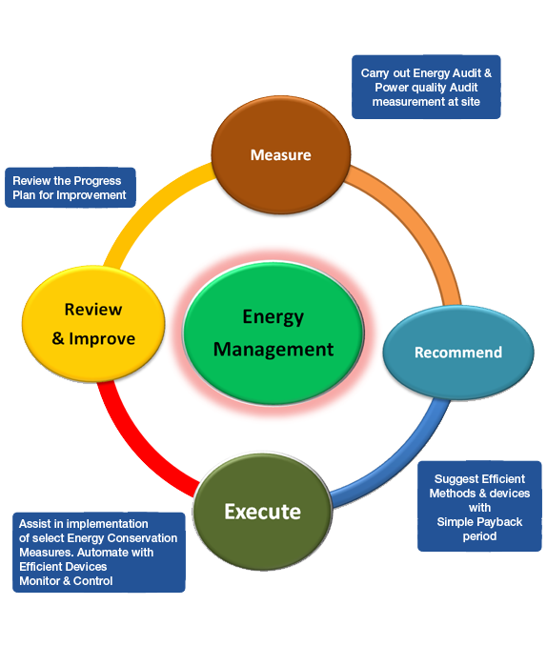
Fig (3):- Steps of Energy audit and the management[2]

4. INDIAN ENERGY SCENARIO

India is one of the countries where the present level of energy consumption, by world standards, is very low. The estimate of annual energy Consumption in India is about 330 Million Tones Oil Equivalent (MTOE) for the year 2004. Accordingly, the per capita consumption of energy is about 305 Kilogram Oil Equivalent (KGOE).
On the supply side, the miss-match between demand and supply is so large that India can ill-afford to choose one option in preference to the other. For several years, in fact may be for next few decades, India would need to exploit all possible options to create reasonably large capacity base on the energy side.
Sector wise consumption of electricity during 2012-2013[4]
Total consumption = 852902GWH
Agriculture = 17.95%
Domestic = 21.79%
Commercial = 8.33%
Industry = 44.87%
Traction and railways = 1.81%
Other = 05%
From this table it is clear that if we concentrate on energy consumption of domestic, commercial, industry where energy audit and management can be don easily then more energy conservation can be done in this sector. The important thing to remember is to focus on major energy users and areas to conserve energy. [4]

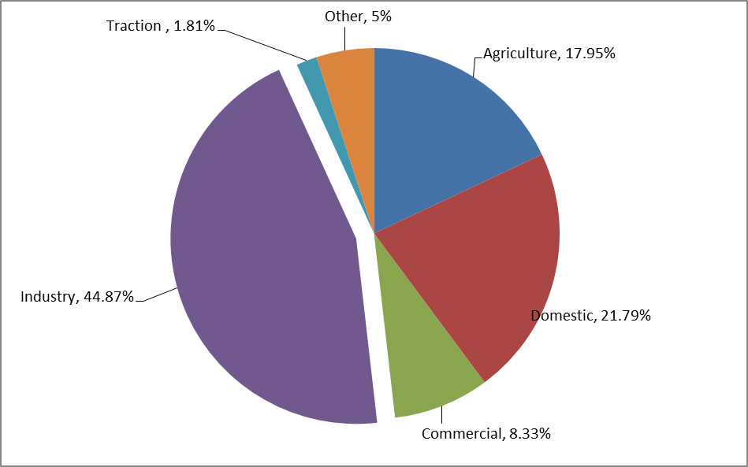

5. MANAGEMENT AND CONSERVATION OF
ENERGY

There are some basic approaches to enable energy efficiency, which are as follows:

1. Improvement of Power Factor: - power factor improvement is very necessary to conserve the power. There are some ways which are use for Improvement of Power Factor:-
1) Using the correct sized motor for a particular job
2) Shutting off unused motors
3) Installing a capacitor.

2. Use high energy star rated loads:- Energy star international standard for energy efficient consumer products originated. Devices carrying the Energy Star service mark, such as computer products and peripherals, kitchen appliances, buildings and other products, generally use 20%–30% less energy than required by federal standards.

3) Technical and Economic feasibility:-
The technical feasibility should address the following issues
• Technology availability, space, skilled manpower, reliability, service etc.
• The impact of energy efficiency measure on safety, quality, production or process.
• The maintenance requirements and spares availability.
The Economic viability often becomes the key parameter for the management acceptance. The economic analysis can be conducted by using a variety of methods.

4. create financial and or tax incentives for energy efficiency: - Financial incentives for energy efficiency come in the form of tax incentives, grants and rebates, and loan programs. These incentives are among the most common ways that states promote energy efficiency. Currently in India 22 states have a tax incentive to promote energy efficiency.

5. Make early decisions about your efficiency effort:- We should make early decisions for energy audit of , it will help to save power from initializing any industry.The National Council on Electricity Policy has also created tools and resources that can help, including guides to financing energy efficiency programs and to state programs that support energy efficiency, such as the 2006 State and Regional Policies That Promote Energy Efficiency Programs Carried out by Electric and Gas Utilities.

6 Awareness of energy issues among workers:- In the factory, doing an energy audit increases awareness of energy issues among plant personnel, making them more knowledgeable about proper practices that will make them more productive. An energy audit in effect gauges the energy efficiency of your plant against “best practices”. When used as a “baseline” for tracking yearly progress against targets, an energy audit becomes the best first step towards saving money in the production plant.

6. ADVANTAGES OF ENERGY AUDIT AND
MANAGEMENT

Greater Comfort - Energy efficiency and comfort go hand in hand. Improving your building envelope by air sealing and increasing insulation; installing window films and shades and radiant barriers, and high efficiency heating and cooling systems means a more comfortable home for a lower operating cost.
Financial benefits – Reduced expenditure on energy; e.g., by reducing consumption or changing tariff or fuel type. Reduced maintenance cost; e.g., following improved utilization of plant and optimization in operation. Saving in other costs; e.g., water charges, where demand is reduced Saving in other costs; e.g., water charges, where demand is reduce.
Operational benefits - Addition to direct cost benefits, further benefits can be achieved by optimizing the operation of a building, process or plant. Ultimately, these may well have financial implications. The information made available to management on energy costs and use could in itself be found invaluable in asset planning and decision making. Measures can also lead to improved working practices or conditions.
Environmental benefits:-Environmental benefits that arise from using energy more efficiently may include reduction of CO2 and other emissions both from the site itself and upstream of energy suppliers that can be harmful to the environment. Reduction of environmental impacts related to transmission, delivery or transport of energy. Reduction of regional and national energy demand. Conservation of natural resources particularly fossil fuels and other non-renewable fuels.
6. CONCLUSION

Energy audits provide a unique pathway for customers to save money. Energy conservation and cutting utility costs are extremely important as energy prices rise. Energy auditing is not an exact science, but a number of opportunities are available for improving the accuracy of the recommendations. Techniques which may be appropriate for small-scale energy audits can introduce significant errors into the analyses for large complex facilities. We began by discussing how to perform energy and demand balance for a company. This balance is an important step in doing an energy use analysis because it provides a check on the accuracy of some of the assumptions necessary to calculate savings potential. We also addressed several problem areas which can result in over-optimistic savings projections, and suggested ways to prevent mistakes. Finally, several areas where additional research, analysis, and data collection are needed were identified. Once this additional information is obtained, we can all produce better and more accurate energy audit results.
Audits are great investments for the future, often resulting in immediate returns and a quick payback.

7. REFERANCES
[1] Energy Management & Audit (BEE).
[2] Energy Conservation, Efficiency & Energy Audit by R.A. Sharma(Electrical India Vol.46 & No.09).
[3] Generation of electrical energy (B. R. Gupta).
[4] Report on Growth of electricity sector in India from 1947-2013 (Central India Authority, Ministry of Power India) .
[5] Energy Auditing of Induction Motor (ISSN: 2248-9622, Vol.4, Issue 1(Version 1), January 2014, pp.238-242.

 

