**“POWER QUALITY IMPROVEMENT BY SOLAR-HYDRO HYBRID SYSTEM”**

**Ms.Shreya Halve Ms.Kalyani Nakhate**

**B.E 8th sem (EE) B.E 8th sem (EE)**

**SRMCEW SRMCEW**

**ABSTRACT**

***The renewable energy systems are an attractive option to electrify the community as they are environment friendly and free of cost. In this project solar and hydro system as a smart technological concept of the sustainable energy which can provide continuous electric power to the load is used. This project deals to improve the efficiency of renewable sources by using them in parallel. Due to intermittent nature of both the hydro and solar energy sources, utility grid is connected to the system for ensuring the continuous power flow. The power contribution of the system is Hydro power-7.4Watt, Solar power- 8-9Watt.***

**Keywords**: Solar panel ,DC generator, Hydro Turbine, PIC Microcontroller.

# INTRODUCTION

. Electricity requirement is increasing day by day all over the world. In recent years, India’s energy consumption has been increasing at one of the fastest rates in the world due to population growth and economic development that’s why it’s time to prepare about the arrival future difficulty. Conventional sources will get exhaust in future thus the system based on non-conventional energy sources are commonly used. A hybrid system usually consists of two or more renewable energy sources use together to improve system efficiency as well as proper balance in energy supply. In proposed system combination of hydro and solar power is use together and gives the output to the load. System consists of Solar Panel, Hydro-Turbine, DC Generator, Stabilizer, Inverter,PIC Microcontroller and Battery. The power contribution of the system is Hydro power-7.4Watt, Solar power- 8-9Watt.

Both renewable energy systems cannot fulfill the power requirement alone as they are intermittent in nature. The only solution to this problem is the hybrid energy system. Some common used hybrid energy systems are solar wind, wind hydro, wind diesel, solar thermal biomass, and so forth. Recently, the researchers are investigating on solar and hydro based hybrid energy system. This hybrid energy system can be implemented to those areas, where solar and hydro resources are moderate in nature..

**2.STRUCTURE OF SYSTEM**

In this paper two models are described. One is sof tware model and second is hardware model. The software model of the system is without switching or controlling operation and hardware model is with control or switching operation.

**2.1 The Software Includes:**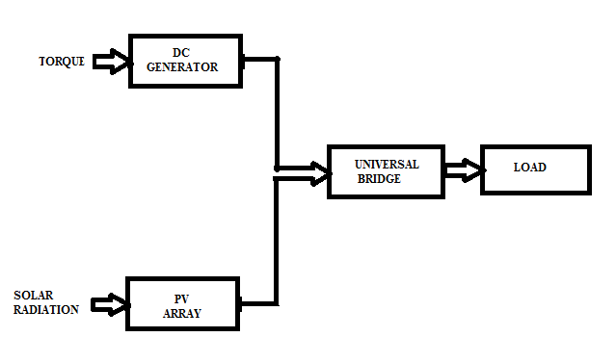

Fig 2.1.1: BLOCK DIAGRAM OF SOFTWARE

**SIMULATION RESULTS**

**The block diagram of DC Generator and PV array with resistive load shown in fig.2.1.1 has been developed in MATLAB/ Simulink.**

SIMULATION RESULTS OF SYSTEM WITHOUT CONTROL SCHEME:

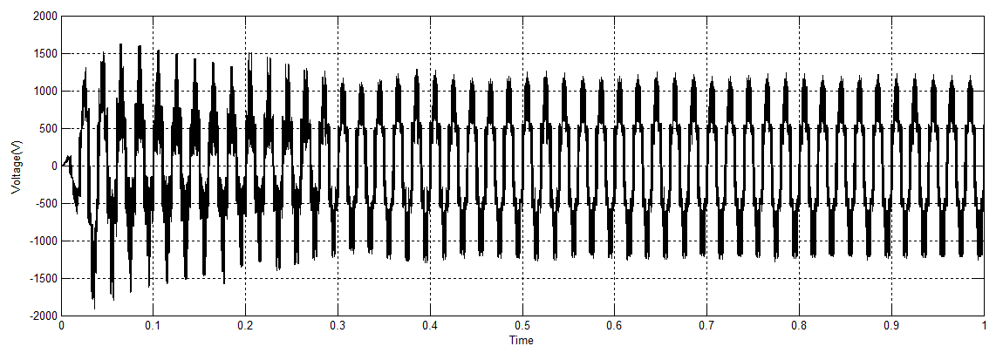

Fig 2.1.2: Output voltage of Hybrid system

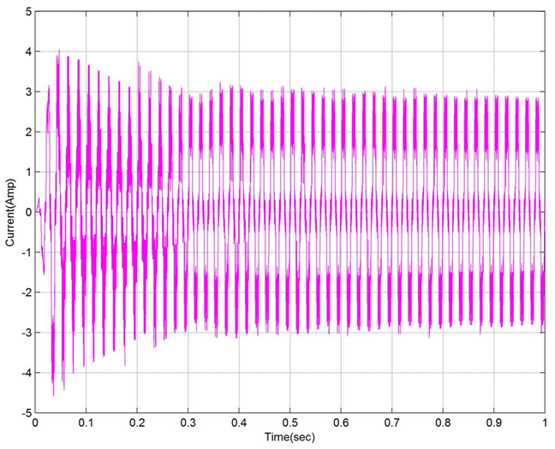Fig 2.1.3: Output current of hybrid system

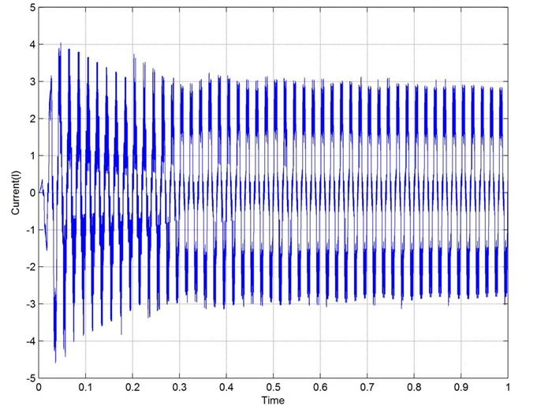

Fig 2.1.4: output Power of hybrid system

**Result Analysis**

**Here DC motor act as DC generator and the input given to DC motor is -50 torque and the output obtained from this system is 2.82KW.Output obtained from PV Array is 132W.Output obtained from complete system are voltage-1.6KV. Current-4.05Amp. power-4.8KW.**

**2.2 The Hardware Includes:**

**BLOCK DIAGRAM** 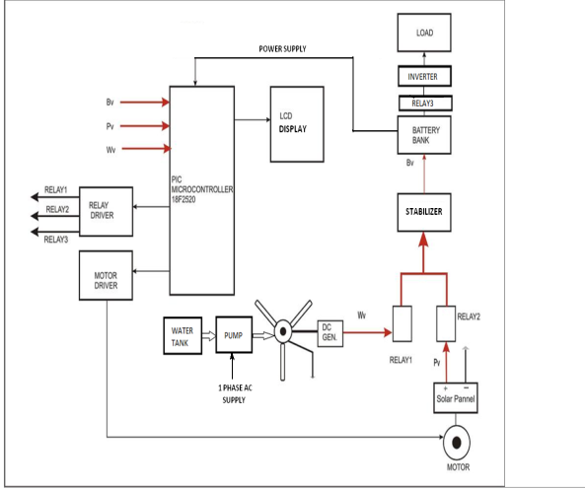

Fig. 2.2 .1: Block diagram of Hardware

**Description of Hardware:**

* Pump: - It is used to eject water on the turbine.
* Turbine:- It converts kinetic energy of water into mechanical energy.
* DC Generator: - The DC generator is used to converts mechanical energy into electrical energy
* Solar Panel: - It collects solar radiations. It is a set of solar photovoltaic module electrically connected and mounted on a supporting structure.
* Battery:-It stores the energy generated by the systems.
* Stabilizer:-To regulate the voltage up to charge level of battery.
* Inverter: - It is a device which converts the dc voltage into ac voltage.
* PIC Microcontroller:-It is 8bit microcontroller with 10bit ADC, which amplifies relay driver and control motor driver.

Control Strategy

The operation of relay1 and relay2 depends upon the availability of supply. If input to the hydro system is 50% less than the solar then relay1 will be at off position and relay2 will be at on position, and power is supplied to the load by solar power system. Similarly if solar power input is 50% less than the hydro then relay2 will be at off position and relay1 will be at on position and power is supplied by hydro power system.

**5.CONCLUSION**

In our project we are expecting to generate power to fulfill the load requirement without any disturbances even when any one of the source is available. For continuity of the supply the hybrid technique is better option. This type of system will increases the efficiency of the power station and also increases the reliability. As we are using renewable energy source the cost of electricity will reduce and it also help in improvement of the environment.

**REFERENCES**

* Sweeka Meshram,Ganga Agnihotri and Sushma Gupta,”Performance analysis of grid integrated hydro and solar based hybrid systems”, MANIT,Bhopal,January 2013
* Deepak Kumar Lal, Bibhuti Bhushan Dash,A.K.Alella,”Optimization of PV/Wind/Hydro/Diesel hybrid power system in HOMER for the study area”, Vol.3,NO.3,2011 International Journal on Electric Engineering and Informatics,
* Shafiqur Rehman,Luai M. Al-Hadrami,”Study of solar PV Diesel Battery hybrid power system for a remotely located population”, 3rd international conference on sustainable energy and environmental protection,Vol.35,SEP2009
* Pragya Nema, Saroj Rangnekar,”A current and future state of art development of hybrid energy system using Wind and PV solar”, Vol.13,October 2009

**Books**

* Power Electronics by M.D. Singh, K.B.Khanchandani
* Power Electronics by Dr. P.S. Bhimra
* Non-Conventional Energy Sources by G.D.Rai
* 8 Bit Microprocessor And Interfacing by Vibhute And Borle