Sensorless Induction Motor Drives for Power Control Fed by a Matrix Converter

Kirti Mohan Dhenge⁽¹⁾ S. R. Gupta⁽²⁾
Priyadarshini College of Engineering, Priyadarshini College of Engineering, Nagpur Nagpur
kirti.dhenge7574@gmail.com sumitra.gupta@rediffmail.com

Abstract—Various control methods have been proposed for the sensorless speed control of an induction motor. For the sensorless control of matrix converter drive using power flowing to the motor a new and simple controlling technique has been introduced in this project. In addition to this the real and imaginary power of an induction motor controlled by control scheme is proposed. The non linearity’s of matrix converter drive such as commutation, delays, turn on and turn off times of switching devices and ON-state switching device voltage drop are minimized by using a reference power control scheme. This scheme improves the low speed sensorless performance of the induction motor drive.
Index Terms— Induction Motor, Matrix Converter, Power Controller, SVM.

INTRODUCTION
INDUCTION motor drives fed by a matrix converter have been developed for the last decades [1]. The matrix converter drive has recently attracted the industry application and the technical development has been further accelerated because of increasing importance of power quality and energy efficiency issues. The induction motor drive fed by matrix converter is superior to the conventional inverter because of the lack of the bulky dc-link capacitors with limited life time, the bidirectional power flow capability, the sinusoidal input/output currents, and adjustable input power factor. Furthermore, because of the high integration capability and the higher reliability of the semiconductor structures, the matrix converter topology is recommended for extreme temperatures and critical volume/weight applications. However, a few of the practical matrix converters have been applied to induction motor drive system because the implementation of switch devices in the matrix converter is difficult. Also, modulation technique and commutation control are more complicated than the conventional pulse width modulation (PWM) inverter [1]–[3].
The instantaneous power control (IPC) scheme for induction motor drives was initially presented in [4]. It is a relatively new high-performance control scheme for induction motors. It is based on controlling the instantaneous real and imaginary powers into the induction motor. It is motivated by the fact that real power controls the torque produced by the motor and the imaginary power controls the flux. The advantages of the IPC are simple algorithm implementation, fundamental physical-laws based algorithm, robustness and limited dependence on detailed knowledge of parameters, and flexibility applicable to all sine wave ac machine. The IPC algorithm conceptually lies somewhere between field oriented control (FOC) and direct torque control (DTC). It has the switching frequency predictability of FOC and the stationary reference frame implementation simplicity of DTC. In this paper, the synchronous reference-frame based IPC is presented for a high performance matrix converter drive.

POWER CONTROL OF A MATRIX CONVERTER DRIVE

The IPC is based on controlling the instantaneous real and
imaginary powers into the induction motor. It is motivated by
the fact that real power controls the torque produced by the motor and the imaginary power controls the flux. The proposed topology of the power control is shown in Fig. 1. The controller contains real and imaginary power PI-regulators. It receives as inputs the torque reference, the real and imaginary powers and generates the inverter’s command voltages in a synchronous reference frame.

Instantaneous Active and Reactive Power
In this section, instantaneous active and reactive powers are
defined by the scalar and vector product of the voltage and the current space vectors [12]. The three phase voltages and currents in abc-coordinates can be transformed in αβ coordinates as

=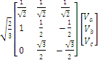
and
=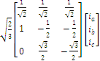 (1)

Active and reactive powers are defined as

=+=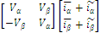 (2)

Fig. 1. Proposed sensorless vector control for matrix converter drives.

where . and . are the average active and reactive power dc term originated from the symmetrical fundamental component of the load current (.iα and.iβ ), . is the average active power delivered to the load, . is the average reactive power circulating between the phases, ˜ and ˜are the active and reactive ac ripple term originating from harmonic and asymmetrical fundamental component of the load current (˜iα and˜iβ ), ˜ is the ripple of active power that corresponds to power oscillations between the source and load, and ˜ is the reactive power’s ripple that corresponds to power oscillations between the phases.
As it can be seen from (2), the instantaneous powers P and Q comprise two parts, one is a dc component and the other one is an ac component. The instantaneous powers can be separated into a dc part and an ac part by filters without energy-storage element since the average values of these are zero. The ac parts ˜ and ˜ are useless powers which come from various nonideal circuit conditions such as unbalanced voltage and loads, distorted system voltages, and nonlinear loads [12].

Power Reference Generation

If The instantaneous real power P into the motor can be separated into three terms such as the power dissipated in the stator and rotor resistance, the time rate of change of the magnetic energy stored in the inductances in the motor, and the power for energy conversion [11]. This means some power is lost in the stator and rotor resistance and iron loss of the motor. While the stator resistance power and iron losses can be ignored, the power in the rotor resistance cannot be ignored, especially under heavy load conditions when the slip of the motor can be large. In this paper, a simple compensation method for those losses will be proposed later. The instantaneous imaginary power Q into the motor is related to the instantaneous rate of magnitude change or vector acceleration of the flux vector in the motor. The space vector diagram for power control can be seen as Fig. 2.
The Q-axis imaginary power reference considered the slip frequency of the motor that can be shown as

Q∗ = im vEM F = im ωe λm = im (P ωm + ωsl ) λm

Where im is the magnetising current vEM F, is the back EMF voltage, ωe is the electrical frequency, λm is the flux magnitude,

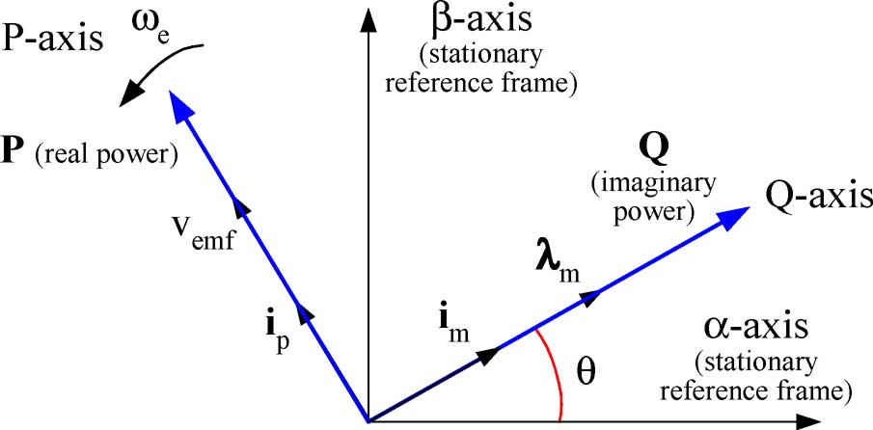

Fig. 2. Space vector diagram for powercontrol.
P is the motor pole pairs, ωm is the mechanical frequency, and
ωsl is the slip frequency.
The slip frequency of the motor is intimately related to the torque. The logical extension to this is that the desired slip frequency is related to the desired torque [13]. The slip equation with the torque expression can be written as

=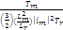 . (4)
By using (3) and (4), the slip can be expressed as

s= (5)
2

The real power reference can be written from (5) as

= (6)

Assuming that the leakage inductance of the motor is very
small related to the Lr, the Q-axis imaginary power reference
can be written as

=+ (7)

SPEED OBSERVER USING POWER THEORY

- Constant Air Gap Flux Operation

An induction motor can be described by the following voltage
equations. The corresponding equivalent circuit in the rotating PQ reference frame is shown in Fig. 3

=+-

=+-

0=+-

0=+- (8)

where and are the stator P- and Q-axis voltages, and are the stator P- and Q-axis currents, i P r and i Qr are the rotor P- and Q-axis currents, and are the P- and Q-axis stator ﬂuxes, and are the P- and Q-axis rotor ﬂuxes, is the stator resistance, is the rotor resistance, is the synchronous angular frequency, and is the rotor angular frequency.

Fig. 3. PQ equivalent circuit of an induction motor.

The ﬂux equations are given as

(9)

where and are the P- and Q-axis air gap ﬂuxes, and are the stator and rotor leakage inductances, and is the magnetizing inductance.
The electromagnetic torque is in terms of d- and q-axis
Components

(10)

The stator voltage equation in (8) can be rewritten using (9)as

=++ + + (11)

If the power control is fulﬁlled such that the time derivative
of P- and Q-axis stator currents in the rotating frame can be
constant during a control sampling period, the electromagnetic torque is controlled only by P-axis current from (10), and (11)can be rewritten as

=+ + + (12)

(13)

Ignoring the terms related to the rate of change of the air gap ﬂuxes and , (12) can be rearranged as

= + + (14)

If the voltage drop across the stator resistance is negligible in comparison with >> , then

≈ ≈ = (15)

where is the magnitude of the back EMF voltage.

If the variations of the air gap ﬂuxes and stator currents in the rotating frame can be constant, can be calculated from the value of magnetizing current and supply voltage.
In order to build a high-performance speed sensorless con-
trol algorithm for the induction motor drives fed by a matrix
converter, more accurate information on the motor speed and
more robust against motor parameters are required. In particu-lar, in the low-speed operation, the machine-model-based ob-server [7], [9] does not produce fairly satisfactory performance without a parameter adaptation scheme when motor parameters vary in operation. New observer using the constant ﬂux air gap and the imaginary power ﬂowing into the motor is proposed to overcome this problem. The proposed speed observer based on the use of the imaginary power would be insensitive to the knowledge of the resistance because the imaginary power is directly related to ﬂux in the motor and frequency, and not power ﬂow due to the consumption of real power in resistance. The proposed algorithm is also very simple and easy to apply to the real industrial applications.

- Design of Speed Observer

The instantaneous real power P is effectively the real power
being consumed in the slip modiﬁed rotor resistance of the motor plus any power stored in the ﬁeld and the imaginary powers Q is related to the instantaneous rate of magnitude change or vector acceleration of the ﬂux vector in the motor. In steady state, Q becomes equal to the conventional reactive power in a motor [12], [13].
Fig. 2 illustrates a vector diagram for an induction motor,
showing the relationship between the currents, voltages, and
ﬂuxes. The imaginary power is the voltage in one axis of the
motor multiplied by the current in the other axis. The instant-
neous imaginary power can be deﬁned as

Q ≈ (16)

Equation (16) can be rewritten by using (15)

Q = () (17)

where =
. Given that Q can be determined from (2), then (17) can be
rewritten so that is the subject of the expression:

= (18)

where =/ and =/
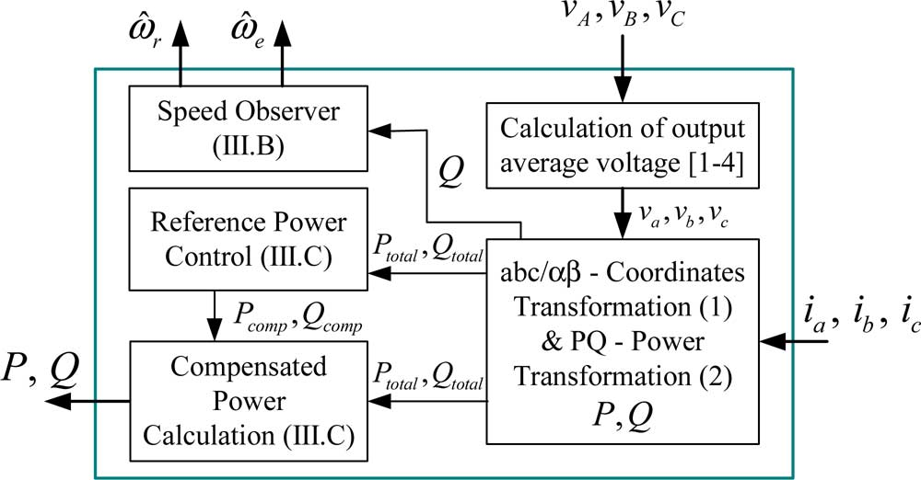
Fig. 4. Speed observer and power calculation with nonlinearity compensation.

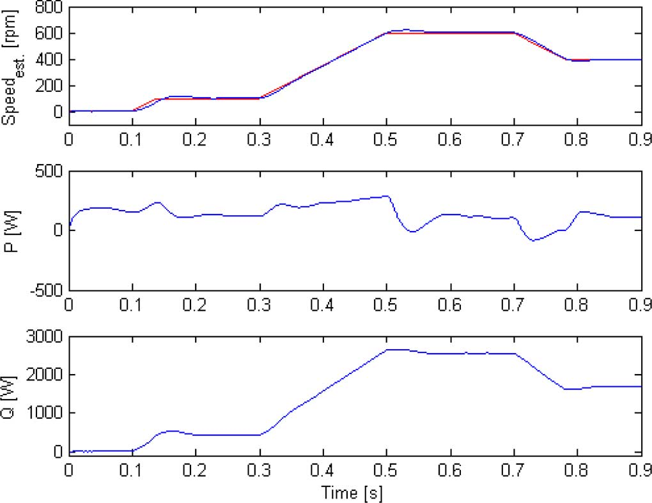
Fig. 5. Speed response of the proposed speed observer: speed reference and speed, speed error, and Q (simulation result).

The proposed scheme is shown in Fig. 4, which consists of
a speed observer, a PQ power transformation, and a reference
power control. Fig. 5 shows the simulated waveforms using the ideal matrix converter model for the proposed speed observer. It is shown in Fig. 5 that the estimated speed converges to theactual value by the proposed observer. It can be also seen by this simulation result that the waveform-shape of imaginary power Q is almost the same as the estimated speed. If the matrix converter is no longer considered ideal, the nonlinearity of matrix converter can cause considerable distortion in the voltages, especially at low speed [6]. Therefore, the distortion of the Q would also occur due to this nonlinearity. Fig. 6 shows the speed observer response at the low-speed region. From this simulation result, the inﬂuence of the nonlinearity of the matrix converter on the speed estimation has to be investigated and compensated for these inﬂuences.

C. Nonlinearity Compensation for Low-Speed Operation Power Reference Generation

As mentioned in the previous section, the voltages due to the nonlinearity of matrix converter drives cause the matrix converter output voltage distortion, and results in the imaginary
power distortion and speed ripple. The disturbance voltages are 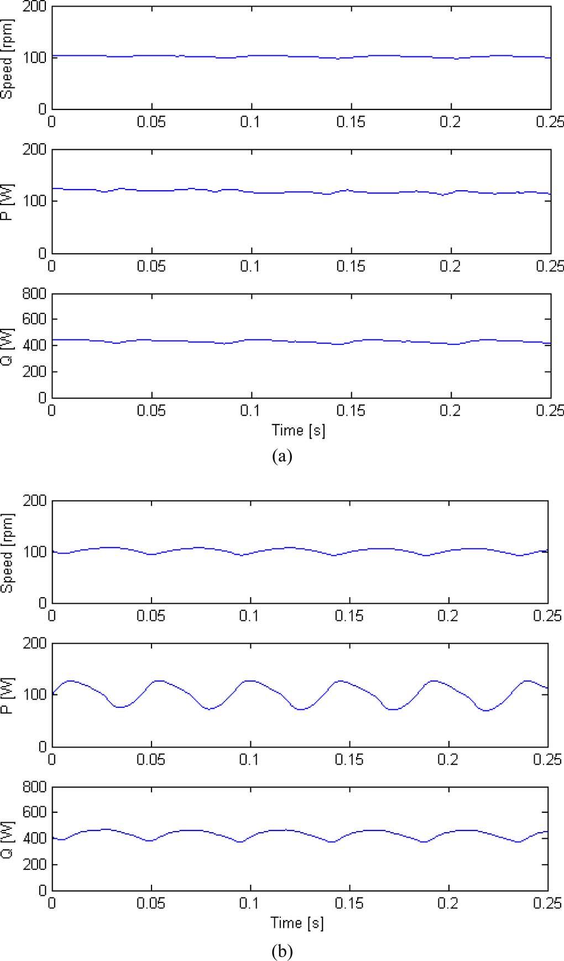

Fig. 6. Speed response of the proposed sensorless observer in the low speed operation (a) with 0.5 s commutation delay and (b) with 2 s commutation delay: speed, P , and Q (simulation result).

a function of a commutation delay, turn-ON and turn-OFF time of the switching device, ON-state switching device voltage drop, and a current polarity [6]. However, the commutation delay, ON-state voltage drop of the switching devices, and a current polarity are varying with the operating conditions. Since it is very difﬁcult to measure the commutation delays and ON-state voltage drops as well as to determine the current sign when the phase currents are closed to zero, it is not easy to compensate the nonlinearity of matrix converter drives in an off-line manner [8], [10]. To alleviate these problems, online nonlinearity compensation method using a power transformation is employed to improve speed sensorless performance.

Fig. 6 shows some cases of the real and imaginary powers.
In Fig. 6(a), real power P and imaginary power Q comprise
almost a dc component. In Fig. 6(b), powers are distorted by
the nonlinearities of a matrix converter. The powers P and Q
contain an ac component.

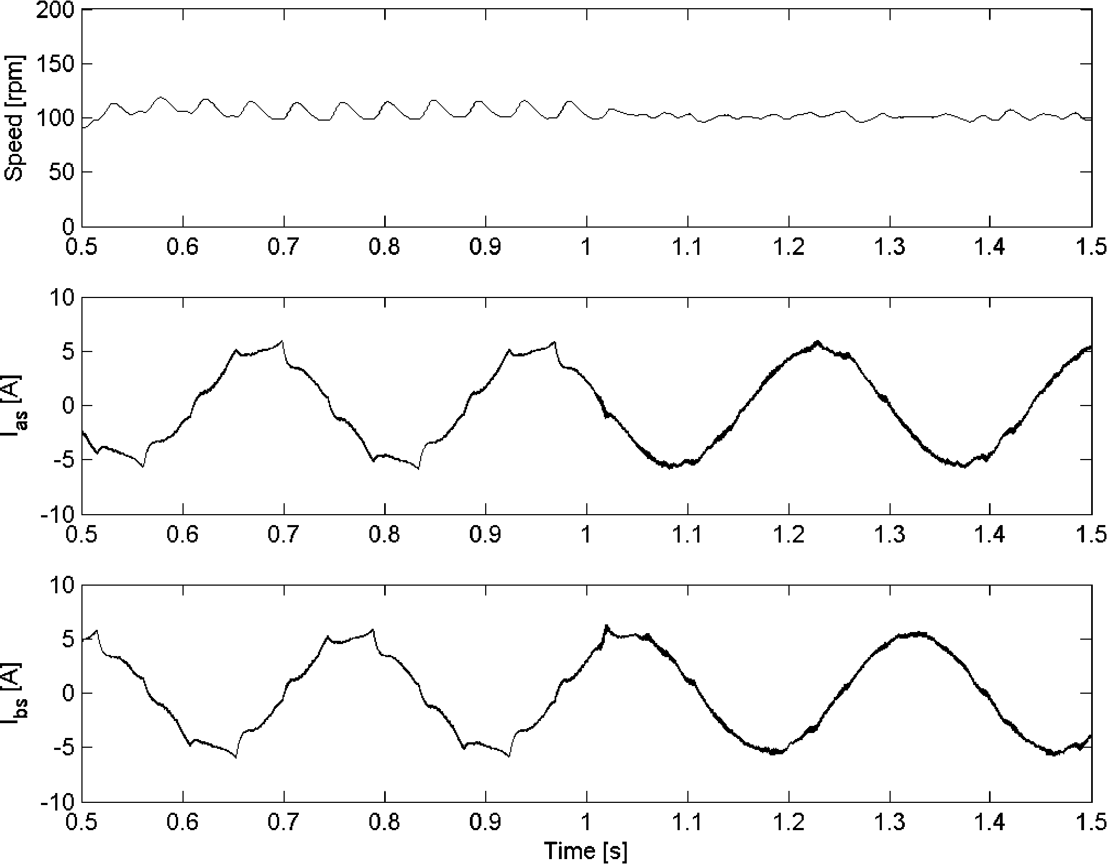
Fig. 7. Simulation results for the presented nonlinearity compensation at 100 r/min: real speed and phase currents (the compensation begins to operate after 1 s).

As it is shown in the simulation results (see Fig. 6), if the matrix converter currents are balanced and sinusoidal, the P and Q comprise only the dc component. When the currents are unbalanced and distorted by nonlinearity of the matrix converter, the unbalanced and harmonic component of the current exists in the P and Q. To eliminate these unbalanced and distorted currents due to current sensing unbalance and distortion by nonlinearity of matrix converter drives, a reference power control method can be introduced. To make the compensation powers simple ﬁrst-order low-pass ﬁlters are used to separate the calculated variables into the ac and dc components (see Fig. 6). The classiﬁed ac and dc components are used to calculate the compensation current for the current controller.
The total powers P and Q are calculated by the PQ transformation, as shown in (2). The instantaneous real power P consists of an ac component and a dc component
. The Q also consists of an ac component and a dc component . The ac components and are related with nonlinear conditions such as harmonics. Therefore, to get the output currents symmetrical and sinusoidal, P and Q have to be controlled to a dc value.
The compensation powers can be represented as
= and = (19)
Fig. 7 shows the simulation waveforms for the nonlinearity
compensation of matrix converter drive. Before starting the compensation, the nonlinearity causes undesired speed pulsations of about six times the electrical frequency. The speed estimation error is almost eliminated after starting the compensation.

V. CONCLUSION

A new and simple sensorless power control for induction motor drives fed by matrix converter using the constant air gap flux and the imaginary power flowing to the motor has been proposed in this paper. The proposed sensorless scheme was independent of the value of the motor parameter. In addition, a nonlinearity compensation strategy using a power theory has been employed to make the speed control performance better in the low-speed region. The experimental results have shown that the satisfactory speed sensorless performance in various speed operations has been obtained.

REFERENCES

[1] M. P. Kazmierkowski, R. Krishnan, and F. Blaabjerg, Control in Power Electronics—Selected Problems. New York: Academic, 2002, ch. 3 (ISBN 0-12-402772-5).
[2] P. Nielsen, F. Blaabjerg, and J. K. Pedersen, “New protection issues of a matrix converter: Design considerations for adjustable-speed drives,” IEEE Trans. Ind. Appl., vol. 35, no. 5, pp. 1150–1161, Sep./Oct.
1999.
[3] P. W. Wheeler, J. Rodriguez, J. C. Clare, L. Empringham, and A. Wein- stein, “Matrix converter: A technology review,” IEEE Trans. Ind. Elec- tron., vol. 49, no. 2, pp. 276–288, Apr. 2002.
[4] L. Huber and D. Borojevic, “Space vector modulated three-phase to three-
phase matrix converter with input power correction,” IEEE Trans. Ind. Appl., vol. 31, no. 6, pp. 1234–1246, Nov./Dec. 1995.
[5] C. Klumpner, P. Niesen, I. Boldea, and F. Blaabjerg, “A new matrix converter-motor (MCM) for industry applications,” IEEE Trans. Ind. Electron., vol. 49, no. 2, pp. 325–335, Apr. 2002.
[6] K. B. Lee and F. Blaabjerg, “A nonlinearity compensation method for a matrix converter drive,” IEEE Power Electron. Lett., vol. 3, no. 1, pp. 19–23, Mar. 2005.
[7] K. B. Lee and F. Blaabjerg, “Reduced order extended luenberger ob- server based sensorless vector control driven by matrix converter with non-linearity compensation,” IEEE Trans. Ind. Electron., vol. 53, no. 1, pp. 66–75, Feb. 2006.
[8] K. B. Lee and F. Blaabjerg, “Performance improvement of sensorless vec- tor control for matrix converter drives using PQR power theory,” Electr. Eng., vol. 89, no. 8, pp. 607–616, Sep. 2007.
[9] K. B. Lee and F. Blaabjerg, “Sensorless DTC-SVM for induction mo- tor driven by a matrix converter using a parameter estimation strat- egy,” IEEE Trans. Ind. Electron., vol. 55, no. 2, pp. 512–521, Feb.
2008.
[10] R. E. Betz and T. Summers, “Instantaneous power control—An alterna- tive to vector and direct torque control?,” in Proc. IAS 2000, pp. 1640–
1647.
[11] N. Urasaki, T. Senjyu, K. Uezato, and T. Funabashi, “A dead-time com- pensation strategy for permanent magnet synchronous motor drive sup- pressing current distortion,” in Proc. IEEE IECON 2003, pp. 1255–

 

