**POWER FACTOR IMPROVEMENT OF INDUCTION MOTOR DRIVES BASED ON SCOTT TRANSFORMER**

**Ms. Snehal M. Khobragade Prof.B.S.Dani**  **Mr.R.S.Kumbhare**

Mtech(IDC) pursuing AP Mtech(IPS)

Priyadarshini college of Engineering Priyadarshini College of Engineering TGPCET

R.T.M.N.U., Nagpur R.T.M.N.U. ,Nagpur R.T.M.N.U. , Nagpur

8600402992 9422816938 7276759275

[skhobragade02@gmail.com](mailto:skhobragade02@gmail.com) bs_dani@rediffmail.com rakesh.s.kumbhare@gmail.com

***ABSTRACT  :*** *A Scott transformer based three phase, two switch power factor correction boost rectifier for improving the power quality in a three level diode clamped inverter feeding induction motor drive we used here. Mitigate power quality problems at the front of IMD. This result in reduction of voltage stress on motor winding In this, the three-phase rectifier with a new connection is presented. Using only two active switches, the rectifier is able to generate symmetrical currents in the line and a balanced split dc-bus output voltage, which is necessary in several applications. Pulse width modulation control are used. There are two voltage controls that regulate the output voltage and the split dc-bus voltage*

***Keywords  -*** *Scott transformer, PFC Rectifier controlling, Induction motor drive, power factor corrector (PFC) converters,, split dc-bus voltage, three-phase rectifier.*

# **I. INTRODUCTION**

One of the improved power quality AC-DC converters for low or medium powered drives is a three-phase, two-switch power factor correction (PFC) boost rectifier based on a Scott transformer. It is used to provide improved PF at AC mains, reduced AC current harmonics, nearly sinusoidal AC current, and constant DC voltage even under varying input AC voltage and loads. Besides, it also provides low frequency isolation for safety[2]-[3]. Multi-level VSIs are used for medium and high-voltage/ power ac motor drives. In this a Scott transformer based three-phase, two-switch boost PFC rectifier for improving the power quality. The proposed PFC rectifier provides nearly improved PF at AC mains along with sinusoidal supply current and effective dc link voltage regulation in wide operating range of load on the drive. The Scott transformer provides galvanic isolation and sine and cosine secondary voltage waveforms to the high power factor rectifiers, resulting in a perfectly regulated dc output voltage[4]. This rectifier has a split dc-bus and the voltages across the switches are VO/2. The control method employed to control the currents of the two boost inductors, Each PFC boost rectifier has two loops one is voltage outer loop and the other inner current loop. Voltage loop of boost rectifier-1 guarantees the voltage regulation and the other guarantees the balanced voltage across two split capacitors[6]. The controller block diagram for generating two PWM pulses is shown in Fig. 1. The voltage of dc link is shown in fig. 2 and voltage across capacitors shown in fig.3.

# **II Literature Survey**

1 A. A. Badin and I. Barbi, “Unity Power Factor Isolated Three-Phase Rectifier With Split DC-Bus on the Scott Transformer,” *IEEE Tran.* Power Electronics, vol.23, no.3 ,pp.1278-1287 ,May 2008.

-have proposed the instantaneous average current control PWM technique for three-phase rectifier PFC based on Scott transformer. The use of the Scott transformer makes a split DC-bus voltage possible and the rectifier operates with unity power factor

2. G. A. Varsamis, E.D. Mitronikas and A. N. Safacas,”Field oriented control with space vector modulation for induction machine fed by diode clamed three level inverter,” *IEEE Tran.* in Proc. Conference on Electrical Machines, ICEM, Sept.2008, pp.1-6.

- have presented FOC method for an IM drive by a three-level DCI using SVM. Also, the use of the control system to eliminate the impact of the DC link voltage unbalance on the torque of the induction machine is examine.

3 S.K.T. Miller and I. Barbi, ”Practical aspects of the unity power factor isolated three-phase rectifier based on the Scott transformer,” in Proc. *IEEE Tran.* Applied Power Electronics Conference and Exposition, March 2005, vol.1, pp. 621-627

- presents a Scott transformer for isolation and uses instantaneous average current control. Models for proper design of the current and voltage loops are obtained by two methods. Using these models, reference current phase-shifting is analyzed and implemented. A design procedure for the boost inductors and the Scott transformer, based on switching functions

# **III. Indentations and Equations**

The PFC boost rectifier controller for generating PWM pulses to its switches. Voltage loop of boost rectifier-1 guarantees the voltage regulation and other guarantees the balance voltage across two split capacitors. Modeling of the controller is explained as follows.

The sensed dc link voltage Vdc is compared with reference ${V_{dc}}^{*}$ to generate ${I_{d}}^{*}$ through a limiter using a PI controller.

$$I_{d\left(n\right)}=I_{d(n-1)}+K_{p}\left(V_{dc_e(n)}-V_{dc_e(n-1)}\right)+K_{i}V_{dc_{e\left(n\right)} } -(1)$$

Where, $I_{d\left(n\right)}$, $I_{d(n-1)}$ are the output of the PI controller and $V_{dc_e(n)}$, $V_{dc_e(n-1)}$ are the errors of the dc link voltage at the $n^{th}$, ${(n-1)}^{th}$ instants . $K_{p}$ and ${ K}_{i}$ are PI controller constant.

Improved power factor is achieved by controlling the boost inductor current to follow the shape of the rectified secondary voltage. $I_{d}$ is multiplied with unit template ( $u_{sT1}$) of tertiary transformer(T1) secondary voltage ($V_{sT2}$) to generate reference dc current ( $i_{dc1}$) .

$${i_{dc1}}^{*}=\left|u_{sT1}\right|×I_{d }-(2)$$

Where $u_{sT1}=V_{sT1 /V_{sT1m}}$, $V_{sT1m}$ is the peak voltage of transformer T1 secondary voltage.

The reference dc current of boost converter1 ( ${i_{dc1}}^{*}$) and the sensed dc current ( $i_{dc1}$) are compared and the current error ( $∆i_{dc1}$) is amplified by multiplying it by a constant gain ( $K$).

Then the amplified error ( $K∆i_{dc1}$) is compared with modulating triangular waveform $m_{tria}$ to generate PWM pulses $S_{1}$.

$$K∆i_{dc1}≥m_{tria};S_{1}=1, else S_{1}=0$$

The difference in two capacitors voltage ( $V_{c1} and V_{c2}$) are passed through another PI controller to generate the reference current ${I_{c}}^{*}$ to make equal voltage across dc bus capacitors.

$I_{c\left(n\right)}=I_{c(n-1)}+K_{p1}\left(V_{c_e(n)}-V_{c_e(n-1)}\right)+K_{i1}V_{c_e(n)} -(3$)

Where, $I_{c\left(n\right)}$, $I_{c(n-1)}$ are the output of the PI controller and $V_{c_e(n)}$, $V_{c_e(n-1)}$ are the errors between half of dc link voltage and $V_{c2}$ ( $V_{c_e(n)}=V_{dc/2}-V_{c2}$) at the $n^{th}$ and ${(n-1)}^{th}$ instant. $K_{p1}$ and $K_{i1}$ are PI controller constant.

Two voltage loops are added together to guarantees the balanced voltage across split capacitors.

The $I_{c}$ is multiplied with unit template ( $u_{sT2}$) of the main transformer (T2) secondary voltage ( $V_{sT2}$) and added with $I_{d }$ to generate reference dc current ( ${i_{dc2}}^{*}$).

$${i_{dc2}}^{*}=\left|u_{sT2}\right|×\left({I_{c}+I}_{d}\right) -(4)$$

Where, $u_{sT2}=V_{sT2/V_{sT2m }}$, $V_{sT2m }$ is the peak voltage of transformer T2 secondary voltage.

The reference dc current of boost converter-2 ( ${i_{dc2}}^{*}$) and sensed dc current ( $i_{dc2}$) are compared and the current error ( $∆i_{dc2}$) is amplified by multiplying it by a constant gain ( K ) and then the amplified error ( $K∆i_{dc2}$) is compared with modulating triangular waveform $m_{tria}$ to generate PWM pulse $S_{2}$.

$If K∆i_{dc2}≥m_{tria};S_{2}=1, else S_{2}=0$ [1]

1. **Figures**

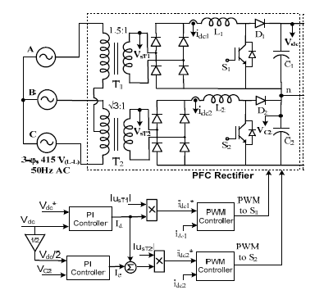Fig.1 Scott transformer based PFC with three-level DCI fed rotor FOC based IMD

# **VI. Result**

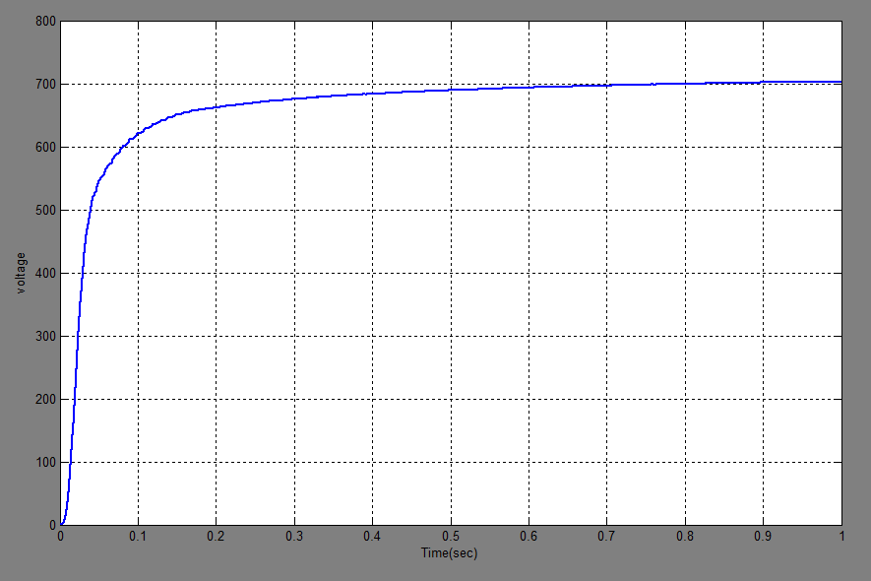

Fig.2 Waveform of Vdc

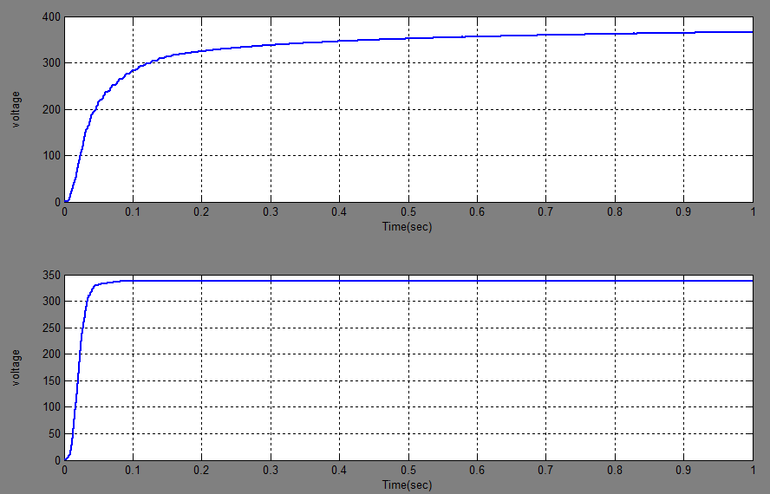

Fig.3 Waveform of VC1 and VC2

# **VI. Conclusion**

The design, modeling and simulation of an isolated PFC boost AC-DC converter are presented for mitigate the power quality problems. With the use of only two active switches it is shown that PFC rectifier provides sinusoidal input currents with improved power factor and dc link voltage regulation.

1. **Advantages.**

i) It is used to provide constant DC voltage even under varying input AC voltage and loads.

ii) It provides low frequency isolation for safety.

1. **Applications.**

Isolated rectifier are widely used for medium or high power drive application which are employed in subways, electrochemical and petrochemical industries

# **References**

[1] G. Bhuvaneswari, Bhim Singh, Sandeep Madishetti ,̋Three-Phase, Two-Switch PFC Rectifier Fed Three-Level VSI Based FOC of Induction Motor Drive”, *IEEE Tran. Ind. Elect*,pp.1-6, May2012

[2] A. A. Badin and I. Barbi, “Unity Power Factor Isolated Tree-Phase Rectifier With Split DC-Bus on the Scott Transformer,” *IEEE Tran.* Power Electronics, vol.23, no.3 ,pp.1278-1287 ,May 2008.

[3] B. Singh, B. N. Singh, A. Chandra, K. Al-Haddad, A. Pandey and D. P. Kothari, “AC review of three-phase improved power quality AC-CD converters,” *IEEE Tran. Ind. Elect*., vol.51, no.3, pp.641-660, June 2004.

[4] S.K.T. Miller and I. Barbi, ”Practical aspects of the unity power factor isolated three-phase rectifier based on the Scott transformer,” in Proc. *IEEE Tran.* Applied Power Electronics Conference and Exposition, March 2005, vol.1, pp. 621-627

[5] F. Liccardo, P. Marino, C. Schiano and Visciano, N.; ,”Three-phase four-wire active front-end feeding a three-level voltage source inverter,” in Proc. *IEEE ISIE*, May 2004,vol.2, pp. 1153-1158.

[6] B Singh, G. Bhuvaneswari and V. Garg ,” Harmonic Mitigation in AC-DC Converter for Vector Controlled Induction Motor Drives*,” IEEE Trans.* Energy Conversion, vol. 22, no.3, pp. 637-646, Sept.2007