RENEWABLE ENERGY
NAME:- NEHA GHUGE & MEGHA GIRAPUNJE & KIRAN HINGNE
BE III YR, Electrical Engineering,K.D.K.C.E,

ABSTRACT
In recent years, India has emerged as one of the leading destinations for investors from developed countries. This attraction is partially due to the lower cost of manpower and good quality production. The expansion of investments has brought benefits of employment, development, and growth in the quality of life, butonly to the major cities. This sector only represents a small portion of the total population.The remaining population still lives in very Poor conditions. India is now the eleventh largest economy in the world, fourth in terms of purchasing power. It is poised to make tremendous economic strides over the next ten years, with significant development already in the planning stages. This report gives an overview of the renewable energies market in India. We look at the current status of renewable markets in India, the energy needs of the country, forecasts of consumption and production, and we assess whether India can power its growth and its society with renewable resources.
KEY WORDS: - Renewable Resources, Development.

What are Renewable and Alternative
Energy Sources?
True renewable energy sources are energy supplies that are refilled by natural processes at least as fast as we use them. All renewable energy comes, ultimately, from the sun. We can use the sun directly (as in solar heating systems) or indirectly (as in hydroelectric power, wind power, and power from biomass fuels). Renewable energy supplies can become exhausted if we use them faster than they become replenished: most of England’s forests were cut down for fuel before the English started using coal. If used wisely, however, renewable energy supplies can last forever.There are other alternatives to our typical energy sources that are not renewable. Although these are“alternative energy” rather than “renewable energy”, they use the energy we have more efficiently than oldertechnologies. In doing this, they help us make our existing energy supplies last longer and give us more time before we run out of stored fossil and atomic fuels.The use of renewable and alternative energy sourcescan save us money, assure that our grandchildren andgreat grandchildren will have enough energy, and free usfrom the uncertainties of depending on energy suppliesoutside the United States.Types of Renewable and AlternativeEnergy.There are several renewable energy sources that arein use today. Listed below are brief descriptions of theseresources; later we will discuss how some of these can beused in residential applications.

Hydropower:
Hydropower represents one of the oldest and largest renewable power sources and accounts for close to 10% of our nation’s electricity. Existing hydropower capacity isabout 80,000 megawatts (MW – one million watts or onethousand kilowatts). Hydropower plants convert theenergy of flowing water into electricity. This is primarilydone by damming rivers to create large reservoirs and thenreleasing water through turbines to produce electricity.Hydropower results in no emissions into the atmospherebut the process of damming a river can create significantecological problems for water quality and for fish andwildlife habitat.

Biomass
Biomass is second to hydropower as a leader in renewable energy production. Biomass has an existingcapacity of over 7,000 MW. Biomass as a fuel consists oforganic matter such as industrial waste, agricultural waste,wood, and bark. Biomass can be burned directly inspecially designed power plants, or used to replace upto15% of coal as a fuel in ordinary power plants. Biomass burns cleaner than coal because it has less sulfur, which means less sulfur dioxide will be emitted into the atmo-sphere. Biomass can also be used indirectly, since it produces methane gas as it decays or through a modern process called gasification.The largest use of biomass energy in Virginia is the forest products industry. Furniture plants, sawmills, and paper mills usually burn their wood waste to produce heat and electricity. Many homeowners use firewood or pellets for winter heat.

Geothermal
Geothermal electric capacity in the United States is over 3,000 MW. Geothermal power plants use high temperatures deep underground to produce steam, which then powers turbines that produce electricity. Geothermal power plants can draw from underground reservoirs of hot water or can heat water by pumping it into hot, dry rock.High underground high temperatures are accessed by drilling wells, sometimes more than a mile deep. In one sense, this geothermal energy is not renewable, since sometime in the future the core of the earth will cool.That time is so far off (hundreds of millions of years) thatthat we think of it as renewable. Most geothermal power plants are located in the western United States, but some costal regions of Virginia (near Wallops Island) havegeothermal power potential.Geothermal heat pumps use compressors to pump heat out of the earth (for winter heating) or into the earth(when running as air conditioners in summer). The energy they pump into and out of the earth is renewable, since
it is replaced by the cycle of the seasons. The energy that runs the compressor can either be renewable or conven-tional.

Solar Energy
Solar energy comes directly from the power of the sun and is used to produce electricity, to produce heat, and for light. Solar represents a small share of the electric.Market in the United States – about ½ of one percent of electrical capacity. Solar's contribution to heating and lighting is much larger.Solar-electric power can be produced either by power plants using the sun’s heat or by photovoltaic (PV)

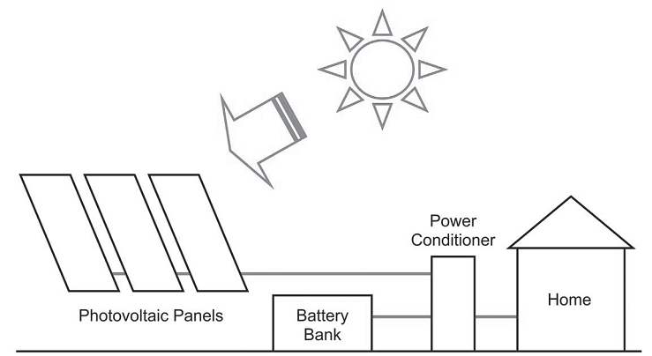

Figure-1 Off-grid residential photovoltaic system
technology, which converts sunlight directly to electricity Using solar cells. PV technology is more practical for residential use.Systems to use the heat of the sun directly can be either active or passive. In active systems, air or liquid circulate through solar collectors and bring heat to where it
is used. In passive systems, buildings are built with windows and heat-absorbing surfaces set up to maximize solar heating in winter. Either technology is suitable for residential use. Systems to directly use the light of the sun are most common. The most usual device for using sunlight is the window, but skylights and skylight tubes are also used.

Fuel Cells
A fuel cell is an alternative energy device, but it is not necessarily a renewable energy device. It is only renewable if the source of the fuel used is renewable. A fuel cell is an electrochemical device, like a battery in thatit converts the energy from a chemical reaction directlyinto electricity and heat. But unlike a battery, which is limited to the stored chemicals within, a fuel cell has the capability of generating energy as long as fuel is supplied.Currently produced fuel cells combine hydrogen and oxygen without combustion to produce electricity. The oxygen comes from the air, while the hydrogen can either be produced from water (using electricity) or extracted from fossil fuels. New fuel cells are being developed that can use fossil fuels directly. Fuel cell technology has been around for over 150 years and it shows great promise in powering vehicles and in providing energy for residential applications.

Wind Power
Wind energy represents 4,700 megawatts (MW) of installed electric capacity in the United States. Wind has been the fastest growing energy source in the U.S. over the last decade mainly due to very significant improve-ments in wind energy technology. The American Wind Energy Association predicts
that 6,000 MW of wind power will be installed by the end of

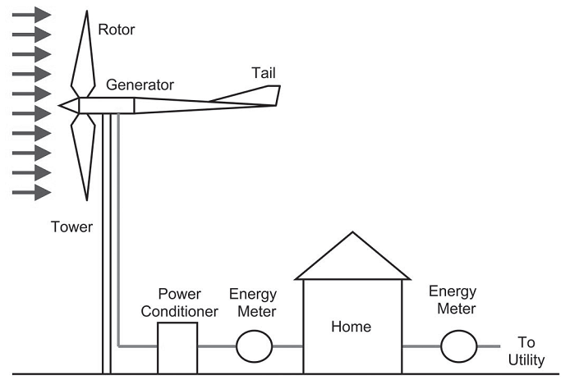

Grid-connected residential wind energy system. Meter between power conditioner and home is optional.

2004. This is enough to power 1.5 million homes. Wind power is produced by the energy of the wind turning aerodynamic
blades mounted to a hub. The hub is connected to a shaft that turns a genera-tor. Large utility-scale wind turbines range in size from 50 kilowatts to over four megawatts. Smaller wind
towers (under 50 kW) are suitable for residential and agricultural use.
Energy Tips and Recommendations
1. Consider the use of renewable energy systems that produce clean and non-polluting energy. The initial cost or investment may be high but over the longterm the savings can be significant. You will also be making an important commitment to saving our natural resources and preserving the environment.
2. If you have a stream on your property, you may be able to develop a small microhydropower system that can produce enough electricity to power your home.
3. Space heating is a low-cost way in which to incorpo-rate biomass into a residential renewable application.

4. Geothermal heat pumps, which use the heat of the earth, to provide heating and cooling for the home are three times more efficient than conventional energyefficient furnaces.
5. Solar electric systems (PV systems) use the power of the sun to produce electricity. Solar panels mounted on your roof or near your home can provide clean, non-polluting, and renewable energy to power your home.
6. Small residential wind energy systems provide a clean, non-polluting source of electricity. You must have a sufficient average annual wind speed and enough installation space for wind energy to be effective.
7. Consider using hybrid power systems, which combine
different renewable energy sources to produce electricity.
8. Fuel cells combine hydrogen and oxygen without combustion to produce electricity. They are efficient, and when fueled with pure hydrogen their only emission product is water vapor. They represent an exciting new technology that is still a few years away but may represent the residential power source of thefuture.
9. Take advantage of existing programs to help offset the cost of renewable energy systems and to receive services and expertise.
10. Keep in mind that reducing energy use through conservation and increased efficiency is almos always a cheaper alternative than installing a renew-able energy system.

REFERENCES:
- India Ministry of Non-Conventional Energy Sources (MNES)
- The Energy & Resources Institute (TERI)
- Power Sector Policies and New Electricity Bill: From Crisis to Disaster (2001), Purkayastha P., Economy and Political weekly, June 23, 2001, Mumbai, India.

