Web Based Monitoring Of Substation Transformer
¹SHUBHANGI R. BAWANE ²PRIYANKA C.BURBURE ³ANJALI V. MESHRAM ⁴ Mr.N.D.DHAPODKAR
Assit.Professer

DEPARTMENT OF ELECTRICAL ENGINEERING (ELECTRONICS & POWER)
KARMAVEER DADASAHEB KANNAMVAR COLLEGE OF ENGINEERING, NAGPUR
¹shubhu.bawane21@gmail.com ²pcb_19may@rediffmail.com ³meshramanjali000@gmail.com

Abstract— The earlier monitoring system for remote substation does not have the capability to monitor the system as quick as possible so the integrated monitoring system has to be adopted which eliminates the failures of GSM based technologies which is being used in day to day monitoring system. This project creates a new integrated monitoring system for high voltage electric power substation system. The substation has important function to maintain the reliability and to keep the quality of electric power transmission system. On the other hand the exposure to high voltage environment may also be able to cause risk to human health. Therefore an integrated monitoring system is crucial to be implemented for easy monitoring and controlling the substation while minimizing the interaction of human to the substation devices. The project creates the comprehensive reporting capability to meet required needs & turn production and engineering data into dynamic knowledge. In our project we are going to collect all the information of required parameter such as voltage, current, humidity, oil level and oil temperature within transformer by using microcontroller which is further connects with PC or laptop. This collected data will further sends to the server which will situated at any part of the world through internet communication.

Keywords— Internet, Communication, Transformer, On-line monitoring, Sensors.
I. Introduction
Distribution transformers have a long service life if they are operated under good and rated conditions. However, their life is significantly reduced if they are overloaded, resulting in unexpected failures and loss of supply to a large number of customers thus effecting system reliability. Overloading and ineffective cooling of transformers are the major causes of failure in distribution transformers. Most power companies use Supervisory Control and Data Acquisition (SCADA) system for online monitoring of power transformers but extending the SCADA system for online monitoring of distribution transformers is an expensive proposition [2]. Distribution transformers are currently monitored manually where a person periodically visits a transformer site for maintenance and records parameter of importance. This type of monitoring cannot provide information about occasional overloads and over heating of transformer oil and windings. All these factors can significantly reduce transformer life. Our system is designed based upon online monitoring of key operational parameters of distribution transformers can provide useful information about the health of transformers which will help the utilities to optimally use their transformers and keep the asset in operation for a longer period [5]. This project will help us to identify problems before any catastrophic failure, thus resulting in a long life service for transformers. It is also has the advantages of significant cost savings and greater reliability.
II. Background Study
In recent years, increased emphasis has been placed on power equipment reliability. In particular, facing deregulation and increasing competition, many utilities are looking for ways to generate and transmit power in more economical and reliable ways. The health of equipment constituting the substation is critical to assuring the supply of power.
Historically the maintenance of electrical power equipment has been time-based. Maintenance crews would inspect the equipment at set intervals based on its age and performance history. As can be expected, this leaves room for many catastrophic failures of improperly or untimely diagnosed equipment. The cost in disruption of business could far outweigh the savings in maintenance costs. On the other hand, too-frequent maintenance can be very costly and unnecessary. Because of the cost of scheduled and unscheduled maintenance, especially at remote sites, new approaches using on-line monitoring and analysis systems of the substation equipment may be more reliable and cost-effective.
In recent years a range of monitoring and diagnosis devices have become available that provide continuous, real-time condition monitoring and analysis of substation equipment. The effective use of on-line monitoring and diagnosis has potential to provide significant benefits for substation owners, technical personnel, and even utility consumers.

The key benefits of on-line monitoring and diagnosis can be summarized as follows:
- Early detection and possible prevention of equipment failure, especially catastrophic failure.
- Long-term data acquisition and understanding about equipment performance.
- Automatically assessing electrical equipment condition.
- Resulting in reducing maintenance time and labor, and reducing maintenance costs associated with any failure.
Transformers are the most expensive piece of equipment in the substation, and therefore, preventing transformer failures is the key to greatly reducing the cost and increasing the reliability of providing the needed electrical energy.
The development has being made to make the transmission system to be more reliable. So in the earlier days the data was being manually monitored, do to which it has become more time consuming and error loaded. Then comes the GSM techniques which has become more effective then the manual one but in our project the implementation is to send the data via internet which very fast.

III. STUDY OF MONITORING AND DIAGNOSIS SYSTEM

1. Basic fundamentals of transformer
“Transformers are exclusively used in electric power systems to transfer power by electromagnetic induction between circuits at the same frequency, usually with changed values of voltage and current.” . There are numerous types of transformers used in various applications including audio, radio, instrument, and power. Power transformers are used extensively by traditional electric utility companies, power plants, and industrial plants. The only connection between the primary and secondary windings is the magnetic coupling effect known as mutual induction, which takes place when the circuit is energized by an AC voltage. The laminated iron core plays an important role in transferring magnetic flux from the primary winding to the secondary winding.

2. Transformer Operation
If an AC current, which is constantly changing in value, flows in the primary winding, the magnetic field produced around the primary winding will be transferred to the secondary winding. Thus, an induced voltage is developed across the secondary winding. In this way, electrical energy can be transferred from the source (primary-winding circuit) to a load (secondary- winding circuit) [5]. The efficient transfer of energy from the primary to the secondary windings of a transformer depends on the coupling of the magnetic field between these two windings. Ideally, all magnetic lines of force developed around the primary winding would be transferred by magnetic coupling to the secondary winding. However, a certain amount of magnetic loss takes place as some lines of force escape to the surrounding air.
A discussion of Transformer Monitoring and Diagnostics has a basis on the fundamental Construction of a transformer. The transformer is basically a machine consisting on several parts. The core and coil are the fundamental components of a transformer providing the coupling of magnetic flux between two windings. The core and coils are placed in a tank filled with oil and connected to bushings. The cooling system and control cabinet are the remaining fundamental components of a transformer.

Figure 1: Basics of a Transformer

There have been significant efforts to understand the various failure modes of power transformers.
Applying the fundamentals of an on-line analysis consisting of 
- Identify functions
- Identify failure modes
- Identify failure causes
-  Identify effects of failure modes
- Identify criticality or risk
- Select on-line monitoring to match characteristic of developing failure cause(s)

The analysis of the failure modes of the various components then leads to a review of the inspection and maintenance procedures of power transformers.

Preventive and predictive maintenance:
- Reduces the risk and costs of unexpected failure
- Actual conditions drive maintenance and repair
- Extending life of assets
- Reducing costs of maintenance

On-Line diagnostic condition assessment addressing common failure modes:
- Multiple sensors
- Multiple on-line models
- All parameters are recorded automatically and continuously
- Trend and limit alarms
Additionally, early detection of problems, at the incipient stage, will help extend the life of the transformers. Detection of these problems is accomplished with several models, which rely on various sensors installed on the transformer and in the substation, combined with other parameters manually entered. This data is then fed into industry standard and accepted models, which calculate the various outputs. These outputs are displayed and trended in the two Master Stations. These capabilities increase the useful data while significantly reducing the shear volume of data.

3. Transformer Polarity and Ratings
Power distribution transformers usually have polarity markings, so that their windings may be connected in parallel to increase their current capacity. The standard markings are H1, H2, H3, et cetera, for the high voltage windings, and X1, X2, X3, et cetera, for the low-voltage windings. Many power transformers have two similar primary windings and two similar secondary windings to make them adaptable to different voltage requirements simply by changing from a series to a parallel connection. The voltage combinations are available with this type of transformer. The ratings of power transformers are very important. Usually, transformers are rated in kilovolt-amperes (KVA). A kilowatt rating is not used, since it would be misleading, because of the various power-factor ratings of industrial loads. Other power transformer ratings usually include frequency, rated voltage of each winding, and an impedance rating.
Power transformers located along a power distribution system operate at very high temperatures. Cooling equipment is necessary for large power transformers. The purpose of the cooling equipment is to conduct heat away from the transformer windings. Several power transformers are of the liquid-immersed type. The windings and core of the transformer are immersed in an insulating liquid, which is contained in the transformer enclosure. The liquid insulates the windings, and conducts heat away from them as well. One insulating liquid that is used extensively is called Askarel. Some transformers, called dry types, use forced air or inert gas as coolants. Some locations, particularly indoors, are considered hazardous for the use of liquid-immersed transformers. However, most transformers, rated at over 500 KVA, are liquid filled.

4. Transformer Malfunctions
Transformer malfunctions result when a circuit problem causes the insulation to break down. Insulation breakdown permits electrical arcs to flow from one winding to an adjacent winding. These arcs, which may be developed throughout the transformer, cause a decomposition of the paper or oil insulation used in the transformer. The usual circuit gets affected due to humidity present within the transformer, oil temperature and the oil level of transformer. This can be a particularly hazardous problem for larger power transformers, since the reaction of the electric arc and the insulating material may produce a gas [5]. For this reason, it is very important for circuit protection to be provided for transformers. They should have power removed promptly whenever some type of fault develops. Current-limiting fuses may also be used to respond rapidly to any circuit malfunction which occurs due to increase in the load current. Therefore it must need to be monitored 24 hours.

IV. INTEGRATION BY INTERNET

In order to accomplish the goal of sharing information related to the integrity of the electric power system with other utilities and organisations that are responsible for the smooth operation of the substation, communication by Internet was 'employed in our system. Using the Internet will be very helpful when the plant is in an emergency situation because all parties concerned are eager to look at the plant data simultaneously [1]. This feature was impossible in the old system using modems, the time for trouble shooting can be shortened and thus the time for system restoration to normal can be shortened as well. Before the details of the implementation are described, the state-of-art of Internet technology is introduced. The Internet is becoming an integral part of life and a comprehensive review can be found in various documents. The authors developed an Internet based building automation system and explored the idea of a global campusless university through an Internet based degree course. With all of these advantages, it is useful for us to put the distributed on-line monitoring system onto the Internet [3].

TCPIP COMMUNICATION

TCP (Transmission Control Protocol) is a set of rules (protocol) used along with the Internet Protocol (IP) to send data in the form of message units between computers over the Internet. While IP takes care of handling the actual delivery of the data, TCP takes care of keeping track of the individual units of data (called packets) that a message is divided into for efficient routing through the Internet.
For example, when an HTML file is sent to you from a Web server, the Transmission Control Protocol (TCP) program layer in that server divides the file into one or more packets, numbers the packets, and then forwards them individually to the IP program layer. Although each packet has the same destination IP address, it may get routed differently through the network. At the other end (the client program in your computer), TCP reassembles the individual packets and waits until they have arrived to forward them to you as a single file.
TCP is known as a connection-oriented protocol, which means that a connection is established and maintained until such time as the message or messages to be exchanged by the application programs at each end have been exchanged. TCP is responsible for ensuring that a message is divided into the packets that IP manages and for reassembling the packets back into the complete message at the other end. In the Open Systems Interconnection (OSI) communication model, TCP is in layer 4, the Transport Layer.

IP ADDRESS (Internet Protocol address)

An Internet Protocol address (IP address) is a numerical label assigned to each device (e.g., computer, printer) participating in a computer network that uses the Internet Protocol for communication. An IP address serves two principal functions: host or network interface identification and location addressing. Its role has been characterized as follows: "A name indicates what we seek. An address indicates where it is. A route indicates how to get there."
The designers of the Internet Protocol defined an IP address as a 32-bit number and this system, known as Internet Protocol Version 4 (IPv4), is still in use today. However, due to the enormous growth of the Internet and the predicted depletion of available addresses, a new version of IP (IPv6), using 128 bits for the address, was developed in 1995 IPv6 was standardized as RFC 2460 in 1998, and its deployment has been ongoing since the mid-2000s

VI. DISPLAY SYSTEM

The display system consists of remote parameter to a native substation in a simple manner which can be achieved by using VISUAL BASICS which allows us to develop the windows which can display the parameters in one view and further decisions can be made to achieve the particular task.

A. VISUAL BASICS .NET
Visual basics is a programming language and development environment crated by Microsoft Visual Basic provides a graphical user interface GUI that allows the developer drag and drop objects into the program as well as manually write program code. Visual Basic, also referred to as "VB," is designed to make software development easy and efficient
A visual basic .net derives from the much older BASIC programming language, and so is considered useful and easy programming language for the beginner to learn. Visual Basic 6.0 was the final edition of Visual Basic.

Feature Of visual basic .net
1. Learning Consists of all necessary tools required to build main stream Windows Applications.
2. Professional Includes advanced features such as tools to develop ActiveX and Internet controls.
3. Enterprise In addition to all Professional features; it also includes tools such as Visual.

Feature Of visual basic
1. GUI Interface
2. Modularization
3. Object Oriented
4. Debugging
5. Macros IDE
6. Data access feature

VII. Experimental Setup & Results
CONSTRUCTION
The microcontroller is main part of the whole circuit. The potential transformer, current transducer, humidity sensor, oil temperature and oil level of transformer. The 5V of supply is being given to the microcontroller, MAX232, and the various sensors. And the 12V is given to the driver IC2803 to operate the relay. The relay is here is used as a switch where it will only connects the contactor in case of normal condition or disconnects in case of abnormal condition.

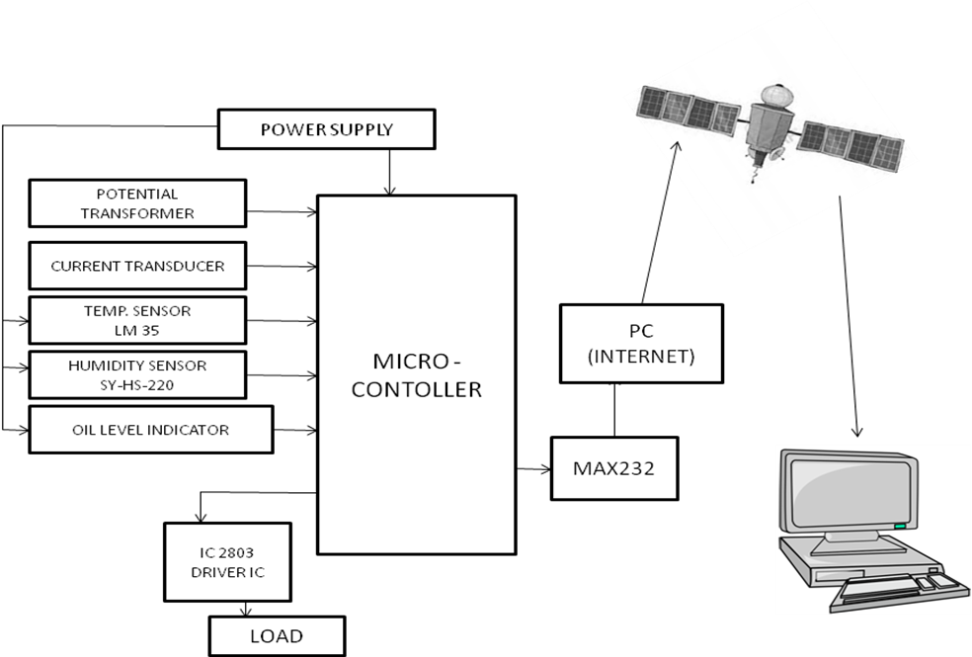

Figure: 2 Block diagram

WORKING
The above block diagram (fig.2) represents the actual block diagram of the web based monitoring of substation transformer. It consists of various blocks such as microcontroller, measurement devices and sensor unit along with interfacing IC. The parameters to be analyse for monitoring are voltage, current, humidity, oil level and oil temperature within transformer by using microcontroller which is further connects with a PC or laptop this collected data will further send to server which will situated at any part of world through internet communication.
In further connection in case of fault such as unbalanced voltage, under voltage, over voltage etc the fault is being analysed by microcontroller programming and the signal is being send to the driver relay to disconnect the contactor and isolate the substation.

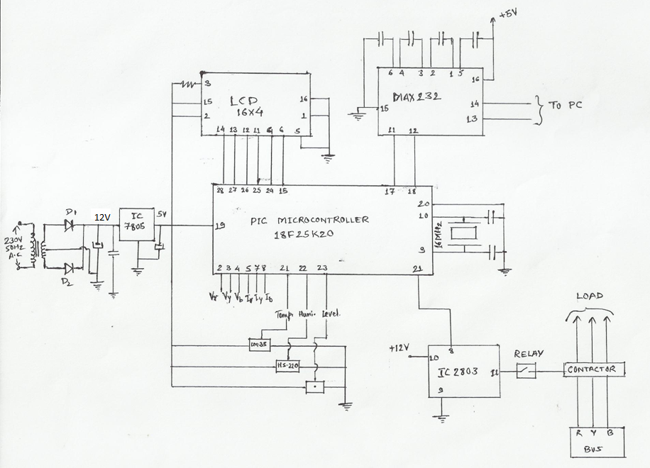

Figure: 3 Circuit diagram

As shown in the figure the power transformer is used to step down the voltage of 230V single phase to 12V. The 12V supply is being rectified to 12V by using the full wave rectifier. This rectified supply is regulated to 5V. This 5V of supply is need for the working of microcontroller, MAX232 IC, and the various equipped sensors. The P.T. and the current transducer are energized by the line conductors. The LCD used to display the monitored parameters on the station substation itself. The driver IC is used as a current booster to amplify the current from the microcontroller, used to drive the relay.
The microcontroller is being programmed to certain limits. Whenever the fault occurs such as over voltage, over current, under voltage, phase failure etc. the direct effect will be developed on the transformer. So in case of fault condition the microcontroller will give the command to driver IC, so that the relay is to be tripped and the transformer will be isolated, i.e. the substation will be protected. The MAX232 IC is used as an interfacing IC so as to interface the data of microcontroller with PC. The PC will send the data to the server of known IP address, and the same data will be retrieved by the known PC who has the known IP address. In this manner the data will be monitored and the data will be used for future forecasting. The actual setup is shown below.

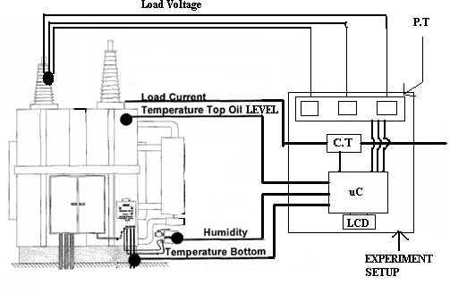
Figure: 4 Experimental setup

VIII. Conclusions
The substation has a crucial function to maintain the reliability and to keep the quality of an electric power transmission system. On the other hand, the exposure to high voltage environment may also be able to cause risk to human health. Therefore an integrated monitoring system is necessary to be implemented for easy monitoring and controlling the substation while minimizing interaction of humans to the substation devices. All the substation devices conditions are displayed uninterruptedly in remote area or a monitoring place. In short the easy parameter monitoring will allow reducing the man power requirement at the substation area. This parameter monitoring system will be done around the clock throughout the year. The overall efficiency of the substation will increase as its maintenance plan is reduced.
References
- W.L. Chan, L.L. Lai, “Internet Based Transmission Substation Monitoring’’, IEEE Transactions on Power Systems, Vol. 14, No. 1, Page no. 293-297, February 1999.
- B. Qiu and H. B. Gooi , “ Web-Based SCADA Display Systems (WSDS) for Access via Internet’’ , IEEE TRANSACTIONS ON POWER SYSTEMS, VOL. 15, NO. 2, Page no. 681-687, MAY 2000.
- Sumit Dutta, Shreya Prakash, David Estrada Eric Pop, IEEE, “A Web Service and Interface for Remote Electronic Device Characterization’’, IEEE TRANSACTIONS ON EDUCATION, VOL. 54, NO. 4, Page no. 646-651, November 2011.
- ‘A Course on Web Languages and Web-Based Applications’, K. Sridharan, IEEE TRANSACTIONS ON EDUCATION, VOL. 47, NO. 2, Page no. 254-260 , May 2004.
- Timo T. Vekara,MEMBER, IEEE, Seppo Pettissalo and N. Rajkumar, MEMBER, IEEE “Remote Monitoring System for Transformer Substations”, VOL 56 NO. 1, Page no. 466-467 FEB. 2008
- V.K. MEHTA , chapter 25, Page no.532-539. (Power System).
- B.L. Theraja & A.K. Theraja , Volume 2, Page no. 1029-1151, (AC &DC machines).

