PHOTOVOLTAIC STREET LIGHTING USING BOOST CONVERTER

Department of Electrical Engineering,

K.D.K.C.E.,Nagpur.

Poojamasram8@gmail.com

**Pooja Masram1, Evendra Gaydhane2, Vivek Raut3, Ast. Prof.- Dinesh Mute**

Abstract—This paper presents a non-isolated high frequency DC-DC converter, which integrates a battery charger, photovoltaic panels, and a high voltage gain boost converter in a single conversion stage with soft-switching characteristic. a low cost microcontroller is proposed to handle the operation of the whole system. The storage system will be charged during the day time using the available sunlight & during the night time the controller will give a signal to the system to connect the LED lamp to be ready for use. Since the LED needs a low dc voltage to be operated, a simple dc-dc converter will be enough for this system resulting in decreasing the cost of the overall system. By this proposed system, streets can be illuminated with lower power lamps, no operating costs, no CO2 emissions, grid energy-free and environmentally friendly.

Keywords—PV cell,LED,charging,discharging.

1. INTRODUCTION

The use of stand-alone photovoltaic lighting system has increased in remote rural areas and in towns. Conventional street lighting is energy intensive and can represent a high cost to local governments, which creates an impetus to investigate more efficient light sources such as photovoltaic- (PV) powered light emitting diodes (PLEDs) lighting systems. Photovoltaic system is gaining increased importance as a renewable source due to its advantages such as little maintenance and no noise and wear due to its absence of moving parts. But there are still two principal barriers to the generalization use of photovoltaic systems.[1]

The high installation cost and the low energy conversion efficiency.To increase the ratio output power/cost of installation it is important that PV panel operates in its maximum power point (MPP) to absorb the maximum power possible. The combination of PV panels with power LEDs makes the called new green light sources.

1. OBJECTIVE

* The main aim of this project to convert solar energy into light energy .
* To obtain maximum power from solar panel.
* To maintain longitivity of battery.
* To make dusk & dawn operation of this system automatic.[1]

1. BASIC BLOCK DIAGRAM

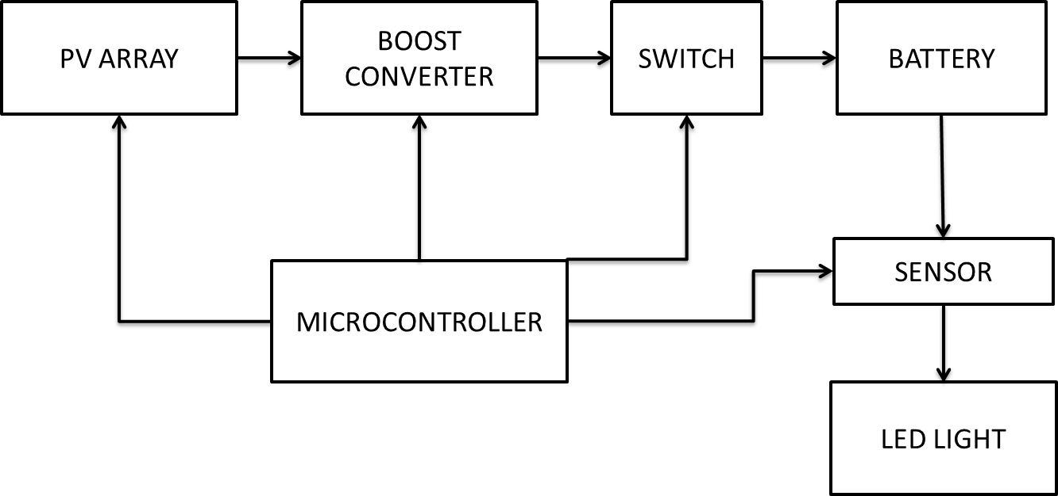

Fig1.basic block diagram

1. BASIC CIRCUIT DIAGRAM

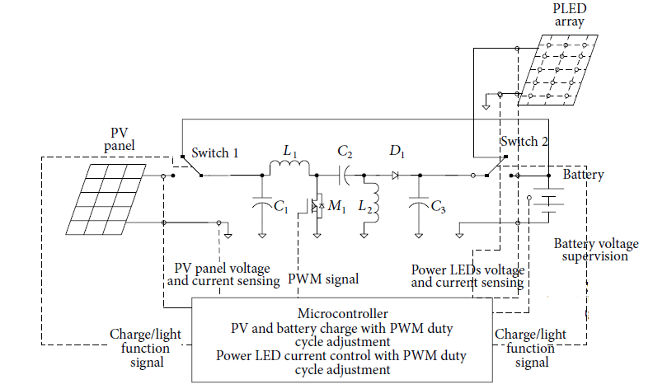

Fig2.basic circuit diagram

A) PV ARRAY

PV cells are made of semiconductor materials, such as silicon. For solar cells, a thin semiconductor wafer is specially treated to form an electric field, positive on one side and negative on the other. When light energy strikes the solar cell, electrons are knocked loose from the atoms in the semiconductor material. If electrical conductors are attached to the positive and negative sides, forming an electrical circuit, the electrons can be captured in the form of an electric current - that is, electricity. This electricity can then be used to power a load. A PV cell can either be circular or square in construction.

The power that one module can produce is not sufficient to meet the requirements of home or business. The modules in a PV array are usually first connected in series to obtain the desired voltages; the individual modules are then connected in parallel to allow the system to produce more current.



Fig.3 phovoltaic system[3]

B) BOOST CONVERTER

Boost converter steps up the input voltage magnitude to a required output voltage magnitude without the use of a transformer. The main components of a boost converter are an inductor, a diode and a high frequency switch. These in a co-ordinated manner supply power to the load at a voltage greater than the input voltage magnitude. The control strategy lies in the manipulation of the duty cycle of the switch which causes the voltage change.the output equation of boost converter is given by

C) MODES OF OPERATION

There are two modes of operation of a boost converter. Those are based on the closing and opening of the switch. The first mode is when the switch is closed, this is known as the charging mode of operation. The second mode is when the switch is open, this is known as the discharging mode of operation.

a) Charging Mode

In this mode of operation; the switch is closed and the inductor is charged by the source through the switch. The charging current is exponential in nature but for simplicity is assumed to be linearly varying . The diode restricts the flow of current from the source to the load and the demand of the load is met by the discharging of the capacitor.

b) Discharging Mode

In this mode of operation; the switch is open and the diode is forward biased . The inductor now discharges and together with the source charges the capacitor and meets the load demands. The load current variation is very small and in many cases is assumed constant throughout the operation.

c) Waveforms

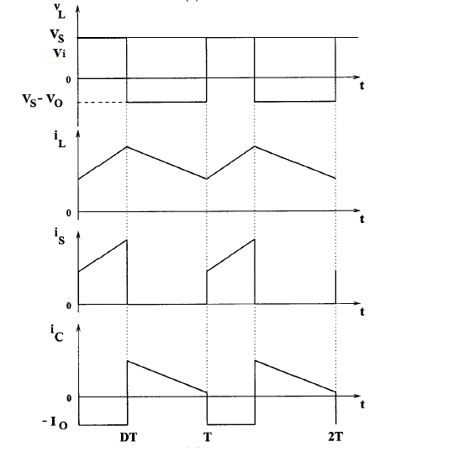

Fig.4.waveforms of output of boost converter[1]

D) LED LIGHT

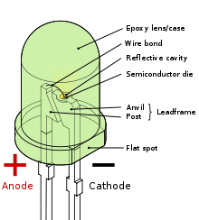

Fig.5.LED structure

An LED consists of several layers of semiconducting material When an LED is operated with DC voltage light is generated in the active layer. The generated light is radiated directly or by reflections. Two types of material (lnGaAlP and InGaN) are used to produce LED with a high luminance in all colors from blue to red and also in white (luminescence conversion).[2]

LED light can be connected in series to divide voltage equally & can be connected in parallel to equalise current . Reflectors are used to increase the intensity obtained from LED light & also used to confine light in one direction.The standalone street lighting system using the most efficient and the cost effective Light Emitting Diode (LED) lamps. This system consists of PV panel, high quality battery, LED lamp, dc-dc converter, and a controller. PV arrays utilize the sun radiation to produce electricity. LEDs with their current performances have proved themselves to be the most suitable solution for LED street lighting.

The LED lamp offers many advantages such as: Extremely long life, 100,000 hours, and extreme robustness as there are no glass components or filaments, no external reflector, a modular construction, no emissions like HID lamps and most importantly their high efficiency. LEDs have efficiency of 160 Lm/W. So, using this type of lamps enables the reduction of more than 50 % of the total energy used by HID lamps; that by its order reduces the required PV arrays.

E) LEAD ACID BATTERY

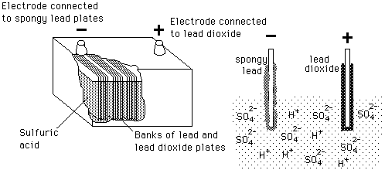

Fig.6.internal construction of lead acid battery[1]

The storage battery or secondary battery is such battery where electrical energy can be stored as chemical energy and this chemical energy is then converted to electrical energy as when required. The conversion of electrical energy into chemical energy by applying external electrical source is known as charging of battery. Whereas conversion of chemical energy into electrical energy for supplying the external load is known as discharging of secondary battery. During charging of battery, electric current is passed through it which causes some chemical changes inside the battery. This chemical changes absorb energy during their formation.When the battery is connected to the external load, the chemical changes take place in reverse direction, during which the absorbed energy is released as electrical energy and supplied to the load.[1]

1. SENSOR

In this project we are using pv array as a sensor to perform dusk & dawn operation.when light source is available & pv panel is working then this sensor must be act as a open switch & when solar light is not available then the sensor switch must be closed to glow LED light.[4]

1. CONCLUSION

• Boost converter act as a effective charging tool for battery.

• LED lamp use is comparatively more economic as compared to other lamps.

• 70% power can be effectively saved.

• We can effectively reduce our conventional energy consumption to a great value.

• LED lamp can replace the use of high energy consuming conventional lights.[2]

1. REFERENCE

[1]“Design of a LED Street Lighting System” by D. R. Nuttall*, R. Shuttleworth*, G. Routledge.

[2] George C. Konstantopoulos, Antonio T. Alexandridis , ‘Non-linear voltage regulator design for DC/DC boost converters used in photovoltaic applications’ IET Renew. Power Gener., 2013, Vol. 7.

[3] A High-Performance Stand-Alone Solar PV Power

System for LED Lighting,” José António Barros Vieira1 and AlexandreManuelMota2”, Received 19 April 2013; Accepted 11 June 2013.