**REVERSE POWER PROTECTION OF TRANSFORMER**

Sarang Manwatkar

Ajinkya Parsodkar

Gaurav Dighore

Papiya Dutta

*VIII sem,Electrical Engineering*

*K.D.K.C.E.,Nagpur,India*

[*manwatkar.sarang@gmail.com*](mailto:manwatkar.sarang@gmail.com)

*megaurav91@gmail.com*

**Abstract**

***This project aims at securing personnel from effects of reverse power by designing protection system. Reverse power flow occurs when power in any circuit flows from receiving end to sending end i.e. in reverse direction. This condition can be dangerous for the working personnel in that area because he is assuming that the power is flowing in regular direction i.e. from sending to receiving end. This project consists of protection circuit including servo motors with their motor drives, electronic control unit, limit switches, RF transmitter and receiver, indicating unit.***

***The signal to the ECU is given through keyboard and is received by the receiver from transmitter by RF module using RF waves. The signal from ECU is then given to motor drive and it will operate the motor drive according to signal. The shaft of motor will operate the limit switch which gives feedback to the ECU and indicated by indicating unit.***

***This arrangement can work automatically and hence there will not be any need to perform the work in person and this eliminates the shock hazard.***

**Introduction**

* 1. **Overview**

Basically, the power flows from the input terminal to the output terminal. However, in the case of reverse power, the power flows from in the reverse

direction that is from the output terminal to the input terminal which may have adverse effects.

Mr. K.M. Dhenge

Assistant Prof.,K.D.K.C.E.,Nagpur,India

In an incident which has recently taken place at Mansar in Maharashtra where a personnel working in the site of distribution transformer faced dire consequences due to the flow of reverse power.

Consider load as a factory which is having its own alternator as auxiliary power source and maintenance work is to be carried out on a transformer in factory premises. For that the isolators should be kept open. Now if by mistake of operator, one of the isolator is failed to open and as the alternator is working, the power from alternator will flow in system and the person working on transformer as he is unaware of this reverse power flow can suffer a shock, which can be fatal.

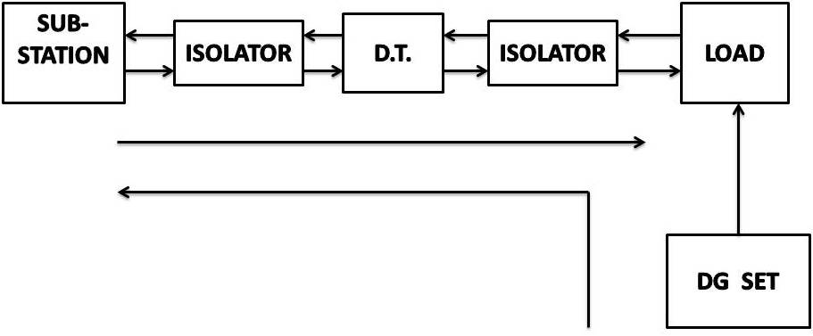

Fig. 1.1 Block diagram showing power flow.

**1.2 Objective**

Our main objective is to design a protection circuit which will prevent the accidents caused due to the flow of reverse power. In this project we have tried to develop such a system which will monitor the occurrence of reverse power using various equipment viz. distribution transformer, DC servomotors with the motor drives, ECU (Electronic Control unit) containing transmitter and receiver, limit switches and relays.

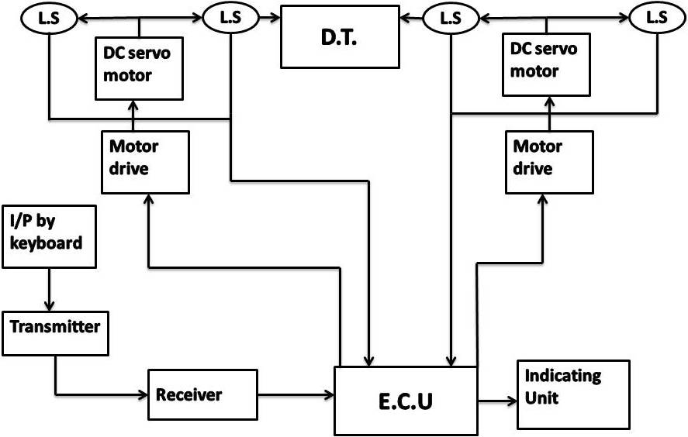

Fig. 1.2 Block diagram of model.

**2.1 Background Study**

One of the major issue associated, while the distribution transformer is detached for the maintenance work, is to detect the flow of reverse power in the circuit and to prevent the adverse effects of it. In the system of distribution transformer from the sub-station to the load, it is a very tedious job to keep an eye on each and every connection. Thus, the personnel working under such condition face disastrous results. So, there is a need for optimal and efficient protection circuit during the occurrence of reverse power.

**2.2 Related Work**

Here, in our project we have tried to provide an optimal solution to the above stated problem. We have developed an application which will detect the flow of reverse power by using indicating lamps.

The following are the main points which we are going to achieve through the project:

* Detection of flow of reverse power.
* Prevention of accidents caused due to it.

**3. Power Supply Circuit**

The power supply circuit is used to provide supply to the circuitry arrangement. In the project we have used the following arrangement consisting of a step-down transformer, a bridge rectifier, voltage regulators 7805 and 7812 and electrolytic capacitor. From the power supply circuit, the supply of 5V DC goes to the digital circuit and 12V DC goes to the analog circuits. The digital circuit here is the Electronic Control Unit which consists of transmitter and receiver. Through which the signals are send to the indicating unit based on which the whole arrangement works.

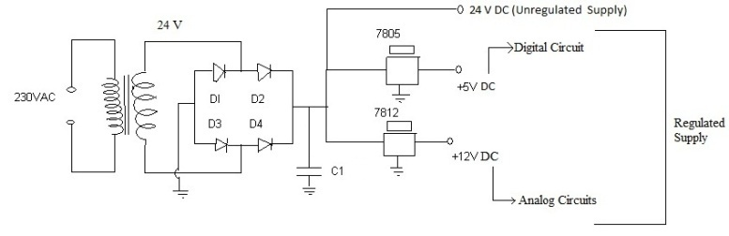

Fig. 3.1 Power supply circuit

Power supply is a device that supplies electric power to an electrical load. The term is most commonly applied to electric power converters that convert one form of electrical energy to another, though it may also refer to devices that convert another form of energy (mechanical, chemical, solar) to electrical energy. A regulated power supply is one that controls the output voltage or current to a specific value, the controlled value is held nearly constant despite variations in either load current or the voltage supplied by the power supply’s energy source. Every power supply must obtain the energy it supplies to its load as well as any energy it consumes while performing that task from an energy source. Depending on its design, a power supply may obtain energy from Electrical energy transmission systems.

Common examples of this include power supplies that convert AC line voltage to DC voltage, energy storage devices such as batteries and fuel cells, electromechanical systems such as generators and alternators.

A power supply may be implemented as a discrete, stand-alone device or as an integral device that is hardwired to its load. Examples of the latter case include the low voltage DC power supplies that are part of desktop computers and consumer electronics devices. Commonly specified power supply attributes include the amount of voltage and current it can supply to its load. How stable its output voltage or current is under varying line and load conditions.

How long it can supply energy without refueling or recharging (applies to power supplies that employ portable energy sources). Power supplies types Power supplies for electronic devices can be broadly divided into line-frequency (or "conventional") and switching power supplies. The line-frequency supply is usually a relatively simple design, but it becomes increasingly bulky and heavy for high-current equipment due to the need for large mains-frequency transformers and heat-sinked electronic regulation circuitry. Conventional line-frequency power supplies are sometimes called "linear," but that is a misnomer because the conversion from AC voltage to DC is inherently non-linear when the rectifiers feed into capacitive reservoirs. Linear voltage regulators produce regulated output voltage by means of an active voltage divider that consumes energy, thus making efficiency low. A switched-mode supply of the same rating as a line-frequency supply will be smaller, is usually more efficient, but would be more complex.

**4. Motor Control with Relay Logic Unit**

In the arrangement of motors, we have connected two servomotors whose shafts are connected to the inlet and outlet of the distribution transformer. The relay logic unit works in such a way that when the normally open and common points are closed, the positive charge and negative charge are indicated at the motor 1 and the motor moves in the forward direction and the same happens in the motor 2 and the motor moves in the backward direction. The two servomotors connected move simultaneously. The motors arrangement using the relay logic unit is as below:

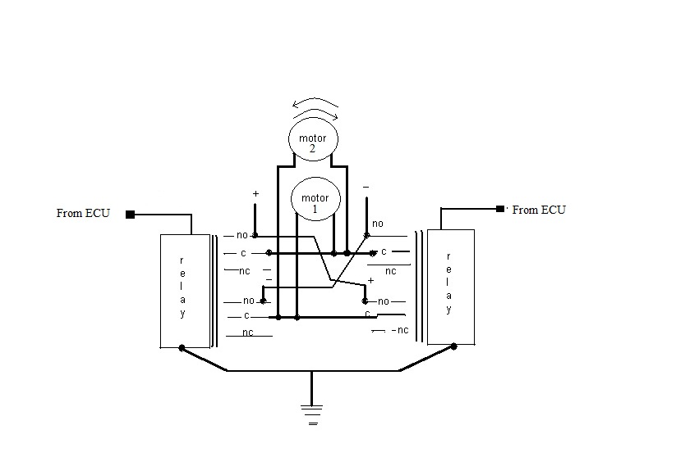

Fig.4.1 Motor control with RLU.

Relay is an electrically operated switch. Many relays use an electromagnet to operate a switching mechanism mechanically, but other operating principles are also used. Relays are used where it is necessary to control a circuit by a low-power signal (with complete electrical isolation between control and controlled circuits), or where several circuits must be controlled by one signal. The first relays were used in long distance telegraph circuits, repeating the signal coming in from one circuit and re-transmitting it to another. Relays were used extensively in telephone exchanges and early computers to perform logical operations. A type of relay that can handle the high power required to directly control an electric motor or other loads is called a contactor. Solid-state relays control power circuits with no moving parts, instead using a semiconductor device to perform switching. Relays with calibrated operating characteristics and sometimes multiple operating coils are used to protect electrical circuits from overload or faults in modern electric power systems these functions are performed by digital instruments still called "protective relays ".

A simple electromagnetic relay consists of a coil of wire wrapped around a soft iron core, an iron yoke which provides a low reluctance path for magnetic flux, a movable iron armature, and one or more sets of contacts (there are two in the relay pictured). The armature is hinged to the yoke and mechanically linked to one or more sets of moving contacts. It is held in place by a spring so that when the relay is de-energized there is an air gap in the magnetic circuit.

In this condition, one of the two sets of contacts in the relay pictured is closed, and the other set is open. Other relays may have more or fewer sets of contacts depending on their function. The relay in the picture also has a wire connecting the armature to the yoke. This ensures continuity of the circuit between the moving contacts on the armature, and the circuit track on the printed circuit board (PCB) via the yoke, which is soldered to the PCB. When an electric current is passed through the coil it generates a magnetic field that activates the armature and the consequent movement of the movable contact(s), either makes or breaks (depending upon construction) a connection with a fixed contact. If the set of contacts was closed when the relay was de-energized, then the movement opens the contacts and breaks the connection and vice-versa if the contacts were open.

When the current to the coil is switched off, the armature is returned by a force, approximately half as strong as the magnetic force, to its relaxed position. Usually this force is provided by a spring, but gravity is also used commonly in industrial motor starters. Most relays are manufactured to operate quickly. In a low-voltage application this reduces noise in a high voltage or current application it reduces arcing .When the coil is energized with direct current, a diode is often placed across the coil to dissipate the energy from the collapsing magnetic field at deactivation, which would otherwise generate voltage spike dangerous to semiconductor circuit components.

Some automotive relays include a diode inside the relay case. Alternatively, a contact protection network consisting of a capacitor and resistor in series (snubber circuit) may absorb the surge. If the coil is designed to be energized with alternating current (A.C), a small copper “shading ring” can be crimped to the end of the solenoid, creating a small out-of-phase current which increases the minimum pull on the armature. A solid-state relay uses a thyristor or other solid-state switching device, activated by the control signal, to switch the controlled load, instead of a solenoid. An optocoupler (a light-emitting diode coupled with a phototransistor) can be used to isolate.

**5. Overview of Reverse Power Protection System**

In the reverse power protection system, the inlet of the distribution transformer is connected to the shaft of the first servomotor and the outlet the distribution transformer is connected to the shaft of the second servomotor. The limit switches work according to the opening and closing operations of the shafts with the servomotors. These operations of the limit switches connected which act as the feedback switches, are send in the form of signal to the indicating unit where lamps are connected. One of the lamp glows when circuit is in the running condition and another lamp glows when the circuit is in the isolation condition. Depending on these indications, the flow of reverse power can be detected and the prevention of the occurrence of the reverse power can be done. The contactors are connected to the three phase supply with the distribution transformer.

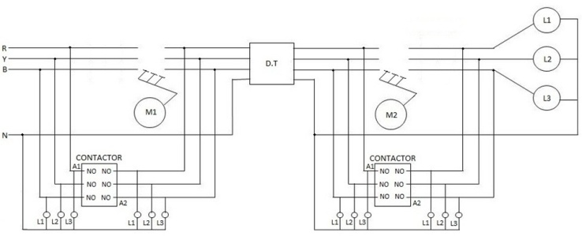

Fig. 5.1 Overview of reverse power protection system.

In semiconductor testing, contactor can also refer to the specialized socket that connects the device under test. In process industries a contactor is a vessel where two streams interact, for example, air and liquid. A contactor is an electrically controlled switch used for switching a power circuit, similar to a relay except with higher current ratings. A contactor is controlled by a circuit which has a much lower power level than the switched circuit. Contactors come in many forms with varying capacities and features. Unlike a circuit breaker, a contactor is not intended to interrupt a short circuit current.

Contactors range from those having a breaking current of several amperes to thousands of amperes and 24 V DC to many kilo-volts. The physical size of contactors ranges from a device small enough to pickup with one hand, to large devices approximately a meter (yard) on aside. Distribution transformer is a transformer that provides the final electric power distribution system, stepping down the voltage used in the distribution lines to the level used by the customer. If mounted on a utility pole, they are called pole-mounted transformers. If the distribution lines are located at ground level or underground, distribution transformers are mounted on concrete pads and locked in steel cases, thus known as pad-mount transformers. Because of weight restriction transformers for pole mounting are only built for primary voltages less than 30 kV.

Distribution transformers are classified into different categories based on certain factors such as Type of insulation - liquid-immersed distribution transformers or dry-type distribution transformers. Number of Phases - single-phase distribution transformers or three-phase distribution transformers voltage class (for dry-type) Low voltage distribution transformers or medium voltage distribution transformers. Basic impulse insulation level (BIL), for medium-voltage, dry-type.

Distribution transformers are normally located at a service drop, where wires run from a utility pole or underground power lines to the customer's premises. They are often used for the power supply of facilities outside settlements, such as isolated houses, farmyards or pumping stations at voltages below30kV. Another application is the power supply of the overhead wire of railways electrified with AC.

In this case single phase distribution transformers are used. The number of customers fed by a single distribution transformer varies depending on the number of customers in an area. Several homes may be fed of a single transformer in urban areas; rural distribution may require one transformer per customer. Many large building save electric service provided a primary distribution voltage. These buildings have customer-owned transformers in the basement for step-down purposes. High voltage hobbyists often use these transformers in reverse (step-up) by feeding 120 or 240 volts into the secondary and drawing the resulting high voltage.

**6. Conclusion**

Our main objective of detecting the reverse power and preventing its adverse effects is achieved. At the end, we can derive the flow of reverse power is detected and accidents due to the reverse power are prevented. The circuit arrangement can be used in sub-stations. This system works automatically. This arrangement can be used in switching stations.

**References**

[1] “Electronic and Electrical Measurement”,

A.K.Sawhney, 2011, Dhanpat Rai, (Page No.-

855-860)

[2] “Electrical Technology (Vol 2)” , B.L.Theraja,

2011, S.Chand, (Page No.-1536-1540)

[3] “Feedback Control systems”, A.R.Barapate,

2012, TechMax, (Page No.- ICS-15, CSC-6,

CSC-9)

[4] Tom Jauch, “Minimizing Reverse Power Operation with Transformers and Regulators”, Power Engineering Society Inaugural Conference, Africa, 2005.

[5] “Power Electronics”, Dr. P.S.Bimbhra, 2012,

Khanna, (Page No.652-657)

[6] Yop Chung, “Operating strategy and control scheme of premium power supply,” IEEE Trans., Vol.20,No.3, July 2005.