**AUTOMATIC SYNCHRONIZATION OF ALTERNATORS USING MICROCONTROLLER**

SAURAV SINGH1

AJAY KUMAR2

**Dept. of Electrical Engg.**

**K.D.K.C.E, Nagpur**

Email-[sauravsingh712@gmail.com](mailto:sauravsingh712@gmail.com)

[kumarajay98856@gmail.com](mailto:kumarajay98856@gmail.com)

***Abstract*:-The manual method of synchronization demands as killed operator and the method is suitable for no load operation or normal frequency condition. Under emergency condition such as lowering of frequency or synchronizing of large machines a very fast action is needed, which may not be possible for a human operator. Thus there is a need of auto synchronizer in a power station or in an industrial establishment where generators are employed. This paper describes a microcontroller based set up for synchronizing a three phase alternator to a bus bar. Also existing methods of synchronization are mentioned.**

**I. INTRODUCTION**

Synchronization by means of manually operated switching is not suitable for the system having large capacity. Hence there is a need of automatic synchronization in a power station or in an industrial establishment where generators are employed .In automatic synchronization process, the adjustment of magnitude of voltage, frequency,and phase sequence of incoming alternator is done automatically.When all the parameter of synchronization are satisfied ,closing of the circuit breaker of the incoming machine is done by the automatic synchronizer.

The manual method of synchronization demands a skilled operator and is suitable for no load operation or normal frequency condition.under emergency condition such as lowering of frequency or synchronizing of large machines a very fast action is needed,which may not be possible for human operator.

PROJECT GUIDED BY:

**PROF. A. M. HALMARE**

**Dept. Of Electrical Engg**.

**K.D.K.C.E , Nagpur**

**II. NECESSARY CONDITIONS TO BE SATISFIED**

a) The terminal voltage of incoming machine must be the same as the bus bar voltage.

b) The speed of the incoming machine must be same such that the frequency is equal to the bus bar frequency.

c) The phase sequence of the bus bar voltage and the incoming machine voltage must in phase.

**III. EXISTING METHODS OF SYNCHRONIZATION AND PRINCIPLE**

**a.Synchronizing lamp**.

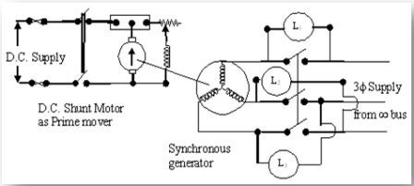

The operation of connecting an alternator parallel with another alternator or with a common busbar is known as synchronizing for proper synchronization of alternators the following three conditions must besatisfied. a. The terminal voltage of incoming machine must be the same as the bus bar voltage.

b. The speed of the incoming machine must be same such that the frequency is equal to the bus bar frequency.

c. The phase of the alternator voltage must be identical to the bus bar voltage.

It means that the switch must be closed at the instant the two voltages are in correct phase.

Condition 1 can be checked with the help of voltmeter, frequency is adjusted by varying the prime mover speed. In the dark lamp method the lamps are connected across the alternator and bus bar terminal. If the phase sequence is different, the lamps will brighten in a cyclic manner correct phase sequence is indicated by simultaneous darkening brightening of lamps. The switch is closed in the middle of the dark period. Once synchronized properly, the twoalternators continue to run in synchronism.

**b. Sychroscope**

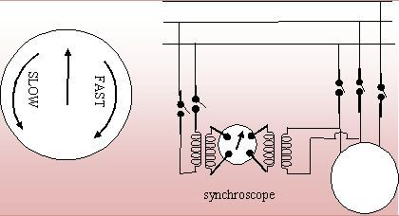

The armature of the sychroscope will align itself so that the axis of windings are R and F are inclined at an angle equal to phase displacement between V and V’. If there any difference between the frequencies of V and V’ a pointer attached to the armature shaft will rotate at slip speed, and the direction of its rotation will indicate whether the incoming machine is running above or below synchronism. At synchronism, the pointer will remain stationary, but it must be brought to the particular position which indicates zero phase displacement between V and V’ before the main switch of the incoming generator is closed.

**IV. HARDWARE DETAILS**

The hardware has been designed to fulfill all the requirements of the synchronizing process.

Block diagram of auto synchronizer setup is shown in fig . The auto synchronizer setup consist of

a. Frequency control unit

b. Voltage control unit

c. Potential transformer unit

d. Signal conditioning card

e. Display card and

f. Circuit breaker with the switching circuit.

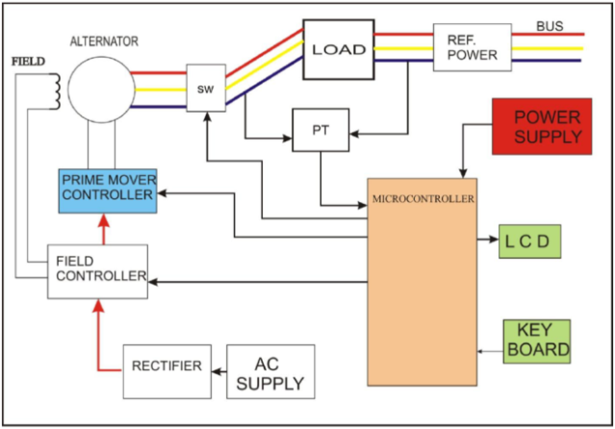

**a. Frequency Controlling Unit**

The frequency of an alternator can be changed by varying the speed of the prime mover which is a DC shunt motor in this case .A rheostat is provided in the field circuit of the motor for this purpose The frequency controlling unit is a lead screw arrangement driven by a stepper motor attached to the variable point on the rheostat the stepper motor is controlled by microcontroller system through a driver circuit.

**b. Voltage Controlling Unit**

Once frequency of alternator is fixed, or adjusted, its voltage is controlled by variation of excitation current. This excitation current is varied by providing a rheostat in the field circuit of the alternator. The automatic variation of excitation current is obtained by lead screw and stepper motor arrangement similar to the one used for frequency control.

**c. Potential Transformer Unit**

This unit consists of a bank of four shell type transformer (P.Ts). Out of the four transformers thee are used for stepping down three phase voltages of alternator and the remaining one is used for stepping down the voltage of the phase R of the bus bar. The potential transformers connected to the phase R of the bus bar and the phase R of the alternator are having two secondary’s. Hence one secondary is used for voltage measurement and the other is used for frequency measurement .The potential transformers connected to the Y and B phases have only one secondary each.

**d. Signal Conditioning Card**

It is subdivided into

a) signal conditioning card and

b) ADC subunit.

The signal conditioning subunit consists of for identical circuits each of which comprises of a zero crossing detector (ZSD)(for ralt,yalt,balt and rbus) two rectifier and filter circuits for ralt2 and rbus2 and an in phase sequence detector and an in phase instant detector as shown in fig.

**e. Display Device**

Display card has been provided for indication of messages during alternator synchronization process it uses four seven –segment LED displays to represent the three in phase synchronization conditions.

**V. CIRCUIT DIAGRAM**

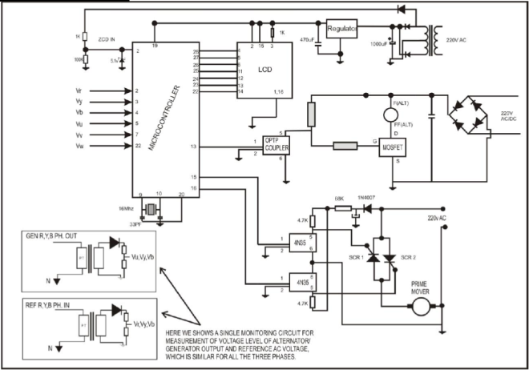

The output voltage both, from the reference & incoming alternator is given to PIC using potential transformer. The PIC has inbuilt ADC (Successive Approximation) which convert this analog signal to digital signals. The PIC compares the incoming voltage to the reference voltage and generate equivalent PWM signal. This PWM signal is a square wave with Ton& Toff time. It is given to the Opto-coupler. Opto-coupler consist of LED and Photo Diode. This will simultaneously turn on & turn off the LED, which will operate the photo-diode. Now when LED is OFF the resistance of Photo diode will be more and hence the positive current from the 220V dc will gate the MOSFET and this will turn on the MOSFET and thus the negative terminal of field wdg will be connected to negative terminal of dc supply and this will increase the excitation voltage of alternator, thus increasing output voltage of the alternator. The same process repeats if the incoming voltage is more than that of reference voltage, the LED will be On, which will decrease the resistance the 220V will be grounded through photo-diode and the MOSFET will be OFF thus decreasing the excitation of the alternator. For the measurement of frequency a ZCD (Zero Cross Detector) circuit is connected to PIC. The input from incoming alternator is given to ZCD using a Half Wave Rectifier unit. The ZCD counts the no of positive to zero going pulse which is equivalent to the frequency. The ZCD is set at 50 Hz frequency, if the incoming frequency is less it will generate equivalent PWM and the same process repeats as the prime mover used here is field excited. The result is displayed on the 16x4 LCD display. A step down transformer along with full wave rectifier circuit is used to provide 5V dc supply to the PIC &LCD Display. LM 7805 is used as voltage regulator IC to provide constant voltage to the PIC.

**VI. CONCLUSION**

PIC18F23K20 microcontroller based an automatic synchronization unit has been achieved for the parallel operation of two alternators.This automatic synchronization can be achieved more effectively compared to the conventional method of synchronization such as synchronizing lamp method and synchronization using synchroscope.

Moreover the microcontroller based synchronization is user friendly and requires less maintainance.It also exploits the advantage of superior performance of the microcontroller like accuracy, speed and reliability.

**REFERENCES**

1. Power Engineering Society, IEEE Standards for synchrophasers for power system, 2005.

2. B.L.Theraja, A.K. Theraja, a text book of Electrical Technology, S.Chand & Company LTD., 2002.

3. Emam, S.E.A.,automatic digital synchronization, international conference on electrical, ICEEC’04.(2004).

4. Ashfaq Hussain, Dhanpat Rai & Co.(Pvt)Ltd.,Electric Machines.(Second Edition),2005

5. Dr. P.S. Bimbhra, Khanna Publishers, Power Electronics, (Fourth Edition).,2009.

6.D.P. Kothari, I.J Nagrath, Electrical power system , TATA McGraw Hill Education 2003.