**VOLTAGE SAG ANALYSIS IN DISTRIBUTION SYSTEM WITH SFCL BY USING MATLAB**

Dipak Pade2, Sagar Gore3, Nikita Latare4 Mrs.V.B.HARDAS1

[dipakshay.pade@gmail.com2](mailto:dipakshay.pade@gmail.com2)Asst.Professor

Department of Electrical Engineering KDKCE Department of Electrical Engineering KDKCE

***Abstract*-In this paper, the effects of a superconducting fault current limiter (SFCL) installed in power distribution systems on voltage sags are analyzed. The power distribution system will be operated a type of loop. In this case, voltage drops (sags) are severe because of the increased fault current when a fault occurs. If SFCL is installed in the power distribution system, the fault current decreases based on the location and resistance value of the SFCL, and voltage sags are improved. In this paper, the improvement of the voltage sag is analyzed according to the fault location, resistance value of SFCL and the length of the power distribution system. First, a resistor-type SFCL model is used using the MATLAB. Next, the power distribution system is modeled. Finally, when the SFCL is installed in the power distribution system with various lengths, voltage sags are evaluated.**

***Keywords*:-Superconducting fault current limiter (SFCL); voltage sag, Power distribution system.**

## I.INTRODUCTION

**O**ver the past decades, superconductivity techniques

have been very grown in various areas. Especially, superconducting fault current limiters (SFCLs) have been developed and are put to practical use in power distribution systems in Korea. SFCL decreases fault current and reduce an adverse effect on power systems, ultimately can make the capacity of circuit breakers small. Moreover, SFCL can provide additional advantage as the improvement of voltage sags [1].

Reference [1] presented the method of voltage sag using the SFCL is applied to a power distribution system. Reference [2] presented the parallel connection of radial systems via the SFCL which can make voltage dipsless severe. References [3] and [4] present the improvement of voltage sags caused by fault current

decreased by installing fault current limiter. Voltage sag is evaluated by magnitude and duration.

In general the series-connected impedance such as SFCL improvesthe magnitude of sag, whereas it may worsen the duration of sag because of the delayed trip time of a protective device by the decreased fault current. These effects of SFCL on voltage sags should be evaluated. Also, power distribution system will be changed to loop system such as microgrid or smartgrid.Thus, effects of SFCLs should be evaluated and analyzed when SFCLs are installed in radial and loop power distribution system according to the location and impedance of SFCL, the length of feeder, and location of fault.

Superconducting fault current limiter (SFCL) is innovative electric equipment which has the capability to reduce

fault current level within the first cycle of fault current [2]. The first-cycle suppression of fault current by a SFCL results in an

increased transient stability of the power system carrying higher

power with greater stability [5].

However, in this paper, we assess the impact of SFCL on voltage sags in power distribution system. In Section II, we model a resistor-type SFCL. In Section III, the voltage sag occurred by fault current is explained. In Section IV, we evaluate the voltage sag magnitude according to the fault location and resistance of SFCL in power distribution system.

# II. SIMULATION SET-UP

Matlab/Simulink/SimPowerSystem was selected to designand implement the SFCL model. A complete power network including generation, transmission, and distribution implemented in it. Simulink/SimpowerSystem has number of advantages over its contemporary simulation software (like EMTP, PSPICE) due to its open architecture, a powerful graphical user interface and versatile analysis and graphics tools. Control systems designed in Simulink can be directly integrated with SimPowerSystem models [7].



# Fig.1. Power system model designed in Simulink/SimPowerSystem Fault and SFCL locations are indicated in the diagram

# A.RESISTIVE SFCL MODEL

The single phase resistive type SFCL was modeled consideringthree fundamental parameters of a resistive type SFCL [7]. These parameters and their selected values are: 1) transition or response time =2msec, 2) minimum impedance=0.01ohms and maximum impedance=20 ohms,

3) Triggering current=1170A, its working voltage is 50 kV.

Fig. 2 shows the SFCL model developed in Simulink/Sim-PowerSystem. The SFCL model works as follows. First, SFCL model calculates the RMS value of the passing current and then compares it with the functioning block. Second, if a passing current is larger than the triggering current level, SFCL’s resistance increases to maximum impedance level in a pre-defined response time. Finally, when the current level falls below the triggering current level the system waits until the recovery time and then goes into normal state.

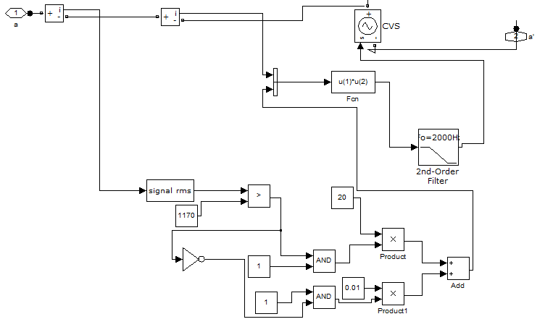

Fig. 2 shows the SFCL model developed in Simulink/Sim-PowerSystem.

# B.POWER SYSTEM MODEL

The modeled power system was based on Korean electric transmission and distribution power system Fig. 1 shows the power system model designed in Simulink/SimPowerSystem. The power system is composed of a 100 MVA conventional power plant, composed of 3-phase synchronous machine, connected with 200 km long 154 kV distributed-parameters transmission line through a step-up transformer TR1.

At the substation (TR2), voltage is stepped down to 45 kV from 154 kV. High power industrial load (6 MW) and low power domestic loads (1 MW each) .Transformer TR3 and is providing power to the domestic loads. In Fig. 1 artificial fault and locations of SFCL are indicated in the diagram fault points are marked as ‘Fault’, which represent three-phase-to-ground faults in transmission line. Location for SFCL installation is marked as ‘three phase SFCL’. SFCL is located in transmission line for which voltage sag is analyzing in section III during fault condition

**III.VOLTAGE SAGS IN POWER SYSTEM MODEL**

When faults occur in power distribution system.The voltage sag generally happens from fault Fig.1 shows the Power system model designed in Simulink/SimPowerSystem. Fault and SFCL locations are indicated in the diagram so; fig.3 shows the voltage sag during fault condition without SFCL location. During transition time i.e. from 0.2 to 0.3 voltage is reduced than the normal value**.**

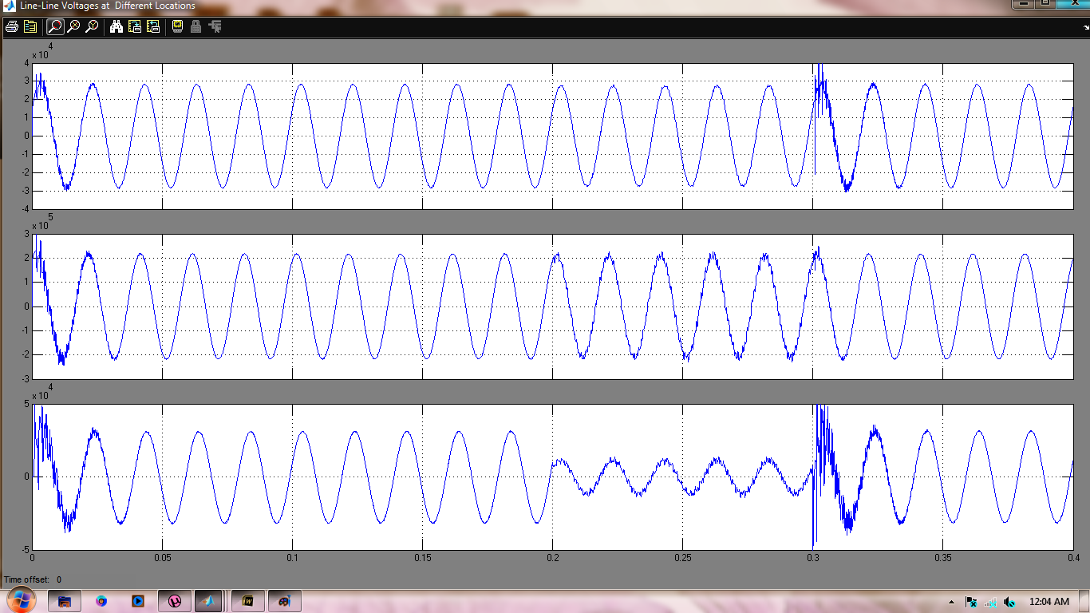

Fig.3 Voltage sag during fault condition without SFCL

As presented above, the faulted power distribution systems can produce various voltage sags to the customers on the neighbor feeder. Moreover, the number of neighbor feeder is about 6 to 10 while the number of faulted feeder is only one.

IV.IMPACT OF SFCL ON VOLTAGE SAGS

When SFCL is located in transmission line , it offer a resistance during fault condition to the fault current and voltage sag is removed fig.4 and fig.5 shows the bus voltages during fault condition with SFCL, at different resistances of SFCL.

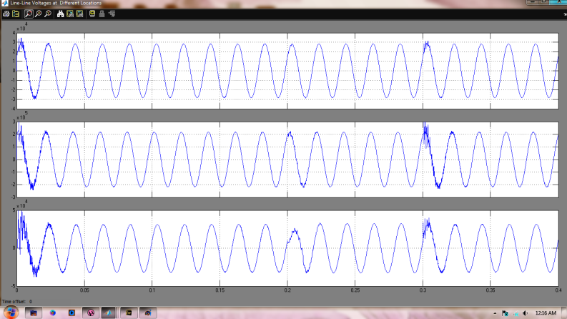

Fig.4 bus voltage when SFCL is located during fault condition having resistance, R=10 ohm

During reduction of voltage sag first, SFCL measure the fault and with respect to fault current it provides the value of resistance during fault condition in normal condition it act as a short circuit element and provide negligible resistance i.e. 0.01 ohm.

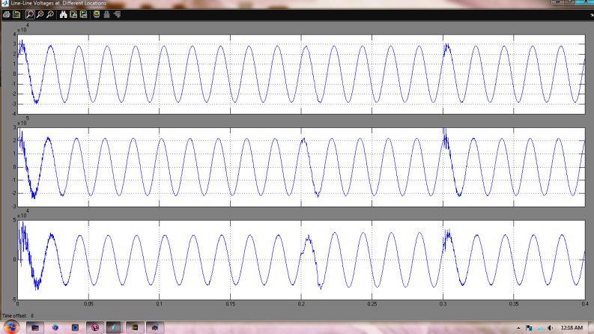

Fig.5 Bus voltage when SFCL is located during fault condition having resistance, R=20 ohm

.

Also, when a fault occurs, the customers at each feeder experienced the various magnitude of voltage according to many factors such as line impedance, fault location, types of fault, and so on.

# V. CONCLUSION AND DISCUSSIONS

In this paper, the effect of SFCL on voltage sag is analyzed when a SFCL is installed to a power distribution system. Firstly, resistor-type SFCL and power distribution system are modeled. Next, impact of SFCL on voltage sags are simulated using MATLAB. Voltage magnitudes are analyzed according to fault locations and SFCL’s resistance values, and the lengths of loop system. The simulation results found that the voltage sags at distribution system isincreased by various faults i.e L-G, LL-G ,LLL-G ,L-L.Moreover, the results of simulation represent the SFCL with bigger resistance is needed to improve the voltage sags in loop system.

# REFERENCES

[1] J.-F. Moon, S.-H. Lim, J.-C. Kim, and S.-Y. Yun, “Assessment of the impact of SFCL on voltage sags in power distribution system,” *IEEE Trans. Appl. Supercond.*, vol. 21, no. 3, pp. 2161–2164, Jun. 2011.

[2] L. Ye, L. Z. Lin, and K.-P. Juengst, “Application studies of superconducting fault current limiters in electric power systems,” *IEEE Trans. Appl.Supercond.*, vol. 12, no. 1, pp. 900–903, Mar. 2002.

[3] J. C. Das, “Limitations of fault-current limiters for expansion of electrical distribution systems,” *IEEE Trans. Ind. Appl.*, vol. 33, no. 4, pp. 1073–1082, Jul./Aug. 1997.

[4] F. Tosato and S. Quaia, “Reducing voltage sags through fault currentlimitation,” *IEEE Trans. Power Del.*, vol. 16, no. 1, pp. 12–17, Jan. 2001.

[5] B. C. Sung, D. K. Park, J. W. Park, and T. K. Ko, “Study on a series resistive SFCL to improve power system transient stability: Modeling, simulation and experimental verification,” *IEEE Trans. Industrial Electron.*, vol. 56, no. 7, pp. 2412–2419, Jul. 2009.

[6] L. Dessaint, K. Al-Haddad, H. Le-Huy, G. Sybille, and P. Brunelle, “A power system tool based on simulink,” *IEEE Trans. Industrial Electron.*, vol. 46, no. 6, pp. 1252–1254, Dec. 1999.

[7] K. Maki, S. Repo, and P. Jarventausta, “Effect of wind power based distributed generation on protection of distribution network,” in *IEEEDevelopments in Power System Protection*, Dec. 2004, vol. 1, pp. 327–330.

[8] H. R. Kim, S. W. Yim, O. B. Hyun *et al.*, “Analysis on recovery characteristics of superconducting fault current limiters,” in *Proc. MT-20 Conf.Magn. Technol.*, Philadelphia, PA, Aug. 27–31, 2007.

[9]Alexander Kusko and Marc T. Thompson “Power quality in electrical systems”

[10] Lin Ye and K. P. Juengst, "Modeling and Simulations of HTc ResistiveType Superconducting Fault Current Limiter", IEEE Transactions on Applied Superconductivity, Vol. 14, No.2, June 2004, 839-842

[11] Lin Ye, L. Z. Lin and K. P. Juengst, "Application Studies of

Superconducting Fault Current Limiter in Electric Power Systems ", IEEE Transactions on Applied Superconductivity, Vol. 12, No.1,March 2002, 900-903