Study and Implementation of Boost DC-DC converter for excitation of alternator
Sonali M. Sonkusare¹ , Poonam S. Duragkar² ,V.G. Naik³
VIII sem¹ ,VIII sem² ,Assisstant professor³
Department of Electrical Engineering, KDK College of Engineering, Nagpur(MH)
Email: shonalisonkusare148@gmail.com¹, duragkarpd@gmail.com²

Abstract — This paper presents a comprehensive study of a boost dc-dc converter for excitation of alternator. A laboratory prototype converter with a 17V input voltage and 141V output voltage is implemented to verify the performance. We are interested in developing DC-DC boost converter by using any sources. In order to design DC-DC boost converter two different power operation modes are obtained. The validity of proposed converter and its control performance is verified by simulation and experimental results for different operation conditions.

Index Terms– DC-DC boost converter, alternator,excitation,simulation.

I. Introduction
A boost converter is DC-DC power converter with an output voltage greater than its input voltage. Several applications require high step-up, non-isolated DC-DC converters. Some applications are renewable energy sources such as fuel cell and uninterruptible power supply (UPS) system. The power for the boost converter can come from any suitable dc sources such as batteries, solar panel, rectifiers, dc generators. The boost converter step-up the input voltage to a high value[2]. The obtained output voltage is 8 times than that input voltage. This increased voltage is then given as excitation to the alternator.
The organization of the paper are as follows: Section II
presents the operational principle of DC-DC boost converter [4]for boosting any dc source output to get the desired value which is required for excitation of alternator. In section III, synchronous machine[1] required desired excitation current which is provided by output of DC-DC Boost Converter. In section IV. simulation gives comparative results as that of small laboratory prototype model which is given by waveforms.

- Operational Principle Of Boost Converter

A boost converter is a power converter with an output dc voltage greater than its input dc voltage. The main components of a boost converter are an inductor, a diode and a high frequency switch. Power for the boost converter can come from any suitable DC sources, such as batteries, solar panels, rectifiers and DC generators. A process that changes one DC voltage to a different DC voltage is called DC to DC conversion. A boost converter is a DC- DC converter with an output voltage greater than the source voltage. A boost converter is sometimes called a step-up converter since it “steps up” the source voltage. Fig. 1 shows the circuit diagram of boost converter. When the power device is ON, the inductor is connected to the supply and inductor stores energy during on period. Hence, diode is reverse biased and isolates the output stage. When the power device is OFF, the output stage receives energy from the inductor as well as from the input. The current which was flowing through the switch would now flow through inductor, diode, capacitor and resistive load.

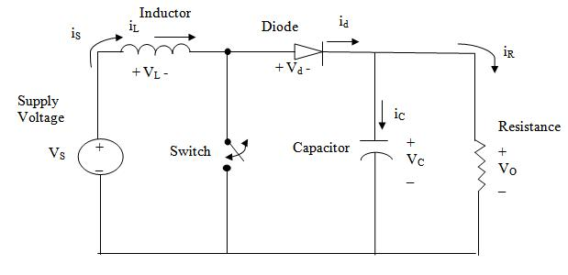
Fig. 1. Circuit diagram of boost converter

There are two modes of operation of a boost converter. Those are based on the closing and opening of the switch. The first mode is when the switch is closed; this is known as the charging mode of operation. The second mode is when the switch is open; this is known as the discharging mode of operation.

  - Mode 1:Charging mode
In this mode of operation; the switch is closed and the inductor is charged by the source through the switch. The charging current is exponential in nature but for simplicity is assumed to be linearly varying. The diode restricts the flow of current from the source to the load and the demand of the load is met by the discharging of the capacitor. When a boost converter operates in continuous mode, the current through the inductor (IL) never falls to zero. Fig. 2 shows the basic circuit diagram of charging mode of DC-DC boost converter. Fig. 3 shows the typical waveforms of currents and voltages in a converter operating in this mode.

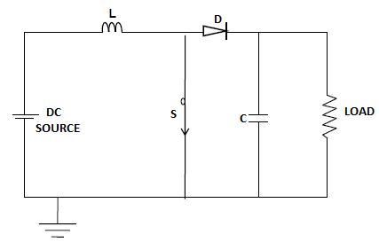

Fig. 2. Circuit diagram of DC-DC boost converter
in charging mode

c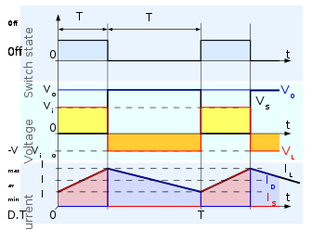

Fig. 3 Waveforms of current and voltage in a boost
converter operating in charging mode.

The output voltage can be calculated as follows, in the case of an ideal converter. During the On-state, the switch S is closed, which makes the supply voltage (VS) appear across the inductor, which causes a change in current (IL) flowing through the inductor during a time period (t) by the formula:

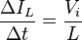
At the end of the On-state, the increase of I_{L} is therefore,
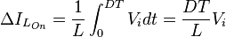
where, D is the duty cycle. It represents the fraction of the commutation period T during which the switch is On. Therefore D ranges between 0 and 1. During the Off-state, the switch S is open, so the inductor current flows through the load. If we consider zero voltage drop in the diode, and a capacitor large enough for its voltage to remain constant, the evolution of I_{L} is:
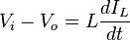
Therefore, the variation of I_{L} during the Off-period is:
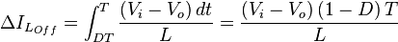
As we consider that the converter operates in steady-state conditions, the amount of energy stored in each of its components has to be the same at the beginning and at the end of a commutation cycle. In particular, the energy stored in the inductor is given by:
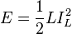
So, the inductor current has to be the same at the start and end of the commutation cycle. This means the overall change in the current (the sum of the changes) is zero:
This can be written as:
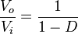
which in turn reveals the duty cycle to be:
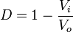
The above expression shows that the output voltage is always higher than the input voltage (as the duty cycle goes from 0 to 1), and that it increases with D, theoretically to infinity as D approaches 1. This is why this converter is sometimes referred to as a step-up converter.
  - Mode 2:Discharging mode
In this mode of operation, the switch is open and the diode is forward biased. The inductor now discharges and together with the source charges the capacitor and meets the load demands. The load current variation is very small and in many cases is assumed constant throughout the operation. In this case, the current through the inductor falls to zero during part of the period. Fig. 4 shows the basic circuit diagram of discharging mode of DC-DC boost converter. Fig. 5 shows the typical waveforms of currents and voltages in a converter operating in discharging mode.

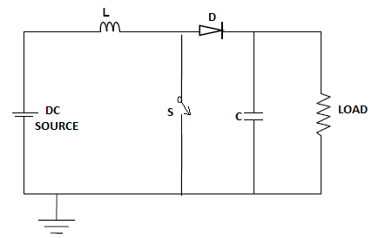
Fig. 4. Circuit diagram of DC-DC boost converter
in discharging mode
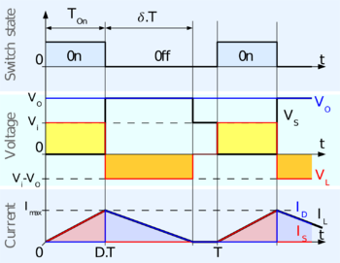
Fig. 5: Waveforms of current and voltage in a boost
converter operating in discontinuous mode.
The output voltage equation can be calculated as follows. As the inductor current at the beginning of the cycle is zero, its maximum value IL(Max) at T=DT.
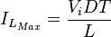
During the off-period, I_{L} falls to zero.
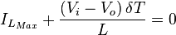
Using the two previous equations, δ is:
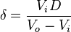
The load current I_{o} is equal to the average diode current (I_{D}). As can be seen on Fig. 3, the diode current is equal to the inductor current during the off-state. Therefore the output current can be written as:
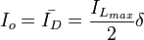
Replacing I_{Lmax} and δ by their respective expressions yields:
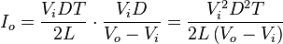
Therefore, the output voltage gain can be written as follows:
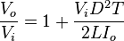
Compared to the expression of the output voltage for the continuous mode, this expression is much more complicated. Furthermore, in discontinuous operation, the output voltage gain not only depends on the duty cycle, but also on the inductor value, the input voltage, the switching frequency, and the output current.
III.Alternator
In this paper a boost converter based PV energy system is used for excitation of an alternator. Alternators operate on the fundamental principle of electromagnetic induction. They consist of an armature winding and a magnetic field. In alternators field rotates, and armature is stationary. The standard construction consists of armature winding mounted on a stationary element called stator and field windings on a rotating element called rotor. When the rotor rotates, the stator conductors are cut by the magnetic flux, hence they have induced e.m.f. produced in them. Because the magnetic poles are alternate, they induce an e.m.f. and hence current in armature conductors, which first flows in one direction and then in the other. Hence, an alternating e.m.f. is produced in the stator conductors whose frequency depends on the number of poles moving past a conductor in one second and whose direction is given by Fleming’s Right hand rule.
IV.Simulation

In order to verify the performance of the proposed project, simulation have been done by using MATLAB software. MATLAB is a high performance language for technical computing. It integrates computation, visualization and programming in an easy to use environment where problems and solutions are expressed in familiar mathematical notations. MATLAB is a high-level language and interactive environment for numerical computation, visualization, and programming. Using MATLAB, you can analyse data, develop algorithms, and create models and applications. The name MATLAB stands for Matrix Laboratory. MATLAB was originally written to provide easy access to matrix software developed by the LINPACK (Linear equations software package) and EISPACK (Eigen system package) projects. MATLAB is a system whose basic data element is an array that does not require dimensioning. MATLAB is used for wide range of applications including signal processing and communications, image and video processing, control systems, test and measurement, computational finance, and computational biology. Simulink is an extension of MATLAB by mathwork. It works with MATLAB of dynamical system under a graphical user interface (GUI) environment. Simulink is a block diagram environment for multidomain simulation and model based design. It supports system-level design, simulation, automatic code generation, and continuous test and verification of embedded systems. Simulink provides a graphical editor, customizable block libraries, and solvers for modeling and simulating dynamic systems. It is integrated with MATLAB, enabling you to incorporate MATLAB algorithms into models and export simulation results to MATLAB for further analysis. Fig. 4 shows the execution of the boost converter using simulation diagram. Various component are used which are having required rating connected in a manner so as to form a boost converter. Certain blocks are introduced in it which are:
1.Current Measurement Block- It is connected in the Input for measuring input current and in output for measuring the outputcurrent. 2. Voltage measurement block- It is connected in the output for measuring the desired output voltage and in the output fo 3.Pulse generator- The pulse generator block generates square wave pulses at regular intervals. 4.Power GUI- The power GUI block provides useful graphical interface (GUI) tools for analysis of power system block set models. It allows you to display steady state value of measured current and voltages as well as state variables in circuit. 5.Scope- The scope block displays input signals with respect to the simulation time.

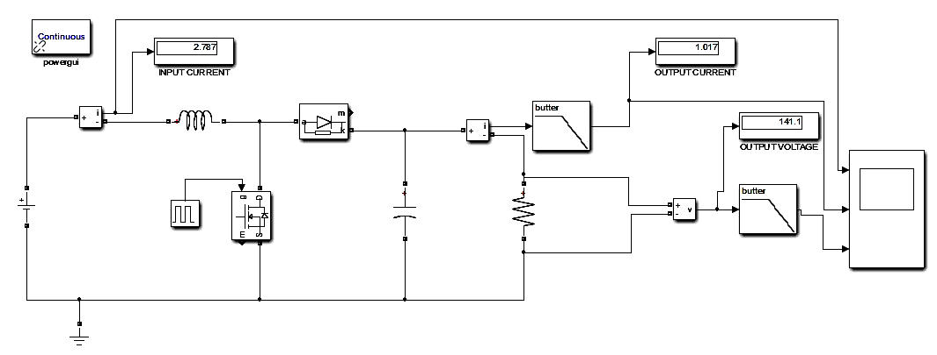
Fig. 6 Simulation diagram of boost converter

Before reaching the steady state value of 2.787 ampere, for a very short period of time there is slight distortion in the input current which is named as transient state followed by sub-transient state whose time period is more than that of transient state.

Fig. 7 Output current waveform

Fig. 8 Output voltage waveform

Fig. 5 shows the variation of output current with respect to time. Before reaching the steady state value of 1.017 ampere, for a very short period of time there is slight distortion in the output current which is named as transient state followed by sub-transient state whose time period is more than that of transient state.
Fig. 6 shows the variation of output voltage with respect to time. Before reaching the steady state value of 141.1 volt, for a very short period of time there is slight distortion in the output voltage which is named as transient state followed by sub-transient state whose time period is more than that of transient state.
V. conclusion
This paper has presented a study of the DC-DC boost converter for excitation of synchronous machine. The step-up voltage of boost converter is utilize for excitation of synchronous machine by connecting boost converter between any dc source and alternator for high voltage dc-dc conversion. As the simulation result shows, the converter control system provides good transient and steady state response for the converter with respect to the different step changes The simulation result are verified by low power range laboratory prototype model with an acceptable efficiency.
References
- Schaefer R.C., kiyong kim, “Excitation control of synchronous generator”, Industrial Application Magzine, IEEE, vol.2, pp37-43, 2002.
- Santiago J. Amodeo, Hector Gerardo Chiacchiarini, and Alejandro R. Oliva, “High performance control of a DC-DC Z-Source converter used for an excitation field driver,” IEEE, Vol 27,No.6, pp.2947-2957,2012.
- Reza Sabzehgar and Mehrdad Moallem,,”A boost type power converter for energy regenerative damping” in IEEE trans on mechatronics, VOL.18, NO.2, pp.725-731,2013.
- Farzam Nejabatkhah, Saeed Danyali, Seyed Hosseini, Mehran Sabahi, and Seyedabdolkhalegh Mozaffari Niapour, “Modeling and control of a new three-input DC-DC boost converter for hybrid PV/FC/Battery power system”, IEEE, VOL. 27,NO. 5, MAY 2012, pp. 2309-2324.
- F. Z. Peng , H. Li, G. J. Su, and J. S. Lawler, “A new ZVS bidirectional dc–dc converter for fuel cell and battery application,” IEEE Trans. Power Electronics, vol. 19, no. 1, pp. 54–65, Jan. 2004.
- R. Watson and F. C. Lee, “A soft-switched, full-bridge boost converter employing active clamp circuit,” in Proc. IEEE PESC, 1996, pp. 1948–1954.
- Ren-Yi Chen,Tsorng-Juu Liang, Member, IEEE, Jiann-Fuh Chen, Member, IEEE,Ray-Lee Lin, and Kuo-Ching Tseng, VOL. 44, NO. 4, JULY/AUGUST 2008,pp. 1218-1226.

