ADVANCED EMBEDDED IRRIGATION SYSTEM
Ali Akbar Shiraz, Mayank Gupta Under the Guidance of:
Fourth Year B.E. Mr S. Sharma
Department of Electronics and Tele-communication Asstt. Professor
Priyadarshini College of Engineering, Nagpur. EXTC Department
Email: mayank692@gmail.com

ABSTRACT:

This paper presents the methodology for handling the current situation of our irrigation system in this present era. The project we have undertaken is entitled as “ADVANCED EMBEDDED IRRIGATION SYSTEM”. This project is taken in India an agriculture oriented country and the rate at which water resources are depleting is a dangerous threat hence there is a need of smart and efficient way of irrigation that consumes less labor and saves time for irrigating the crops.
In this paper we have discussed the implementation of an automatic irrigation system which uses moisture sensors to detect the humidity level in the soil (agricultural field) and the amount of irrigation required by the field. The project is 80C51 microcontroller based design which controls the water supply and the fields to be irrigated. There are sensors present in each field which are not activated till moisture level of the soil is above the threshold level.
Once the field gets dry, sensors sense the requirement of moisture in the field and send the information to the microcontroller. Microcontroller then switches ON the circuit and the water pump gets ON. At the same time the details of the moisture level are sent to the farm owner via GSM Module. In case when there is more than one signal for water requirement then the microcontroller will prioritize the first received signal and irrigate the fields accordingly.

INTRODUCTION:
Irrigation is the artificial application of water to the land or soil. But now days due to improper availability of the labor because of increasing wages in the cities they are migrated from rural to urban areas. Hence farm lands facing problems for irrigating the crops. Therefore, it is advisable to discover such technology which consumes less labor and saves time for irrigating the crops.
We are introducing an AUTOMATIC IRRIGATION SYSTEM for better growth of plants. In this system moisture level of soil will be checked continuously and if it goes below threshold value then water pump will be automatically turned ON and moisture level will be maintained.
We can also keep a continuous check on the moisture level and its values will be sent continuously on the person’s mobile and according to the observation of the moisture level the person can just make water pump ON by sending the message.

Detailed Block Diagram of the setup

Solar Panel

A to D Convertor
Microcontroller
Moisture Sensor
To operating side

Fig. 1.1: Block diagram Sensing Side of irrigation system

Solar Panel

GSM Module
12V D.C. Supply
Microcontroller

Water Distribution
Relay
Pump

Fig. 1.2: Block diagram Operating Side of irrigation system

IMPLEMENTATION:

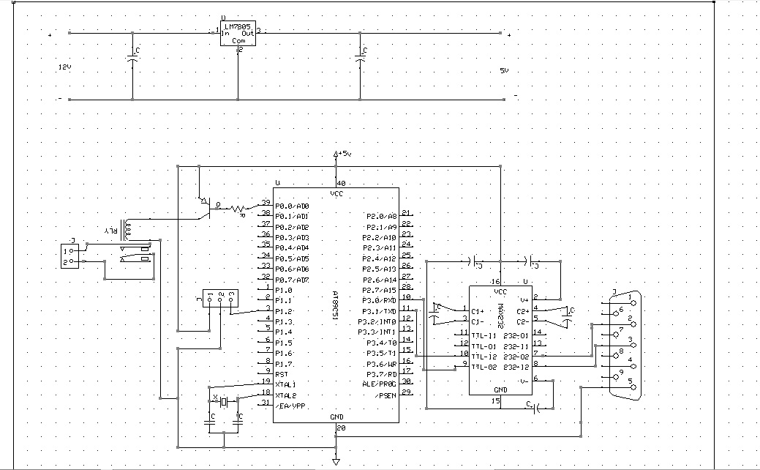

Fig. 1.3: Circuit Diagram of irrigation system

Fig:1.3 shows the basic working of the “ADVANCED EMBEDDED IRRIGATION SYSTEM”.

When soil moisture sensor senses the dry soil, it will give trigger to the microcontroller & the microcontroller is programmed as per the condition. When controller gets the trigger for the dry soil it will make the port pin p0.0 pin low (i.e. Zero) which will make the transistor ON and as soon as transistor becomes on relay gets triggered and pump will get the 12 V and pump will be started.
Now as soil starts getting wetter, after sometime, sensor will give the trigger to controller that soil is wet now. And controller will make the port pin p0.0 high which will make transistor off as well as relay which will in turn switches off the pump automatically.
And in the complete process whenever pump gets ON or OFF we are going to receive the status as a update that pump is ON or OFF.

RESULTS:

The system has been developed which gives desired output and performs respective operations perfectly.

CONCLUSION:

Future scope of our project is to improve the existing irrigation technology in our agricultural oriented country. As we know that in future power sources will be limited therefore in spite of relying on traditional methods we have chosen solar power source. This method makes our project not only power saving but also ecofriendly. It’s a 3rd generation farming technique which will replace the traditional ways of farming techniques. Our aim is to target the masses, as we know that India is country whose economy solely depends on agriculture.

REFERENCES:

- Venkata Naga Rohit Gunturi
Micro Controller based Automatic Plant Irrigation
System:-
International Journal of Advancements in Research
& Technology, Volume 2, ISSN
2278-7763,Electronics and communication
engineering department, Anna University,
Chennai.
- Rafael Muñoz-Carpena and Michael D. Dukes
Automatic Irrigation System based on Soil
MoisturePaper No.:- AE354 IFAS
Extension, University of Florida
- B.L.S. Lui
Trial use of Solar Power Automatic Irrigation
System, Geo Report No. 194,
Geotechnical Engineering Office Civil Engineering
and Development Department,
The Government of Hong Kong
- H2o.org/irrigationsystem
- wikipedia.com
- Philips Semiconductors: P89V51RD2:8-bit 80C51 5 V low power 64 kB Flash microcontroller with 1 kB RAM Rev. 01 — 01 March 2004
- National Semiconductors: LM78LXX Series 3-Terminal Positive Regulators
- ON Semiconductors: 2N3906 Preferred Device General Purpose Transistors
- Texas Instruments: SLLS047L − FEBRUARY 1989 − REVISED MARCH 2004: MAX 232
- SIM Com Hardware Design SIM300_HD_V4.02
- HKE make JQC-3FC/T73 model 12VDC PCB MOUNTED SUGAR CUBE RELAY

