Direct Sequence Spread Spectrum For Different Modulated Signals.

1. Abhay Vighare , 2) Milan Malekar, 3) Abhilash Nimbalkar, 4) Nilesh Kuhikar.

Department of Electronics Engineering,

KDK college of Engineering, Nagpur.

Email Address

[abhay1607@gmail.com](mailto:abhay1607@gmail.com)[1]

ABSTRACT

**Spread spectrum is a type of modulation that spreads data transmission across available frequency band, in excess of minimum bandwidth available. Spread spectrum signals may be divided into two main groups - direct sequence spread spectrum (DSSS) and frequency hopping spread spectrum (FHSS).**

**This project is concerned with demonstrating some of the principles of the DSSS. Here, we will perform direct sequence spread spectrum (DSSS) modulation for different types of modulated signals viz. BPSK, QPSK, 16PSK and 64PSK. After this, we will compare the above signals for DSSS modulation to conclude which modulated signal is best suitable with DSSS modulation. All this will be done with the help of MATLAB.**

**INTRODUCTION TO DSSS**

In some situations it is required that a communication signal be difficult to detect, and difficult to demodulate even when detected. Here the word ‘detect’ is used in the sense of ‘to discover the presence of’. The signal is required to have a low probability of intercept .

In other situations a signal is required that is difficult to interfere with, or ‘jam’. The ‘spread spectrum’ signal has properties which help to achieve these ends. Spread spectrum signals may be divided into two main groups - direct sequence spread spectrum (DSSS), and frequency hopping spread spectrum (FHSS). This experiment is concerned with demonstratig some of the principles of the first**.**

**DS-CDMA**

Direct Sequence Code Division Multiple Access (DS-CDMA) grant access of the same channel to a number of user, by distinguishing them in the so called ‘code-domain’. Unlike TDMA and FDMA systems, user can then transmit their messages simultaneously and over the entire bandwidth. Process of message orthogonalization achivies this and is as such the key to the operation of DS-CDMA systems.

Given the task of extracting the desired user’s signal out of the received composite signal, the receiver needs to generate a replica of the desired user’s code in synchronism with the code contained in the signal being received. Correlating it with the incoming signal, isolates user signal ( Symbol level matched Filtering). It may be notified here that in case of multipath environment RAKE receiver is employed to resolve the multipath components and then add them coherently through Maximal Ratio Combing (MRC) to yield the final soft decision values. Error decoding and source decoding proceed then to complete the message recovery process.

**TRANSMITTER AND RECEIVER**

Transmitter:-

Binary data sequence will be given as i/p to DSSS transmitter and PN sequence, generated by the logic circuit, will spread it.

This spread signal will be given as i/p to Orthogonal frequency division multiplexing (OFDM) transmitter and at one end and modulated signal as i/p at another end. The o/p signal of OFDM will be transmitted by the antenna.

Receiver:-

The transmitted signal will be received by the antenna and OFDM receiver will demodulated it into spreaded signal.

This spreaded signal will be converted back into original Binary data sequence by the DSSS receiver.

**OFDM**

An OFDM carrier signal is the sum of a number of orthogonal sub-carriers,with based data on each on sub-carrier being independently modulated commonly using some type of phase-shift keying(PSK).

The receiver picks up the signal\scriptstyle r(t), which is then quadrature-mixed down to baseband using cosine and sine waves at the carrier frequency. This also creates signals centered on\scriptstyle 2 f_c, so low-pass filters are used to reject these. The baseband signals are then sampled and digitised using analog-to-digital converters(ADCs), and a forword FFT is used to convert back to the Frequency domain.

**INPUT PARAMETER OF OFDM**

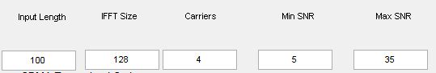

**SIGNALS SENT**

(1)BPSK:-

BPSK (also sometimes called PRK, phase reversal keying, or 2PSK)[3] is the simplest form of phase shift keying (PSK). It uses two phases which are separated by 180° and so can also be termed 2-PSK.

(2)QPSK:-

Quadrature phase-shift keying (QPSK)[3]is also known as quaternary PSK, quadriphase PSK, 4-PS or-QAM, QPSK uses four points on the constellation diagram, equispaced around a circle. With four phases, QPSK can encode two bits per symbol, shown in the diagram with gray coding to minimize the bit error rate (BER).

(3)16-PSK:-

16-PSK uses sixteen phases.

(4)64-PSK:**-**

64-PSK uses sixty four phases.

1. BPSK 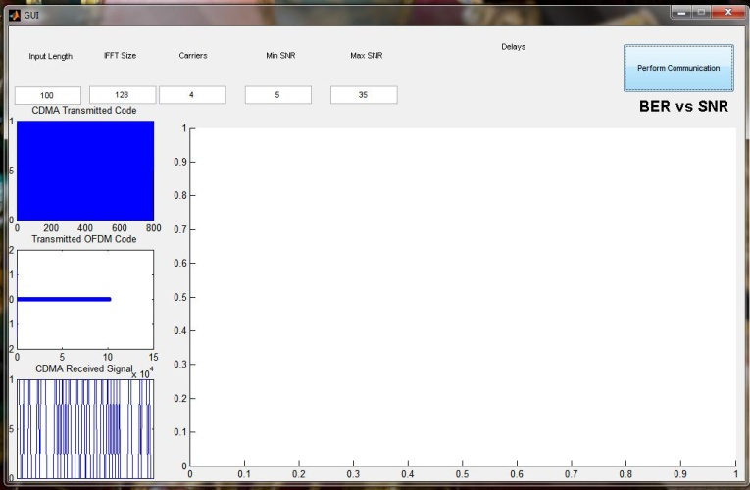
2. QPSK

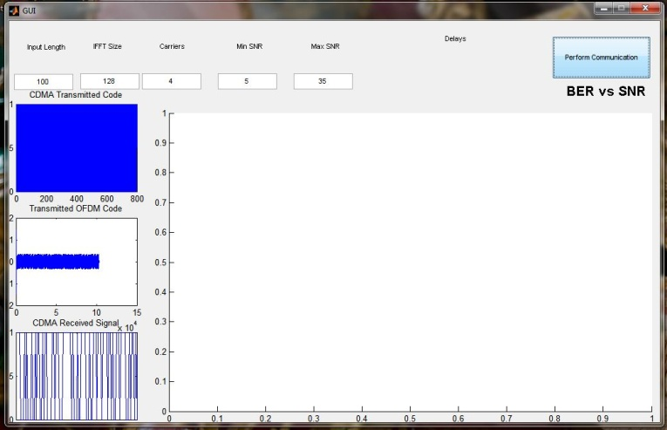­­­­­

(3) 16PSK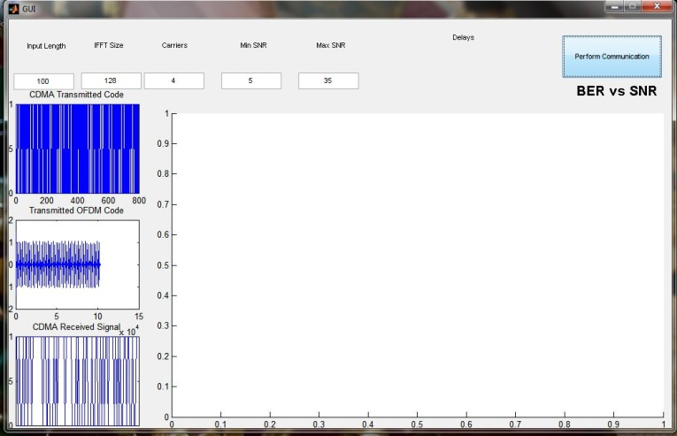

(4) 64PSK

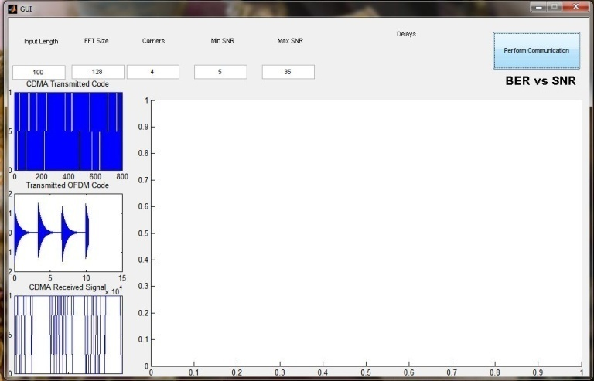

**OUTPUT**

The output for the different signals shown in the figure of BER vs SNR

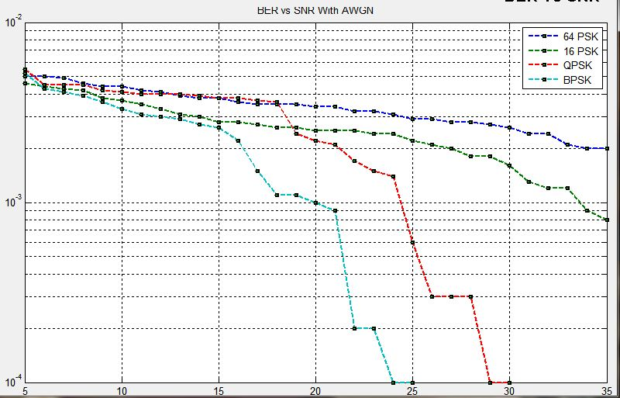

**APPLICATIONS OF DSSS**

* The United States [GPS](http://en.wikipedia.org/wiki/GPS), European [Galileo](http://en.wikipedia.org/wiki/Galileo_positioning_system) and Russian [GLONASS](http://en.wikipedia.org/wiki/GLONASS) [satellite navigation](http://en.wikipedia.org/wiki/Satellite_navigation) systems.
* DS-CDMA (Direct-Sequence Code Division Multiple Access) is a [multiple access](http://en.wikipedia.org/wiki/Multiple_access) scheme based on DSSS, by spreading the signals from/to different users with different codes. It is the most widely used type of [CDMA](http://en.wikipedia.org/wiki/CDMA).
* [Cordless phones](http://en.wikipedia.org/wiki/Cordless_telephone) operating in the 900 MHz, 2.4 GHz and 5.8 GHz [bands](http://en.wikipedia.org/wiki/Band_(radio))
* [IEEE 802.11b](http://en.wikipedia.org/wiki/IEEE_802.11b) 2.4 GHz [Wi-Fi](http://en.wikipedia.org/wiki/Wi-Fi), and its predecessor [802.11-1999](http://en.wikipedia.org/wiki/802.11-1999). (Their successor [802.11g](http://en.wikipedia.org/wiki/802.11g) uses both [OFDM](http://en.wikipedia.org/wiki/Orthogonal_frequency-division_multiplexing) and DSSS.
* [Automatic meter reading](http://en.wikipedia.org/wiki/Automatic_meter_reading).

**Conclusion And Result**

From the above discussion,BPSK is the most preferable modulated signal on the basis of parameter BER vs SNR.

**FUTURE SCOPE**

* Implementing ad-hoc mesh networks to introduce more flexibility in mobile spectrum-based applications.
* Taking SDR technologies a step further cognitive radios.
* Making spectrum-based systems more flexible with software-defined radios.
* Increasing spectrum efficiency by implementing new technologies along other parts of the value chain of spectrum-based services.
* Increasing spectrum efficiency directly developments in spread spectrum technologies.

**REFERENCES**

1. Electronic Communication Systems by *George Kennedy.*
2. Digital Communication Systems by *Simon Haykins.*
3. IEEE Transactions on communication vol.44 no.9 sep 1996 Direct Sequence spread spectrum John Henry, Senior member ,IEEE and starke,fellow ,IEEE.
4. OFDM – Orthogonal Frequency Division Multiplexing Dr. Jean Armstrong Department of Electronic Engineering La Trobe University.
5. ofdm-by VIJAYA CHANDRAN RAMASAMI