Automatic toll tax system
Akshay S. Nasre, Tejaswini P. Parate
B. T Polytechnic Mouda
Department of Electronics Engineering,
{akshaynasre3@gmail.com,sonuparate1994@gmail.com}
Mobile no: akshay 9975076593, tejaswini 7387971921.

Abstract :
The automatic toll tax system is just not a case of automation but it also deals with saving the fuel and also time. In today’s world time is as expensive as fuel itself and thus this project will tell us about this fact.
This gives the idea on a type of automation which many countries are after and have spend millions of dollars after this but are not still in the stage to highly atomize the toll tax systems.
This shows automation of the toll tax system by just the old concept of frequency, the automation talked in this project will take the help of transmitter circuit and the receiver circuit to automate the toll systems which runs the software program that deduces the money from the owner’s (i.e. of the vehicle) account and the vehicle will be allowed to Pass through the gate.
This synopsis about the automation has many limitations but it is a step which can be used in the automation of the present day toll tax systems.

Introduction
AUTOMATIC TOLL TAX SYSTEM
In the fast paced life, Toll Tax System on the highways are supervised and operated by human assistance. On most of the Toll Tax Center, you will find queues. It is time consuming and also requires human assistance. The main objective of this project is to make Automatic Toll Tax System which reduces the manual assistance, deliver secure and time efficient solution for the busy roads. Automatic Toll Tax System maintains the data base of the vehicles. By entering the data of lost/stolen vehicles, these vehicles can be tracked through the system. Automatic Toll Tax System does not allow unregistered or lost vehicles.
Design Approach for Automatic Toll Tax system
The presence of the car is detected with the help of the GPS Module. This identity is compared with the database of the Automatic Toll Tax System. If the identity matches with the data base, then vehicle is allowed to pass through the barrier and necessary toll tax amount (depending on the category of the vehicle) is deducted from the amount of the vehicle. If database do not contain the vehicle data, then vehicle can be registered. Database also check for the lost Vehicles information, if the vehicle is found to be lost/stolen it is not allowed to pass through the Toll Tax barrier. Automatic Toll Tax System allows recharge of the account, if the balance is lower than some threshold; driver is notified for the recharge of the account. The balance amount is also displayed on the LCD Display. The whole idea is to make secure, automatic, failsafe Automatic Toll Tax System.
Electronic Toll Collection
Electronic Toll Collection (ETC) evolved in an attempt to speed up traffic flow and minimize queuing at toll plazas. The basic definition of ETC is a toll system that allows drivers to pay the toll without paying cash at the toll plaza. Thus, methods of payment for ETC systems include Smart Cards, prepaid accounts, monthly charged accounts, as well as systems that automatically debit money directly from the user’s bank account. ETC systems offer the toll operator the advantage of lower labor costs—no one is needed to collect the tolls—in addition to the advantage it provides the motorists via elimination of queuing and faster travel.
Places were the System is implemented
EZ PASS
well known example of an ETC system in the United States is the E-Z Pass system present in the northeast A corridor. The original E-Z Pass system, installed in 1993, required that drivers whose vehicles were equipped with the E-Z Pass transponder stop or slow to less than 5 mph in the toll booth, while the system verified the transponder and recorded the transaction. This system was still significantly faster than the traditional methods of paying via cash or tokens. On the Garden State Parkway, a toll road in New Jersey utilizing ETC technology, average collection time for E-Z Pass is three seconds compared to 9.6 for cash and 4.6 for token based transactions (Peters & Kramer, 2003). While this represents a significant time savings and thereby increases the total number of vehicles that can pass through a toll plaza, this ETC technology is not nearly as advanced as ETC technology that is in place today in several parts of the world, although the basic components of the systems are quite similar.
FREE FLOW TOLLING
The new ETC technology is also referred to as free flow tolling, because the system allows cars to pass through the toll gantries without deviating from typical highway speeds. This technology, in combination with OCR that allows the system to read the license plates of vehicles without transponders, creates a system where there is no longer a need for a toll plaza, and their accompanying congestion. Since free flow ETC means that travel plazas are no longer necessary, it is possible to install tolling equipment on virtually any road, no matter the amount of space available. This is a picture of a tolling point on a free flow tolling highway. As can be seen, there are no lane or speed restrictions that accompany the large tolling plazas often seen in the United States. Additionally, the tolling points do not require any additional land to operate. The removal of congestion and land availability concerns allow planners to further implement tolling for a variety of purposes including raising funds to pay for maintenance costs, raising funds to pay for the cost of the roadway, variable pricing to influence traffic patterns (i.e. discouraging travel during peak periods with higher toll fees), and finally promoting more efficient lane use by allowing single occupant vehicles access to high occupancy vehicle lanes by paying a toll.

How It Works
How ETC works is that each vehicle is equipped with a transponder or Dedicated Short Range Communication (DSRC) device. When the vehicle nears a toll point, an overhead antenna sends a signal to the DSRC. Then, depending on the type of DSRC employed, the signal is either reflected with slight modification, or a different signal is sent back to the control tower. The signal modification is device unique allowing the system to identify the user by the signal. The user information is then relayed from the toll site to a central computer system that processes all toll transactions. Depending on the type of tolling system, open, closed, etc, the computer keeps a record of each time that a vehicle crosses the barrier and then compiles the total toll once the vehicle has left the toll way. Once this occurs, the toll procession computers relay the information to a different set of computers that then bill the user, either by debiting or adding the bill to a monthly invoice.

Block Diagram Description:

The System consists of micro controller card. LCD is used to display current balance and other related messages. LED indication will be provided for ON/Off gate status.
Card reader will be used to read the data from the card. Memory is provided for future application such as any vehicle related data can be stored in it. The RTC will be used to display the current time on LCD.
On the spot recharge facility will be also provided in this system. For this PC is connected to the system. We can enter recharge code through PC to recharge the card by particular value.
We will use Micro Controller 89V51RD2, MAX 232 level converter for PC interface, Serial memory AT24C04 and RTC DS1307, 16 *2 LCD etc.
The cards consist of memory 24C04 with SMD pack.

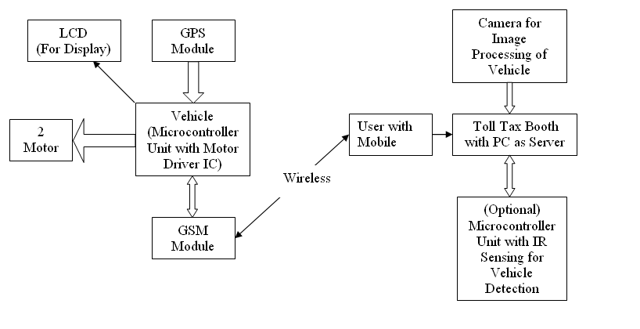
Fig1. Block Diagram
ADVANTAGES:
- Save time
- Save fuel
- More efficient
- Reduced traffic
- Reduced manpower
APPLICATION:
1. Toll tax
2. Parking slot
CONCLUSION:
- It consume time and does not required manual assistance.
- The object of this project is to make ATTS which reduce manual assistance, deliver secure, and time efficient solution for the busy road.
- ATTS maintain the data base of the vehicle, by entering the data of lost vehicle then this vehicle can be track through system.

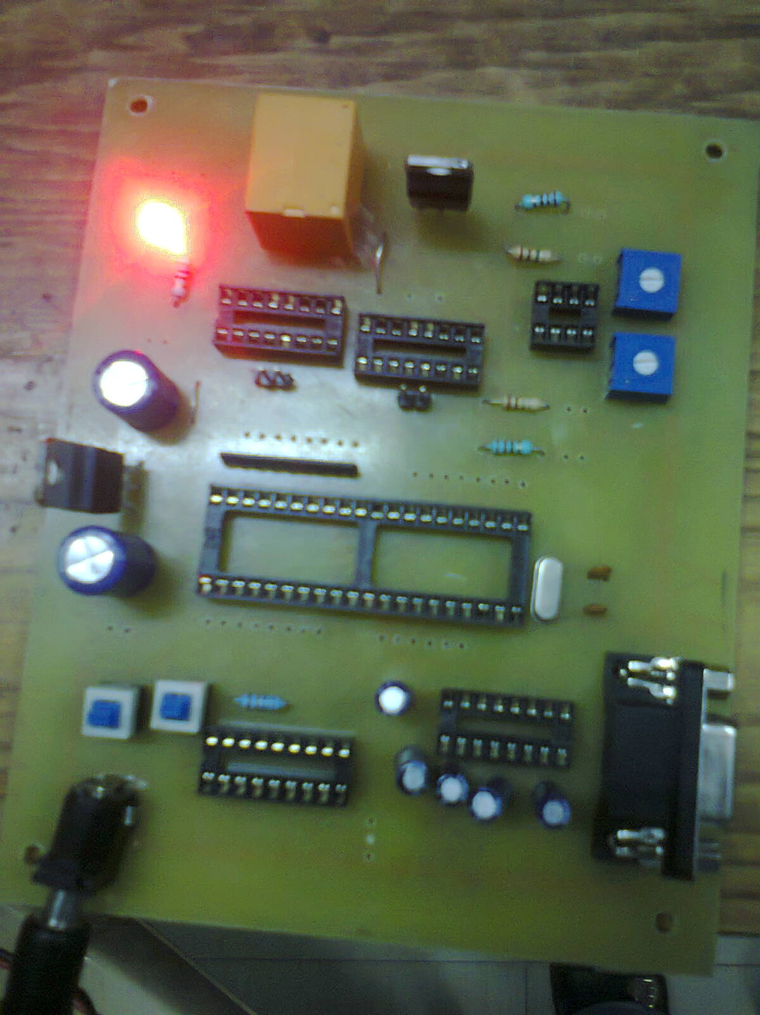

Fig2transmitor Circuit PCB
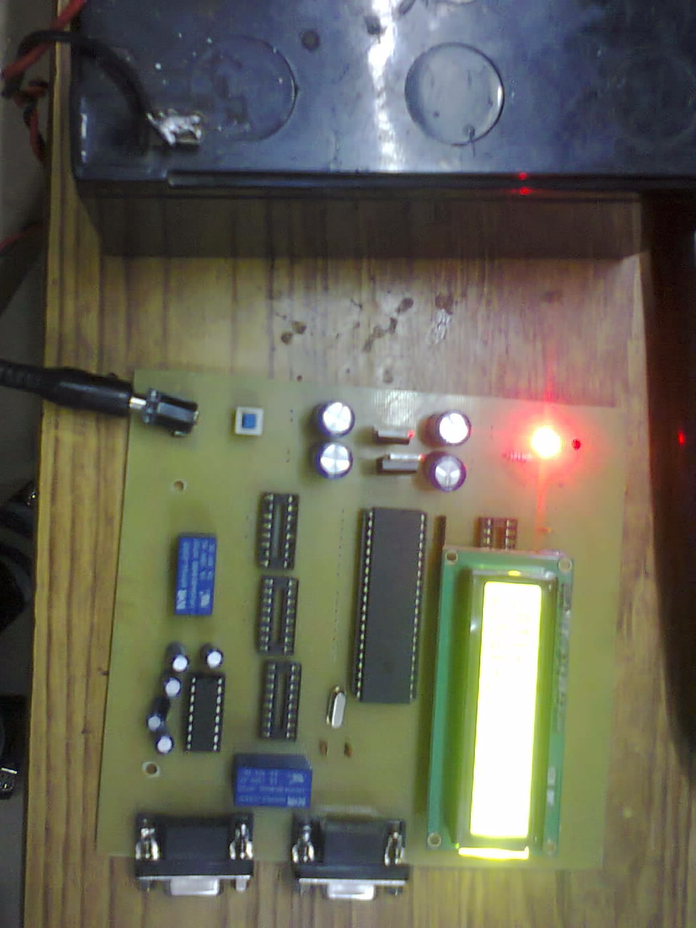
Fig 3-reciver ckt pcb
References
[1] R. Zhengang and G. Yingbo, “Design of electronic toll collection system in Expressway Based on RFID,” in Proc. ESIAT ’09 , 2009, p.779.
[2] Z. Xiao, Z. Guan, and Z. Zheng, “The research and the development of the highway’s Electronic toll collection system,” in Proc . , 2008, p. 359.
[3] R. Turnock and J. Kohli “High occupancy vehicle status signal ingusing electronic toll collection infrastructure,” U.S. Patent20100085213, Apr. 8, 2010.
[4] A. Demisch, H. Iseki, and B.D. Taylor, “Examining the linkages between electronic roadway tolling technologies and road pricing policy goals,” Univ. of California, Berkeley, UCB-ITS-PRR-2009-31,Jul. 2009
[5] Goh, M., “Congestion management and electronic pricing in Singapore.
.[6] J. Y.T. Wang, R. Lindsey, and H. Yang, “Nonlinear pricing on private roads with congestion /

