***ABSRACT***

Traffic control has been an issue since human put the first wheel on the first cart. The modern world demands the mobality. Cars represent the main method of mobality, but today’s congested highways and city streets don’t move fast, and sometimes they don’t move at all. Intelligent traffic system (ITS) sometimes called intelligent transport system apply communications and information technology to provide solution to this congesion as well as other traffic control issues. Intelligent transport system (ITS) represents the major transition in transportation on many dimensions. ITS is an international program intended to improve the effectiveness and efficiency of surfaces transportation system through advance technologies in information system, communication and sensors. ITS (Intelligent transport system) is a system design to promote advance technology, to ensure that the electronic toll collection system (ETC) is effective and to support the safe driving. With this system people, roads & vehicles use the latest information communication technologies.

Intelligent traffic system (ITS) take the first step towards meeting this challenge by providing effective reliable and meaning full knowledge to motorits in time. Problems like high traffic congesion, low transportation efficiency, low safety and endangered environment can be solved through innovative and sophisticated ways of handling latest techniques that have emerged in recent year in integrating information technology, electronic and telecommunication with roads and traffic management. Intelligent transport systems, or ITS encompass a broad range of wireless and wire line communication based information, controls and electronic technologies.

When integrated to transportation system infrastructure, and vehicle themselves, these technologies help and monitor and manage traffic flow, reduse congesion, provide alternate routes to travelers, enhance productivity, and saves life, time and money. Intelligent transport system provide the tools for skilled transportation professionals to collect, analyze, and archive data about the performance of the system during the hours of peak use. Having this data enhance traffic operators ability to respond to incidents, adverse weather or other capacity constricting events.

***INTRODUCTION***

The goal of intelligent transportation systems (ITS) is to improve the effectiveness, efficiency, and safety of the transportation system. Long range planning for the deployment of ITS technologies depends in part on the knowledge of which technologies are most effective. Thus, it is important to understand the benefits of emerging and existing technologies. ITS deployments have occurred at the national, state, and local levels. Oregon’s transportation infrastructure is being asked to serve a growing demand while financial resources are becoming increasingly limited. As the focus of transportation moves to operating the system in the most efficient manner, ITS technologies are a potential way to address these needs in Oregon’s transportation system. There are a great variety of ITS deployments and programs. The scope of this literature review is to synthesize some particular ITS benefits based on real experiences in urban areas. The review by no means intends to be a comprehensive evaluation of benefits in these areas. Instead, the purpose of the report is to highlight examples under each category on the national or international level and include a synthesis of documented benefits from ITS programs in Oregon. The ITS Benefits Database is a project of the United States Department of Transportation (U.S. DOT) ITS Joint Program Office (JPO). The JPO has been actively collecting information regarding measured benefits of ITS deployments to help transmit knowledge to transportation professionals who may not well be versed in ITS products and services. It also provides researchers with information on ITS areas in which further study may be needed.

***INTELLIGENT TRANSPORT SYSTEM PARTS:-***

* **ITS ARCHITECTURE:-**

framework for planning, defining, and integrating intelligent transportation systems.

Having discussed a set of intended applications and several possible sensing methods, the next question to ask is how to put it all together for Indian cities, so that the maximum possible number of applications are handled with ease and accuracy. Should we prioritize the list of applications, so that some are given higher importance than the others? How should we select what sensing methods to use? What should be the overall system architecture, including the communication model needed to gather sensed and/or computed data from the roads and dissipate information back to commuters dedicated static sensors on the road that give highly accurate and strictly periodic updates about traffic conditions. Static sensors are costly but accurate, mobile and hybrid sensors are cheap but noisy. Based on applications, we need to make

a careful choice of which mode to use when and how to mix them appropriately. The red squares and blue dots in Fig. would thus be probable candidates for static sensing, while the mobile and hybrid sensors would span the city, in varying densities over time, as the green triangles in the figure. Even within each mode, choices can be made based on level of information needed and installation and maintenance costs. If vehicle classification is vitally important, videos are a must. But if only level of congestion or length of traffic queues are needed for certain intersections, RF sensors, cheaper than videos or loops, can be used.

**Benefits of Architecture:-**

* Reduces time and resources required to integrate the technologies to local needs
* Helps identify agencies and jurisdictions & seeks their participation
* **COMMUNICATION SYSTEMS:-**
* Effective and efficient operation of transit systems relies on a communications infrastructure and vehicle-based communications technologies.
* Communications systems are used to transmit voice and data between transit vehicles and operation centers, and to transmit commands between operators and technologies.
* Transit communications systems are comprised mostly of wireless technologies and applications.
* ***FLEET MANAGEMENT AND OPERATIONS***

These includes separate technologies often are combined in various software packages, which allow for the integration of many different transit functions.

* ***ELECTRONIC TOLL COLLECTION(E T C):-***

1)Non-stop toll facilities and segregated traffic management.

2)Electronic payment by means of contactless smart cards to promote fast passage through the toll lanes.

* ***GLOBAL POSITIONING SYSTEM(G P S):-***

A system of satellites, computers, and receivers in which traffic data is incorporated in the map, the driver can get the fastest route, can know the position of the signals ahead, predict traffic jams, etc

* ***ADVANCED TRAVELLER INFORMATION SYSTEM(ATIS):-***

1)Advance travelers information system (ATIS), a part of new technology applications in transportation, provide accurate and timely information that help travelers to select routes, times of travel and travel modes. They work even better with inclusion of geographic tourist guides and yellow pages that enable travelers to select destinations based on proximity to other places. Deliver data directly to travelers,empowering them to make better choices about alternate routes or modes of transportation.when archived,this historical data provides transportation planners with accurate travel pattern information,optimization the transportation planning process.

2)It helps to save the travel time, reduce cost reliability, more comfort to travelers, gives safety and security.

3)The information which the travelers want are of both static and dynamic. static information includes routes and schedules. whereas dynamic information includes, traffic conditions, real-time transit schedules, incidents, weather, parking etc.

4)Transportation management centers respond to real-time traffic conditions, control which lanes may be used, traffic signal timing.

* ***IN-VEHICLE TRANSIT INFORMATION SYSTEM:-***

1)announcing stops, transfer possibilities, based on the vehicle's location, route, and direction of travel.

2)Information via variable message signs placed at one or more locations in the bus.

3)Primarily motivated by support for the disabled, helpful for those unfamiliar with the route, when the bus is crowded, and when it is difficult to see outside the vehicle.

4)Provides news and weather, video clips, and other travel-related information on a flat-panel display.

* ***AUTOMATIC PASSENGER COUNTER:-***

1)The apc automatically records the number of passengers, time and location of each stop as passengers get on and off the bus.

2)The apc can collect data, with a reduction in time, cost, and effort by means of infrared beams at the doors or pressure sensitive mats on the steps.

3)With the information provided by the apcs, transit planners can make changes to routes and schedules that better serve the transportation needs of their community.

* ***advance traffic management system(ATMS):-***

This system can benefit the public with improved traffic and public safety, by monitoring the flow of traffic and making appropriate decisions in a timely manner. Additional benefits include less fuel consumption and reduced environmental impact. They employ a verity of relatively inexpensive detectors, cameras, and communication systems to monitor traffic,optimize signal timings on major arterials, and control the flow of traffic.

* ***ADVANCE PUBLIC TRANSPORT SYSTEM(APTS):-***

APTS Technologies are a collection of technologies that increase the efficiency and safety of public transportation systems and offer users greater access to information on system operations. The implementation of APTS technologies is transforming the way public transportation systems operate, and changing the nature of the transportation services that can be offered by public transportation systems. The goal is to provide public transportation decision-makers more information to make effective decisions on systems and operations and to increase travelers convenience and rider ship. APTS technologies can be organized into three broad categories that describe the technologies relevance to transit applications. Each category is comprised of a variety of technology choices that are available to help transport agencies and organizations meet traveler’s service needs while increasing safety and efficiency. The three APTS technology categories are: Fleet management system, travelers information system and electronic payment system.

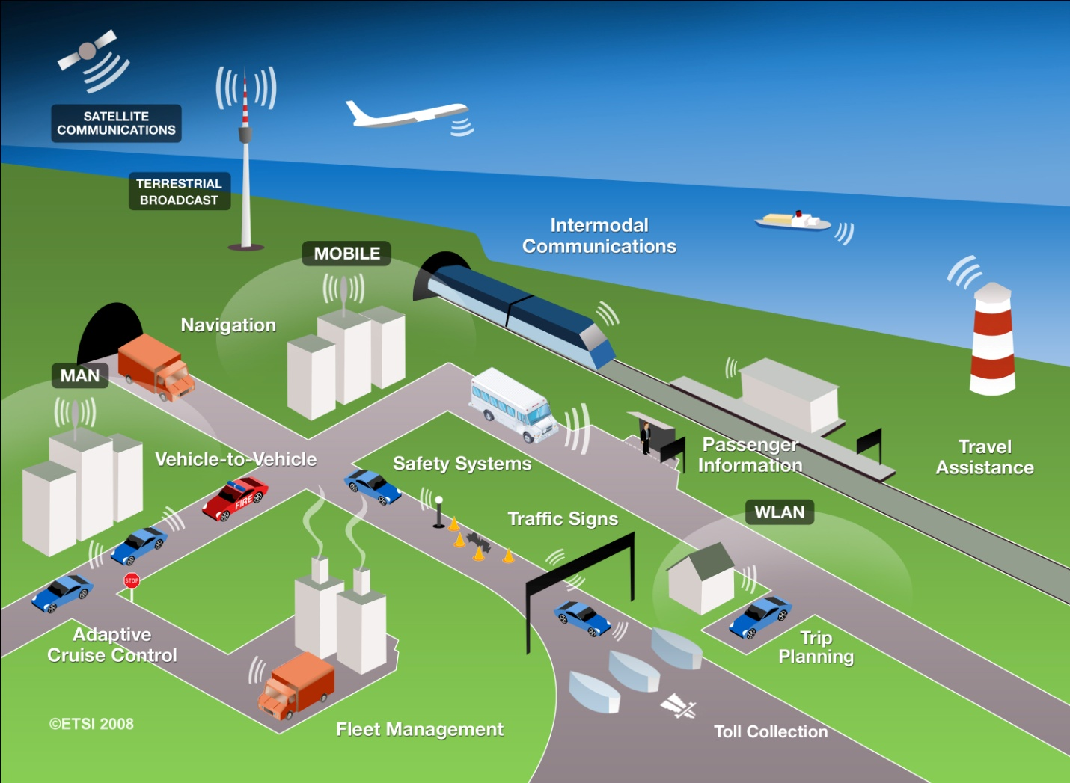

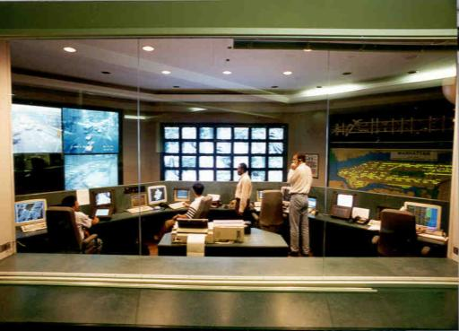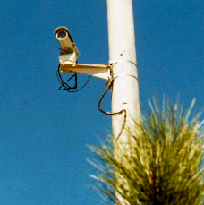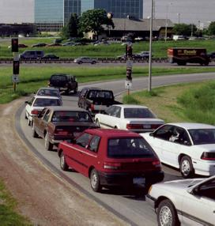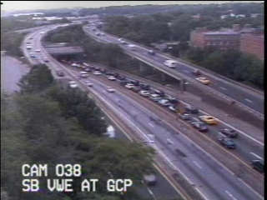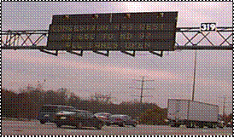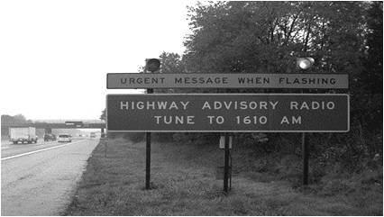

***ADVANTAGES OF I T S***

* Improved safety
* Better traffic flow
* Lower travel cost
* Better environmental quality
* Increased business activity
* Greater user acceptance
* Better travel information
* Better planning information
* Travel to unknown destinations using best possible route
* Never get lost.
* Locate restaurants, highways, hospitals , etc.
* Use the traffic flow data to predict the traffic situations ahead

***DISADVANTAGES OF I T S***

* Difficult to use in mixed traffic
* Preliminary difficulties in understanding
* ITS equipments costly
* The control system software could be hacked by hackers
* Additional cost of installation
* Lack of availability of detailed map of all regions
* Discrepancy b/w local names and indicated names
* Insufficient traffic data analysis to predict traffic conditions

***USE OF I T S SYSTEM :-***

**ITS World Congress**

[ITS World Congress](http://en.wikipedia.org/w/index.php?title=ITS_World_Congress&action=edit&redlink=1) is a world-wide annual event to promote and showcase ITS technologies. ERTICO – ITS Europe, ITS America and ITS Japan work closely together in the preparation of the annual ITS World Congress and Exhibition attracting over 8,000 people. Each year the event takes place in a different region (Europe, Americas or Asia-Pacific).

## Europe:-

[The Network of National ITS Associations](http://www.itsnetwork.org/) is a grouping of national ITS interests formed in order to ensure that ITS knowledge and information is transmitted to all actors at the local and national level - such as small and medium sized companies - and support ITS promotion from the ground up. It was officially launched 7 October 2004 in London. The Network currently consists of 27 member organisations. The Network Secretariat is at ERTICO - ITS Europe.

[ERTICO – ITS Europe](http://www.ertico.com/) is a multi-sector, public/private partnership pursuing the development and deployment of Intelligent Transport Systems and Services (ITS). We connect public authorities, industry players, infrastructure operators, users, national ITS associations and other organisations together and work to bring “Intelligence into Mobility”. The ERTICO work programme focuses on initiatives to improve transport safety, security and network efficiency whilst taking into account measures to reduce environmental impact. Our vision is of a future transport system working towards zero accidents, zero delays and fully informed people, where services are affordable and seamless, the environment is protected, privacy is respected and security is provided.

## United States:-

In the United States, each state has an Intelligent Transportation Systems (ITS) chapter that holds a yearly conference to promote and showcase ITS technologies and ideas. Representatives from each Department of Transportation (state, cities, towns, and counties) within the state attend this conference.

**India:-**

Association For Intelligent Transport Systems, India is a registered not-for-profit organization working towards the development and deployment of ITS in India since 2001. AITS, India is a forum that brings Government, Academia and Industries together to focus on visions set- up by the Government and direct Research and Development for implementing visions in the field of ITS.

***CONCLUSION:-***

Cities around the world face common transport challenges – from increasing congestion, safety concerns and aging infrastructure to a lack of funding and increasing environmental impacts. Like their colleagues in city administration and government, transport officials are starting to implement “smart solutions” to address these challenges and provide improved mobility in their cities, better services for citizens and a more cost-effective transport network.

Intelligent transport is about more than implementing discrete technologies. Leading cities are using these technologies to evolve their transport systems from single modes to integrated ones, improve transport services and provide an improved value proposition to customers.

***REFERANCE:-***

* Jill A. Hough, Crystal Bahe, (2002) , “Intelligent Transportation System: Helping public transit support welfare to work initiatives”, North Dakota State University Journal,701,pp 2-15 www.ugpti.org
* Dr. L.P. Kadiyali, (1999), “Traffic Engineering and Transport Planning”
* Narain.A.D, (1997), “Intelligent Transport System: Prospects and possibilities in India”, Indian Highways, pp 31-36.
* <http://en.wikipedia.org/wiki/Intelligent_transportation_system>,[www.its](http://www.its/) world.com
* http:/www.standard.its.bot.gov/D/advisories/bsrc_advisory.htm.