***4 Bit Flash Analog to Digital converter using LTE and NAND Gate Comparator***

Asst.Professor **Leela S.Bitla**

Priyadarshini Bhagwati College of Engineering

Nagpur, Maharashtra , India.

*leelabitla@gmail.com*

*Abstract*:-**This Paper introduces 4 bit flash ADC design using Linear Tunable Transconductance Element based comparators for high speed and low power consumption using180nmtech.**

**Thermometer to binary decoder with low power consumption, less area & short critical path is selected for the design of low power high speed. Proposed comparator provides improved PSRR (Power Supply Rejection Ratio) compared TIQ (Threshold Inverter Quantizer) comparator NAND based topology is used which improves PSRR as well as linearity; thus eliminates basic limitation of TIQ inverter.**

***Keywords*—CMOS-LTE,CMOS-NAND gate MUX Decoder, ADC, Gain Booster network.**

1. INTRODUCTION

Although the full-flash type A/D converter architecture is the most attractive solution for high-speed A/D converter designs, from a power dissipation and area perspective[2] Therefore the comparator structure is the most critical part in full-flash type architecture. The need arises for ADCs with higher resolution and faster conversion speed .The most popular type of fast converter is the flash ADC .This architecture required 2N-1 Comparator to achieved N bit resolution. For 4 bit ADC we required 15 comparators. The large number of comparators make it difficult to align and fabricate. The proposed improved threshold Inverter can used to preprocess the analog input signals, thus reducing the number of comparator.

II .Design of Flash ADC

This section describes the design of 4-bit flash ADC. It consists of three blocks: (1) Comparator bank, and (2) Gain Booster and (3) Decoder.

CMOS-LTE

COMPARATOR

THERMOMETER TO BINARY CODE CONVERTER CIRCUIT

GAIN

BOOSTER CIRCUITS

**vin**

O/PP

Figure 1: Block diagram of Flash ADC

However due to non-ideal effects such as short channel and narrow channel effects, the above design process cannot be so practical, therefore higher level MOS transistor design is to be used, therefore effective threshold voltage are re-calculated after the transistor sizing process to handle these non-ideal effect such as narrow channel effect.[2]

The design process can be obtain as below

1. Design process involve the minimum size inverter which determine the threshold voltage value of the midpoint Quantizer Qn

Where the value of Wn = Wp we maintain the channel length is kept at minimum value.

2. Determine the analog input voltage range as by the following equation

Analog range = Vdd-( Vtn + |Vtp| )

Where Vtn & Vtp are the threshold voltage for NMOS and PMOS device.[2]



Figure 2: Block diagram of design process

To calculate LSB value like

LSB=Analog range/2n

Then calculate the ideal threshold points for each quantizer consider the center is Qn. the quantizer of Qn+1…….Qn+p it is called PMOS side,(W/L) is kept at minimum value, The same process is applicable for NMOS but in opposite way[2].

Replicate this entire quantizer block & complete the interconnection to get the cascaded structure, which will be the analog part of the entire A/D code converter.

A. *LTE COMPARATOR FLASH ADC*

The reference voltage are changed when there is a noise in the power supply voltage to overcome this problem the CMOS LTE comparator are proposed. Where input voltage is compare with reference voltage to get Logic ‘1’ or ‘0’.when Vin > Vref then we get logic ‘1’ at the output and When Vin< Vref the we get the logic ‘0’ at the output of comparator circuit. Thisproposed scheme has the following advantages .Use Digital Comparator for high speed & low power consumption. To increase the voltage gain of the comparator. To reduced the noise problem & to reduced charge rejection ratio. Power supply voltage & Temperature are much smaller.

The CMOS-LTE Comparator uses Linear Tunable Transconductance Element and inverter as shown in Figure(3).The internal reference voltages are generated by systematically varying the transistor sizes of the CMOS linear tunable transconductance element. All transistor sizes of this element are identical in this design, with Vg1 and Vg4 as fixed voltages[1,2]. The output of this component is connected to CMOS inverter to increase the voltage gain of the comparator. Using CMOS-LTE (CMOS Linear Tunable Transcoductance Element) Comparator. Voltage Transfer characteristics of an Inverter can be calculated mathematically by equation[1,2]

Vm =(r(Vdd-│Vtp│)+Vtn) / (1+r)

With

r=(Kp/Kn)1/2

where Vtp and Vtn represent the threshold voltages of the PMOS and NMOS devices respectively and

Kn = (W/L)n . μn Cox

Kp = (W/L)p . μp Cox

It can be shown that the Vm point on the Voltage transfer curve (VTC).The VTC is set for 15 comparator as shown in figure 3(b)

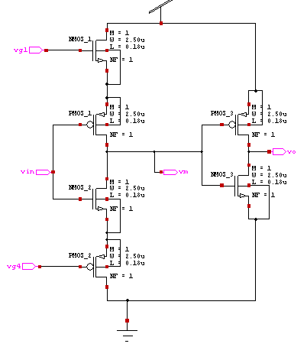

Figure 3(a) : CMOS Linear Tunable Transconductance Element

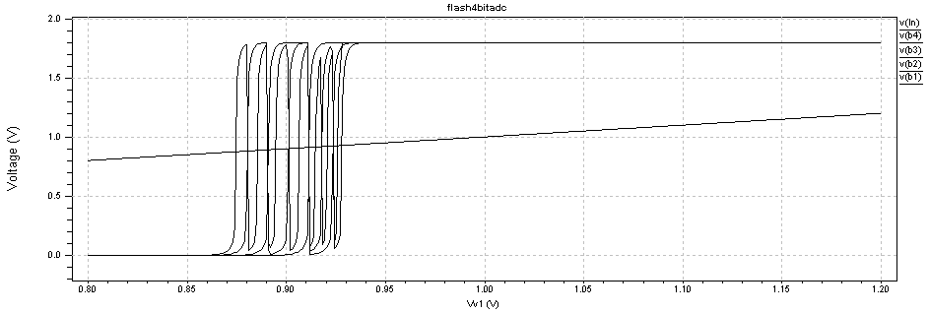

Figure 3(b) :Voltage transfer curve (VTC) for LTE comparator

B. *Structure Of Proposed Comparator*

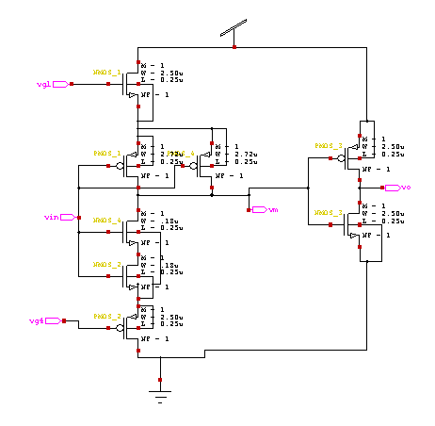

Figure 4(a): CMOS NAND GATE COMPARATOR

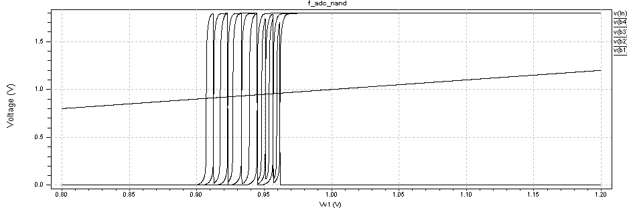

4 (b) Voltage transfer curve (VTC) for CMOS NAND GATE COMPARATOR

The Structure of the Proposed Flash ADC using NAND GATE comparator is as shown in Figure4(a) By using CMOS-NAND gate comparator we are getting the linearity at the output as compare with CMOS-LTE Comparator. The gain boosters make shaper threshold of the comparator output voltage swing.

*C. Gain Booster*

Each gain booster consists of two cascaded inverters. The transistor size of each gain booster is identical The gain booster is used to increase voltage gain of the output of the comparator so that it provides a full digital output voltage swing.[1,2]

D. *The Multiplexer Based Decoder*

For an N-bit flash ADC the most significant bit (MSB) of the binary output is high if more than half of the outputs in the thermometer scale are logic one. Hence MSB is same as the thermometer output at level 2N-1. To find the value at the second most significant bit (MSB-1) the original thermometer scale is divided into two partial thermometer scales, separated by the output level at 2N-1.

The partial thermometer scale to decode is chosen by a set of 2-to-1 multiplexers where the previous decoded binary output is connected to the control input of the multiplexers. MSB-1 is then found from the chosen partial thermometer scale in the same way as MSB was found from the full thermometer scale. The chosen scale is there by the scale that contains the information about MSB-1, i.e. the lower partial thermometer scale if the output at level 2N-1 is logic 0 otherwise the upper partial thermometer scale is used. This is continued recursively until only one 2-to-1 multiplexer remains. Its output is the least significant bit of the binary output.[4,3]

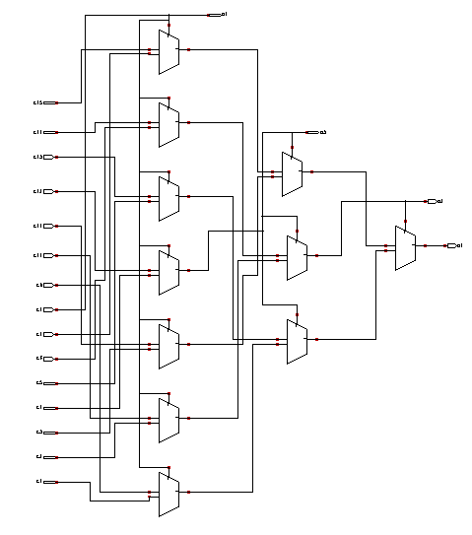

Figure 5: The Multiplexer Based Decoder

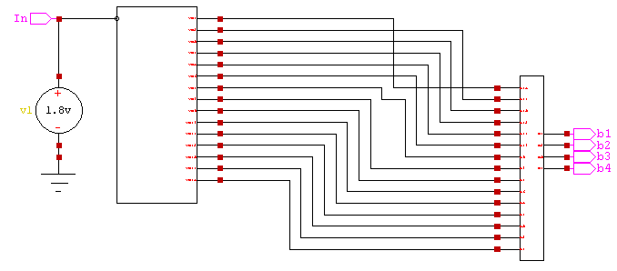

Figure 6 : Complete Full Flash ADC Design

III. *SIMULATION AND CHARACTERIZATION RESULTS OF 4-BIT FL ASH ADC* *using 0.18µm TECH*

|  |  |  |  |  |
| --- | --- | --- | --- | --- |
| Process | Min. Vm  (V) | Max. Vm  (V) | VFSR  (V) | VLSB  (V) |
| TT | 1.196399 | 2.040600 | 0.844201 | 0.06030 |
| SS | 1.3934 | 1.760600 | 0.3672 | 0.02622 |
| FF | 1.305399 | 1.774600 | 0.46921 | 0.03351 |
| SF | 1.390399 | 1.801599 | 0.4112 | 0.02937 |
| FS | 1.328399 | 1.774600 | 0.446201 | 0.03187 |
| Deviation | 0.197 | 0.28 | 0.47 | 0.034 |

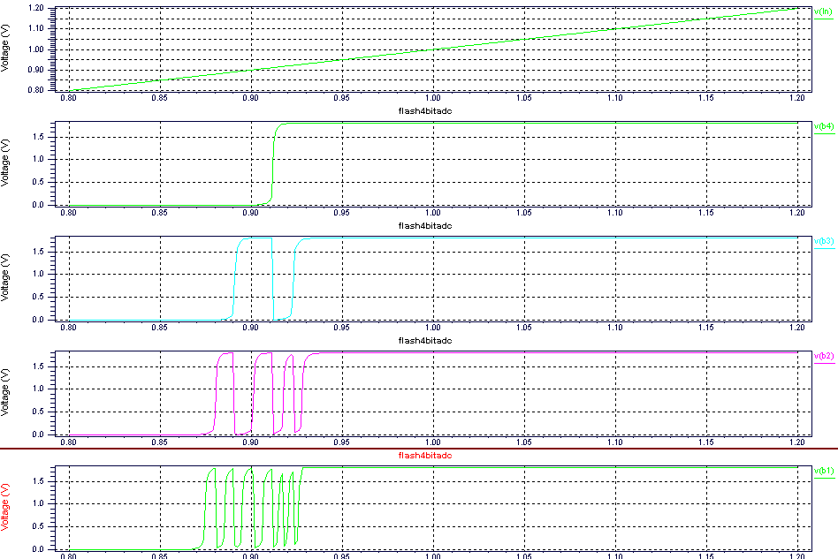

Figure 7: Transient response of the 4-bit flash ADC for ramp signal

**TABLE 1:** COMPARISION OF COMPARATORS FOR ±5% POWER SUPPLY VARIATIONS

|  |  |  |  |
| --- | --- | --- | --- |
| Comparator | Vdd variations | Minimum Vm in volts | Maximum Vm in volts |
| TIQ | 1.8v | 0.71586 | 0.81448 |
| 1.71v (-5%) | 0.68897 | 0.78759 |
| 1.89v (+5%) | 0.75172 | 0.85034 |
| CMOS- LTE | 1.8v | 0.87377 | 0.92899 |
| 1.71v (-5%) | 0.87448 | 0.92828 |
| 1.89v (+5%) | 0.87377 | 0.92756 |
| CMOS-NAND | 1.8v | 0.90604 | 0.96127 |
| 1.71v (-5%) | 0.90676 | 0.96199 |
| 1.89v (+5%) | 0.90676 | 0.96342 |

|  |  |  |  |  |  |
| --- | --- | --- | --- | --- | --- |
| Technology | Comparator | Wp  (µm) | Wn  (µm) | Vm(v) | Analog input range |
| 0.25µm | Min comp  Max. comp | 0.42 µm  2.72 µm | 0.18 µm  1.9 µm | 1.19439  2.03960 | 1.19 - 2.03 |
| 0.18 µm | Min comp  Max. comp | 0.27 µm  2.7 µm | 1.35 µm  0.15 µm | 0.87377  0.92899 | 0.87 - 0.92 |
| 0.09 µm | Min comp  Max. comp | 42n  1.72 µm | 90n  450n | 0.62760  0.90539 | 0.62 – 0.90 |

**TABLE 2:** COMPARATOR TRANSISTOR SIZE USED IN 0.25µm TECHNOLOGY

**TABLE 3**: PROCESS VARIATIONS

|  |  |
| --- | --- |
| **Parameter** | **Value** |
| Technology | 0.18 µm |
| Resolution | 4 bit |
| Supply Voltage | 1.8v |
| DNL | +0.12/-0.10 LSB |
| INL | +0.10/-0.012 LSB |
| VLSB | 0.1125 |

**TABLE 4**: ADC PERFORMANCE

IV. *CONCLUSIONS:*

LTE Comparator Flash ADC and CMOS-NAND Comparator Flash ADC have been designed and simulated with 180 nm technology. The results obtained are encouraging and indicate that the CMOS-LTE Comparator approach has the advantage of better power supply noise rejection. Also the power dissipation is reduced because of the internally generated reference voltages. Future NAND based topology is used which improves PSRR as well as linearity; thus eliminates basic limitation of TIQ inverter.

**References:**

[1] Meghana Kulkarni1, V. Sridhar2 , G.H. Kulkarni3 “4-Bit Flash Analog to Digital Converter Design using CMOS-LTE Comparator” 978-1-4244-7456-1/10/$26.00 ©2010 IEEE

[2] Ali Tangel and Kyusun Choi, “The CMOS Inverter as a Comparator in ADC Design” ,Analog Integrated Circuits and Signal Processing, 39,147-155, 2004.

[3] E.Sall and M. Vesterbacka, “A multiplexer based decoder for flash analog-to-digital converters,” Proc. TENCON 2004, Nov. 21-24, 2004.

[4] G.L.Madhumati, K.Ramakoteswara Rao, M.Madhavi Latha, “Comparison of 5-bit Thermometer- to-Binary Decoders in 1.8V, 0.18μm CMOS Technology for Flash ADCs,” Proceedings of 2009 International Conference on Signal Processing Systems (ICSPS 2009), May 15-17,2009, Singapore,pp.516-520.

**[5]** Jincheol Yoo, Kyusun Choi, and Jahan Ghaznavi, “Quantum Voltage Comparator for 0.07μm CMOS Flash A/D Converters”, Proceedings of the IEEE Computer Society Annual Symposium on VLSI (ISVLSI’03).

[6] Excert from textbook “Analysis & Design of analog Integrated circuits” by Gray & Meyer 2nd edition

[7] S.Park and R. Schaumann, “A High-Frequency CMOS Linear Trasconductansce Element,” IEEE trans. Circuits Syst, vol. CAS-33, no.11, November, pp. 1132-1138, 1986.