Speaker recognition
Apurva Adikane, Minal Moon, Pooja Dehankar, Shraddha Borkar
Department of Electronics and Telecommunications, Yeshwantrao Chavan College of Engineering
Hingna Road, Wanadongri, Nagpur-441110
appuadikane@gmail.com
gudiyamoon18@gmail.com
pooh.dehankar09@gmail.com
shraddhab15@rediffmail.com

Abstract— This paper aims at showing the accuracy of a text independent speaker recognition system using mel frequency cepstrum coefficient (MFCC) and Gaussian Mixture Model (GMM). The goal of speaker recognition is to determine which one of a group of known speakers best matches the input voice samples. Voice samples were taken, MFCC were extracted, and these coefficients were statistically analyzed by GMM in order to build each profile. We concentrate on the task of improving the performance of Gaussian Mixture Models for speaker identification by using Support Vector Machines (SVM) and Expectation-Maximization (EM) methods. These methods are combinely implemented resulting in decreased error rates.

Keywords— Automatic speaker recognition, access control, authentication, speaker verification, Gaussian Mixture Model (GMM), feature extraction.
- Introduction
Speech is the primary means of communication between humans. For reasons ranging from technological curiosity about the mechanisms for mechanical realization of human speech capabilities to the desire to automate simple tasks which necessitate human-machine interactions, research in automatic speech and speaker recognition by machines has attracted a great deal of attention for five decades. Based on major advances in statistical modeling of speech, automatic speech recognition systems today find widespread application in tasks that require human-machine interface, such as automatic call processing in telephone networks and query-based information systems that provide updated travel information, stock price quotations, weather reports, etc.
The development of speaker recognition began in early 1960’s. In 1960’s the Bell Labs built experimental systems aimed to work over dialed-up telephone lines [5]. Text dependent and independent methods began to develop. In 1980’s, speaker recognition systems based on Hidden Marcov Model (HMM) architecture were developed. Also Vector Quantization (VQ) algorithms were implemented along with HMM. In 1990’s, research on increasing robustness became a central theme. Text prompted methods and score normalization were also developed. In 2000’s, new score normalization methods were developed and high level features such as word idiolect, pronunciation, phone usage, prosody, etc have been successfully used in text independent speaker recognition systems.
Speech conveys several levels of information. On a primary level, speech conveys the words or message being spoken, but on a secondary level, speech also reveals information about the speaker. Given a speech signal there are two kinds of information that may be extracted from it. On one hand there is the linguistic information about what is being said, and on the other there is also speaker specific information. This report deals with the task of speaker recognition where the goal is to determine which one of a group known speakers best matches the input voice sample.
Given a speech sample, speaker recognition is concerned with extracting clues to the identity of the person who was the source of that utterance. Speaker recognition is divided into two specific tasks: verification and identification. In speaker verification the goal is to determine from a voice sample if a person is whom he or she claims. In speaker identification the goal is to determine which one of a group of know voices best matches the input voice sample. In either case the speech can be constrained to a known phrase (text-dependent) or totally unconstrained (text-independent) [1,3,4].

Fig. 1 Speaker recognition system

There are many algorithms and models that can be used for speaker recognition including Neural Networks, unimodal Gaussians, Vector Quantization, Radial Basis Functions, Hidden Markov Models and Gaussian Mixture Models (GMMs). These perform well under clean speech conditions, but in many cases performance degrades when test utterances are corrupted by noise, mismatched conditions or if there are only small amounts of training and testing data. Among these methods GMMs are usually preferred because they offer high classification accuracy while still being robust to corruptions in the speech signal.
In this paper, we propose text independent ASR system based on Mel-Frequency Cepstrum Coefficients (MFCC) [8,9] and Gaussian Mixture Models (GMM) [2,7]. Then the model parameters are estimated with the maxi-mum similarity making use of the Expectation and Maximization (EM) algorithm . The novel combination of these two techniques, allows the system to reach high recognition rates and high operative velocities, as shown in the following, allowing to use the proposed system in real security context.
The paper is organized as follows: Section 2 describes the feature extraction.. Section 3 introduces the MFCC technique, while Section 4 introduces the GMM models. Section 5 describes the SVM method and Section 6 shows EM algorithm. Finally Section 7 concludes the work.

- feature extraction
Feature extraction is the process that extracts a small amount of data from the voice signal that can later be used to represent each speaker.
The purpose of this module is to convert the speech waveform, using digital signal processing (DSP) tools to a set of features (at a considering lower information rate) for further analysis. This is often referred as the signal-processing front end.
There are a number of different speech features that have been shown to be indicative of speaker identity. These include pitch related features, Linear Prediction Cepstral Coefficients (LPCCs) and Maximum Autocorrelation Value (MACV) features. Although there are no exclusively speaker distinguishing features, the speech spectrum has been shown to be very effective for speaker recognition. Here we use Mel Frequency Cepstral Coefficients (MFCCs) extracted from the spectrum. The main reason for this is that in many applications speaker identification is a precursor to further speech processing, especially speech recognition, to identify what is being said. Among the possible features MFCCs have proved to be the most successful and robust features for speech recognition. So, to limit computation in a possible application, it makes sense to use the same features for speaker recognition.
Figure 2.1 shows the block diagram of the procedure used for feature extraction in the front end. The speech signal is divided into 30 msec long segments overlapping by 15 msec using a Hamming window. The magnitude spectrum of this short time segment is passed through a simulated mel-scale filter bank consisting of 30 filters. The filter bank is similar to the one described in . The log of the output energy of each filter is calculated and collected into a vector. This is then cosine transformed into cepstral coefficients. The cepstral coefficients are truncated to obtain MFCCs.
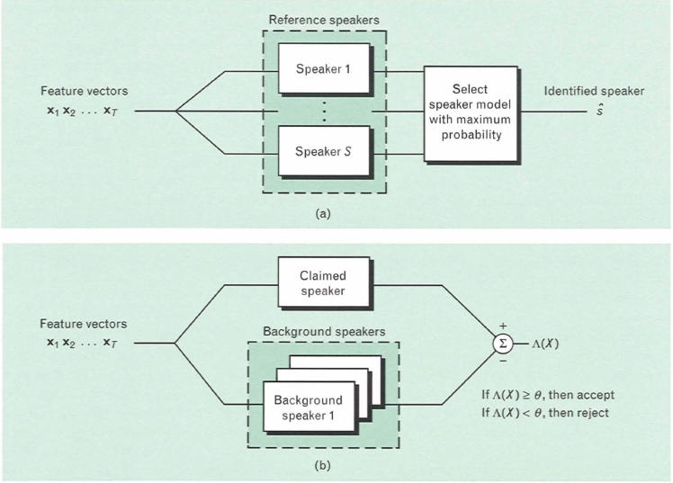

- Mel frequency ceptral coefficient
Mel Frequency Cepstral Coefficents (MFCCs) are a feature widely used in automatic speech and speaker recognition.
We will give a high level intro to the implementation steps, then go in depth why we do the things we do. Towards the end we will go into a more detailed description of how to calculate MFCCs.
- Frame the signal into short frames.
- For each frame calculate the periodogram estimate of the power spectrum.
- Apply the mel filter bank to the power spectra, sum the energy in each filter
- Take the logarithm of all filter-bank energies.
- Take the DCT of the log filter-bank energies.
- Keep DCT coefficients 2-13, discard the rest.
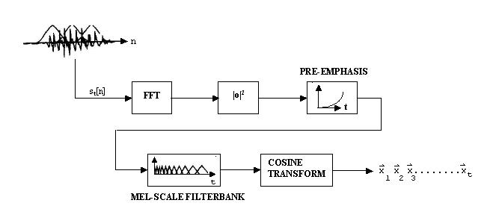
The term “ceptrum” is a pun where the first letters of the term “spectrum” are reversed. Ceptrum is defined as in verse fourier transform of the logarithm of the spectrum of the signal.
When ceptrum is applied to the voice, its strength is to be able to divide excitation and transfer function. In a signal y(n)
Based on the source-filter model, in this specific context, respectively the vocal cords and the vocal tract, ceptrum allows separation in y(n)=x(n)*h(n),where the source x(n) passes through a filter described by the impulse response h(n).
The spectrum of y(n) obtained by the fourier transform is Y(k)=X(k)H(k) where k index of discrete frequencies, i.e. the product of two spectra, respectively the source and the filter one. Sepa-rating these two spectra is complicated. On the contrary, it is possible to separate the real envelope of the filter from the remaining spectrum by formulating all the phase at the beginning. The cepstrum is based on the properties of the logarithm that can transform the product of the argument in sums of logarithms.
Starting from the logarithm of the modulus of the spectrum:
Mel-cepstrum estimates the spectral envelope of the output of the filter bank. Let Yn represent the logarithm of the output energy from channel n, applying the discrete cosine transform (DCT) we obtain the cepstral coefficients MFCC through the equation:
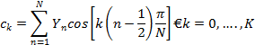
The simplified spectral envelope is rebuilt with the first coefficients with <k;
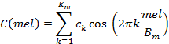
where Bm is the bandwidth analyzed in Mel domain and Km = 20 is a typical value assumed by Km. ck is the mean value in dB of the energy of the filter bank channels, hence it is in direct relation with the energy of the sound and it can be used for the estimation of the energy.
- GAUSSIAN MIXTURE MODEL
A Gaussian Mixture Model (GMM) is a parametric probability density function represented as a weighted sum of Gaussian component densities. GMMs are commonly used as a parametric model of the probability distribution of continuous measurements or features in a biometric system, such as vocal-tract related spectral features in a speaker recognition system. GMM parameters are estimated from training data using the iterative Expectation-Maximization (EM) algorithm or Maximum A Posteriori (MAP) estimation from a well-trained prior model.

- Conclusions
For a D-dimensional feature vector ,x, the mixture density used for the likelihood function is defined as
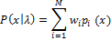
The density is a weighted linear combination of M unimodal Gaussian densities, pi(x)
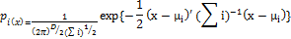
- Conclusions
Automatic speaker recognition is the use of a machine to recognize a person from a spoken phrase. Speaker recognition systems can be used in two modes: to identify a particular person or to verify a person’s claimed identity. The scope of this work is limited to speech collected from cooperative users in real world office environments and without adverse microphone or channel impairments.
The use of SVM and EM algorithms along with GMM and MFCC improves the system performance
Acknowledgment
The authors wish to thank Lect. S. A. Desai for his help and efforts.
References
- D. A. Reynolds, “An Overview of Automatic Speaker Recognition Technology,” Acoustics, Speech and Signal Processing (ICASSP), 2002, pp. 4072-4075.
- D. A. Reynolds, “Gaussian Mixture Models,” Technical Report, MIT Lincoln Laboratory, Cincinnati, 2001.
- D. A. Reynolds, T. F. Quatieri and R. B. Dunn, “Speaker Verification Using Adapted Gaussian Mixture Models,” Digital Signal Processing, Vol. 10, No. 2, 2000, pp. 19- 41.
- R. Reynolds, “Robust Text-Independent Speaker Identi-fication Using Gaussian Mixture Speaker Models,” IEEE Transactions on Speech and Audio Processing, 1995, pp. 72-83.
- Sadaoki Furui, “50 years of progress in speech and speaker recognition”, Department of Computer Science, Tokyo Institue of Technology.
- “The EM Algorithm for Gaussian Mixtures”, Probabilistic Learning: Theory and Algorithms, CS274A:
http://www.ccs.neu.edu/home/jaa/CS6140.13F/Homeworks/HW05/8-em.pdf.
- Balakrishnan Narayanaswamy, “Improved Text-Independent Speaker Recognition using Gaussian Mixture Probabilities”, May 2005.
[8] Homayoon Beigi, “Fundamentals of Speaker Recognition”, Recognition Technologies, Inc., Yorktown Heights New York, NY, USA, 2012.
[9] Joseph P. Campbell, “Speaker Recognition: A Tutorial”, Proceedings of the IEEE, vol 85, no. 9, September 1997.
[10] Samudravijaya K, “Speech and Speaker Recognition: A Tutorial”, Tata Institute of Fundamental Research, Homi Bhabha Road, Mumbai.
[11] Alex Solomonoff, Carl Quillen, and William M. Campbell, “Channel Compensation for SVM Speaker Recognition”, MIT Lincoln Laboratory, Lexington, Massachusetts, USA.

