DTH ENERGYMETER
Mr. Gaurav Kalemore, Ms. Prachi Gedam, Mr. Danish Sabir, Mr.Shoaib Sheikh, Ms. Nikita Kumbhare
Fourth Year B.E.
Department of Electronics
K.D.K.C.E.., Nagpur.
Email: gaurav.kalemore@gmail.com

Abstract - This paper presents the methodology for monitoring the energy meter installed at the consumer’s residence. An automated reading system includes fetching the reading from the energy meter and sending it to the nearby distribution centre for billing purpose. The system will consist of devices such as Energy Meter interfaced to AVR (Advanced Virtual RISC) microcontroller. A GSM modem will also be interfaced with AVR to use the Global System for Mobile communication (GSM) network. A GSM dongle will be connected to the computer at the distribution center. The major reason for the development of the said system is to automate the process of billing and to implement an error free reading system to read the energy consumption from the energy meter. The energy meter reading can be obtained by interfacing it with AVR which will be triggered with each pulse of Calibration from the energy meter. It will be programmed to count the number of pulses from the meter. It will send this reading as a text message over the GSM network using GSM modem. The SMS of reading can be scheduled or directly monitored. This methodology can also be used in industries for remote monitoring.

INTRODUCTION
The energy distribution system is a very wide network, which takes its presence from remote interior terrains to the densely populated areas. In such diverse conditions of inaccessibility and presence of continuous vigilance over the distribution network, it becomes more prone to energy thefts. Also, the process of reading the energy consumption by individual consumer is very time consuming in nature and monotonous as well. The presence of humans in the process makes it more prone to errors.
To make the system safe from energy thefts and error free continuous timely efforts are taken by the electricity distribution companies. But none of them made it possible to reduce the errors and the energy thefts.
Thus there was a strong demand to revolutionize the process of completely. Earlier efforts were made to convert the existing system into prepaid billing system. But it did not took the required pace as there comes the limitations on the usage of energy and made it more complex introducing the concept of prepaid billing.
The "GSM based energy meter reading system" will provide an alternative to the existing system of billing and energy distribution system to limit down the energy thefts. This system will involve the use of the implementation GSM networks to transfer the information from consumers’ device to the billing facilities.
A further aim is to monitor the readings remotely from the distribution centre itself to keep surveillance on energy thefts.
The GSM module and the energy meter will be interfaced with AVR microcontroller. There is reading from the energy will be stored in AVR memory. AVR microcontroller is to be programmed such that it can send the reading in the form of SMS over the network to the billing facility.
At the distribution center, a GSM dongle will be connected to the computer. This dongle will receive the text message sent from the customer’s end. The computer will be programmed to recollect the reading from the message. This reading will then be inserted into database. For the identity of the customer, the cell number will be used. This cell number will already be present in the database for the specified customer.
The facility of sending the bill to customer’s mobile phone will be the extension of this project.

SYSTEM DESCRIPTION

The system is designed to automate the process of reading an energy meter. It will have the following aspects.
The system will consist of devices such as Energy Meter interfaced to AVR microcontroller. A GSM modem will also be interfaced with AVR to use the Global System for Mobile communication (GSM) network. A GSM dongle will be connected to the computer at the distribution center.
AVR will be triggered with each pulse of Calibration from the energy meter. It will be programmed to count the number of pulses from the meter. A meter is always designed to a specific number of impulses/kWh. This means that the calibration signal will trigger for a specific number of times for a single unit of energy i.e. 1kWh.
The programming of AVR will be such that it will show a reading on software which can be matched at any moment with the hardware.
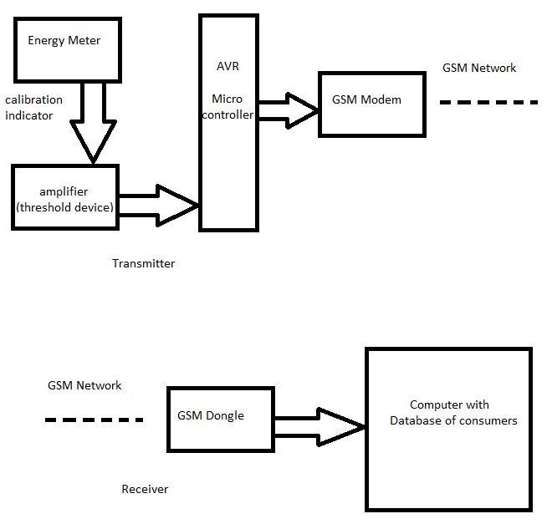
Fig. 1.1: Block diagram for GSM based automated energy meter reading system using AVR

If the system is installed to a new meter, then software and hardware readings will be synchronized. For a used meter, there will be a provision to enter the reading which is already on the meter. Once this reading is entered, the system will not be reset again.
Thus, AVR will have a correct reading for both new and old meter. It will send this reading as a text message over the GSM spectrum using GSM modem. The SMS of reading can be scheduled.
At the receiver section i.e. at the distribution center, GSM dongle connected to the main computer will receive the SMS. With programming in the computer along with the connectivity with the database, the reading will be entered as per the customer.
The customer’s identity can be revealed by comparing the number from which SMS is received and numbers already present in database.
The remote monitoring can be done by the distribution center by installing the same system at the local transformer in the area along with the consumers’. The readings from the consumers and the transformer will be periodically matched. Any aberration will indicate illegal energy theft in that area. For this, the center will send a predefined text to the devices. The microcontrollers will detect and decode the text and will then respond as per the instruction.

IMPLEMENTATION

As stated above, the system requires an energy meter, AVR microcontroller, GSM modem for the transmitter purpose. While at receiver’s end, we require a GSM dongle connected to a computer.
The interfacing of the energy meter with AVR is done with the help of ‘calibration’ indicator of the meter. The signal will be slightly amplified to match digital standards for triggering digital devices. Initially, AVR is programmed to sense this trigger signal which acts as its interrupt signal. With each pulse of trigger, it will increment the counter initiated in its inbuilt EEPROM and then go in power saver mode. After a scheduled period, it will send this reading to the distribution centre via GSM network.
At the distribution centre, GSM dongle will be connected to the computer. It will receive the text message from individual consumers and through proper programming; this reading can be inserted in the database for the respective consumer.
For monitoring purpose, the distribution centre can send a predefined text to this microcontroller. Even with this input, the microcontroller will again send its current reading to the distribution centre.

RESULTS

The readings from individual consumers are obtained at the distribution centre automatically, periodically and without a human interface.
We have partially implemented the project to transmit the reading from consumers’ energy meter over GSM.

CONCLUSION

The regular manual process of fetching the readings from the consumers’ residence will be automated with this system.
Any aberration between the readings from consumers and the local transformers in the area will help in detection of illegal energy thefts. This will allow the distribution company to take a quick action in the respective areas.

REFERENCES

- Shanghai Belling's Single phase energy meter IC BD6051
- Atmel Corporation - Atmel 8-bit and 32-bit microcontrollers.
http://www.atmel.com/products/avr
- Prepaid electricity billing system-
http://www.seminarprojects.com/Thread-prepaidenergy-meter-using-gsm-mobile#ixzz1BUylZEck
- Sim300 GSM Module-
http://probots.co.in/Manuals/SIM300.pdf
- AT-commands:-
http://probots.co.in/Manuals/atcommands.pdf

