TELECONFERENCING

Veena Deshmukh, Ashwini Dhawale ,Abha Khanna, Surbhi Pawar, Abhishek Hatwar

KDKCE, Nagpur.

deshmukh.veena11@gmail.com mob No.:9021195804

**Teleconference**  is the live exchange and mass articulation of information  among several persons and machines remote from one another but linked by a telecommunications system. Terms such as audio conferencing, telephone conferencing and phone conferencing are also sometimes used to refer to teleconferencing.

The telecommunications system may support the teleconference by providing one or more of the following: audio, video, and/or data

services by one or more means, such as telephone, computer, telegraph, teletypewriter, radio, and television Internet teleconferencing

**Internet teleconferencing** includes internet telephone conferencing, videoconferencing, web conferencing, and Augmented Reality conferencing. Teleconferencing means meeting through a telecommunications medium. It is a generic term for linking people between two or more locations by electronics. There are at least six types of teleconferencing: audio, audiographic, computer, video, business television (BTV), and distance education. The methods used differ in the technology, but common factors contribute to the shared definition of teleconferencing:

* + Use a telecommunications channel
  + Link people at multiple locations
  + Interactive to provide two-way communications
  + Dynamic to require users' active participation

Internet telephony involves conducting a teleconference over the Internet or a Wide Area Network. One key technology in this area is Voice over Internet Protocol (VOIP). Popular software for personal use includes Skype, Google Talk, Windows Live Messenger and Yahoo! Messenger.

A working example of an Augmented Reality conferencing was demonstrated at the Salonedi Mobile in Milano by AR+RFID Lab. is another AR teleconferencing tool. **Types of Teleconferences**

**Audio Teleconference:** Voice-only; sometimes called conference calling. Interactively links people in remote locations via telephone lines. Audio bridges tie all lines together. Meetings can be conducted via audio conference. Preplanning is necessary which includes naming a chair, setting an agenda, and providing printed materials to participants ahead of time so that they can be reviewed.

Distance learning can be conducted by audio conference. In fact, it is one of the most underutilized, yet cost effective methods available to education. Instructors should receive training on how to best utilize audio conferences to augment other forms of distance learning. **Audiographics Teleconference**: Uses narrowband telecommunications channels to transmit visual information such as graphics, alpha-numerics, documents, and video pictures as an adjunct to voice communication. Other terms are desk-top computer conferencing and enhanced audio. Devices include electronic tablets/boards, freeze-frame video terminals, integrated graphics systems (as part of personal computers), Fax, remote-access microfiche and slide projectors, optical graphic scanners, and voice/data terminals.

Audiographics can be used for meetings and distance learning.

**computer Teleconference**: Uses 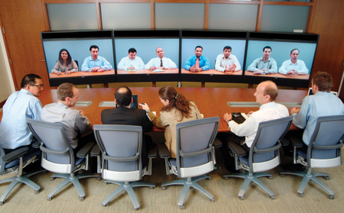telephone lines to connect two or more computers and modems. Anything that can be done on a computer can be sent over the lines. It can be synchronous or asynchronous. An example of an asychronous mode is electronic mail. Using electronic mail (E-Mail), memos, reports, updates, newsletters can be sent to anyone on the local area network (LAN) or wide area network (WAN). Items generated on computer which are normally printed and then sent by facsimile can be sent by E-Mail.

Computer conferencing is an emerging area for distance education. Some institutions offer credit programs completely by computer. Students receive texts and workbooks via mail. Through common files assigned to a class which each student can assess, teachers upload syllabi, lectures, grades and remarks. Students download these files, compose their assignment and remarks off-line, then upload them to the common files.

**Video Teleconference**: Combines audio and video to provide voice communications and video images. Can be one-way video/two-way audio, or two-way video/two-way audio. It can display anything that can be captured by a TV camera. The advantage is the capability to display moving images. In two-way audio/video systems, a common application is to show people which creates a social presence that resembles face-to-face meetings and classes and enables participants to see the facial expressions and physical demeanor of participants at remote sites. Graphics are used to enhance understanding. There are three basic systems: freeze frame, compressed, and full-motion video.

Video conferencing is an effective way to use one teacher who teaches to a number of sites. It is very cost effective for classes which may have a small number of students enrolled at each site. In many cases, video conferencing enables the institution or a group of institutions to provide courses which would be canceled due to low enrollment or which could not be supported otherwise because of the cost of providing an instructor in an unusual subject area. Rural areas benefit particularly from classes provided through video conferencing when they work with a larger metropolitan institution that has full-time faculty.

Through teleconferencing, institutions are able to serve all students equitably

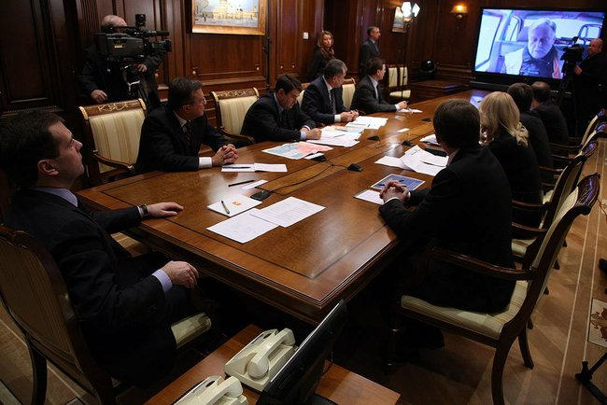

**Why Use a Teleconference?**

Videoconferencing increases efficiency and results in a more profitable use of limited resources. It is a very personal medium for human issues where face-to-face communications are necessary. When you can see and hear the person you are talking to on a television monitor, they respond as though you were in the same room together. It is an effective alternative to travel which can easily add up to weeks of non-productive time each year. With videoconferencing, you never have to leave the office. Documents are available, and experts can be on hand. A crisis that might take on major proportions if you are out of town, can be handled because you're on the job. Videoconferencing maximizes efficiency because it provides a way to meet with several groups in different locations, at the same time.

As the limited resource of funding has decreased, limited resources now include instructors, parking spaces and buildings. Students now include time as a limited resources. Teleconferencing enables institutions to share facilities and instructors which will increase our ability to serve students.