A Development on Brain - Machine Interaction Using Brain Waves Electric Signal

Ms. Pallavi Shelke  Mtech IV Sem. (Department of Electronics and Communication Engineering & Technology),  TGPCET ,RTMNU, Nagpur, India  e-mail :- pallavi9015@gmail.com  Contact No.9371345266 | Ms. Kanchan Dhote  Asst.Professor, (Department of Electronics and Communication Engineering & Technology),  TGPCET ,RTMNU, Nagpur, India  e-mail :- kanchan.dhote@rediffsmail.com  Contact No.8805001726

Abstract— Human brain mainly works on electric signals transmitting all over the body to send the information in order to operate the body parts. Even while rotating eye ball body increases or decreases the resistance near eye area. This variation in electric signals can be measured using electrodes or the myoelectric sensors. By implementing these signals processor we can interface different devices to control on demand. Hence proposed system is designed to control movement of directions hardware system wheelchair model using brain waves electric signals. Wheelchair model help the physically disabled Person. Proposed systems will detection the variations in electric signal strength through voltage level near the eye area and generates a wireless radio frequency signals in order to control the robotic prototype model. By implementing this system we can further extend it to bio enabled human body parts to control through brain waves. Proposed system based on the phenomenon of electro-oculography.

Keywords–Brain–computer interface, Electroencephalography, Rehabilitation, Neuroprosthesis, Brain–machine interface
,Electro-oculography
- Introduction
A brain–computer interface (BCI), often called a mind-machine interface (MMI), or sometimes called a direct neural interface or a brain–machine interface (BMI), is a direct communication pathway between the brain and an external device. BCIs are often directed at assisting, augmenting, or repairing human cognitive or sensory-motor functions. A brain–computer interface (BCI) is a device that enables severely disabled people to communicate and interact with their environments using their brain waves. Most research investigating BCI in humans has used scalp-recorded electroencephalography or intracranial electrocorticography [2]. The use of brain signals obtained directly from stereotactic depth electrodes to control a BCI has not previously been explored. A BCI is a communication system in which messages or commands that an individual sends to the external world do not pass through the brain output pathways normal of peripheral nerves & muscles. For example, in an EEG based BCI the messages are encoded in EEG activity. A BCI provides its user with an alternative method for acting on the world. BCIs fall into two classes: dependent and independent.
A dependent BCI does not use the brain’s normal output pathways to carry the message, but activity in these pathways is needed to generate the brain activity (e.g. EEG) thatdoes carry it. For example, one dependent BCI presents the user with a matrix of letters that flash one at a time, and the user selects a specific letter by looking directly at it so that the visual evoked potential (VEP) recorded from the scalp over visual cortex when that letter flashes is much larger that the VEPs produced when other letters flash In this case, the brain’s output channel is EEG, but the generation of the EEG signal depends on gaze direction, and dependent and independent.
A dependent BCI does not use the brain’s normal output pathways to carry the message, but activity in these pathways is needed to generate the brain activity (e.g. EEG) thatdoes carry it. For example, one dependent BCI presents the user with a matrix of letters that flash one at a time, and the user selects a specific letter by looking directly at it so that the visual evoked potential (VEP) recorded from the scalp over visual cortex when that letter flashes is much larger that the VEPs produced when other letters flash In this case, the brain’s output channel is EEG, but the generation of the EEG signal depends on gaze direction, and therefore on extra ocular muscles and the cranial nerves that activate them. A dependent BCI is essentially an alternative method for detecting messages carried in the brain’s normal output pathways: in the present example, gaze directionis detected by monitoring EEG rather than by monitoring eye position directly. While a dependent BCI does not give the brain a new communication channel that is independentof conventional channels, it can still be useful .In contrast, an independent BCI does not depend in anyway on the brain’s normal output pathways. The message is not carried by peripherals nerves.
pathways. The message is not carried by peripheral nerves and muscles, and, furthermore, activity in these pathways is not needed to generate the brain activity (e.g. EEG) that does carry the message. For example, one independent BCI presents the user with a matrix of letters that flash one at a time, and the user selects a specific letter by producing a P300 evoked potential when that letter . In this case, the brain’s output channel is EEG ,and the generation of the EEG signal depends mainly on the user’s intent, not on the precise

orientation of the eyes The normal output pathways of peripheral nerves and muscles do not have an essential role in the operation of an independent BCI. Because independent BCIs provide the brain with wholly new output pathways, they are of greater theoretical interest than dependent BCIs. Furthermore, for people with the most severe neuromuscular disabilities, who may lack all normal output channels(including extra ocular muscle control), independent BCIs are likely to be more useful[1][3].

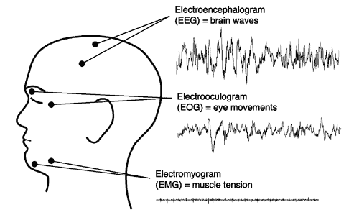

Figure 1: EEG, EOG ,EMG

II .PROPOSED SYSTEM
This proposed system implements a human-computer interface based on electro-oculography (EOG) that allows interaction with a computer using eye movement. The EOG registers the movement of the eye by measuring, through electrodes, the difference of potential between the cornea and the retina. A robotic vehicle is a part of control parameter in proposed system where user can control the vehicle in multiple direction using facial motions near eye areaby using EOG technique.
Objective:-
The main objective in system is to Detection of electric signal near eye area and using electrodes system will try to identify the changes in electric pulse in order to conclude the motion to be taken. As a proof of concept system will be enabled to control different platform and devices like computer or the hardware system as per mentioned below

Wireless robotic vehicle design: Proposed system includes the wireless robotic vehicle which can be controlled in 4 different directions. User can have access to this vehicle using radio frequency enabled circuitry through brain signals generated using eye motion
.
- ELECTRODES PLACEMENT

The electrodes are placed on face of disable person for the movement of wheelchair model. One electrode is placed at left eye of face, next electrode is placed on right eye of face.
Placement of these left & right electrode helps for the left –right movement of wheelchair model . The electrodes which are placed on upper & lower area of eyes on a physically disabled person are helps for the forward & backward movement of wheelchair model. This movement of wheelchair is possible not only by the placement of electrode on face but AVR placed on Wheelchair model & dc motor placed near of wheelchair model.

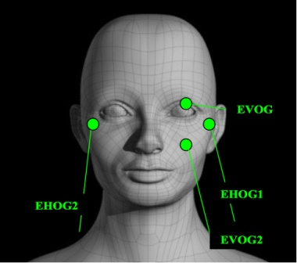

Figure 2: PLACEMENT OF ELECTRODE

Electroencephalography (EEG) is the most studied potential non-invasive interface, mainly due to its fine temporal resolution, ease of use, portability and low set-up cost. But as well as the technology's susceptibility to noise, another substantial barrier to using EEG as a brain–computer interface is the extensive training required before users can work the technology. For example, in experiments trained severely paralysed people to self-regulate the slow cortical potentials in their EEG to such an extent that these signals could be used as a binary signal to control a computer cursor. (Birbaumer had earlier trained epileptics to prevent impending fits by controlling this low voltage wave.) The experiment saw ten patients trained to move a computer cursor by controlling their brainwaves. The process was slow, requiring more than an hour for patients to write 100 characters with the cursor, while training often took many months. Here AD 620 Instrumentation amplifier is used for the signal amplification. The specifications of Instrumentation Amplifier is as follows.
EXCELLENT DC PERFORMANCE
- 50 µV max, Input Offset Voltage
- 0.6 µV/^{º}8C max, Input Offset Drift
- 1.0 nA max, Input Bias Current
- 100 dB min Common-Mode Rejection Ratio (G = 10)
- 9 nV/√Hz, @ 1 kHz, Input Voltage Noise
- 0.28 mV p-p Noise (0.1 Hz to 10 Hz)
An Instrumentation amplifier is specially made for the ECG and Medical Instrumentation. The AD620, with its high accuracy of 40 ppm maximum nonlinearity, low offset voltage of 50 µV max and offset drift of0.6 µV/°C max, is ideal for use in precision data acquisition systems, such as weigh scales and transducer interfaces the low noise, low input bias current, and low power of the AD620 make it well suited for medical applications such as ECG and non invasive blood pressure monitors.At the output of signal amplifier circuit we are using analog to digital converter for the conversion of signal & make it suitable for the AVR which is placed on the wheelchair model.

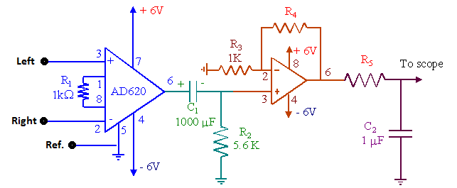

Figure 3: Conversion of EOG signal into digital

- CONCLUDED EXPERIMENTAL RESULT
In this paper a BCI allows a person to communicate with or control the external world without using the brain’s normal output pathways of peripheral nerves and muscles. Messages and commands are expressed not by muscle contractions but rather by electrophysiological phenomena such as evoked or spontaneous EOG features(e.g.SCPs,P300,mu/beta rhythms) or cortical neuronal activity. BCI operation depends on the interaction of two adaptive controllers, the user, who must maintain close correlation between his or her intent and these phenomena, and the BCI, which must translate the phenomena into device commands that accomplish the user’s intent. Present-day BCIs have maximum information transfer rates #25 bits/min. With this capacity, they can provide basic communication and control functions (e.g. environmental controls, simple word processing) to those with the most severe neuromuscular disabilities, such as those locked in by late-stage ALS or brainstem stroke. They might also control a neuroprosthesis that provides hand grasp to those with mid-level cervical spinal cord injuries. More complex applications useful to a larger population of users depend on achievement of greater speed and accuracy, that is, higher information transfer rates.

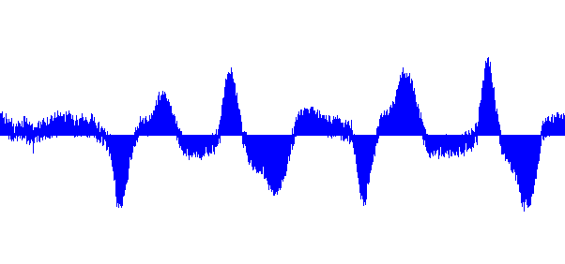

Figure 4: Waveform from sound wave recorder for left right movement of eyes

The above waveform[4] is the concluded result from left to right movement of eyes from the electrodes placed on left & right side of the physically disabled Person so that he can move in left right direction.

V . SYSTEM OVERVIEW
The final system overview of robotic prototype wheelchair model is as shown in figure[5]
The Electrical Signals captured by eye side area by using EOG technique is amplified by the signal amplifier circuit. The signal amplified by the signal amplifier circuit is filtered out using High pass filter & Low Pass filter. The Filtered out signal is fed to motor controller of wheelchair. Obstracle sensor is placed near

Figure 5: System overview of wheelchair mode

VI. ACKNOWLEDGMENT
This work was supported in part by a grant from my project Guide Ms.Kanchan Dhote, (Assistant Professor in M. Tech Department of Electronic & Communication Engineering & Technology), Nagpur University, India.I appreciate the efforts & numerous suggestions of my reviewers. and i express my sincere appreciation to her for constant encouragement during the preparation of the manuscript

VII. REFERENCES

[1]Joshua Michael Paschal , Robin Roberson Murphy “On the Human–Machine Interaction of Unmanned Aerial System Mission Specialists” IEEE transaction on human machine system, VOL. 43 , JANUARY 2013

[2]Jonathan R. Wolpawa, b Niels Birbaumerc,d, Dennis J. McFarlanda,Gert Pfurtschellere, Theresa M. Vaughana “ Brain computer interface for communication and control” IEEE transactions on neurophysiology (2010) 310-317

[3] A. Materka1, P. Poryzała , ” High-Speed Non-invasive Brain-Computer Interfaces” IEEE transaction on HIS June 2010
[4] Ji Won Yoona_, Stephen J. Roberts a, Matt Dysonb, John Q. Ganb “Adaptive classification for Brain Computer Interface systems using SequentialMonte Carlo sampling” June 2009 IEEE
[5] Bayliss JD, Ballard DH. A virtual reality testbed for brain–computer interface research IEEE Transaction Rehabil Eng 2000;8:188–190.
[6]Wolpaw JR, Birbaumer N, McFarland DJ al. (2002) Brain–computer interfaces for communication and control. ClinNeurophysiol 113:767–91.
[7] Zhu D, Bieger J, Molina GG et al. (2010) A survey of Stimulation Methods Used in SSVEP Based BCIs. Computational Intelligence and Neuroscience Article ID 702357 (12 pages) doi:10.1155/2010/702357
[8] Schlogl A., Kronegg J, Huggins JE et al. (2007) Evaluation criteria for BCI research. In: Toward Brain-Computer Interfacing, MIT Press, Massachusetts: 327–342.
[9] Wang Y, Zhang Z, Gao X et al. (2004) Lead selection for SSVEP-based brain-computer interface. Engineering in Medicine and Biology Society, 2004. IEMBS ’04. 26t Annual International Conference of the IEEE, 2:4507–4510.
[10] Poryzala P. Materka A, Byczuk M (2012) Cluster analysis of canonical correlation coefficients for the SSVEP based brain-computer interfaces. IEEE Conf. NTAV/SPA 2012: 149-154.

