**VEHICLE IDENTIFICATION, DATA MONITORING AND VERIFICATION USING RFID AND ZIGBEE TECHNOLOGY**

*Ms. Gargi Supare*

*Deptt. Of Electronics Engg, ,*

*K.D.K.C.E*

*Nagpur, Maharashtra, India*

[*gargisupare@gmail.com*](gargisupare@gmail.com)

*Mob No: +919860960735*

***ABSTRACT:***

**Amidst the rapid increase in population and urbanization, the use of automobiles is increasing rapidly. Though there are improved safety and security features with advancement in technology, there are no vehicle regulatory systems that provide automation in vehicle monitoring and act violations. Nowadays, many vehicles carry illegal documents such as vehicle number, RC book, pollution, insurance etc., because the traffic control RTO departments are unable to verify all these documents of each and every vehicle thoroughly. The verifying staff is also less. This made us to bring this project in life where it will help to do all this verification without stopping the vehicle.**

**ZigBee and radio frequency identification (RFID) are two wireless technologies that have each developed hosts of applications independent of each other. Each has benefits, with ZigBee supporting advanced sensor networks and RFID suitable for low-power wireless tracking of people and objects. By combining the two technologies, it is possible to create a**

**ZigBee mesh network with integrated active RFID tracking capability.The overall activity of an RFID reader is received by a number of RFID tags at one time in a single hop, although clarification may be directed to a single tag. This activity consumes power on-board the active tag, reducing battery life. Moreover, collisions may occur when several tags try to provide information to the RFID reader at the same time and on the same channel. With ZigBee, the read range of the RFID system was enhanced the transmitting capability via mesh routing, which allows data packets to traverse multiple nodes (hops) in a network to route data from any source to any destination. It provides the approach to avoid collisions between readers and extends tag lifetimes in the process. But in our project we are using PASSIVE RFID tags as these do not require a direct power source to work.**

**In our project we use both Zigbee and RFID as per our convenience. This project consists of three units. One is the vehicle unit, where the vehicle is provided with an RFID tag embedded in the vehicle which possesses a unique code and stores all the vital information regarding the vehicle. This vehicle when passed from the front of the second unit, the hand held unit, is completely scanned by the RF reader in the device. This information is cross checked by the third unit, the RTO server unit, where the information is checked for its originality. This whole communication between hand held device and the RTO unit is done by the zigbee modules embedded in both these units. If the data is true, it will not file a case but if it is fake it will file a case against the owner.**

**Zigbee is a PAN technology based on the IEEE 802.15.4 standard. Unlike USB or Bluetooth devices, zigbee devices have the ability to form mesh networks between nodes. This technology allows the short range of individual node to be expanded and multiplied, covering a much larger area.**

**INDEX:**1)Introduction 2)Objectives 3)Scope and Existing Systems 4)Concept 5)Working Principle 6)Block Diagram 7)Software 8)Advantages and Application 9)Conclusion and Future Scope 10) References

1. **INTRODUCTION:**

Embedded system is now an emerging technology in various fields, which is well known for its compact size, processing speed etc. It also plays a leading role in security and process management. Smart card driving license is a plastic card with a chip containing some KB of memory is widely used in many countries. The details about the license holder like his/her name, address, computer generated license number, date of issue, biometric fingerprint and Digital signature will be recorded in the computerized database and also on the chip. Radio Frequency Identification (RFID) is a common term used to depict a system utilizing radio waves by which the object or person is identified by means of a unique serial number. A centralized database management system on the other hand has many advantages in taking the technology to the next level. The work deals with the federalization of vehicle act automation which has a centralized database helps in maintaining the data’s of vehicles and drivers. The RFID based system helps in tracking the vehicles and collecting the penalties/toll charges directly from their bank accounts. Zigbee are the most effective and are widely used wireless communication techniques. The zigbee module helps to notify the persons about the debited charge amount and the reason for the deduction. Zigbee is used for communication between the vehicle unit and the main server. This security system is simple and cost effective when compared to the use of gadgets which are of high cost.

1. **OBJECTIVES:**

The main objective of this project is to identify, verify and monitor the data of vehicle without stopping it. Data like:-

* Registration number
* Chassis number
* Engine number
* Insurance lapse date
* Records for previous penalty and punishment

Also the information can be updated present on the tag as the user will be provided a unique code and a password for authorized permission, which when fed into the system will contact the main server unit and make the updation of the data.

1. **SCOPE AND EXISTING SYSTEMS:**

This project has a vast scope and is being currently used in large scale in Asian metropolitan countries like Singapore, Malaysia, Indonesia and Korea. Here they are using this project in an advanced version with additional features like GPS. SMS alerts, installing these devices on every traffic signal along with a CCTV camera to have the record of late night vehicles passing by. Also they are using it for speed limit enforcement, over loaded trucks check etc.

In order to prevent thefts, there exist many methods: AIDC (Automatic Identification and Data Capture) such as biometric systems, image processing techniques like LPR (License Plate Recognition) systems, OCR (Optical Character Recognition), Virtual Barcodes, smart cards, authentication methods such as one time passwords (OTP) etc.

1. **CONCEPT:**

The total system is divided into 3 basic units, they are:

1. Moving unit i.e. vehicle unit
2. Hand held device (unit)
3. Sever unit of RTO

RFID system is applied in between the vehicle and the hand held device where small RFID tags are embedded in the vehicle as transmitter used also as a data storage device and RFID reader is installed in the hand held device of the policeman which scans the vehicle.

The hand held set also possess a zigbee module which communicates with the server unit of the RTO connected to a computer database having a zigbee module with a serial data output/input.

These zigbee modules, due to its key feature of decentralized networking, covers a large area of network and communicates with all the hand held sets distributed all over the city traffic signals with the help of mesh network topology concept.

The information scanned is checked for its authentication and then after confirmation from the RTO database the result is displayed on the set. According to the result the action is taken.

**SYSTEM GIVES ALERT ON:**

* Signal break
* Insurance lapse
* Fraud vehicle details
* Past penalties and punishments
* Non-updated information of the tag.

**5) WORKING PRINCIPLE:**

Radio Frequency Identification (RFID) devices consist of tags and readers that assist in the tracking of goods and vehicles. Tags are the devices that give identity to the vehicle and work like a wireless name plate. It transmits it identity to readers which are placed at strategic locations like entry/exit of a premise, highway, weighing bridge, parking lots and others. Readers pick up these signals and transmit them to the centralized data servers from where the information can be viewed or utilized any- where. These readers can also trigger the other peripheral devices like an access control mechanism- boom barrier to operate as per the business logic. For. E.g. on identifying a known vehicle, a reader can signal the boom barrier to open and allow the vehicle automatically. The read-range of the reader varies from 5m to 30 m depending upon the technology (Passive V/s Active) in place. The use of RFID technology also necessitates the purchase and utilization of either fixed or hand held readers which can help the guard to quickly access the vehicle information by bringing the device near the vehicle.

The entire system can be categorized into three units.

1. Vehicle unit

2. Vehicle detection unit

3. Main server unit

**1)Vehicle Unit**

In each vehicle there is a radio frequency identification (RFID) tag embedded along with rest of the system. This RFID tag is fed with all the vital information during the registration of the vehicle at RTO. This information consists of registration no, engine no, chassis no, pollution check certificate, insurance lapse statement etc.

All this data is authenticated providing the user a unique code and a password so that no invader would tamper the data.

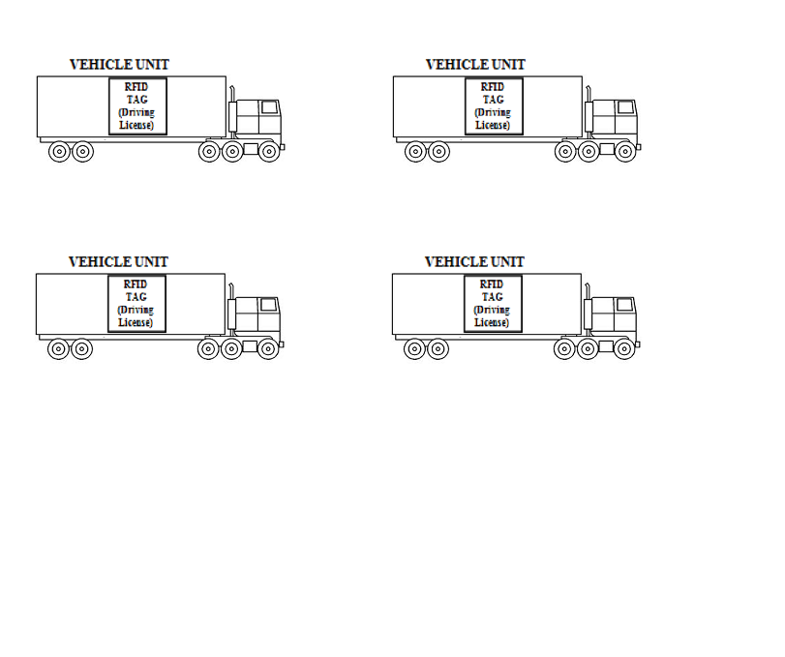

**Fig.** Vehicle unit

**2)Vehicle Detection Unit**

This unit includes AT89S52 microcontroller, RFID reader, LED/signal, LCD display and a Zigbee module. Whenever a vehicle crosses a signal, toll gate or check post, the RFID reader placed in the device reads the unique code of the RF tag of the vehicle and gains the complete data fed in the tag and displays it on the LCD display of the device.

This complete data is send to the RTO server unit. The server checks with the unique code of the vehicle to find out any false data or penalties for the current user and for the vehicle.

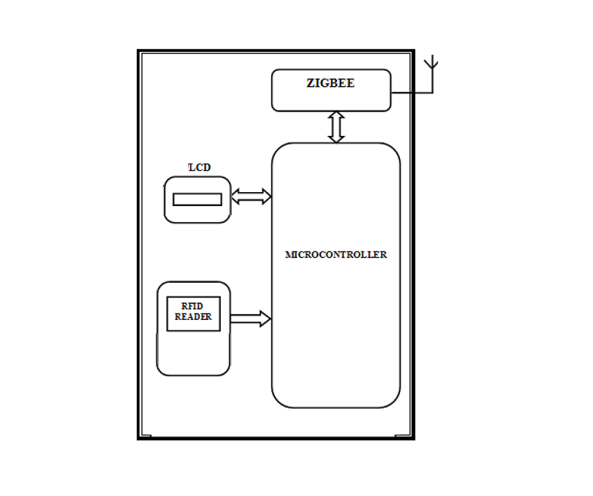

**Fig .** vehicle detection unit

**3)Main Server Unit**

When the vehicle detection unit sends the data to the RTO server, here it communicates using Zigbee nodes formed by the mesh network between the RTO server and the hand held devices all over the city.These nodes by using the same power consumption required for a small network, communicate a whole large mesh network due to its decentralization of nodes feature.

The RTO server unit consists of a Zigbee module, Max232 to give a serial data input and output all these interfaced with the motherboard of a CPU.The software is installed in this computer and complete database is provided of all the registered vehicles.The data send by the remote device is cross checked here in RTO for its originality and update. If the data found correct, then it will glow GREEN LED on the hand held device and display OK on the LCD screen.

But if the data found is false, then RED LED will glow and the data which is false or not updated or any penalty record will be displayed on the LCD screen of the device. All this process is carried out wirelessly in very few seconds.

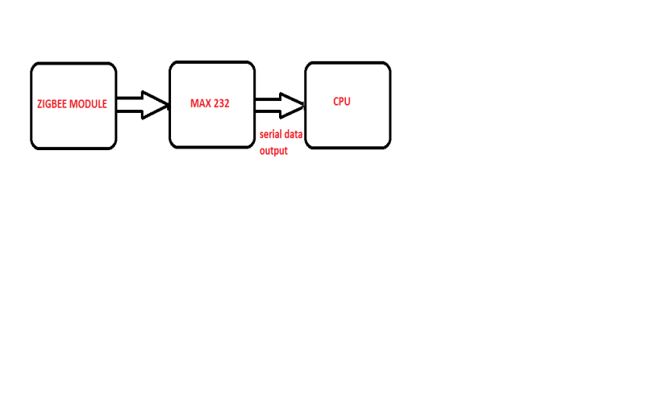

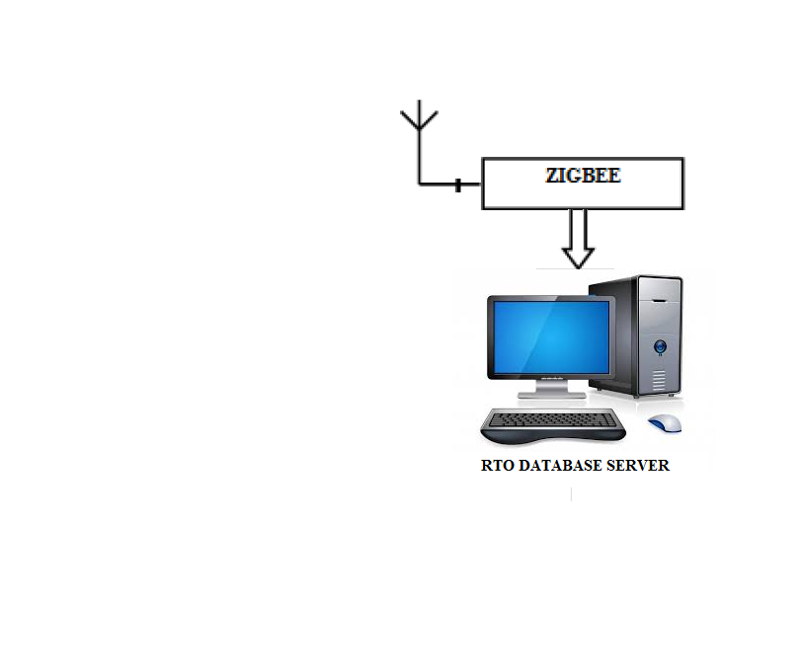

**Fig .**main server unit

1. **BLOCK DIAGRAM:**

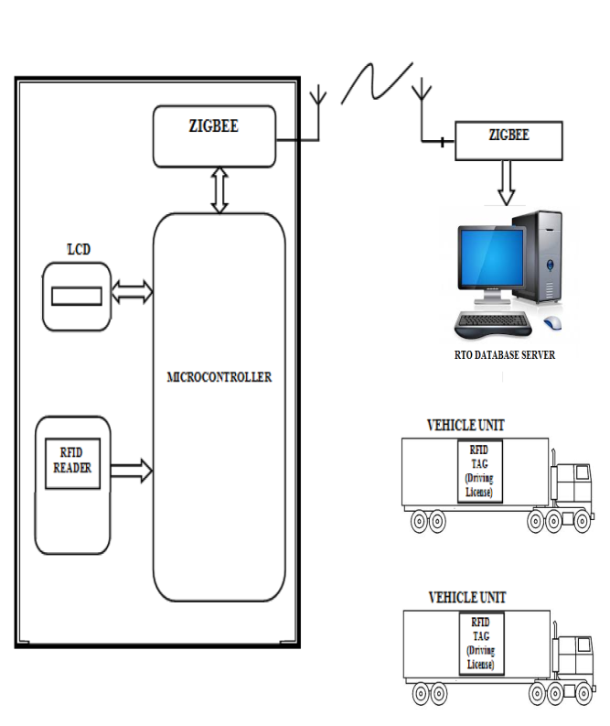

Fig. Block diagram of the project

1. **SOFTWARE:**

**KEIL ìVision 4:**

KEIL ìVision IDE development tool is used to compile and debug the 8051 program written in C . Its working process is simple and easy to use. It helps to develop the embedded programs rapidly. Once the target code is generated it is dumped using flash magic software.

**C #.NET:**

C# (pronounced as C sharp) language is proposed to be simple, robust, economical, Multiplatform support, general purpose language suitable for embedded applications ranging from dedicated functions to very large sophisticated systems. C# 3.0 Microsoft visual studio 2008 .NET Framework IDE is used in this application.

1. **ADVANTAGES AND APPLICATIONS:**

**Advantages of RFID:**

* Tamper proof
* Concealed installation of antennas
* Weather proof
* 100 % detection for two-wheelers / four-wheelers
* No height restrictions on vehicles as scanning is done from underneath
* RFID tags can be affixed to automobiles for activating hands-free access to communities and parking lots.
* The RFID reader can also trigger surveillance cameras or video recorders whenever a vehicle enters or exits the controlled area.

**Advantages Of ZIGBEE :**

* Safe and commercial application
* Mobility and traffic model.
* Security and privacy.
* Cross layer optimization technique
* Uses mesh network , so makes flexible to reach long distance.
* Less power consumption as nodes involved.
* Cost effectiveness.
* Much beneficial than other technologies like Wi-Fi and Bluetooth.

**Key Advantages Of Project:**

* No physical document verification.
* No tampering the vehicle data.
* Environmental friendly.
* No messy cables involved.
* Authorized permission access so completely safe and private.
* Real-time and historical tracking information
* Improved data accuracy
* Auto IN-OUT tracking of vehicles
* Easily scalable to include features such as access control , monitoring, GSM.
* Manageable Locally & Centrally
* Replicable to any number of locations
* Possible to integrate with different types of barriers

**Applications:**

* Vehicle authentication
* Toll Tax Collection system
* Tracking
* Parking system
* Registration
* Database management and collection
* Traffic management system
* Automatic speed limit enforcement
* Rerouting traffic congestion( i.e. hand held set data)
* Sophisticated data exchange
* Notification of accident head ups.
* Extended communication.

1. **CONCLUSION AND FUTURE SCOPE:**

* The proposed work gives a unique way to protect vehicles along with an automatic toll collection that helps to regulate the process in an easy way. In an outlook, automated vehicle tracking and monitoring may be done with a GPS system for tracing the vehicle speed and giving automated warning when a vehicle reaches the speed limit and deducing the penalty directly if the object ignores the warning. Identifying the stolen car using GPS and controlling the car from remote using server can also be added. In addition to registering a bank account, a prepaid card can be allotted to each vehicle and object for those who don’t wish to register their bank accounts, so that the amount will be deducted from the card which should be recharged when there is not enough balance in the card. Displaying the sign boards on the roadside in the LCD may also be implemented.

The unique identifiers linked to the respective person’s bank account debits the penalty/toll fare when the vehicle passes by toll gates/check posts. This provides a way for reducing any possibility of corruption in motor vehicles section as the penalty will be deducted straightforwardly from the person's account by an automated system.

* **Tracking vehicles within the plant:** The use of RFID in a vehicle assembly line ensures optimum
* operation, enhanced efficiency and eliminates the possibility of fraud and theft. Strategically positioned fixed RFID readers with multiple tag reading capability trace the newly finished cars as they leave the product line. In this way vehicles can be tracked throughout the plant installing ZIGBEE.
* **Prevents manipulation of data:**The security issues RFID tags to the trucks that are coming inside the premises. It is attached to the truck that carries the cane load and identification is done
* throughout its journey. The RFID antenna and ZIGBEE modules will be coupled to the PC and once the truck is over the weigh bridge the data is captured from the tag and this is passed on to the PC for processing. This can reduce your fraud activities drastically.



* **Better Fleet Management:**RFID has enabled better fleet management. Now the transporters have a fix on reasons behind vehicular downtime. They know how long it takes to load raw materials and they can measure the performance of drivers. Transporters can plan availability of trucks based on the latest tracking data and make optimum use of their fleets.



* **Parking Lot Access Control:**We also provide parking barrier drop-arm control systems to control authorized access into and out of the parking area. RFID-ZIGBEE based access control systems ensures that only authorized vehicles can get into and get out of the parking area. Parking barrier arms automatically lifts to let the vehicle pass through on success identification of the vehicle RFID tag. This can be done by fixing RFID tag to the windscreen of the vehicle. When the vehicle comes in range of the reader, the reader reads the card ID and authenticates the same communicating to ZIGBEE. If ID is authenticated the relay for moving the boom barrier is fired and access to the parking lot isenabled. In this way there is no need for any guard to be monitoring the exit and entry of vehicles to the parking lot. The vehicles will be logged automatically and a total report of the usage of the parking lot can be generated.

**10) REFERENCES:**

[1] Nor Azlina , Bt Abd Rahman , Mohsen Bafandehkar, Behzad Nazarbakhsh , Nurul Haniza Bt Mohtar , “Ubiquitous Computing For Security Enhancement Of Vehicles”, IEEE International Conference on Vehicular Electronics and Safety (ICVES) ,Beijing, pp: 113- 118, 2011.

[2] Omidiora E.O, Fakolujo O.A, Arulogun O.T, Aborisade D.O, “A Prototype of a Fingerprint Based Ignition Systems in Vehicles”, European Journal of Scientific Research, pp: 164-171, 2011.

[3] Weiqi Yuan, Yonghua Tang, “The Driver Authentication Device Based on the SCharacteristics of Palm print and Palm Vein”, International Conference on Hand-Based Biometrics (ICHB), Hong kong, pp: 1-5, 2011.

[4] Hugo Silva, Andr’e Lourenc¸ O’Ana Fred, “In-Vehicle Driver Recognition Based on Hands ECG Signals”, International Conference on Intelligent User Interface , Lisbon, Portugal, pp: 25-28, 2012.

[5] Ronghua Chen, Mary Fenghua She, Xiangping Sun, Lingxue Kong, Yuchuan Wu , “Driver Recognition Based on Dynamic Handgrip Pattern on Steeling Wheel”, 12th ACIS International Conference on Software Engineering, Artificial Intelligence, Networking and Parallel/Distributed Computing, Sydney NSW, pp: 108-112, 2011.

[6] Pazhampilly Sreedevi A, Sarath S Nair B, “Image Processing Based Real Time Vehicle Theft Detection And Prevention System”, International Conference on Process Automation, Control and Computing (PACC), Coimbatore, pp: 1-6, 2011.

[7] Aditya I.V.N.S, Radha Krishna Murthy Y, Ravindra Babu Kallam Lt, “Alternate Method for the Failure of Antitheft Device used in Motor Vehicles”, International Journal of Computer Applications, Vol. 13, No.6, pp: 23-26, 2011.